
Formulation development and evaluation of a novel bi-dependent clarithromycin gastroretentive drug delivery system using Box-Behnken design

The objective of this research paper is to develop a novel bi-dependent gastroretentive tablet (BDGRT) formulation containing clarithromycin and to evaluate pharmacokinetics in beagle dogs. Design of experiments (DoE) methodology is implemented for the optimization of the BDGRT formulation.
The factors (independent variables) examined are: X₁ = amount of HPMC K4M (mg), X₂ = amount of NaHCO₃ (%) and X₃ = amount of camphor (%). All the factors are continuous. The responses (dependent variables) examined are: Y₁ = floating lag time (sec), Y₂ = friability (%), Y₃ = tablet crushing strength (kg/cm²), Y₄ = cumulative drug release at 5th h (%) and Y₅ = cumulative drug release at 10th h (%). The applied DoE method is Box Behnken design.
Isalos version used: 2.0.6
Scientific article: https://www.sciencedirect.com/science/article/abs/pii/S1773224716301800

Step 1: Box Behnken Design
In the first tab named “Action” define the factors in the column headers and fill each column with the low and high levels of the corresponding factors. This tab can be renamed “Box Behnken.” Afterwards, apply the Box Behnken method: DOE $→$ Response Surface $→$ Box Behnken

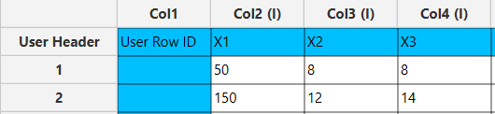

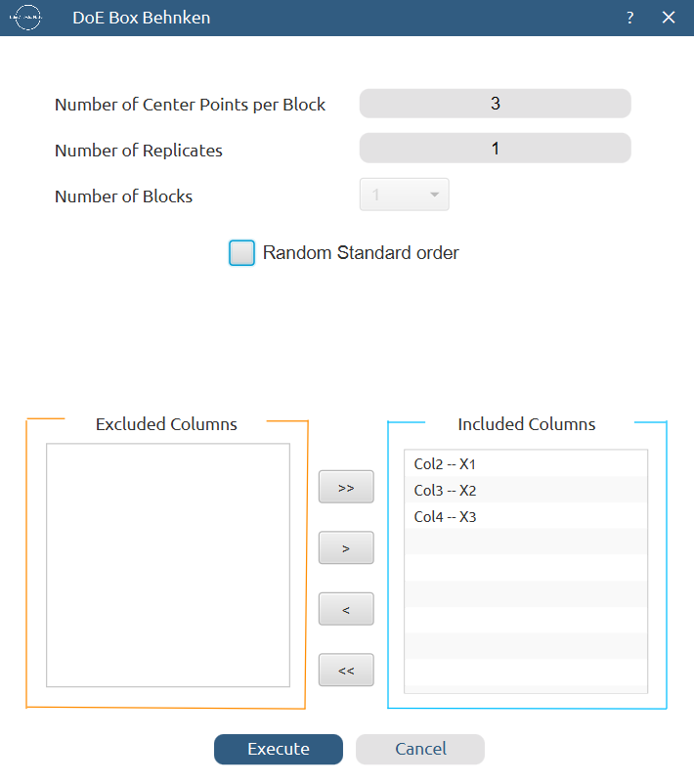

Results (right spreadsheet):
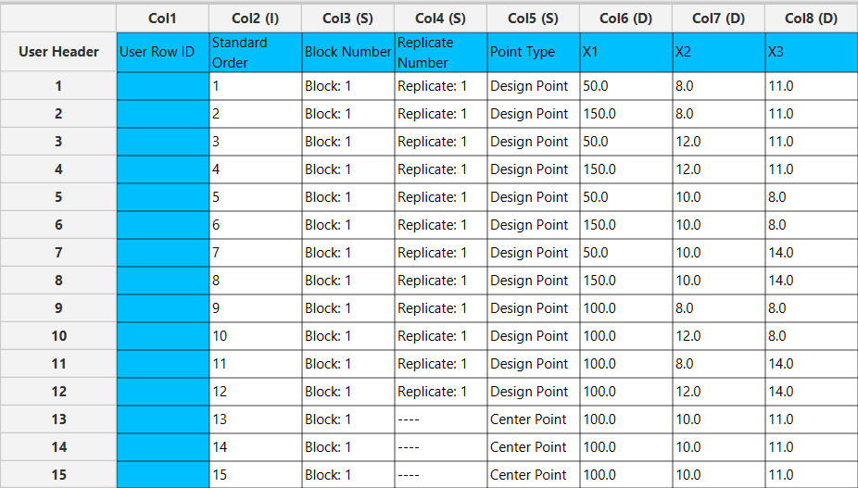

Step 2: Definition of response variables
Create a new tab named “Responses” and define the responses in the column headers. Fill each column with the values of the corresponding responses that were observed and make sure the values follow the order of the experiments as given by the Box Behnken method. Then, select all columns to be transferred to the right spreadsheet: Data Transformation $→$ Data Manipulation $→$ Select Column(s)

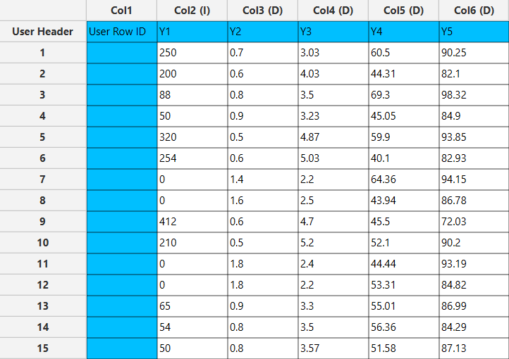

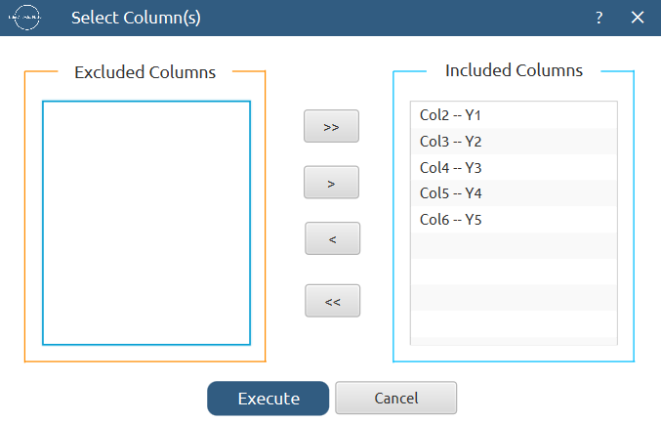

Step 3: Data isolation
Create a new tab named “Data” and import the results from the “Box Behnken” and “Responses” spreadsheets by right clicking on the left spreadsheet. Then, select only the factors and responses columns to be transferred to the right spreadsheet: Data Transformation $→$ Data Manipulation $→$ Select Column(s)
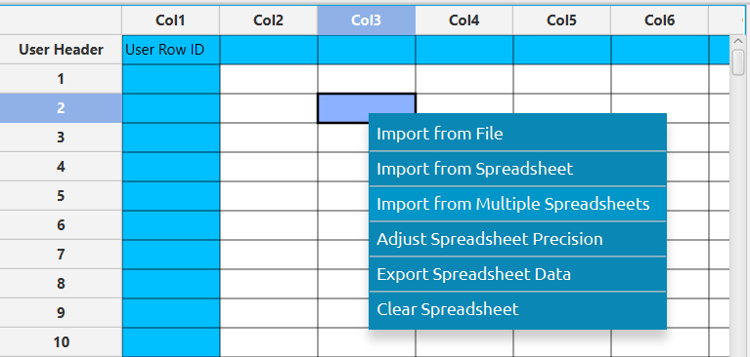

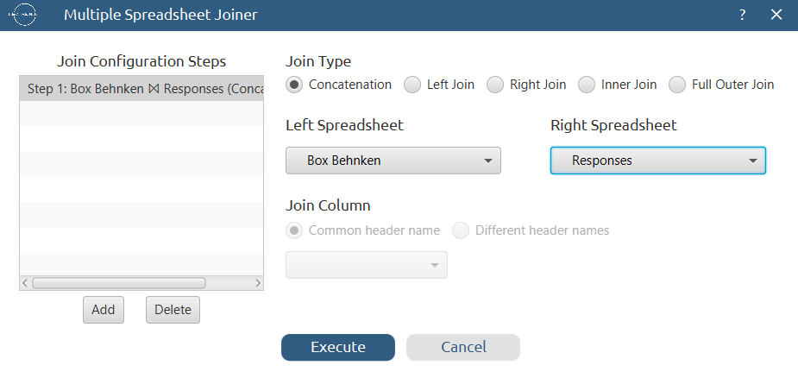

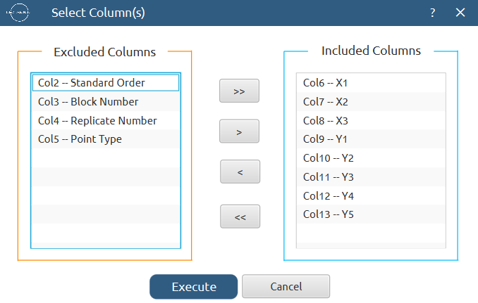
Results:
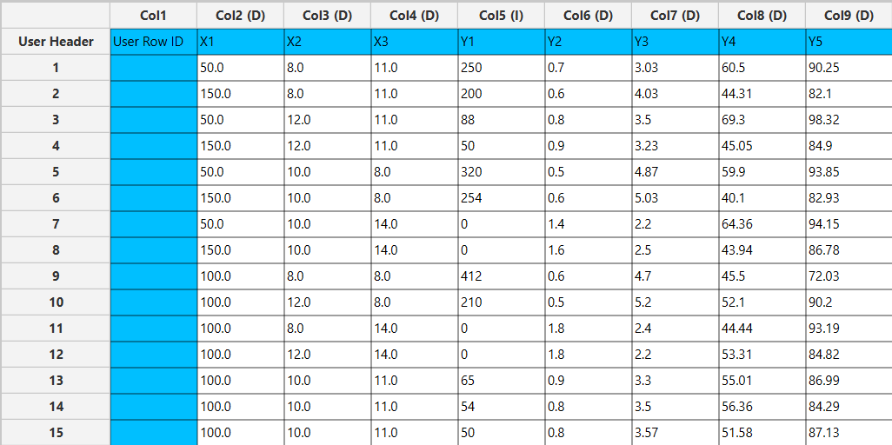

Step 4: Normalization
Create a new tab named “Normalized data” and import the results from the “Data” spreadsheet. Afterwards, normalize the factor columns to take values in the range [-1, 1]: Data Transformation $→$ Normalizers $→$ Min-Max


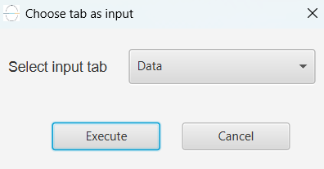
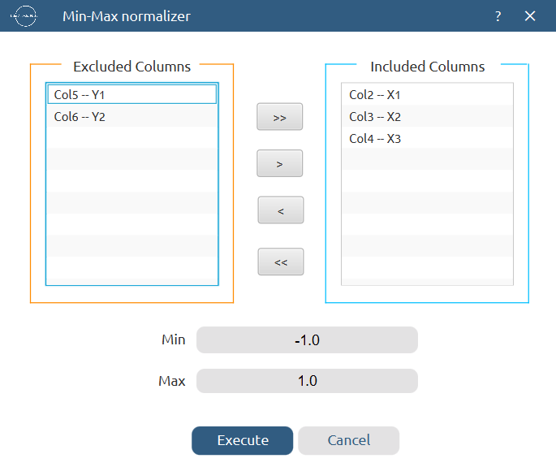

Results:
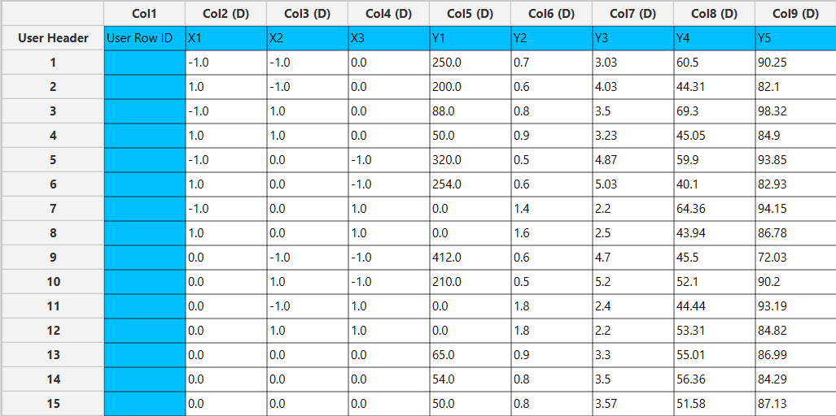

Step 5: Regression
The goal here is to produce a regression equation that includes main effects, two-factor interactions and quadratic effects for Y₁:
$$Y=b_{0}+b_{1}X_{1}+b_{2}X_{2}+b_{3}X_{3}+b_{12}X_{1}X_{2}+b_{13}X_{1}X_{3}+b_{23}X_{2}X_{3}+b_{11}{X_{1}}^{2}+b_{22}{X_{2}}^{2}+b_{33}{X_{3}}^{2}$$

Create a new tab named “Regression – Y1” and import the results from the spreadsheet “Normalized data”. Afterwards, fit a generalized linear model to the data: Analytics $→$ Regression $→$ Statistical fitting $→$ Generalized Linear Models

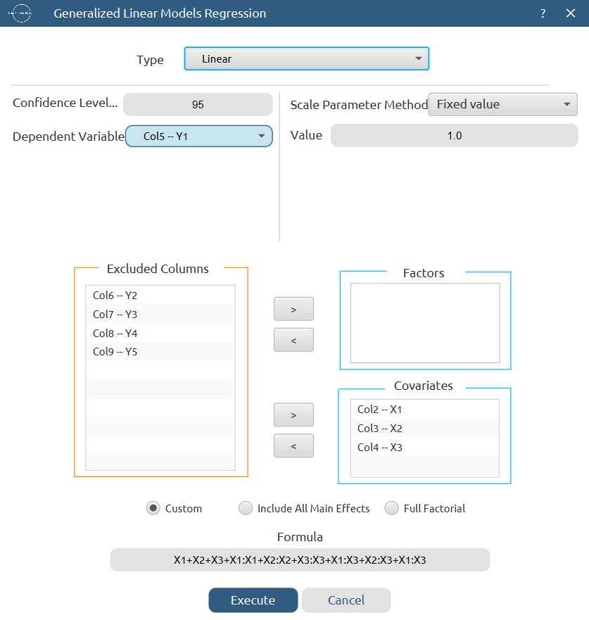

Results:

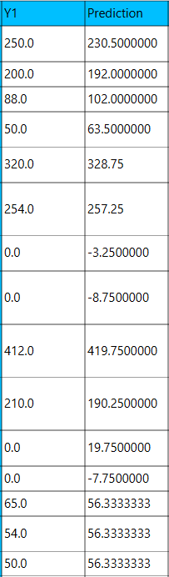
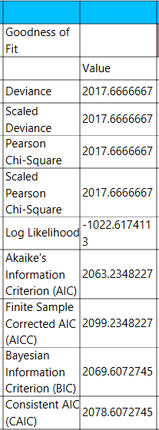

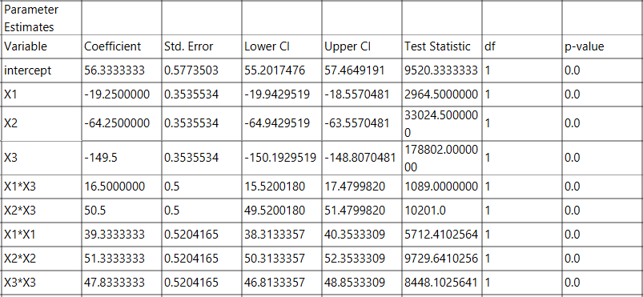

Repeat this step for the rest of the response variables. Results, Y₂:

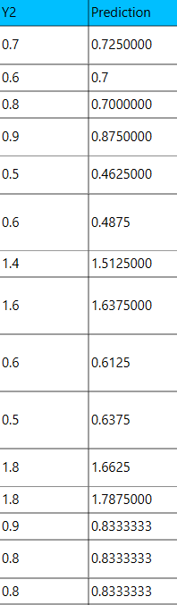

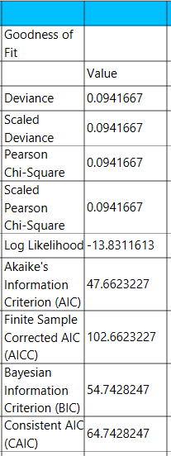

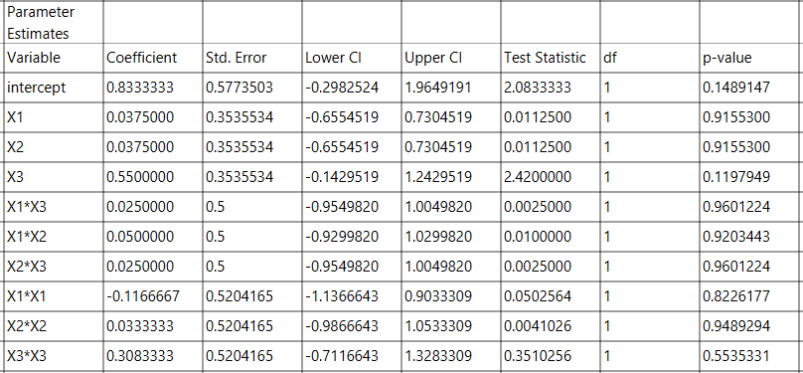

Results, Y₃:

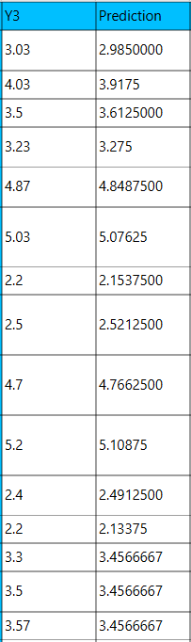
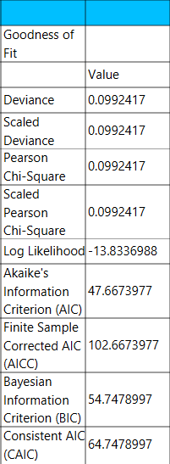

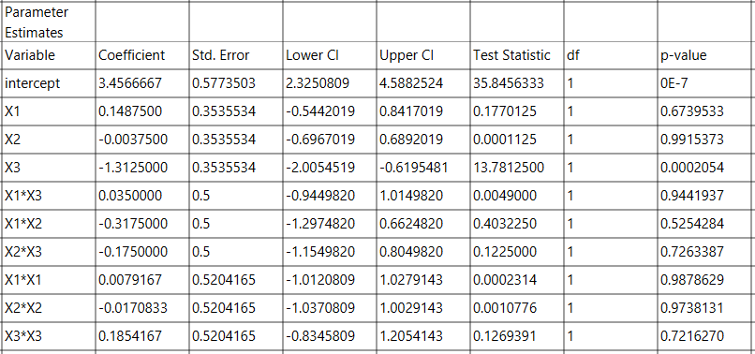

Results, Y₄:

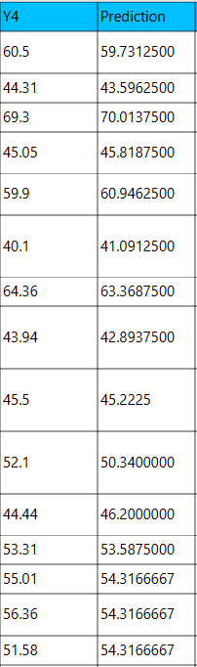
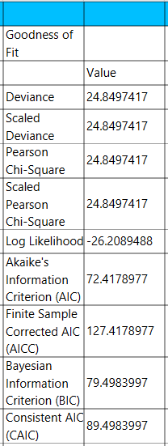

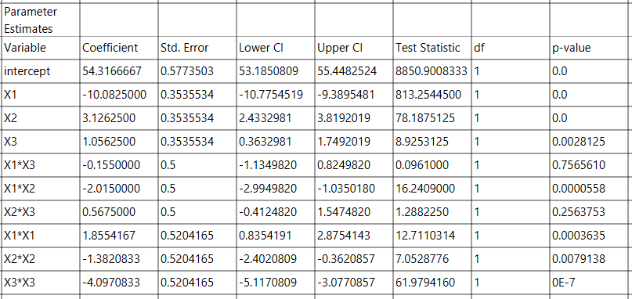

Results, Y₅:

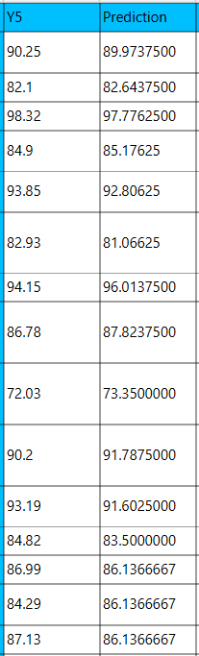
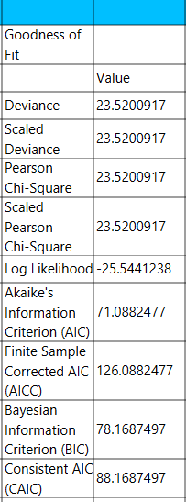

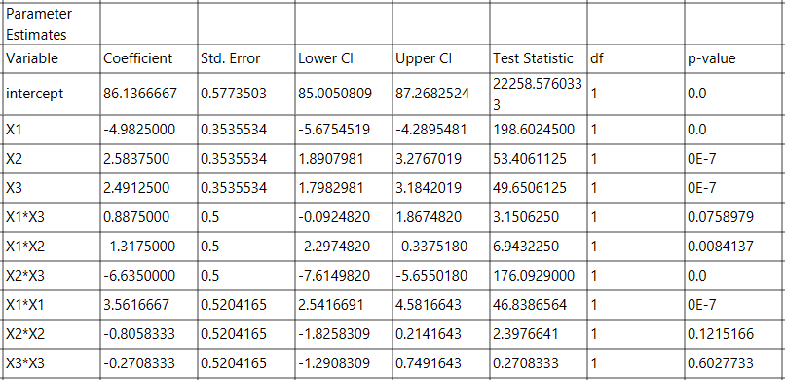

Step 6: Regression Metrics
Create a tab named “Metrics – Y1” and import the results from the spreadsheet “Regression – Y1”. Then, produce the regression metrics for the Y₁ regression equation: Statistics $→$ Model Metrics $→$ Regression Metrics

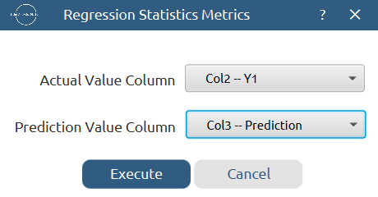

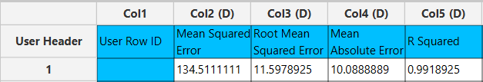

Repeat this step for the rest of the response variables. Results, Y₂:
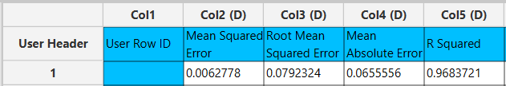
Results, Y₃:
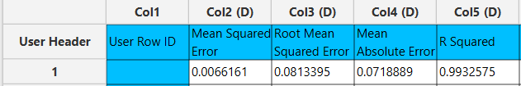
Results, Y₄:
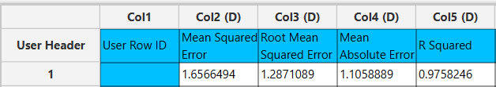

Results, Y₅:
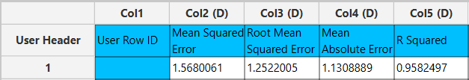

Step 7: Analysis of Covariance
Create a new tab named “ANCOVA – Y1” and import the results from the spreadsheet “Normalized data”. Afterwards perform analysis of covariance for Y₁: Statistics $→$ Analysis of (Co)Variance $→$ ANCOVA
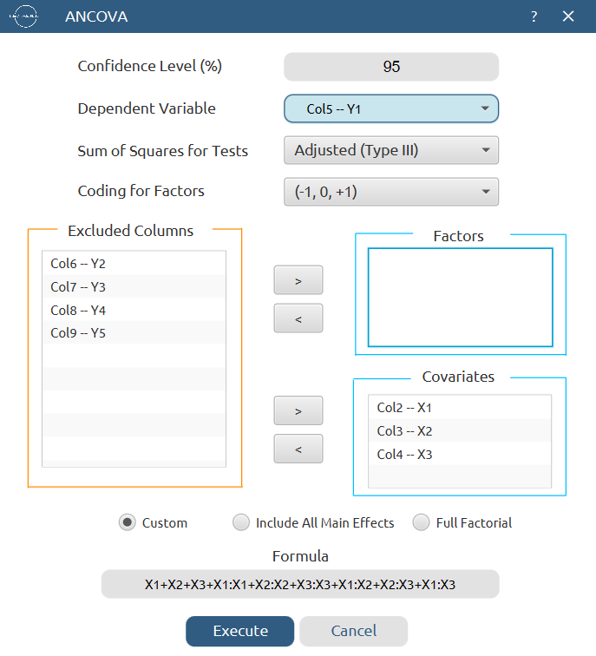

Results:
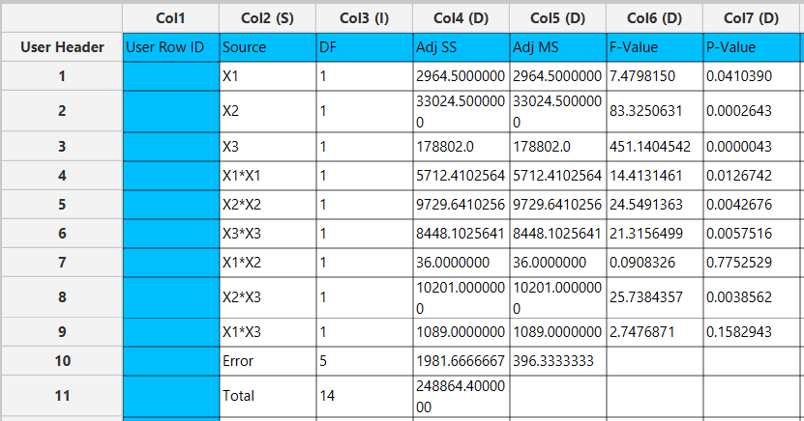

Repeat this step for the rest of the response variables. Results, Y₂:
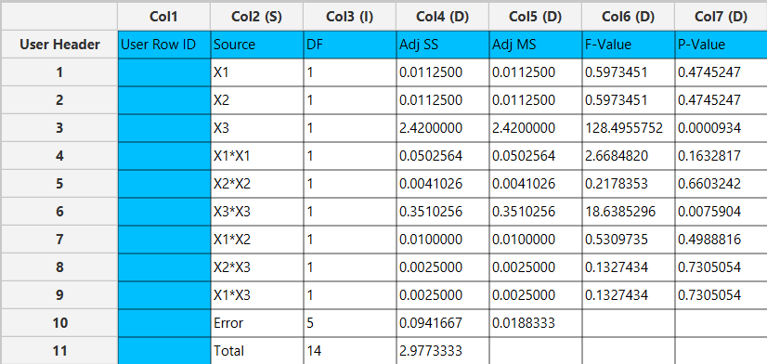

Results, Y₃:
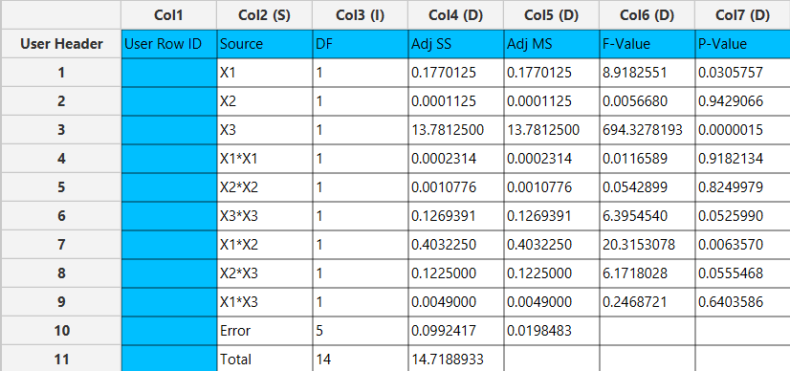

Results, Y₄:
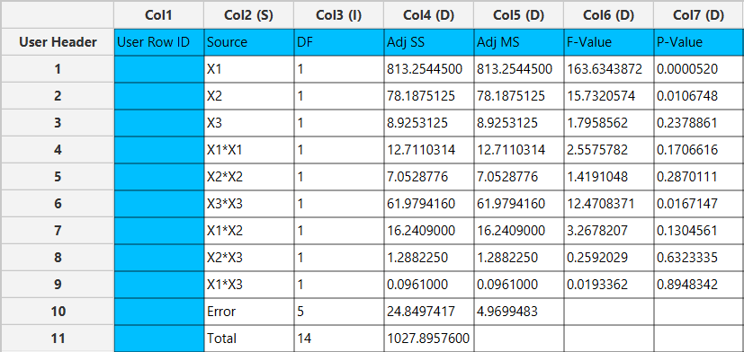

Results, Y₅:
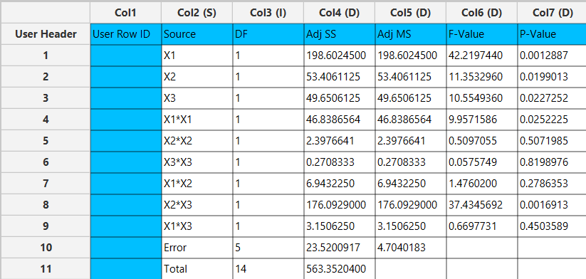

Final Isalos Workflow
The final workflow is presented below (doesn’t fully fit):
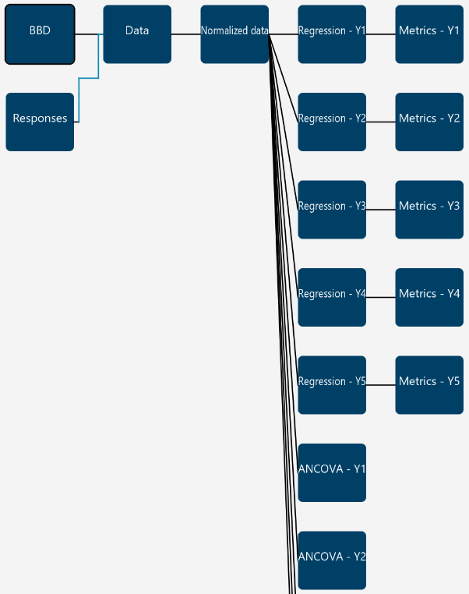

References
- Malladi, M.; Jukanti, R. Formulation Development and Evaluation of a Novel Bi-Dependent Clarithromycin Gastroretentive Drug Delivery System Using Box-Behnken Design. Journal of Drug Delivery Science and Technology 2016, 35, 134–145. https://doi.org/10.1016/j.jddst.2016.06.003.

