
Development of nanostructured lipid carriers containing salicyclic acid for dermal use based on the Quality by Design method

This research paper aims to evaluate the applicability of the Quality by Design (QbD) methodology in the development and optimalization of nanostructured lipid carriers containing salicyclic acid (NLC SA). Design of experiments (DoE) methodology is implemented in order to evaluate the role of the independent and dependent variables.
The factors (independent variables) examined are: X₁ = surfactant concentration (w/w %), X₂ = solid/liquid lipid ratio and X₃ = ultrasonication time (min). All the factors are continuous. The responses (dependent variables) examined are: Y₁ = particle size (μm) and Y₂ = particle size distribution. The applied DoE method is 2³ full factorial design.
Isalos version used: 2.0.6
Scientific article: https://www.sciencedirect.com/science/article/abs/pii/S0928098716305607

Step 1: Full Factorial Design
In the first tab named “Action” define the factors in the column headers and fill each column with the low and high levels of the corresponding factors. This tab can be renamed “Full Factorial”. Afterwards, apply the full factorial method: DOE $→$ Factorial $→$ Full Factorial

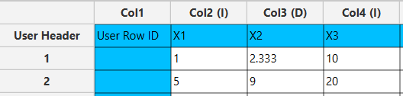

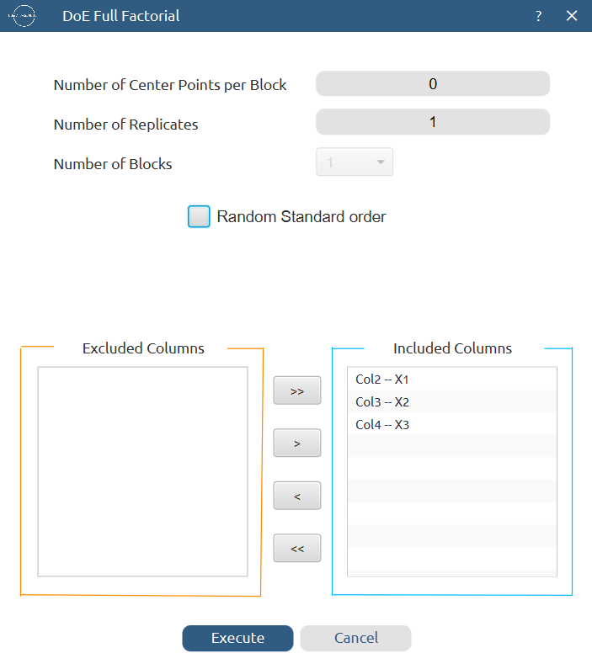

Results (right spreadsheet):
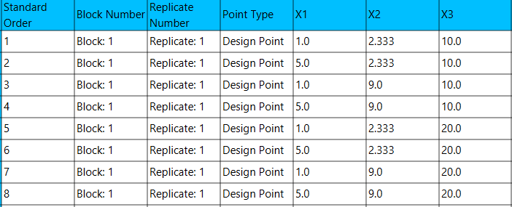

Step 2: Factor isolation
Create a new tab named “Factors” and import the results from the “Full Factorial” spreadsheet by right clicking on the left spreadsheet. Then, select only the factor columns to be transferred to the right spreadsheet: Data Transformation $→$ Data Manipulation $→$ Select Column(s)



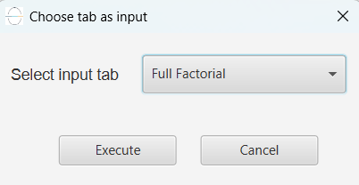

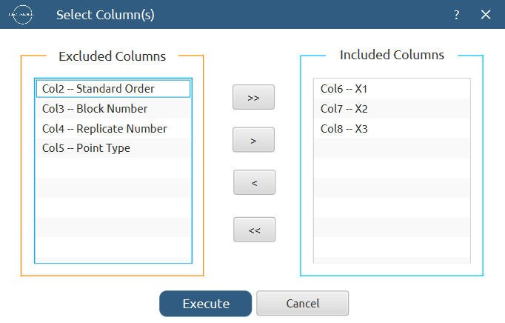

Results:
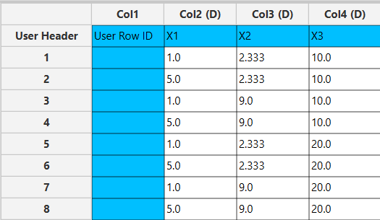

Step 3: Definition of response variables
Create a new tab named “Responses” and define the responses in the column headers. Fill each column with the values of the corresponding responses that were observed and make sure the values follow the order of the experiments as given by the full factorial design. Then, select all columns to be transferred to the right spreadsheet: Data Transformation $→$ Data Manipulation $→$ Select Column(s)

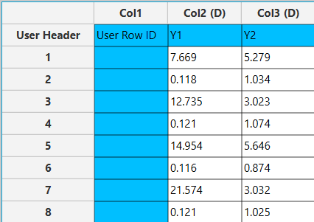

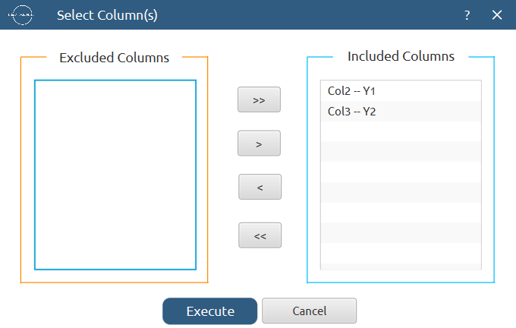

Step 4: Normalization
Create a new tab named “Normalized data” and import the results from the “Factors” and “Responses” spreadsheets. Afterwards, normalize the factor columns to take values in the range [-1, 1]: Data Transformation $→$ Normalizers $→$ Min-Max

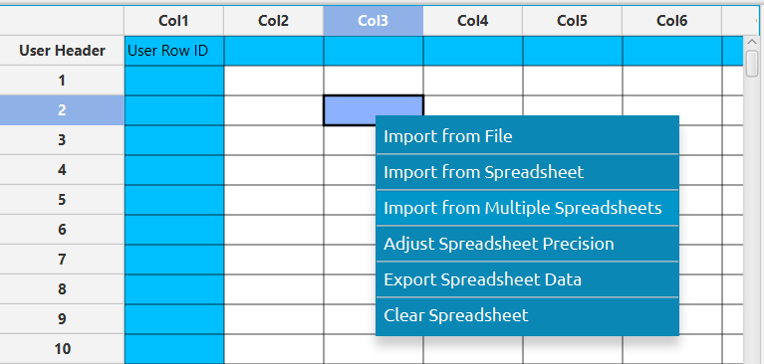

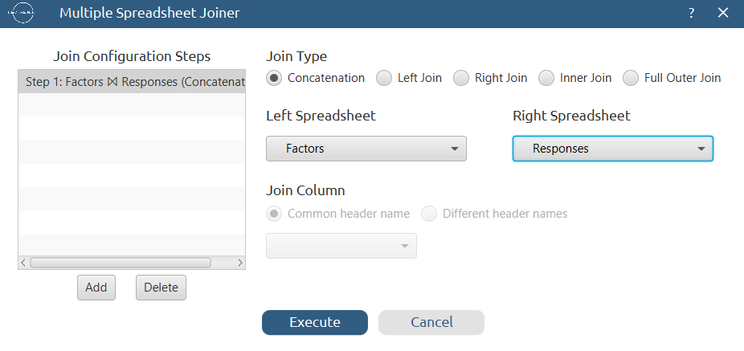

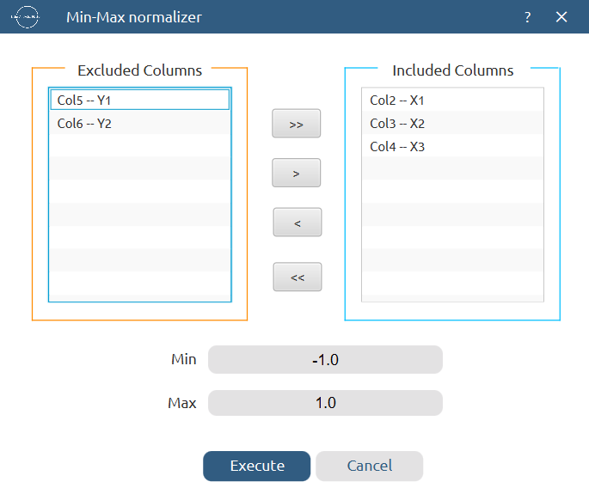

Results:
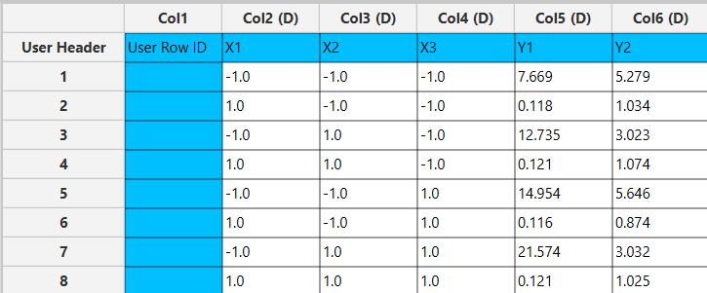

Step 5: Pareto analysis
Create a new tab named “Pareto Analysis – Y1” and import the results from the spreadsheet “Normalized data”. Then, conduct pareto analysis for the first response variable, Y₁: DOE $→$ Post DoE Analysis $→$ Pareto Analysis

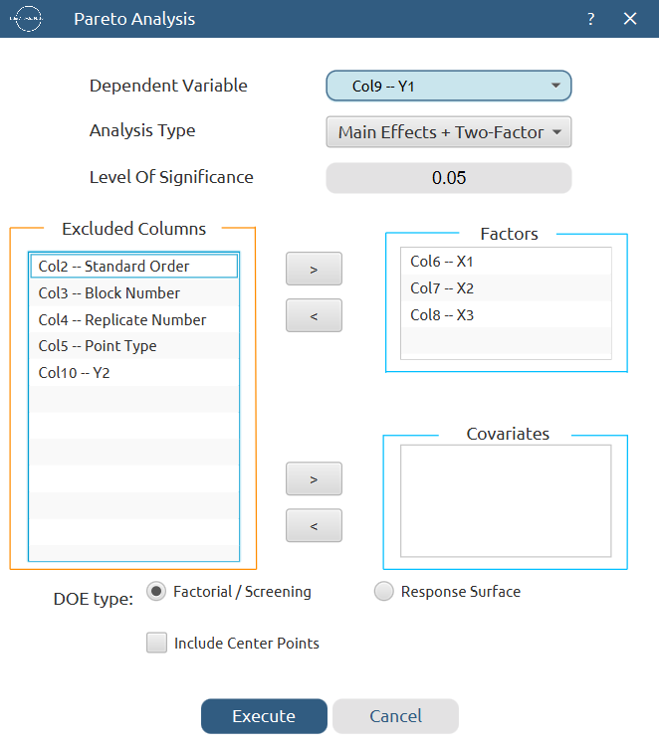

Results:
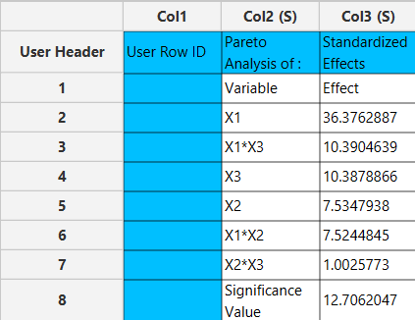

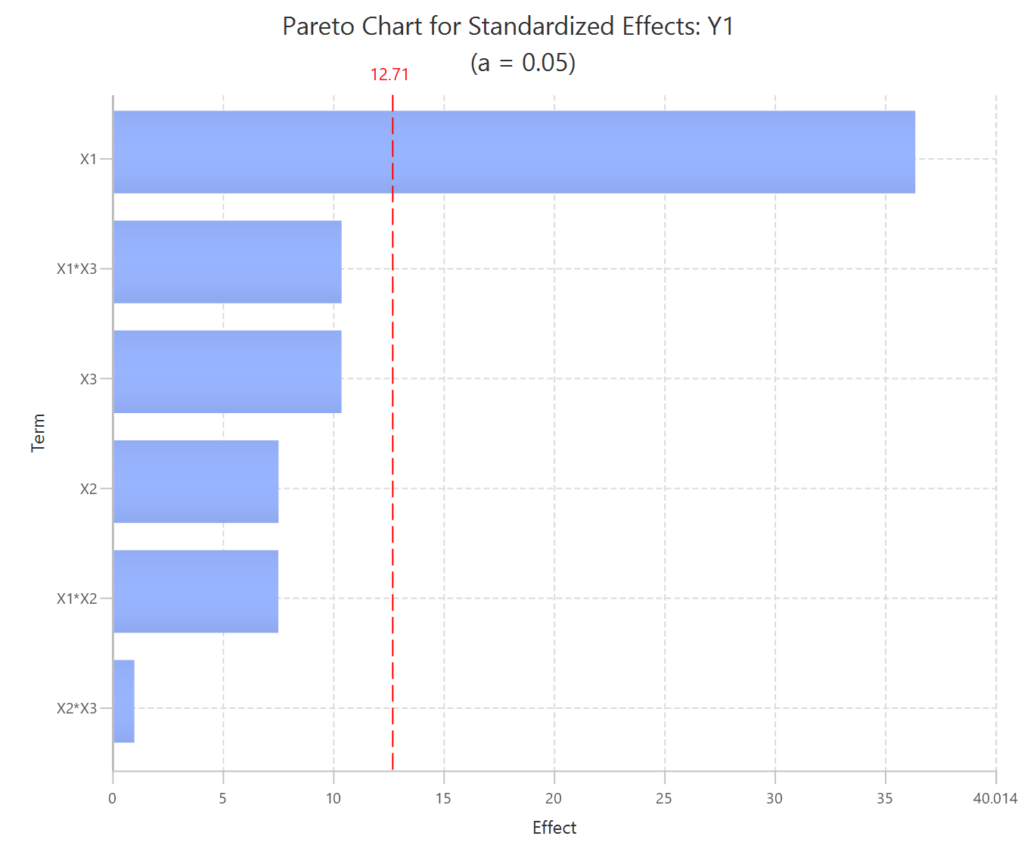

Repeat this step for the second response variable, Y₂. Results:
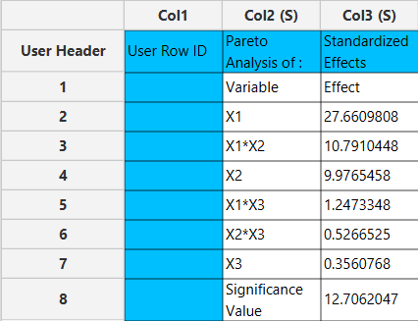

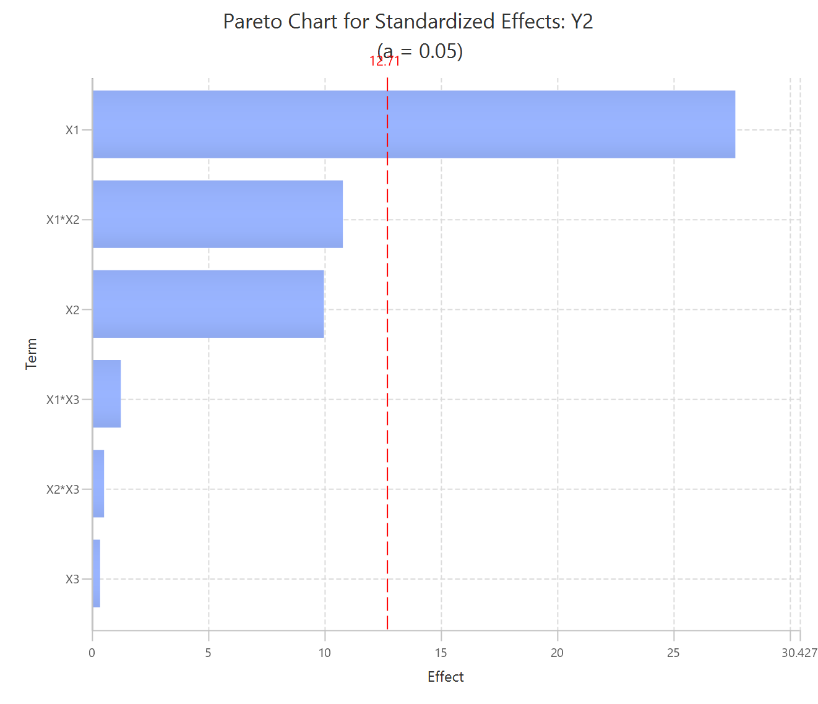

Step 6: Regression
The goal here is to produce a regression equation that includes main effects and two-factor interactions for Y₁: $Y=b_{0}+b_{1}X_{1}+b_{2}X_{2}+b_{3}X_{3}+b_{12}X_{1}X_{2}+b_{13}X_{1}X_{3}+b_{23}X_{2}X_{3}$
Create a new tab named “Regression – Y1” and import the results from the spreadsheet “Normalized data”. Afterwards, fit a generalized linear model to the data: Analytics $→$ Regression $→$ Statistical fitting $→$ Generalized Linear Models

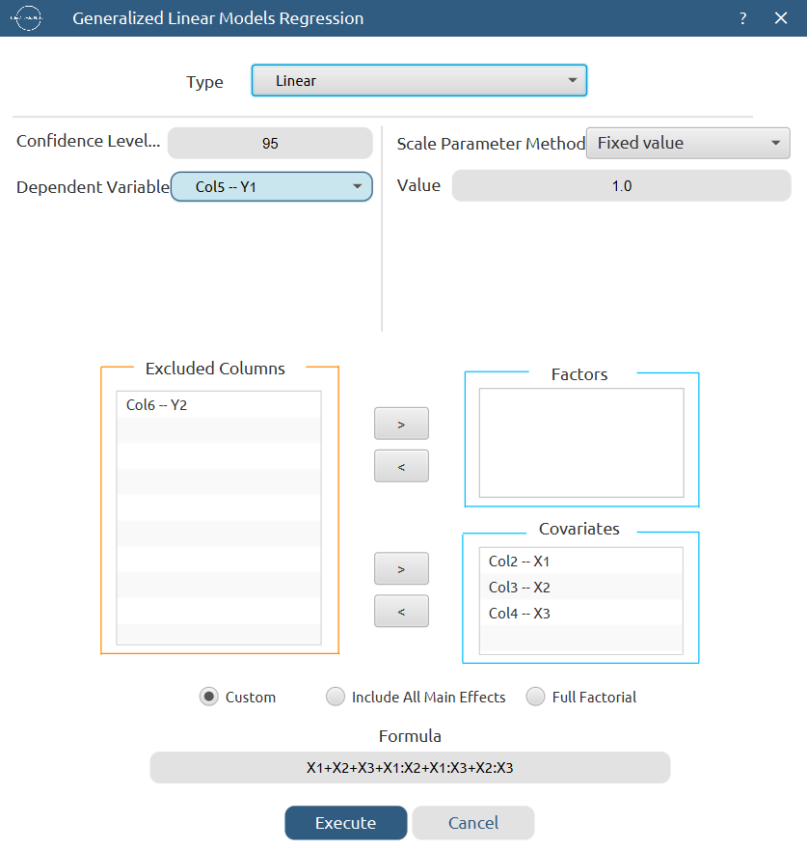
Results:

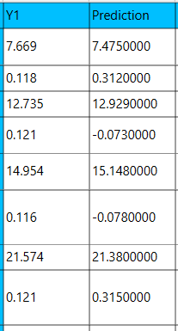
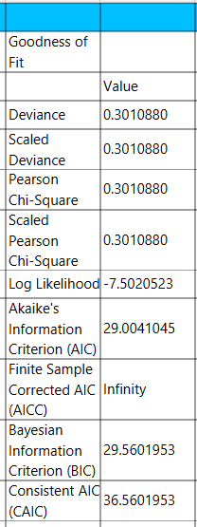

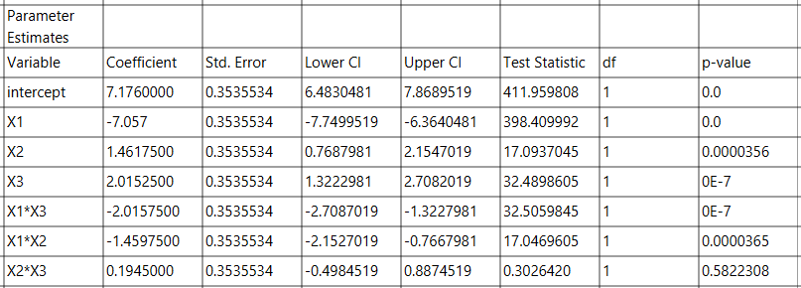

Repeat this step for the second response variable, Y₂. Results:

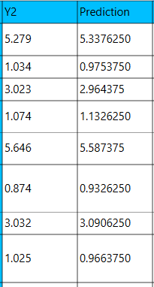
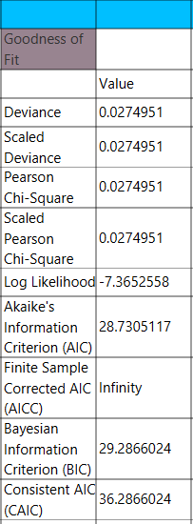

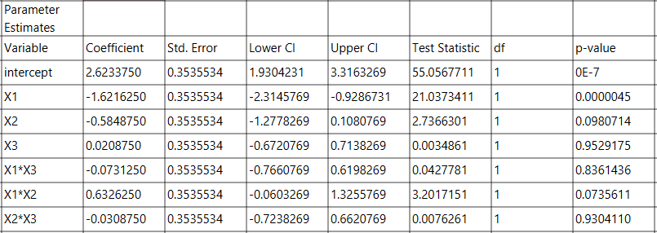

Step 7: Regression Metrics
Create a tab named “Metrics – Y1” and import the results from the spreadsheet “Regression – Y1”. Then, produce the regression metrics for the Y₁ regression equation: Statistics $→$ Model Metrics $→$ Regression Metrics

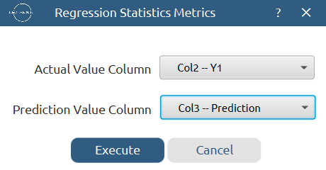

Results:
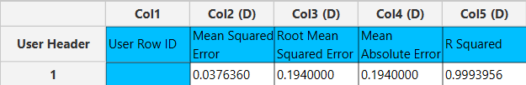

Repeat this step for the second response variable, Y₂. Results:
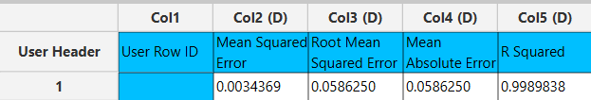

Step 8: Analysis of Covariance
Create a new tab named “ANCOVA – Y1” and import the results from the spreadsheet “Normalized data”. Afterwards perform analysis of covariance for Y₁: Statistics $→$ Analysis of (Co)Variance $→$ ANCOVA

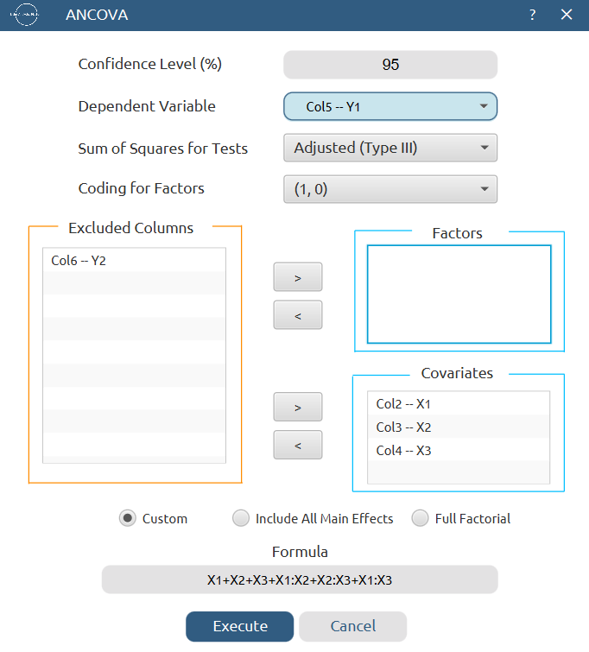

Results:
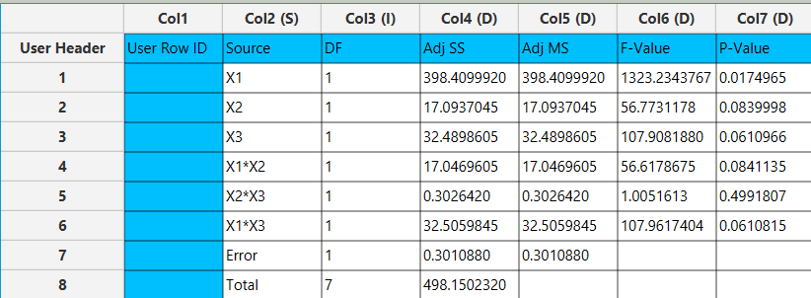

Repeat this step for the second response variable, Y₂. Results:
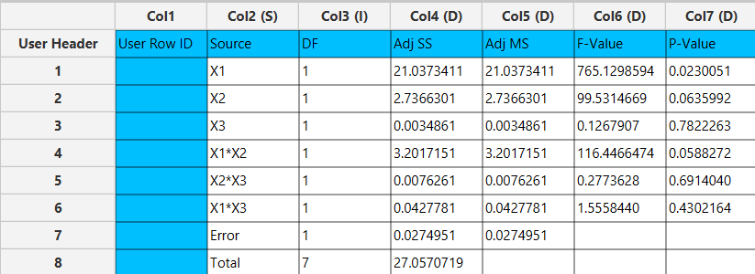

Final Isalos Workflow
The final workflow is presented below:
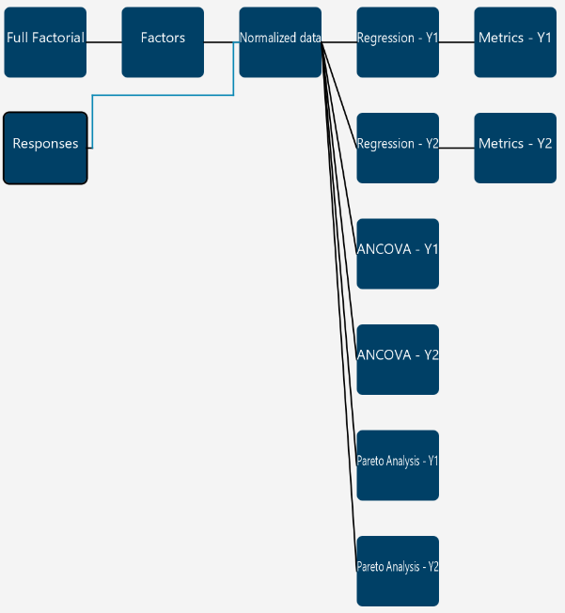

References
- Kovács, A.; Berkó, Sz.; Csányi, E.; Csóka, I. Development of Nanostructured Lipid Carriers Containing Salicyclic Acid for Dermal Use Based on the Quality by Design Method. European Journal of Pharmaceutical Sciences 2017, 99, 246–257. https://doi.org/10.1016/j.ejps.2016.12.020.

