
Quality by Design approach for an in situ gelling microemulsion of Lorazepam via intranasal route

This research paper applies the concept of Quality by Design in the development, optimization and evaluation of Lorazepam loaded microemulsion containing ion responsive in situ gelator gellan gum and carbopol 934. Design of experiments (DoE) methodology is implemented in order to evaluate the effect of the independent variables on the responses.
The factors (independent variables) examined are: X₁ = oil to surfactant/cosurfactant ratio and X₂ = concentration of gellan gum (% w/v). All the factors are continuous. The responses (dependent variables) examined are: Y₁ = in vitro drug release (%) and Y₂ = viscosity at physiological pH (Pa∙s). The applied DoE method is 3² full factorial design.
Isalos version used: 2.0.6
Scientific article: https://www.sciencedirect.com/science/article/pii/S0928493117308020

Step 1: Full Factorial Design
In the first tab named “Action” define the factors in the column headers and fill each column with the low and high levels of the corresponding factors. This tab can be renamed “Full Factorial”. Afterwards, apply the full factorial method: DOE $→$ Factorial $→$ Full Factorial

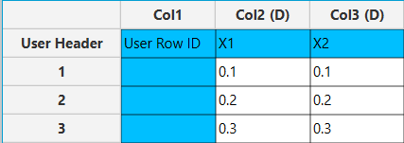

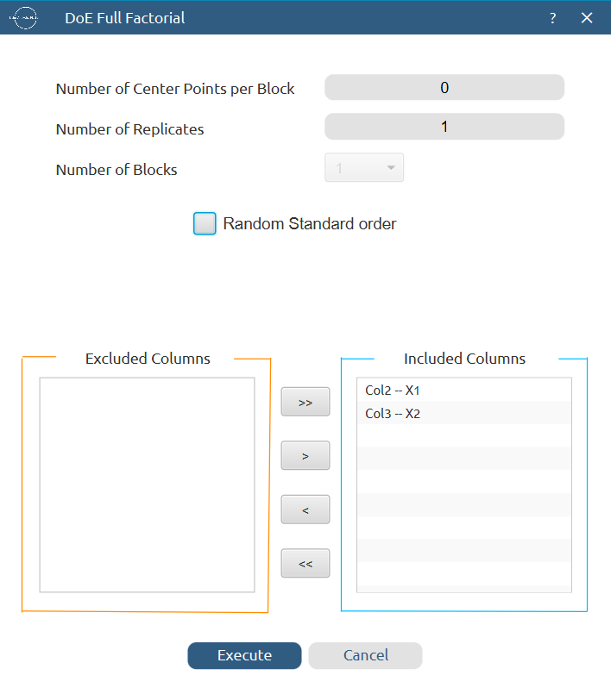

Results (right spreadsheet):
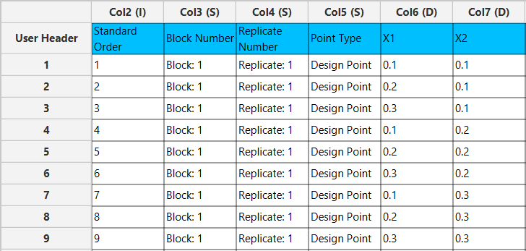

Step 2: Factor isolation
Create a new tab named “Factors” and import the results from the “Full Factorial” spreadsheet by right clicking on the left spreadsheet. Then, select only the factor columns to be transferred to the right spreadsheet: Data Transformation $→$ Data Manipulation $→$ Select Column(s)



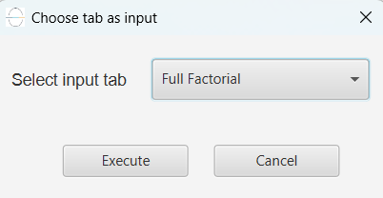

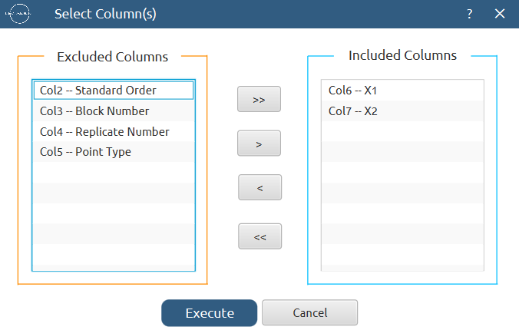
Results:
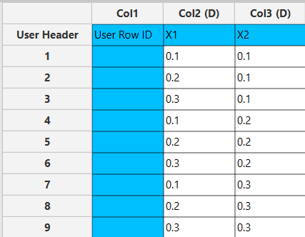

Step 3: Definition of response variables
Create a new tab named “Responses” and define the responses in the column headers. Fill each column with the values of the corresponding responses that were observed and make sure the values follow the order of the experiments as given by the full factorial design. Then, select all columns to be transferred to the right spreadsheet: Data Transformation $→$ Data Manipulation $→$ Select Column(s)

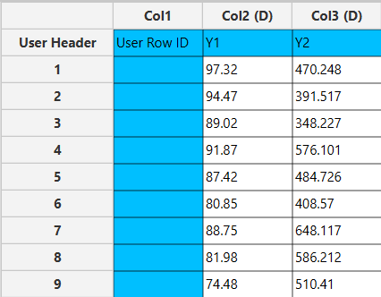

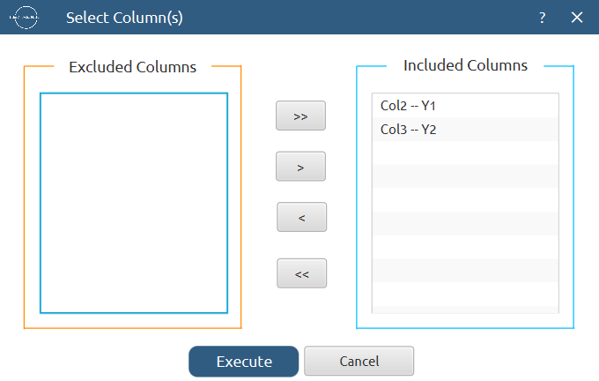

Step 4: Normalization
Create a new tab named “Normalized data” and import the results from the “Factors” and “Responses” spreadsheets. Afterwards, normalize the factor columns to take values in the range [-1, 1]: Data Transformation $→$ Normalizers $→$ Min-Max

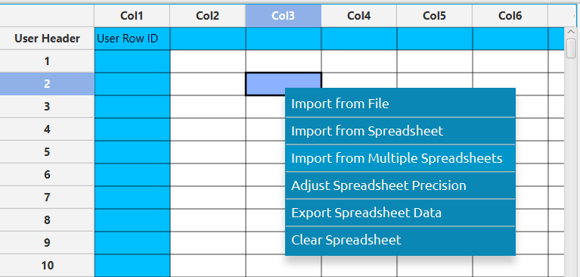

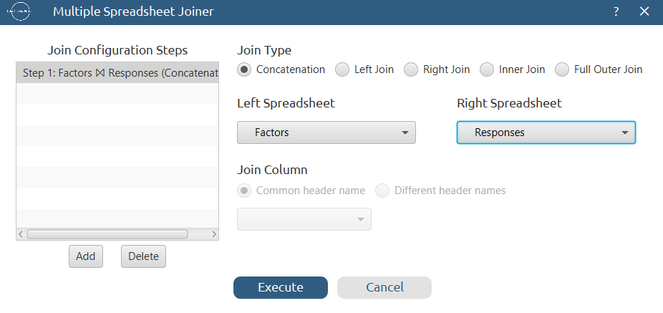
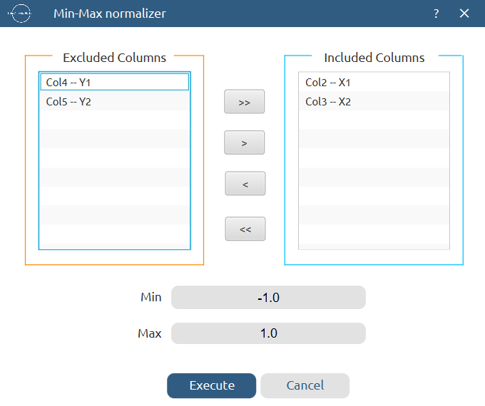

Results:
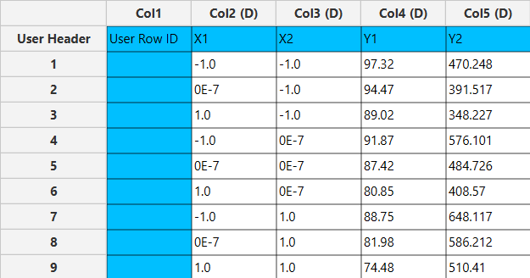

Step 5: Regression
The goal here is to produce a regression equation that includes main effects, two-factor interactions and quadratic effects for Y₁: $Y=b_{0}+b_{1}X_{1}+b_{2}X_{2}+b_{12}X_{1}X_{2}+b_{11}{X_{1}}^{2}+b_{22}{X_{2}}^{2}$
Create a new tab named “Regression – Y1” and import the results from the spreadsheet “Normalized data”. Afterwards, fit a generalized linear model to the data: Analytics $→$ Regression $→$ Statistical fitting $→$ Generalized Linear Models

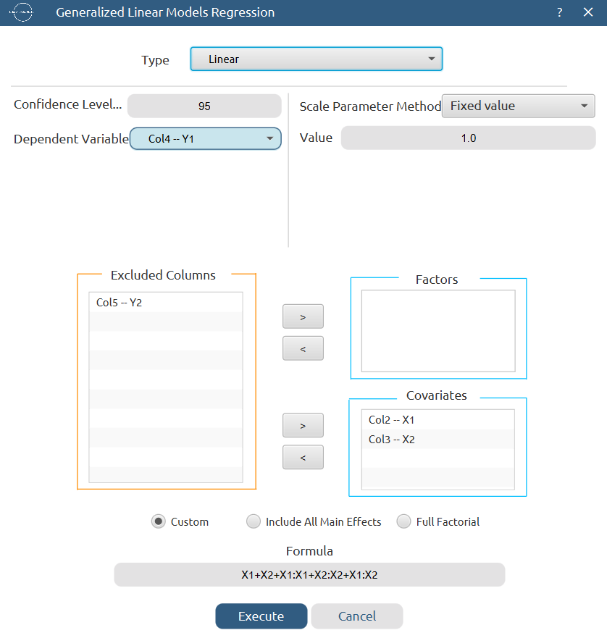

Results:

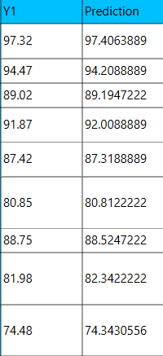

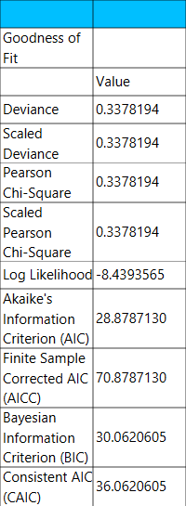

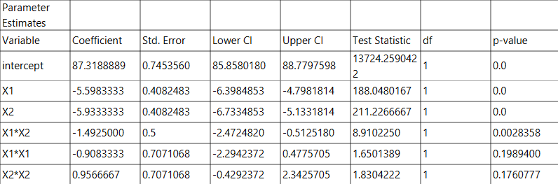

Repeat this step for the second response variable, Y₂. Results:

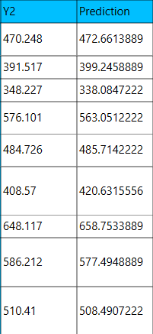

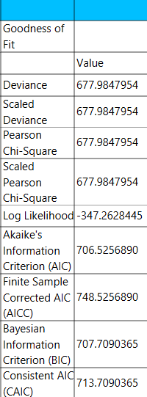

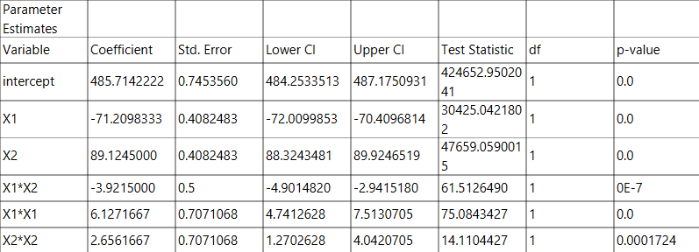

Step 6: Regression Metrics
Create a tab named “Metrics – Y1” and import the results from the spreadsheet “Regression – Y1”. Then, produce the regression metrics for the Y₁ regression equation: Statistics $→$ Model Metrics $→$ Regression Metrics

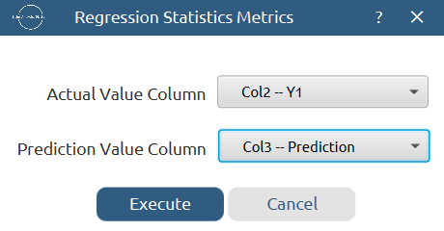

Results:
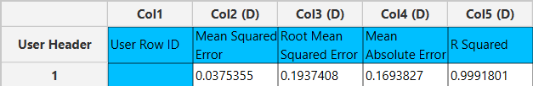

Repeat this step for the second response variable, Y₂. Results:
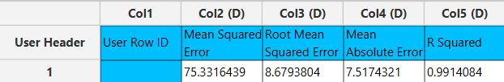

Step 7: Analysis of Covariance
Create a new tab named “ANCOVA – Y1” and import the results from the spreadsheet “Normalized data”. Afterwards perform analysis of covariance for Y₁: Statistics $→$ Analysis of (Co)Variance $→$ ANCOVA

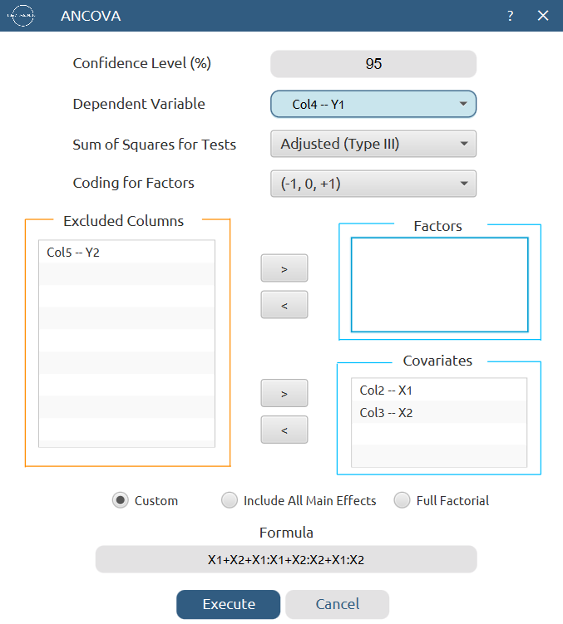

Results:
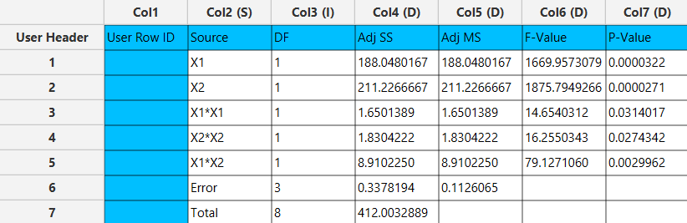

Repeat this step for the second response variable, Y₂. Results:
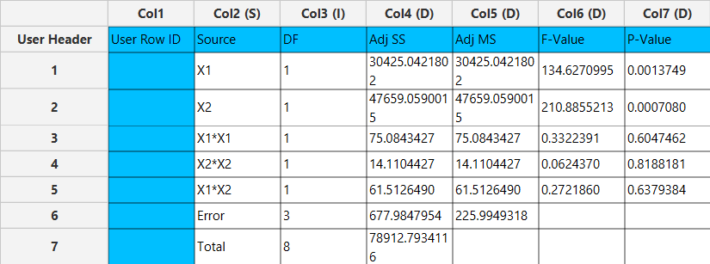

References
- Shah, V.; Sharma, M.; Pandya, R.; Parikh, R. K.; Bharatiya, B.; Shukla, A.; Tsai, H.-C. Quality by Design Approach for an in Situ Gelling Microemulsion of Lorazepam via Intranasal Route. Materials Science and Engineering: C 2017, 75, 1231–1241. https://doi.org/10.1016/j.msec.2017.03.002.

