
Application of CFD, statistical analysis and DoE for optimising H₂ generation through ammonia borane catalytic hydrolysis: A novel approach for multiobjective optimisation

The objective of this research paper is to study the hydrolysis of ammonia borane with a non-noble metal catalyst to produce H₂. Design of experiments (DoE) methodology is implemented to study the effects of the reaction parameters on the critical response variables.
The factors (independent variables) examined are: X₁ = catalyst to substrate ratio, X₂ = reaction temperature (ºC) and X₃ = ammonia borane concentration (mM). All the factors are continuous. The responses (dependent variables) examined are: Y₁ = reaction time (min), Y₂ = turnover frequency (sec⁻¹) and Y₃ = H₂ yield (%). The applied DoE method is Box Behnken design.
Isalos version used: 2.0
Scientific article: https://www.sciencedirect.com/science/article/abs/pii/S1385894725116173

Step 1: Box Behnken Design
In the first tab named “Action” define the factors in the column headers and fill each column with the low and high levels of the corresponding factors. This tab can be renamed “Box Behnken.” Afterwards, apply the Box Behnken method: DOE $→$ Response Surface $→$ Box Behnken

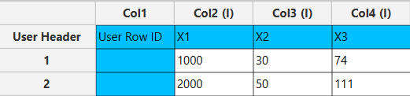

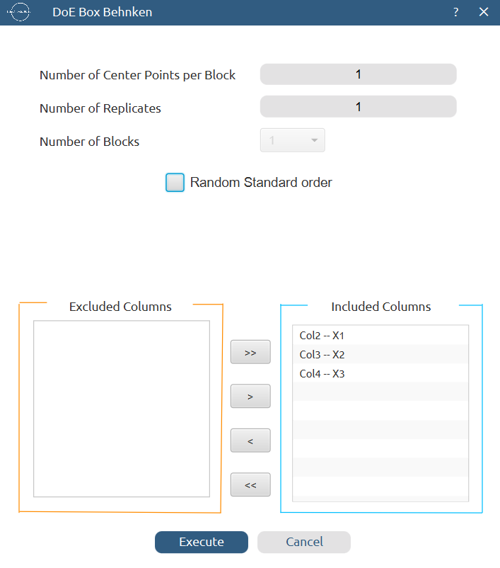

Results (right spreadsheet):
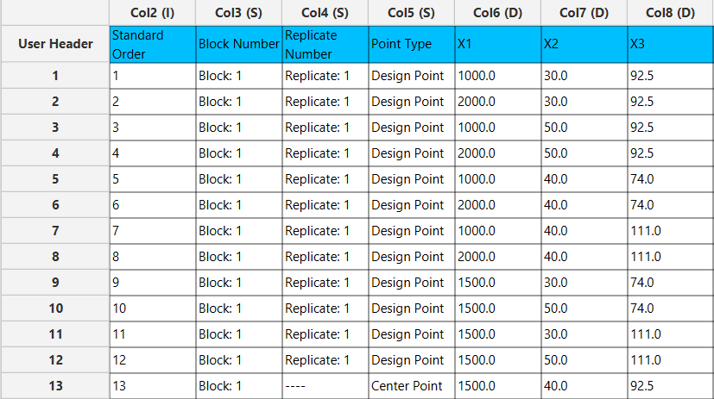

Step 2: Definition of response variables
Create a new tab named “Responses” and define the responses in the column headers. Fill each column with the values of the corresponding responses that were observed and make sure the values follow the order of the experiments as given by the Box Behnken method. Then, select all columns to be transferred to the right spreadsheet: Data Transformation $→$ Data Manipulation $→$ Select Column(s)

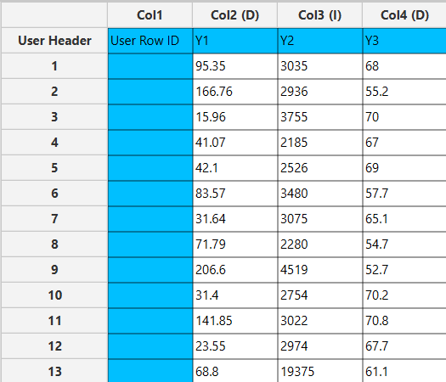

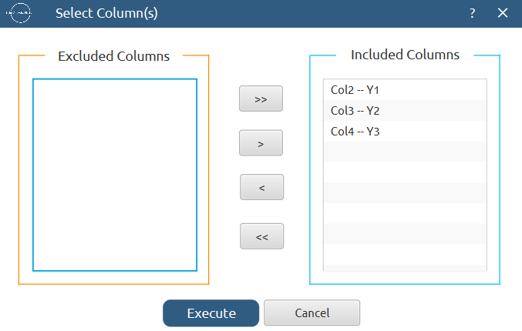

Step 3: Data isolation
Create a new tab named “Data” and import the results from the “Box Behnken” and “Responses” spreadsheets by right clicking on the left spreadsheet. Then, select only the factors and responses columns to be transferred to the right spreadsheet: Data Transformation $→$ Data Manipulation $→$ Select Column(s)

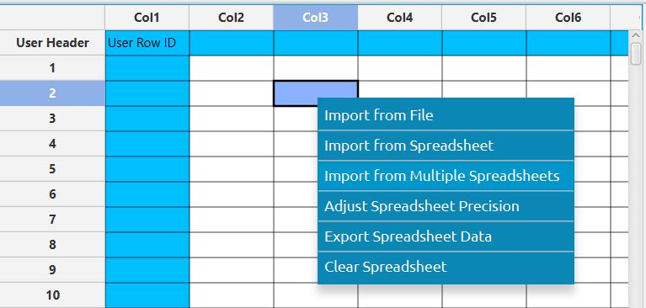

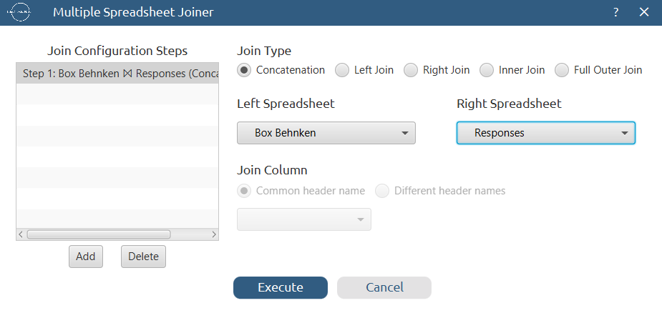

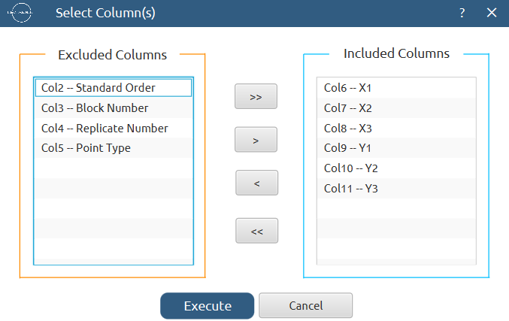
Results:
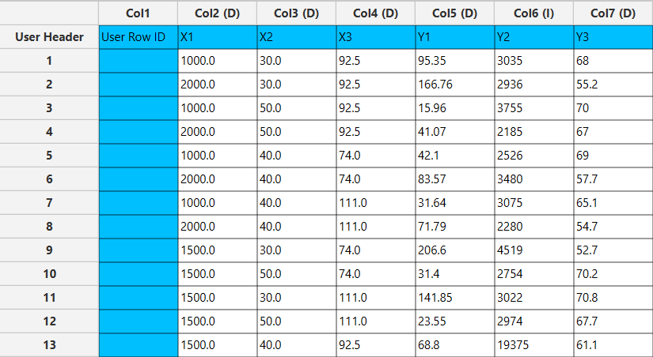

Step 4: Factorial Analysis
Create a new tab named “Factorial analysis – Y1” and import the results from the “Data” spreadsheet. Afterwards, conduct factorial analysis for the first response variable, Y₁, to produce main effects and interaction plots: DOE $→$ Post DoE Analysis $→$ Factorial Plot Analysis

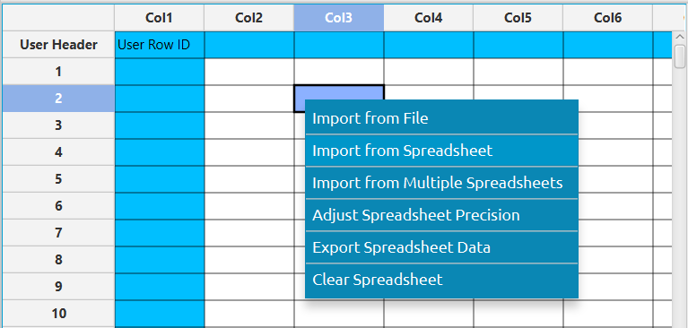
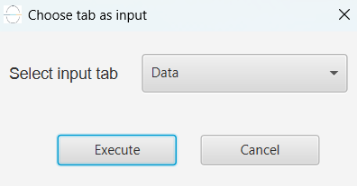

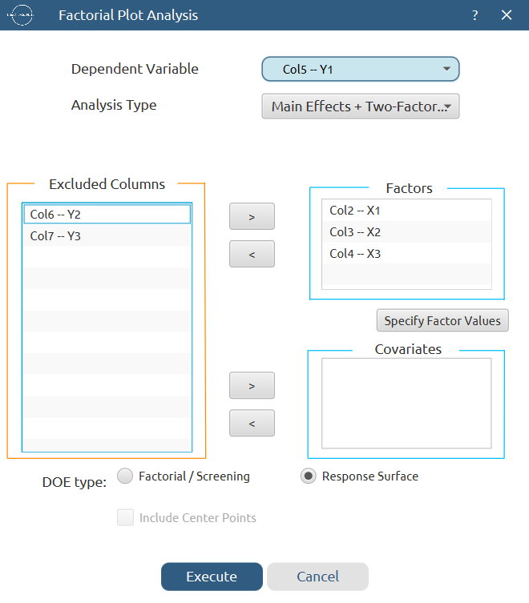

+Quadratic

Results (also given in table format, not displayed here):
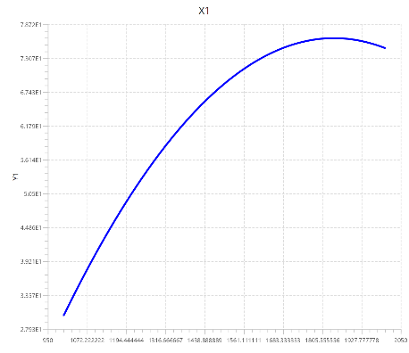
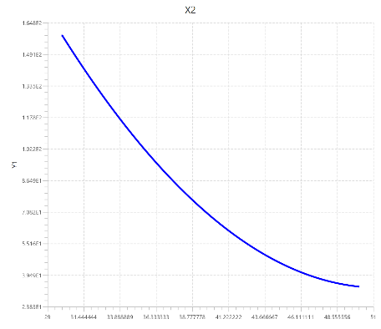
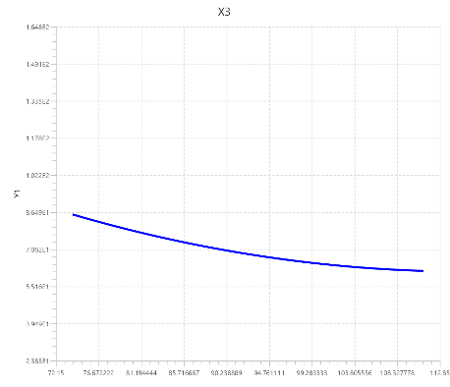

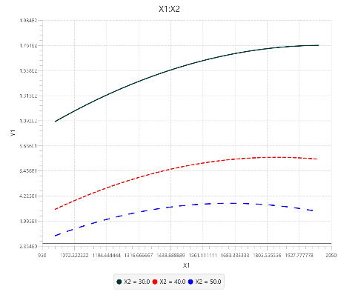
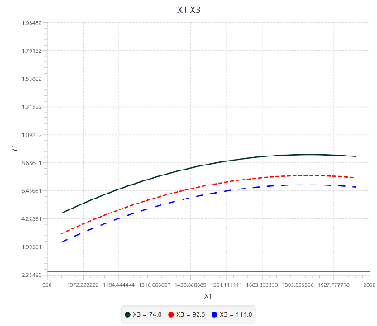
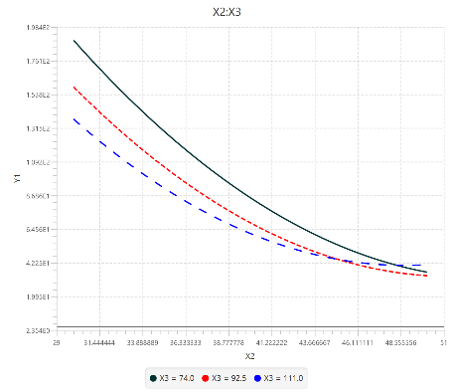

Repeat this step for the rest of the response variables. Results, Y₂:
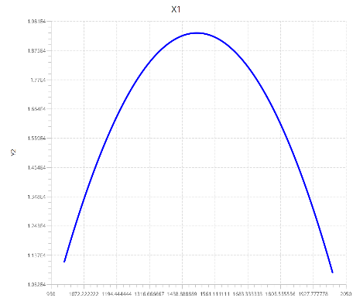
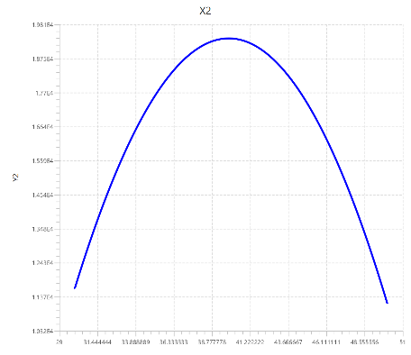
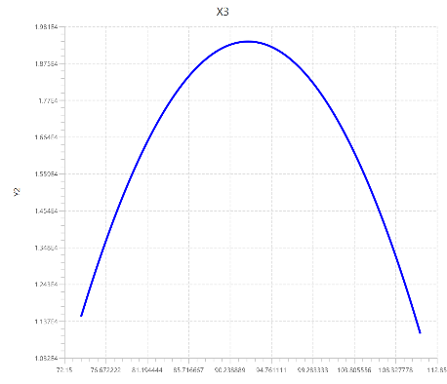

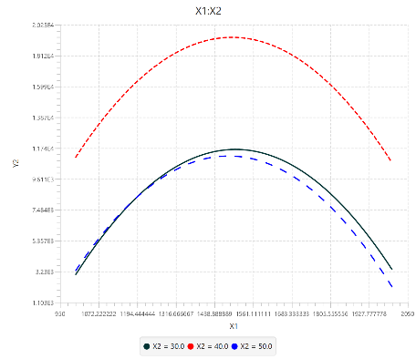
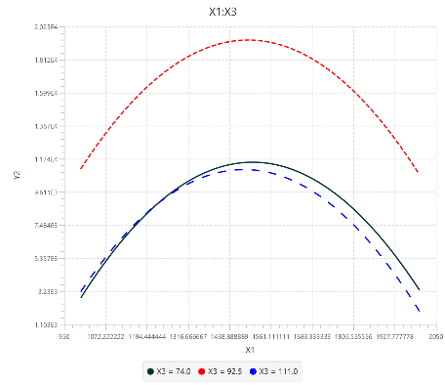
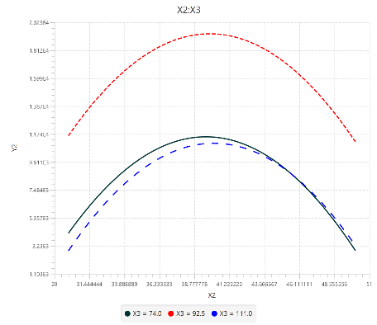

Results, Y₃:
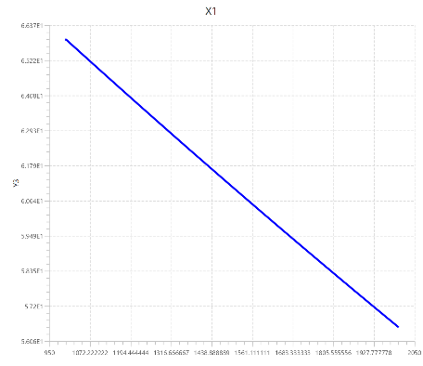
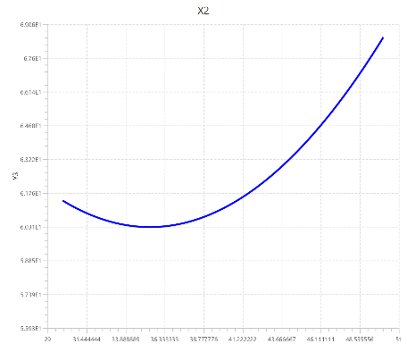
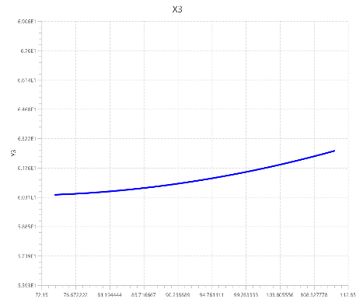

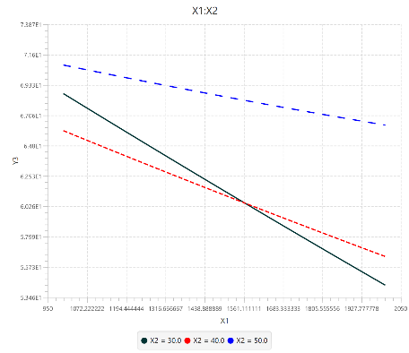
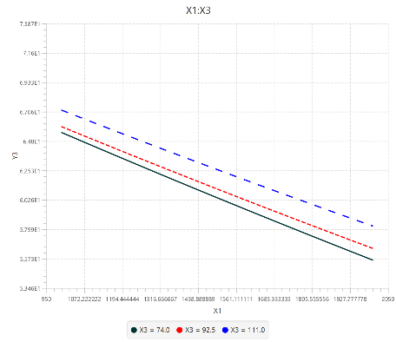
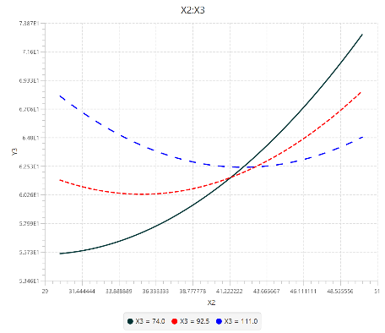

Step 5: Define additional experimental points
Create a new tab named “Full data” and import the results from the “Data” spreadsheet. Then, add in each column the values of the additional experimental runs that were executed and select all the columns to be transferred to the right spreadsheet: Data Transformation $→$ Data Manipulation $→$ Select Column(s)

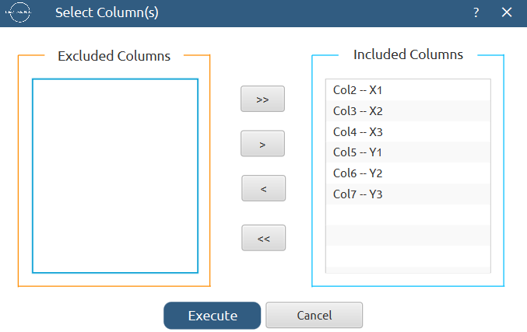

Results:
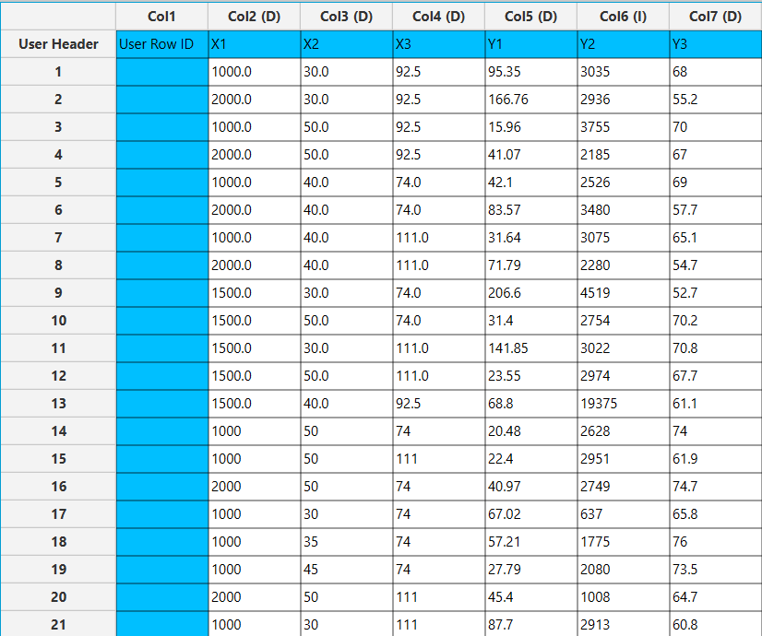

Step 6: Normalization
Create a new tab named “Normalized data” and import the results from the “Full data” spreadsheet. Afterwards, normalize the factor columns to take values in the range [-1, 1]: Data Transformation $→$ Normalizers $→$ Min-Max

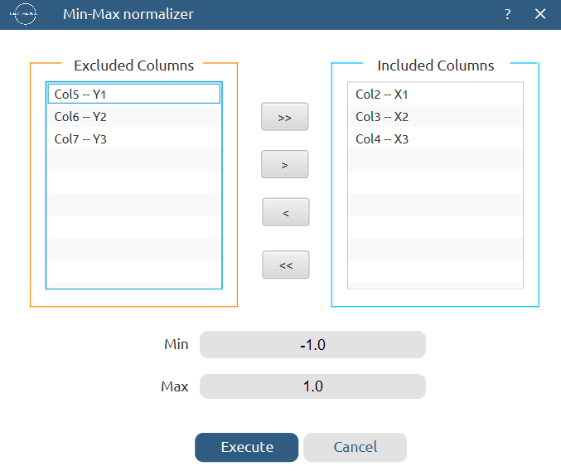

Results:
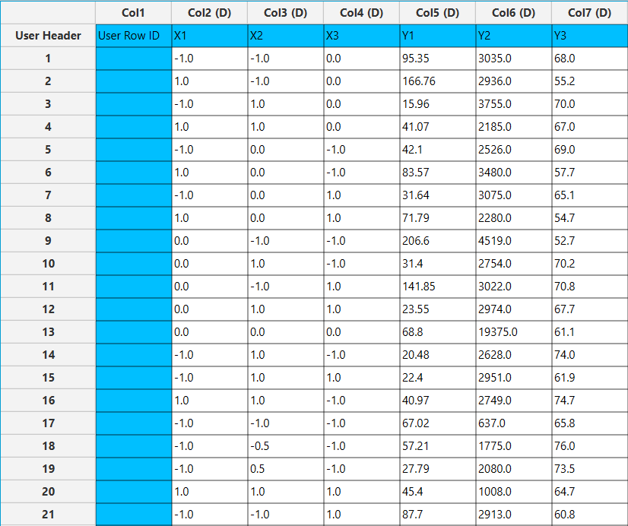

Step 7: Pareto Analysis
Create a new tab named “Pareto analysis – Y1” and import the results from the “Full data” spreadsheet. Afterwards, conduct pareto analysis for the first response variable, Y₁: DOE $→$ Post DoE Analysis $→$ Pareto Analysis

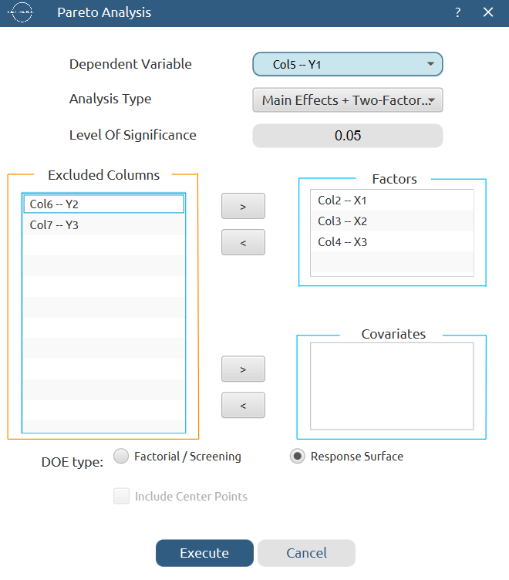
+Quadratic

Results:
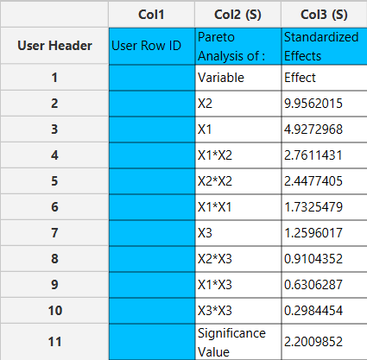
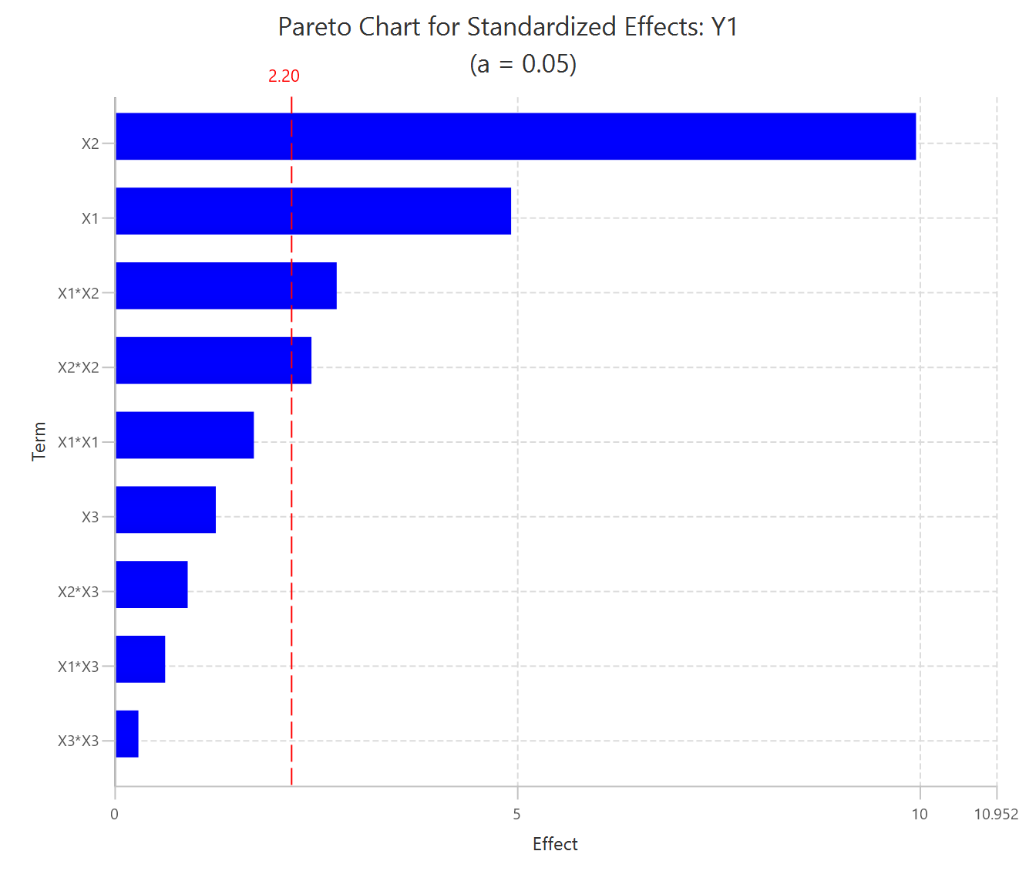

Repeat this step for the rest of the response variables. The experimental point (1500, 40, 92.5) is not included in the analysis of Y₂. Results, Y₂:
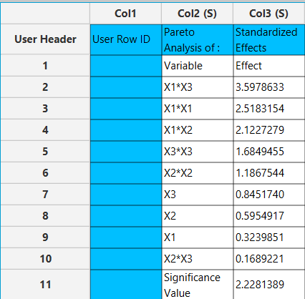

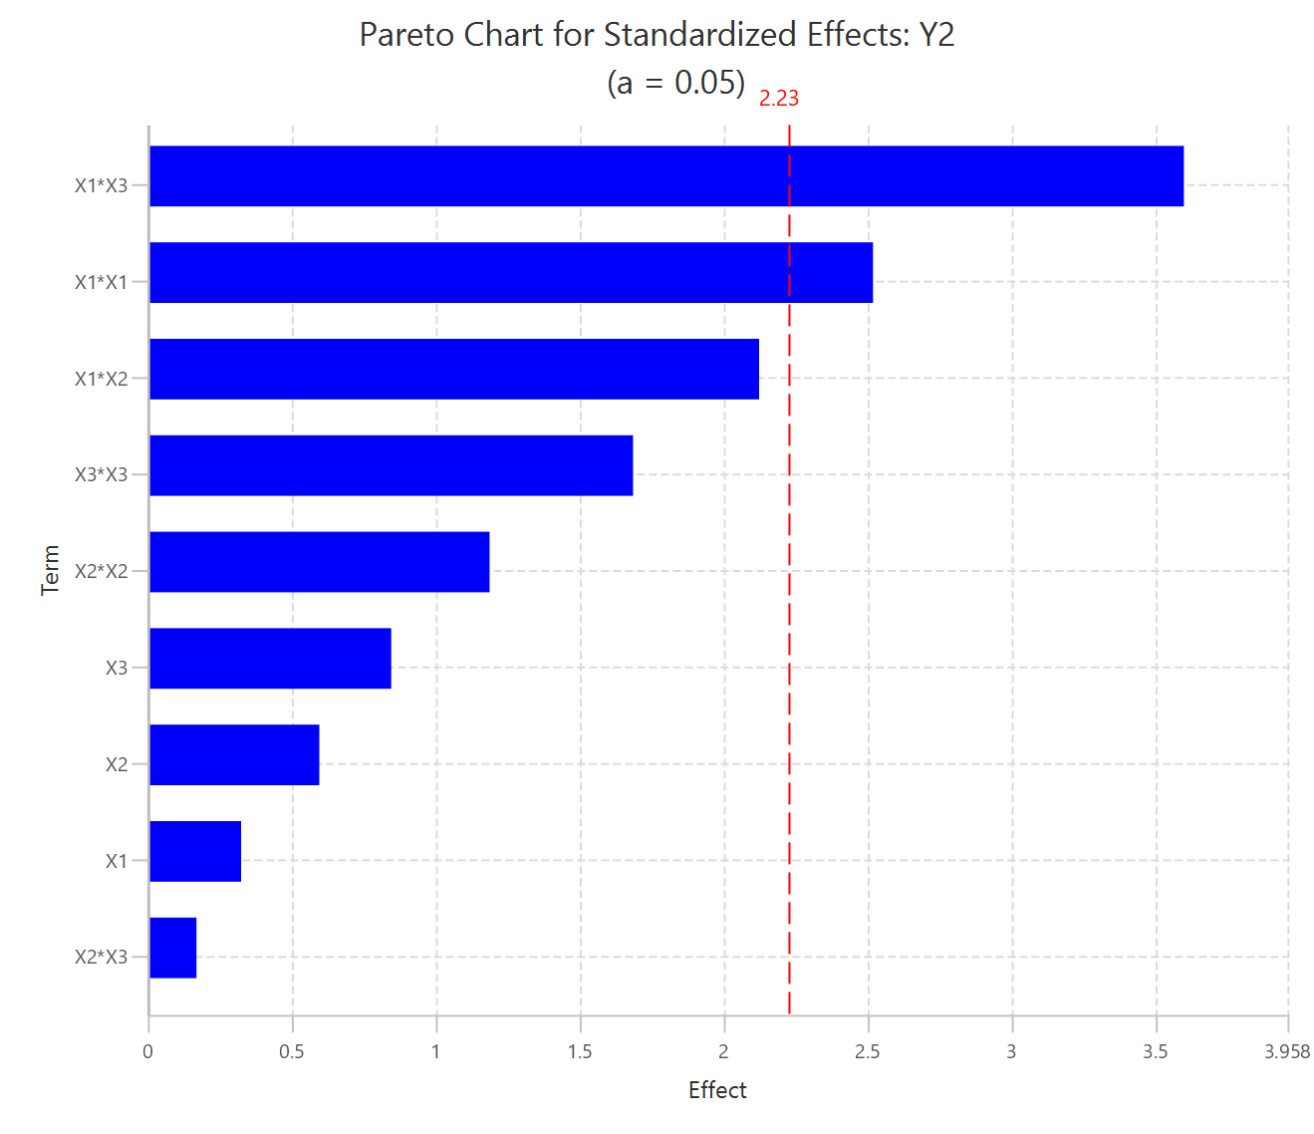

Results, Y₃:
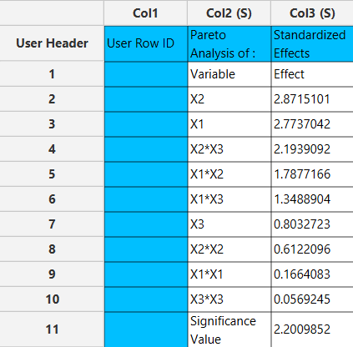

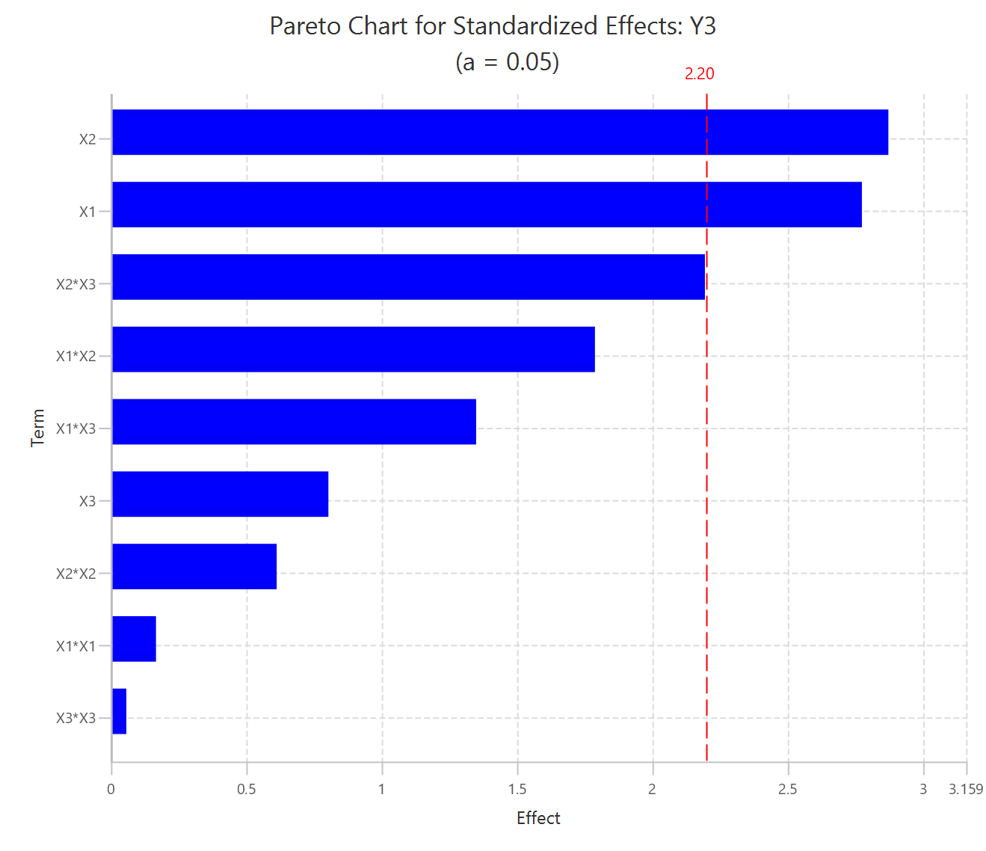

Step 8: Regression
The goal here is to produce a regression equation that includes main effects, two-factor interactions, and quadratic effects for Y₁:
$$Y=b_{0}+b_{1}X_{1}+b_{2}X_{2}+b_{3}X_{3}+b_{12}X_{1}X_{2}+b_{13}X_{1}X_{3}+b_{23}X_{2}X_{3}+b_{11}{X_{1}}^{2}+b_{22}{X_{2}}^{2}+b_{33}{X_{3}}^{2}$$
Create a new tab named “Regression – Y1” and import the results from the spreadsheet “Full data”. Afterwards, fit a generalized linear model to the data: Analytics $→$ Regression $→$ Statistical fitting $→$ Generalized Linear Models

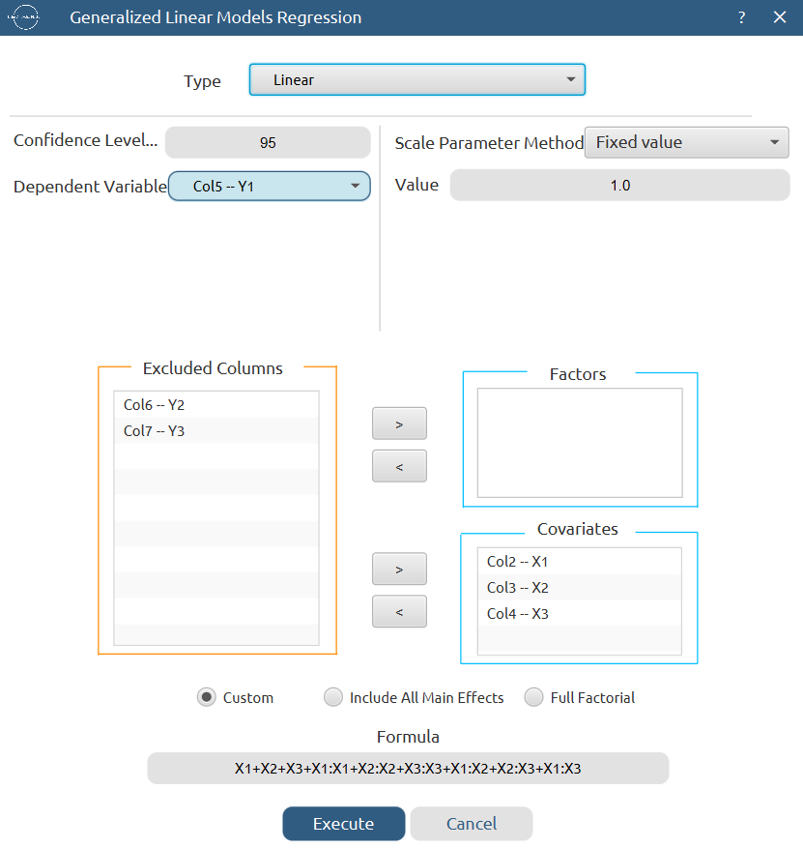
Results:
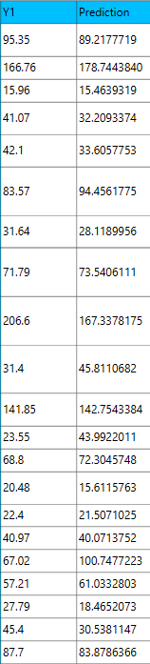
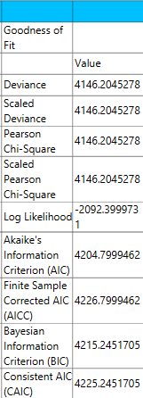

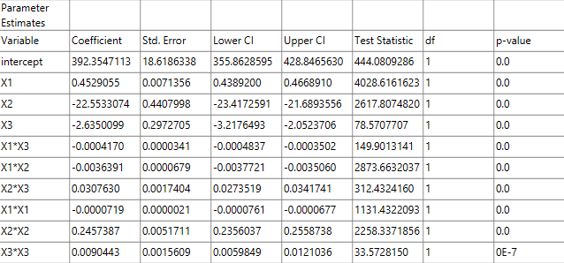

Repeat this step for the rest of the response variables. The experimental point (1500, 40, 92.5) is not included in the analysis of Y₂. Results, Y₂:
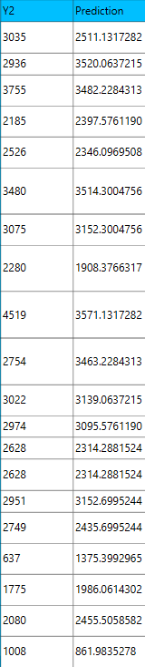
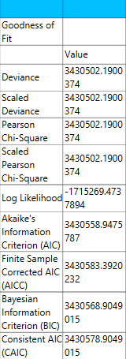

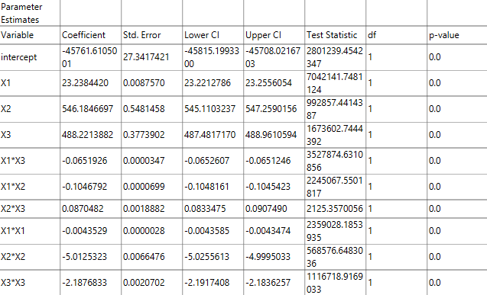
Results, Y₃:
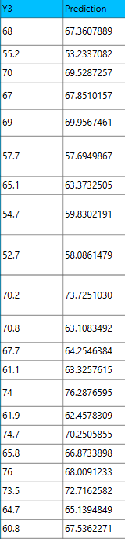
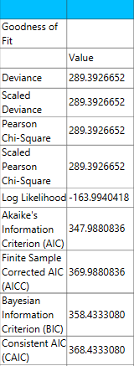

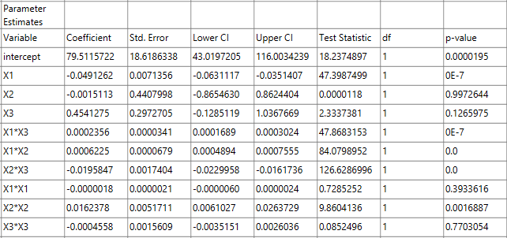

Step 9: Regression Metrics
Create a tab named “Metrics – Y1” and import the results from the spreadsheet “Regression – Y1”. Then, produce the regression metrics for the Y₁ regression equation: Statistics $→$ Model Metrics $→$ Regression Metrics

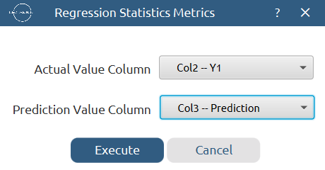

Results:
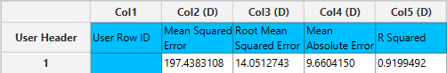

Repeat this step for the rest of the response variables. Results, Y₂:
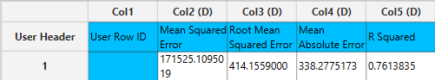

Results, Y₃:
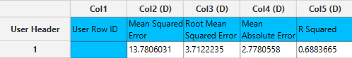

Step 10: Analysis of Covariance
Create a new tab named “ANCOVA – Y1” and import the results from the spreadsheet “Normalized data”. Afterwards perform analysis of covariance for Y₁: Statistics $→$ Analysis of (Co)Variance $→$ ANCOVA

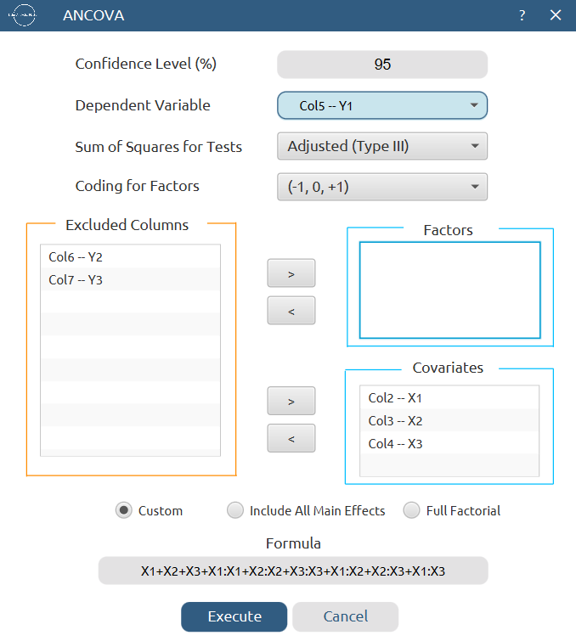

Results:
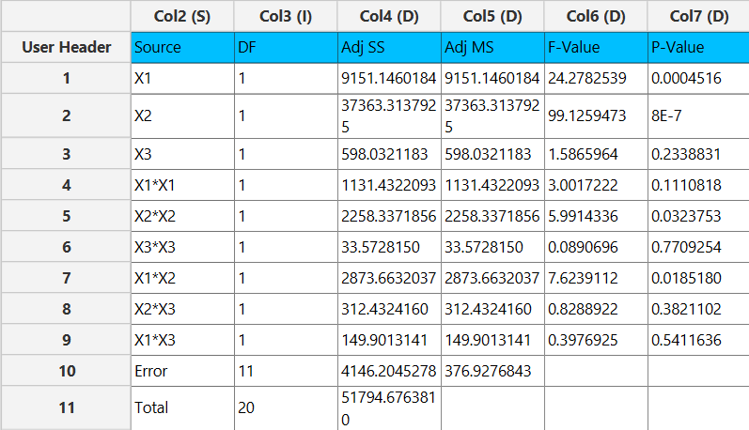
Repeat this step for the rest of the response variables. Results, Y₂:
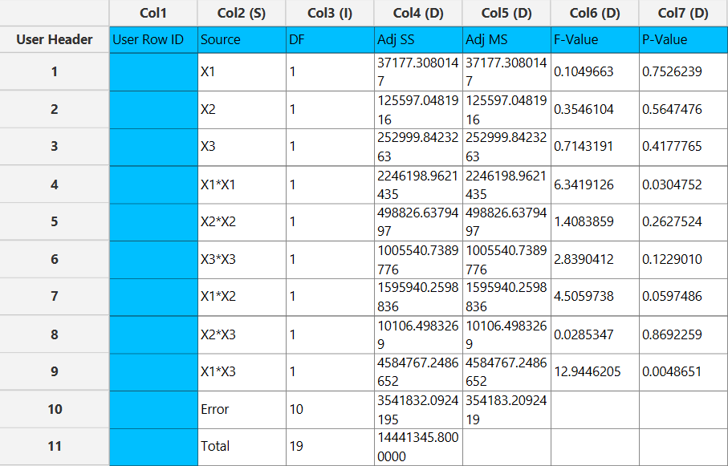

Results, Y₃:
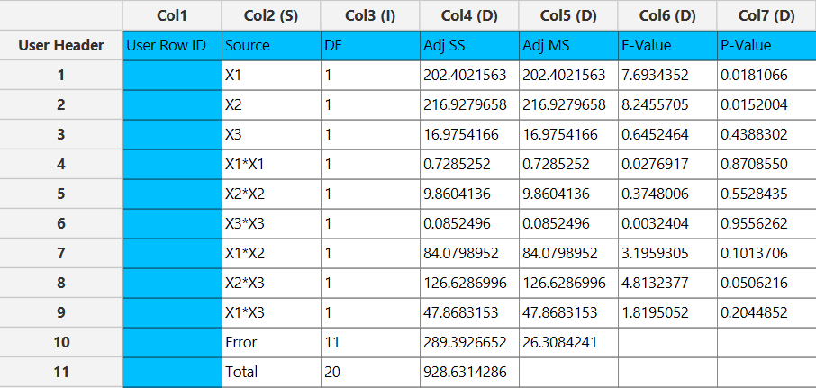

Final Isalos Workflow
The final workflow is presented below (does not fully fit):
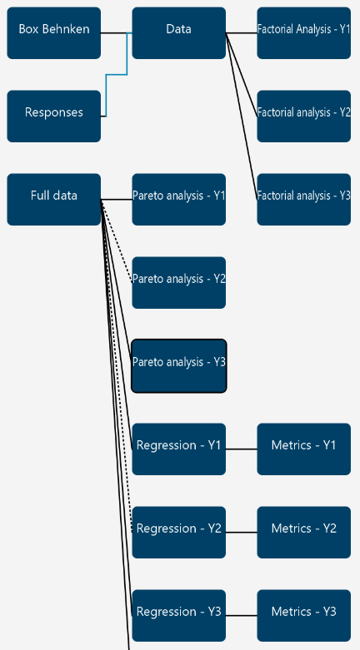

References
(1) Michael, A.; Adamou, P.; Harkou, E.; Christodoulou, C.; Barlocco, I.; Mintis, D.; Afantitis, A.; Delgado, J. J.; Chen, X.; Manos, G.; Dimitratos, N.; Villa, A.; Constantinou, A. Application of CFD, Statistical Analysis and DoE for Optimising H2 Generation through Ammonia Borane Catalytic Hydrolysis: A Novel Approach for Multiobjective Optimisation. Chemical Engineering Journal 2025, 525, 170772. https://doi.org/10.1016/j.cej.2025.170772.

