1.

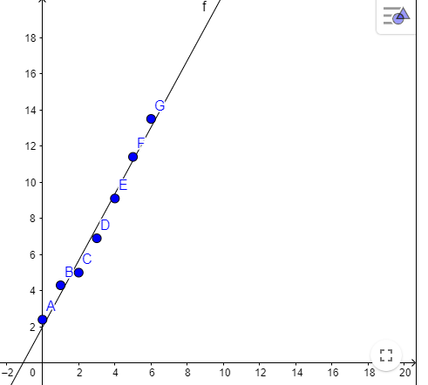

2. Positive correlation

3. 1.84x + 1.99

$\frac{\sum{y}*\sum{x^{2}}- \sum{x}*\sum{xy}}{n(\sum{x^{2}-{(\sum{x)}}^{2})}}= \frac{52.6*91-21*209.4}{7*91-21*21} ≈1.99$

$\frac{n\left(\sum{xy}\right)-\sum{x}\sum{y}}{n(\sum{x^{2}-{(\sum{x)}}^{2})}}=\frac{7*209.4-21*52.6}{7*91-21*21}≈1.84$

4a. 8.43 1.84(3.5) + 1.99

4b. 16.71 1.84(8.0) + 1.99