|  |  |  |  |  |  |  |  |
| --- | --- | --- | --- | --- | --- | --- | --- |
| Speaker | Average Strongly Agree | YouTube live streamers | Total YouTube views | Total YouTube Watch Time | Newsletter Opens | Newsletter Clicks | Clusters |
| Dr. David Danks | 80% | 17 | 159 | 23.6 | 114 | 7 | 2 |
| Dr. Colin Allen | 73% | 11 | 61 | 7.6 | 158 | 5 | 2 |
| Dr. LaTonya Trotter | 70% | 21 | 204 | 17.6 | 144 | 9 | 2 |
| Dr. Sallie Keller/Dr. Stephanie Shipp | 68% | 8 | 92 | 7.3 | 148 | 5 | 2 |
| Dr. Donna Chen | 68% | 8 | 92 | 13.4 | 148 | 6 | 2 |
| Dr. Maritza Salazar Campo | 67% | 10 | 108 | 13.4 | 143 | 4 | 2 |
| Johanna Loomba | 61% | 6 | 129 | 15.3 | 115 | 0 | 2 |
| Renee Cummings | 59% | 15 | 223 | 12.8 | 151 | 7 | 2 |
| Dr. Edward Dove | 56% | 8 | 81 | 11.2 | 147 | 4 | 2 |
| Dr. Yann Joly | 54% | 13 | 140 | 9.3 | 141 | 6 | 2 |
| Dr. Randall Moorman | 54% | 9 | 79 | 6.8 | 130 | 6 | 1 |
| Dr. Brian Wright | 45% | 6 | 16 | 0.1 | 139 | 2 | 1 |
| Dr. Mark Albert | 45% | 14 | 55 | 10 | 143 | 5 | 1 |
| Dr. Sean Valles | 45% | 67 | 214 | 12.9 | 144 | 4 | 0 |
| Dr. Caitlin Wylie | 45% | 10 | 126 | 12.3 | 133 | 7 | 1 |
| Dr. Claudia Perlich | 38% | 8 | 126 | 16.5 | 126 | 7 | 1 |
| Dr. Lana Garmire | 30% | 15 | 330 | 36.5 | 128 | 5 | 1 |
| Dr. Jennifer Miller | 21% | 17 | 104 | 5.8 | 121 | 5 | 1 |
| Dr. Alison Antes | 0% | 19 | 119 | 10.4 | 159 | 6 | 0 |
| Dr. Jarrett Zigon | 0% | 11 | 133 | 12 | 146 | 7 | 0 |

The table above highlights the average strongly agree selected across four questions of participants in evaluating each candidate descending order. As an example, Dr. David Danks received on average 80% strongly agree when participants where asked the following questions:

1. I look forward to future scheduled presentations in the Biomedical Data Science Seminar Series.
2. The lecture provided a useful overview that contained valuable information I expect to leverage in my research.
3. The lecture was pitched at the right level for the varied professional backgrounds of the audience.
4. Many of the questions asked and answered by the speaker were helpful for clarifying points unclear to me.

The table also shows the results of clustering the speakers based on evaluation, newsletter activity following the speaker and engagement on YouTube. As the you can see from the image below and in reference to the cluster labels in the table there appears to be a clear group of speakers that resulted in higher engagement that correlates with higher rankings in evaluation scores and larger number of attendees for the speaker. We will use this information to further refine the selection of speakers moving forward.

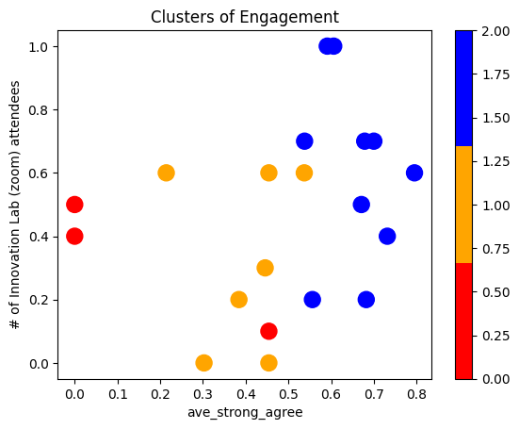

Table 2 below shows the standardized scores for each of the speakers across a variety of viewership measures. These include the number of viewers in real time, measures for impact on YouTube and data tracking the traffic through the weekly newsletter (No. of Opens/No. of Clicks). All these measures were set on the same scale between 0 and 1 then summed to generate the individual speaker impact scores seen in the fair right of the table. Some limitations in this process are related to the length of time that speakers YouTube videos were available online, as those that spoke earlier in the year are likely to have more views, total watch time and average percentage viewed. This is also try of the newsletter data but much less so as a large majority of the traffic in terms of clicks and opens happens the week following the lecture.

Table 2 Lecture Impact Scores

|  |  |  |  |  |  |  |  |  |
| --- | --- | --- | --- | --- | --- | --- | --- | --- |
| Speaker | No. Innovation Lab attendees | No. YouTube live | No. of Total YouTube views | Total Watch Time | Average Percentage Viewed | No. of Opens | No. of Clicks | Impact Score |
| Dr. LaTonya Trotter | 0.70 | 0.25 | 0.60 | 0.48 | 0.24 | 0.67 | 1.00 | 3.93 |
| Renee Cummings | 1.00 | 0.15 | 0.66 | 0.35 | 0.00 | 0.82 | 0.78 | 3.76 |
| Dr. Sean Valles | 0.10 | 1.00 | 0.63 | 0.35 | 0.22 | 0.67 | 0.44 | 3.41 |
| Dr. Donna Chen | 0.70 | 0.03 | 0.24 | 0.37 | 0.53 | 0.76 | 0.67 | 3.29 |
| Dr. David Danks | 0.60 | 0.18 | 0.46 | 0.65 | 0.56 | 0.00 | 0.78 | 3.22 |
| Dr. Lana Garmire | 0.00 | 0.15 | 1.00 | 1.00 | 0.18 | 0.31 | 0.56 | 3.19 |
| Dr. Alison Antes | 0.50 | 0.21 | 0.33 | 0.28 | 0.14 | 1.00 | 0.67 | 3.13 |
| Dr. Colin Allen | 0.40 | 0.08 | 0.14 | 0.21 | 0.64 | 0.98 | 0.56 | 3.00 |
| Dr. Jarrett Zigon | 0.40 | 0.08 | 0.37 | 0.33 | 0.19 | 0.71 | 0.78 | 2.86 |
| Dr. Yann Joly | 0.70 | 0.11 | 0.39 | 0.25 | 0.01 | 0.60 | 0.67 | 2.74 |
| Dr. Mark Albert | 0.00 | 0.13 | 0.12 | 0.27 | 1.00 | 0.64 | 0.56 | 2.73 |
| Dr. Maritza Salazar Campo | 0.50 | 0.07 | 0.29 | 0.37 | 0.27 | 0.64 | 0.44 | 2.58 |
| Dr. Randall Moorman | 0.60 | 0.05 | 0.20 | 0.18 | 0.48 | 0.36 | 0.67 | 2.53 |
| Dr. Caitlin Wylie | 0.30 | 0.07 | 0.35 | 0.34 | 0.24 | 0.42 | 0.78 | 2.49 |
| Dr. Claudia Perlich | 0.20 | 0.03 | 0.35 | 0.45 | 0.37 | 0.27 | 0.78 | 2.45 |
| Dr. Edward Dove | 0.20 | 0.03 | 0.21 | 0.30 | 0.48 | 0.73 | 0.44 | 2.40 |
| Dr. Sallie Keller/Dr. Stephanie Shipp | 0.20 | 0.03 | 0.24 | 0.20 | 0.05 | 0.76 | 0.56 | 2.04 |
| Dr. Jennifer Miller | 0.60 | 0.18 | 0.28 | 0.16 | 0.07 | 0.16 | 0.56 | 2.00 |
| Johanna Loomba | 1.00 | 0.00 | 0.36 | 0.42 | 0.13 | 0.02 | 0.00 | 1.93 |
| Dr. Brian Wright | 0.60 | 0.00 | 0.00 | 0.00 | 0.26 | 0.56 | 0.22 | 1.64 |