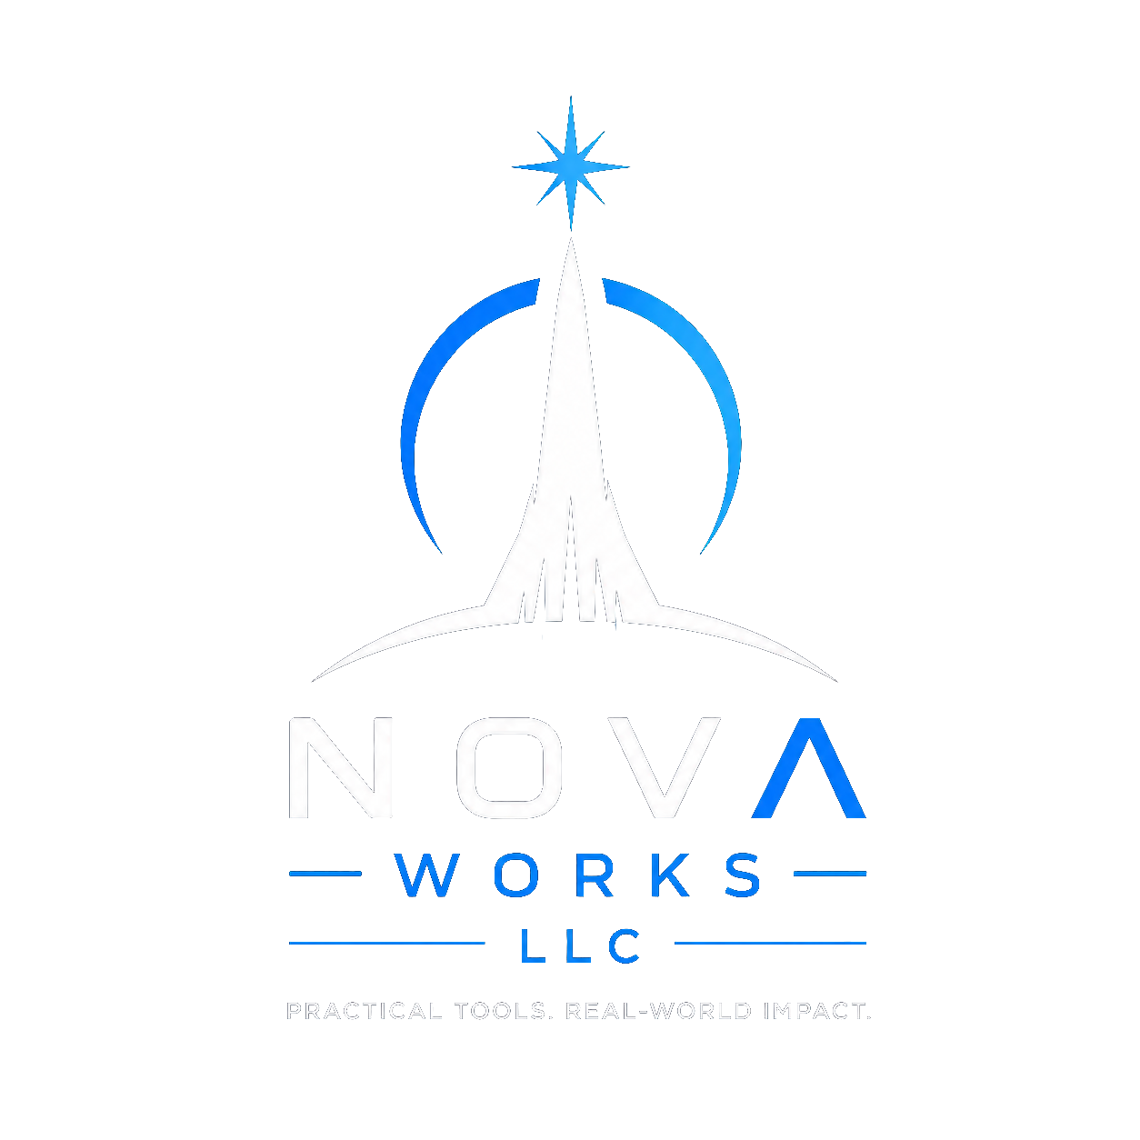

Tenant Receipts for Landlords
  - Request tracking and records for property management teams
Manage repair requests and tenant documentation through a shared case workspace. Tenant Receipts brings reports, assignments, contractor coordination, and dated records together so your team can act on requests and explain what happened later.

See what needs attention
Receive requests from connected tenants or log issues reported by phone, during an inspection, or by staff. Organize cases by property and unit, identify urgency, assign a responsible person, and track acknowledgement through scheduling and completion. Configurable response targets and overdue indicators help your team spot requests that need follow-up.

Keep the history with the property
Preserve photos, attachments, notes, visit schedules, and case updates in one place. Unit histories and move-out records help a new manager understand earlier issues. Common-area requests and recurring maintenance plans give your team a place to record work beyond an individual tenant submission.

Coordinate work without losing the record
Maintain contractor contacts, prepare a text or email work request, and review the recipient and message before sending. Delivery status and follow-up attempts remain in the case history. A scheduled visit is visible on the calendar; internal notes and contractor communications stay separate from tenant-visible updates.

Give tenants a clearer view
Invite tenants through an expiring QR code, link, or manual code. They choose which records to share from the Android app and can follow the updates made available to them. Dated PDFs can be downloaded for their own files, reducing the need to repeatedly ask management for copies.

A record you can review and export
Timeline corrections add a new entry rather than replacing the original. Dated PDF records carry SHA-256 fingerprints for checking whether a file differs from its recorded version. Print tenant or internal copies and export a property’s available cases, records, and attachments as a ZIP package.
Available workflows depend on the activated service and configuration. Email, push, and SMS delivery depend on provider services, device settings, and connectivity.

How clearer records can help later
The value grows when your team uses the system consistently. A record created while work is happening is easier to review than a history reconstructed months later from separate inboxes and memories.
Situation | How the service can help
A tenant says a request was ignored | Review the recorded submission, acknowledgement, assigned staff, updates, and follow-up. Identify gaps that still need action.
Staff responsibilities change | Transfer assignments while keeping the property and unit history available to the next manager.
A contractor misses a visit | Check the scheduled date and message history, record the outcome, and document the next attempt.
Conditions at move-out are disputed | Compare available move-in and move-out reports, dated photos, and unit history. The records support review without deciding responsibility.
An insurer, attorney, or reviewer asks for records | Export available documents and attachments for an organized review, rather than collecting scattered screenshots.
A file version is questioned | Compare its SHA-256 fingerprint with the recorded fingerprint to check whether the file bytes match.

Reduce avoidable work and uncertainty
Consistent use may reduce time spent searching for records, repeating status explanations, reconstructing contractor follow-up, or handing work between staff. It can also expose missed actions earlier. Savings depend on your portfolio, staff practices, and actual use; no fixed savings amount is promised.

Records support action and accountability
Good records can help explain your company’s actions during a complaint or dispute. They may also reveal an unanswered request or incomplete work. The service does not prevent lawsuits, replace required repairs or notices, prove that every entry is true, or guarantee insurance coverage or acceptance by a court. A file fingerprint verifies a matching version, not the accuracy of the underlying report.

Choose a subscription for your portfolio
A tailored subscription can cover an agreed number of rental units, owner and manager accounts, and a fixed term. Unit capacity is separate from staff access: a unit is counted once even if several managers work on it. Prices, messaging allowances, retention, and special service requirements are confirmed in a written quote.
Request a demonstration or portfolio quote
tenant.receipts@nova-worksllc.com | nova-worksllc.com
Tell us your unit count, staff count, and the recordkeeping problems you want to address.

