Web Pages – home, view, configure, login

Mobile – scan, to-do, rewards

Configure

View

Login / settings

Logo

Home

Profile

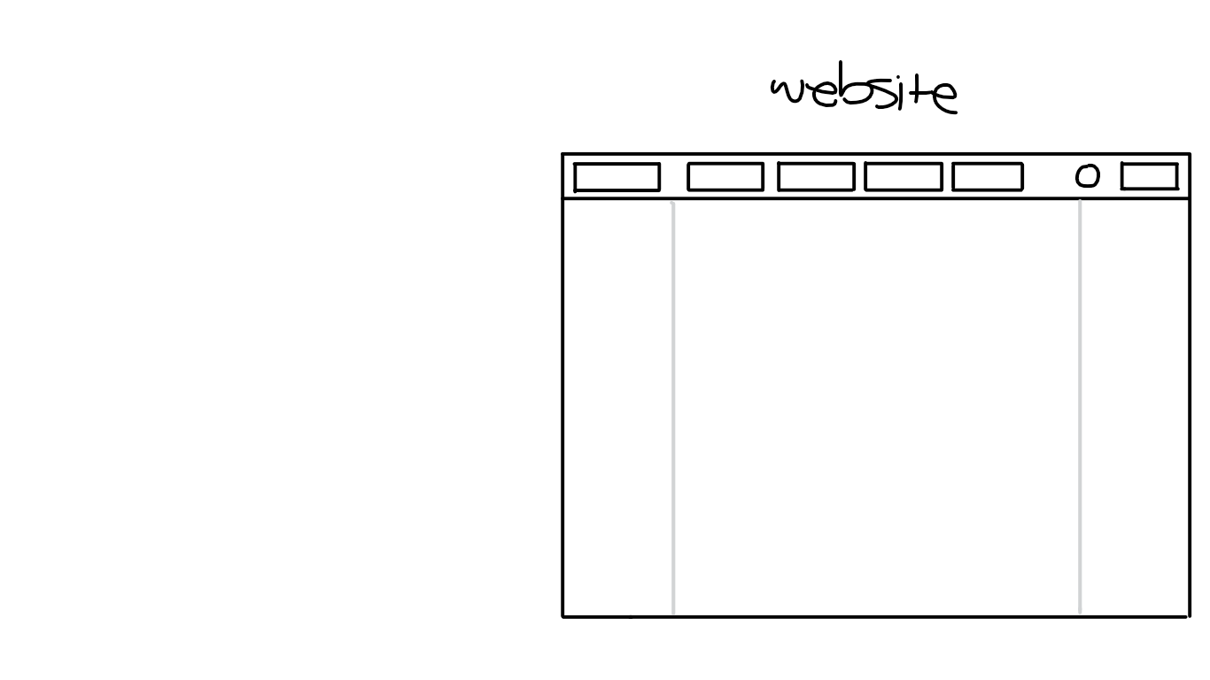 Home

Description about Company

About Us:

Some graphics

View

Feedback

Product

ID

Configure



Survey question(s)

List of Products