**A**daptive **S**oftware **D**evelopment

**ASD**

ASD is an extremely agile method of software development. Instead of the traditional, “plan, execute, test”, ASD uses cycles, to offer easy and agile way of development. These cycles consist of speculate, collaborate and learn. With these cycles, ASD provides continuous learning and adaptation that fulfill the needs of the project.

ASD was developed by Jim Highsmith and Sam Bayer, and it originates from **R**apid **A**pplication **D**evelopment (**RAD**) and **C**omplex **A**daptive **S**ystems (**CAS**). The main principle being, that continuous adaptation of the process to the work at hand, is the normal state of affairs.

One of the cornerstones of **ASD** is “Do it wrong the first time”, instead of always trying to reach perfection on the first time, the developer should focus more on the functionality and not be afraid of doing it wrong.

Speculate, most likely refers to the fact that the client/stakeholder is usually wrong, or doesn’t understand the concept of what he/she actually wants or needs. By gathering information, our aspiring developers, can set certain release cycles that will be required for the project. This information includes, but is not limited to, mission statements, project constraints like delivery dates or user descriptions, and basic requirements of the project as a whole.

Collaboration refers to the difficult challenge of balancing workload based on the predictable parts of the project and adapting to changes caused by various factors and situations.

And finally, the Learning cycle, means learning the needs and wants to the client or stakeholder, testing, design and building. This cycle is usually shorter than others, due to the fact that this cycle consists mostly of trial and error, fixing mistakes and learning from them.

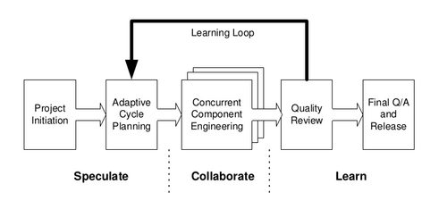

Figure

Sources:

<http://www.adaptivesd.com/articles/messy.htm>

* Read 15.8.2018, offers the core ideas and believes of Jim Highsmith about ASD and what went into creating it.

<https://en.wikipedia.org/wiki/Adaptive_software_development>

* Read 15.8.2018, basic overview of the core principles and logic behind ASD

<http://www.wiki.amachu.in/index.php?title=Adaptive_Software_Development>

* Read 15.8.2018, Figure one originated from here