Stellar Singularity Explorer
[Novák Botond] , [VXN605]

- Purpose of the project:
The Stellar Singularity Explorer is an interactive web-based simulation designed to bridge the gap between theoretical astrophysics and accessible digital media. I chose this specific theme because the mechanics of General Relativity specifically gravitational time dilation near high-mass entities provide a perfect foundation for a dynamic, data-driven application.
The primary objective of this project was to build a functional "research dashboard" that allows users to catalog stellar anomalies and simulate the relativistic effects on probes approaching deep gravitational wells. By calculating the dilation factor based on mass and distance, the site transforms complex physical theories into a digestible, interactive experience.
Interesting video to understand how time dilation works theoretically: [link]
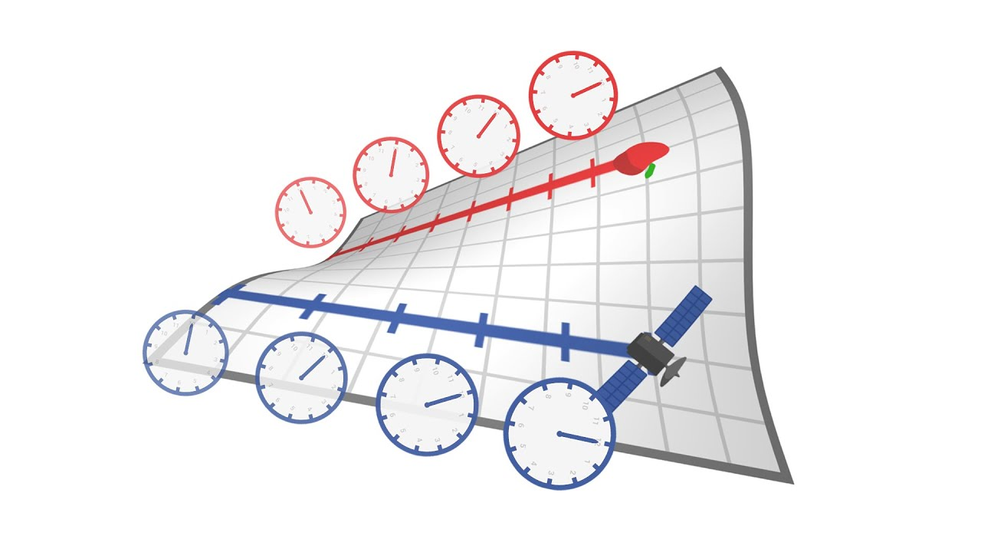
Picture about time dilation between two objects.
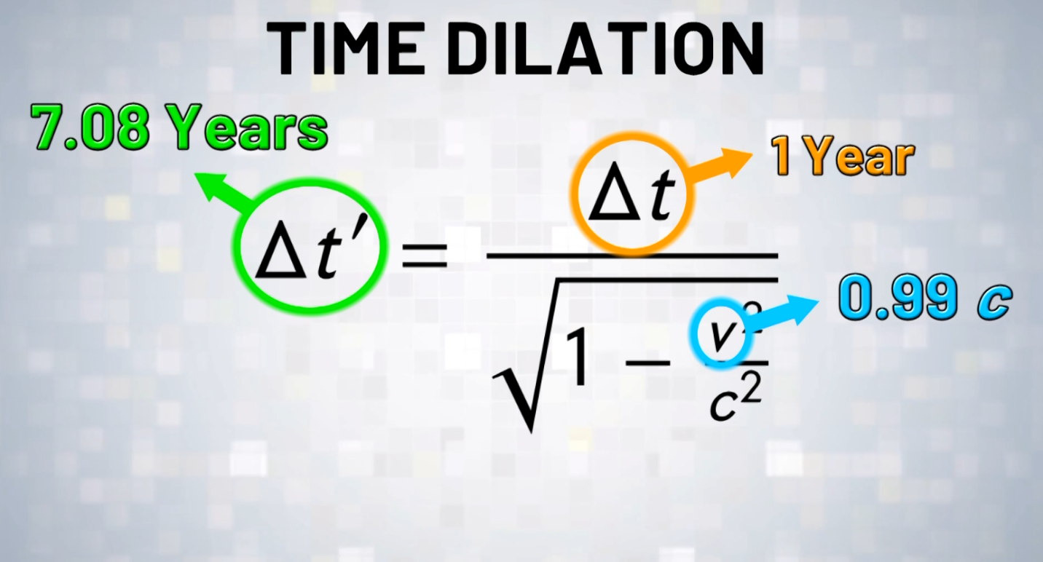
Picture about how can we calculate time dilation between two objects

- Interface design & User Experience
So overall the main point of this project is to help a starter physicist to calculate time dilation and help to learn how does time dilation work in the real world, with real world examples. For the interface design I chose deep blue colors, which can get more attention from the users, and gives back a more futuristic look than if it was mainly black. The color code I usually used is (#0d1117). It reduces eye strain and balances contrast.
More about the UI: In the front page we can see an animated solar system with the SUN and the planets (Mercury, Venus, Earth, Mars, Jupiter, Saturn, Uranus, Neptun) as Pluto was voted out back in the days from the “real” planets, I didn’t count it in as well in the animation.
The navigation system is built using CSS Flexbox to create a sticky, responsive header menu. This ensures that the user can seamlessly transition between the four primary environments of the application: the Home dashboard, the Stellar Archive page, the Escape Lab simulation page, and the About us specifications page.
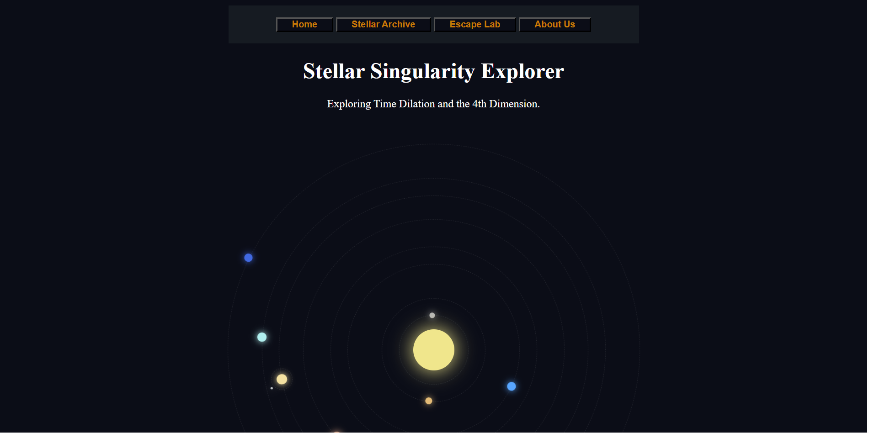
Picture about the front page
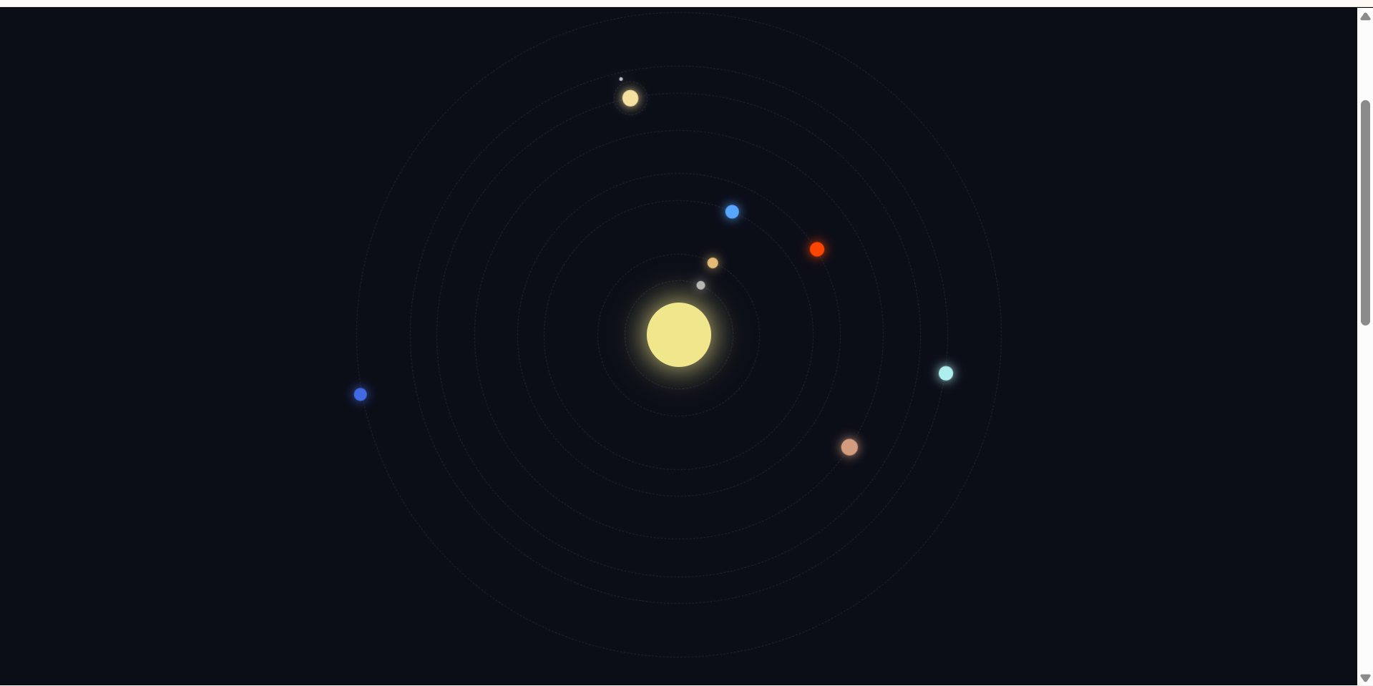
Picture about the working solar system animation

- Structural Implementation(CSS, HTML)
The foundation of the site relies on semantic HTML5 tags to ensure the content is structurally sound and accessible. The Stellar Archive utilizes complex table formatting to organize incoming entity data, utilizing specific headers and rows to keep numerical values readable. Additionally, organized lists are deployed throughout the project—bulleted lists for research notes and numbered lists for strict observational protocols.
The styling approach is intentionally hybrid. An external stylesheet handles the global layout, typography, and flexbox parameters. However, I heavily utilized ID-based CSS selectors to target unique components. For example, specific buttons and alert zones rely on targeted ID styling to trigger visual changes, while classes like .input-row manage the repeatable form layouts.

To store temporary data in the Archive page, I used tables with error checking in every cell, so if the user gave wrong or no data, it will give back a message to let them know.

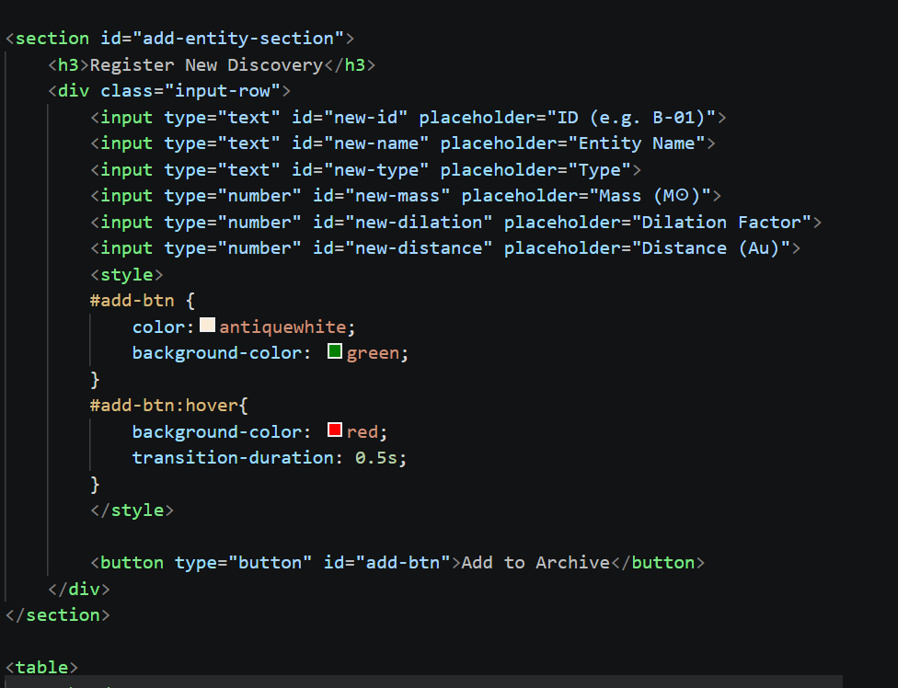
Picture about archive page, where you can add the new entity with properties

- Interactive Simulation
The Escape Lab page serves as the interactive core of the project, built to handle a diverse array of user inputs. Rather than relying solely on basic text fields, the simulation requires the user to interact with multiple data types to generate a mission report:
- Date input: Used to define when the rocket was launched.
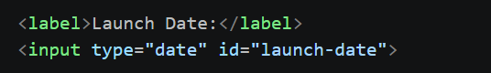
Picture about date input
- Text input: Used to add specific flight note + Probe designation
- Radio buttons and checkbox: Radio buttons here are used to choose from specific engine types and that if you want to travel with shield on or off
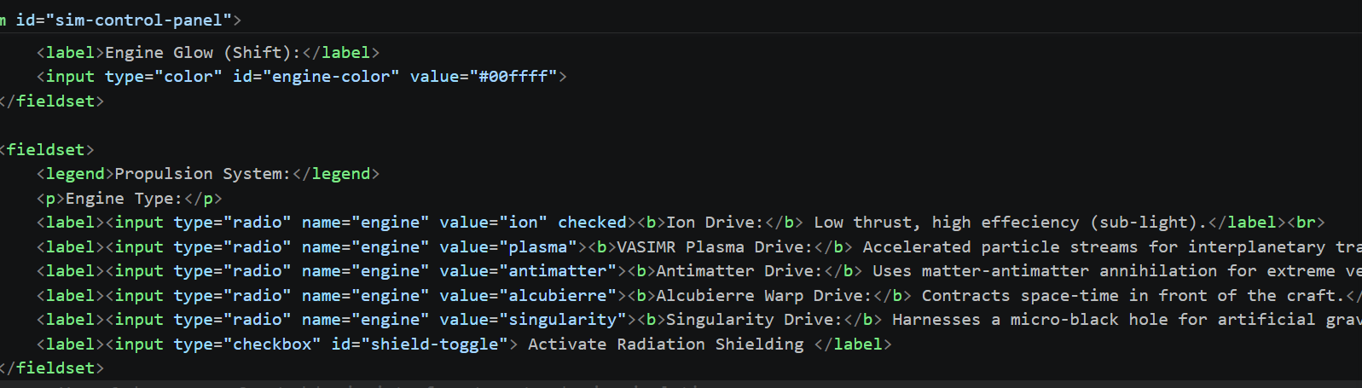
- Color picker: With the color picker you can pick the specific thrust color you want to use through your travel


- jQuery use, and logic
The most technically demanding aspect of the project was building the real-time calculation and validation engine using jQuery. The application does not rely on static pages; it dynamically generates new HTML elements based on user interaction.
When a user submits new entity data to the Archive, the script captures the input variables, formats them into a new table row string, and uses the .append() method. To make this transition smooth, I implemented jQuery animations like .fadeIn() and .slideDown(), ensuring that newly created data entries and simulation reports appear fluidly rather than snapping into place.

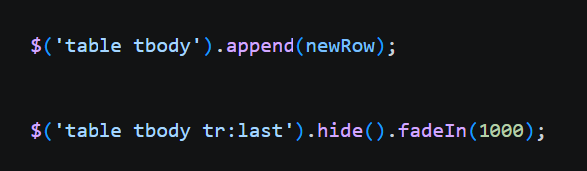
Adding new elements and animation (fadein)
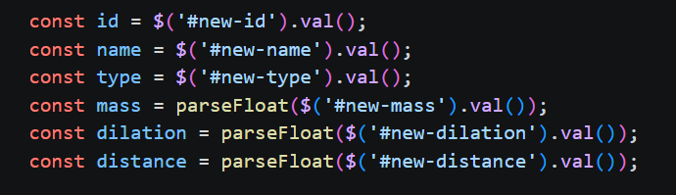
Created internal variables from the external ones in the html

To maintain the integrity of the "scientific data," robust form-checking logic was built into the submission buttons. If a user attempts to run a simulation or log an entity without filling out the mandatory fields (or if they enter non-numerical data where numbers are required), the script halts the execution. It triggers an alert and dynamically applies a stark red border to the specific empty fields, providing immediate, precise visual feedback to correct the user's error before proceeding. 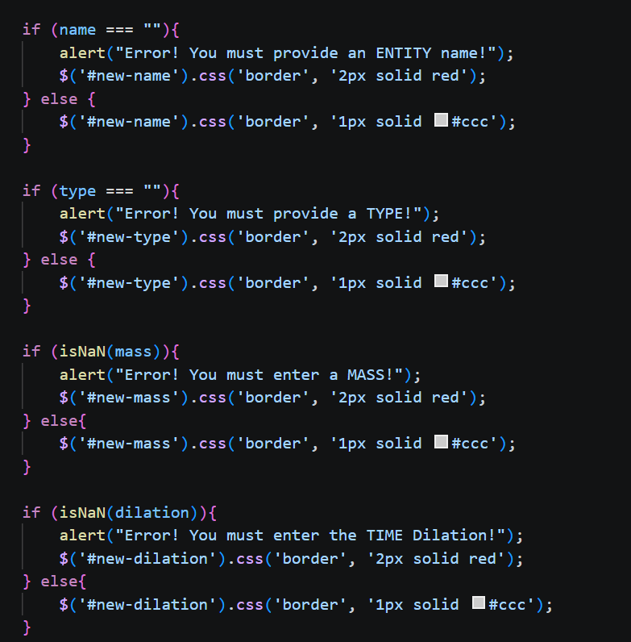
Partial picture about the validation logic for user input
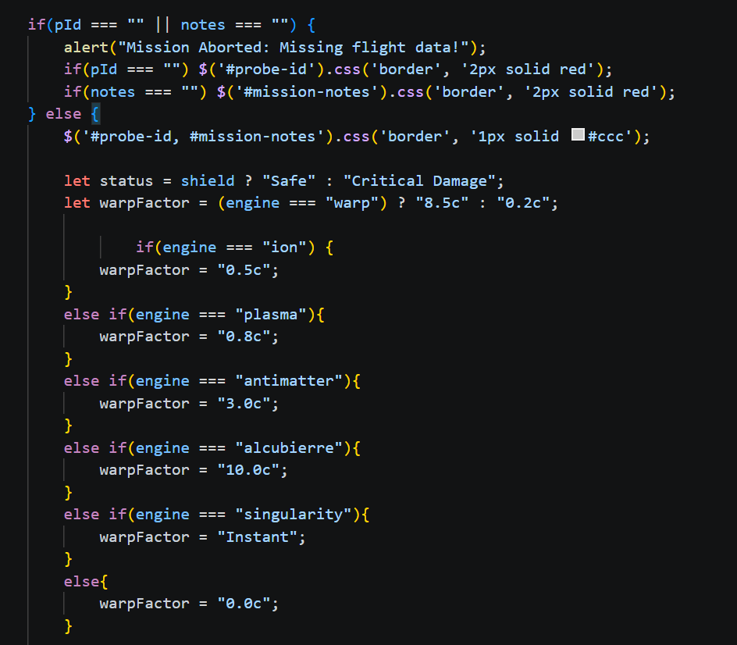
The logic behind the radio buttons for engines, so every engine have separate values in ( c ) = notation for light speed . + validation

- Finally about the About Us page:
It is a simple page containing the necessary information about the project, made with as minimal ui what is also easy to read but contains a lot of information.
The formatting contains basic <ul> <li> tags to Separate the necessary parts from each other. This page also helps the user to imagine what the project is for, also so that they can handle the pages well, give the informations correct so that the inputs will be valid and the calculations will be correct an accurate.

- Overall:
This project has several parts that can be developed, the time dilation can be more accurate, more data could be entered to make it more professional and accurate but for a basic user these values are more than enough. There is a short video about time dilation in the first that can be useful to understand how the whole time dilation thing works it’s really interesting or with better words mindblowing.

