**Tugas Pertemuan Ke – 8**

**Bab 8 : SQLITE DATABASE**

|  |  |
| --- | --- |
| **Nama** | Mochammad Nouval Saputra |
| **Nim** | 2018067 |
| **Kelas** | C |
| **Pemberi Tugas** |  |

1. **Menambahkan work manager pada project sebelumnya.**
2. **Langkah – langkah pengerjaan**
3. Buka Android Studio kemudian buka *project* pada bab sebelumnya.

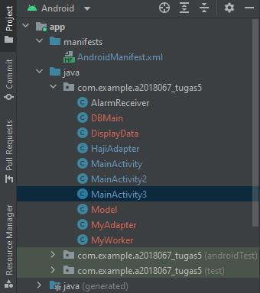

#### Tampilan Project sebelumnya

1. Langkah pertama double klik pada *setting*.*gradle*

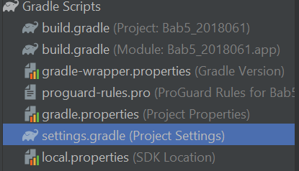

#### Tampilan *Setting* *Gradle*

1. Kemudian tambahkan jcenter(), lalu *comment* //*mavenCentral*() seperti pada gambar dibwah ini.

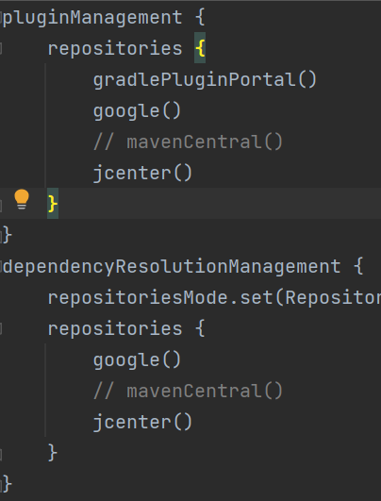

#### Tampilan menambahkan *jcenter*

Source code :

|  |
| --- |
| jcenter()  // mavenCentral() |

1. Kemudian double klik pada *build*.*gradle*

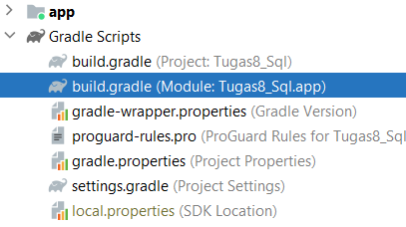

#### Tampilan membuka *build*.*gradle*

1. Kemudian tambahkan *library* seperti source code dibawah ini lalu klik “*Sync* *Now*” pada *pop up gradle* yang akan muncul.

|  |
| --- |
| //activation binding view  buildFeatures{  viewBinding true  }  //crop image  api 'com.theartofdev.edmodo:android-image-cropper:2.8.0'  //loading image in image view  implementation 'com.squareup.picasso:picasso:2.5.2' |

1. Kemudian *double file* *AndroidManifest.xml*, lalu tambahkan kode seperti  
   dibawah ini.

|  |
| --- |
| //Activation permission camera, read, and write external storage  <uses-permission android:name="android.permission.CAMERA" />  <uses-permission  android:name="android.permission.READ_EXTERNAL_STORAGE" />  <uses-permission  android:name="android.permission.WRITE_EXTERNAL_STORAGE" />  //Activation libarary cropper  <activity  android:name="com.theartofdev.edmodo.cropper.CropImageActivity"  /> |

1. Buatlah *vector* *assets* pada *drawable* dengan cara klik kanan pada *folder* *drawable*  
   lalu pilih *New >> Vector Assets*

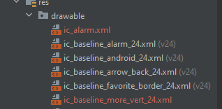

#### Tampilan membuat *vector*

1. Carilah *clip art more vert* dan *star rate* sesuai seperti pada gambar dibawah ini lalu  
   simpan.

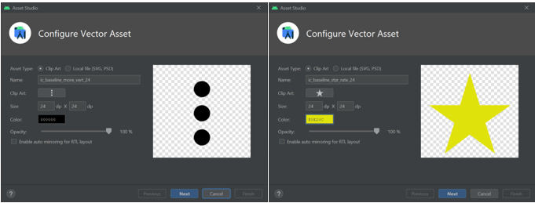

#### Tampilan menambahkan *vector* pada folder *drawable*

1. Kemudian membuat *empty activity* dengan cara klik kanan pada *com.example > new > Activity > Empty Activity.* Untuk membuat activity display data*.*

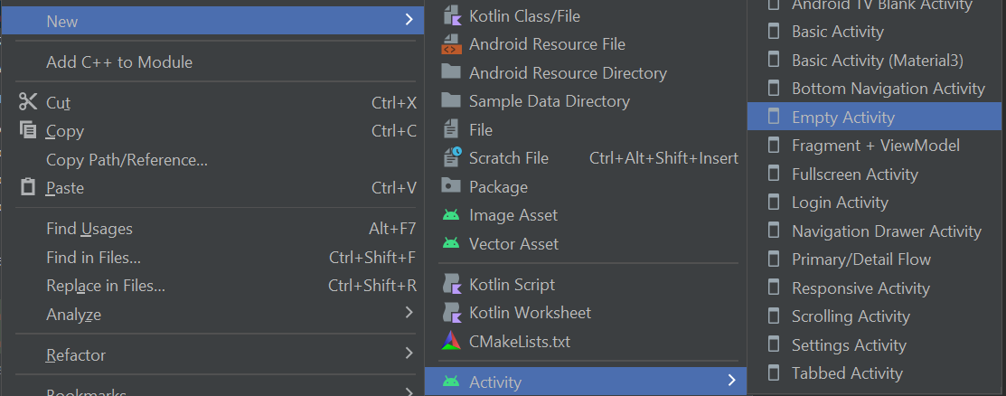

#### Tampilan membuat *Empty Activity*

1. Berikan identitas *Empty Activity* seperti pada gambar dibawah ini.

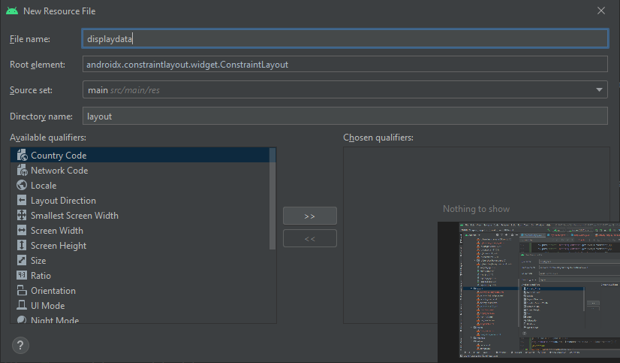

#### Tampilan membuat *Activity display data*

1. Kemudian membuat java class baru dengan cara klik kanan pada *com.example >* *new > Java Class.*

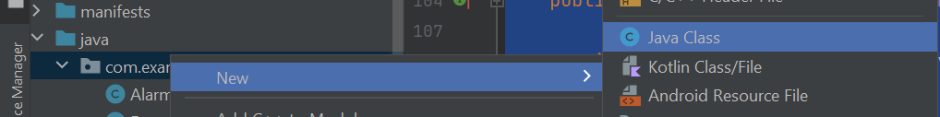

#### Tampilan membuat *Java Class*

1. Buat 3 file Java class dengan nama masing – masing adalah *DBmain*, *Model*,  
   *MyAdapeter* seperti pada gambar dibawah ini.

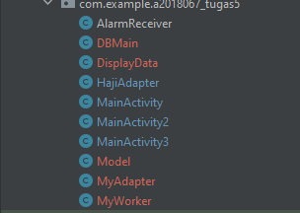

#### Tampilan membuat *Java Class*

1. Kemudian membuat *Layout Resource File* dengan cara klik kanan pada *folder layout  
   > new > Layout Resource File*.

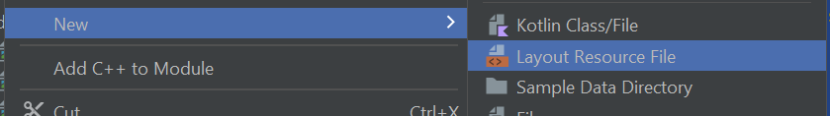

#### Tampilan *membuat Layout Resource File*

1. Beri identitas *Layout Resource File* seperti pada gambar dibawah ini.

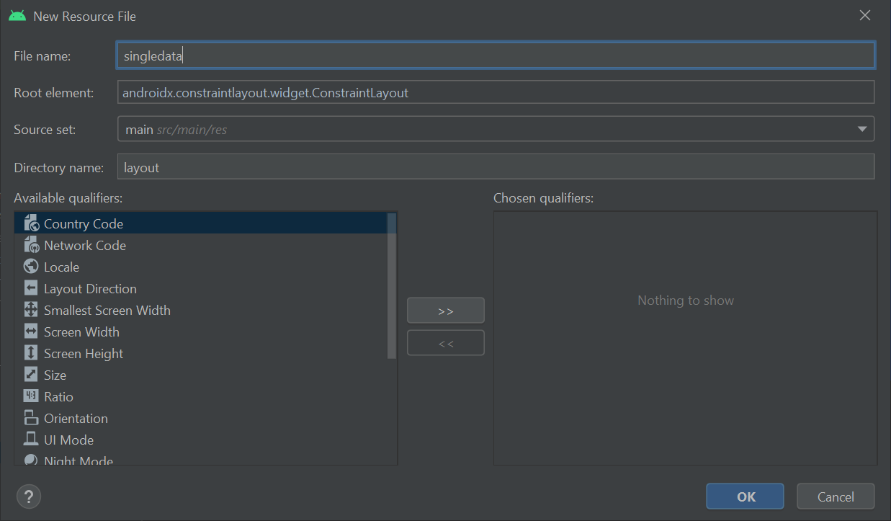

#### Tampilan mengisi identitas

1. Kemudian buka folder *layout > double* klik *file* *singledata.xml*, lalu tambahkan  
   source code berikut.

|  |
| --- |
| <?xml version="1.0" encoding="utf-8"?>  <androidx.cardview.widget.CardView  xmlns:android="http://schemas.android.com/apk/res/android"  android:layout_width="wrap_content"  android:layout_height="130dp"  xmlns:app="http://schemas.android.com/apk/res-auto"  app:cardElevation="2dp"  app:cardPreventCornerOverlap="true"  app:cardUseCompatPadding="true"  app:cardCornerRadius="8dp">  <RelativeLayout  android:layout_width="match_parent"  android:layout_height="match_parent">  <ImageButton  android:background="@null"  android:layout_width="wrap_content"  android:layout_height="wrap_content"  android:layout_marginTop="10dp"  android:id="@+id/flowmenu"  android:layout_centerVertical="true"  android:layout_alignParentRight="true"  android:src="@drawable/ic_baseline_more_vert_24"  android:layout_alignParentTop="true"/>  <ImageView  android:scaleType="fitXY"  android:layout_marginTop="10dp"  android:layout_marginBottom="10dp"  android:layout_width="100dp"  android:layout_height="100dp"  android:paddingLeft="10dp"  android:id="@+id/viewavatar"  android:src="@drawable/ic_launcher_background"/>  <TextView  android:layout_width="match_parent"  android:layout_height="wrap_content"  android:layout_toRightOf="@+id/viewavatar"  android:text="@string/app_name"  android:id="@+id/txt_name"  android:layout_marginTop="10dp"  android:layout_marginLeft="20dp"/>  <LinearLayout  android:layout_width="match_parent"  android:layout_height="20dp"  android:layout_toRightOf="@+id/viewavatar"  android:layout_alignTop="@+id/txt_name"  android:layout_marginTop="25dp"  android:layout_marginStart="10dp"  android:id="@+id/linear"  android:orientation="horizontal">  <ImageView  android:layout_width="30dp"  android:layout_height="wrap_content"  android:foregroundGravity="left"  app:srcCompat="@drawable/ic_baseline_star_rate_24" />  <TextView  android:layout_width="match_parent"  android:layout_height="match_parent"  android:layout_toRightOf="@+id/viewavatar"  android:text="@string/app_name"  android:id="@+id/txt_star"/>  </LinearLayout>  <TextView  android:layout_width="match_parent"  android:layout_height="wrap_content"  android:layout_toRightOf="@+id/viewavatar"  android:text="@string/app_name"  android:layout_alignTop="@+id/linear"  android:id="@+id/txt_price"  android:layout_marginTop="30dp"  android:layout_marginLeft="20dp"/>  </RelativeLayout>  </androidx.cardview.widget.CardView> |

Analisa :

Pada source code diatas sebuah single data untuk menu yang menampilkan sebuah gambar dan teks

1. Kemudian buka folder *com.example > double* klik *file DBmain.java*, lalu tambahkan  
   source code berikut.

|  |
| --- |
| package com.example.a2018067_tugas5;  import android.content.Context;  import android.database.sqlite.SQLiteDatabase;  import android.database.sqlite.SQLiteOpenHelper;  import androidx.annotation.Nullable;  import android.view.View;  import android.content.Context;  import android.content.Intent;  public class DBMain extends SQLiteOpenHelper {  public static final String DBNAME="olehHaji.db";  public static final String TABLENAME="tradisional";  public static final int VER=1;  public DBMain(@Nullable Context context) {  super(context, DBNAME, null, VER);  }  @Override  public void onCreate(SQLiteDatabase db) {  String query = "create table "+TABLENAME+"(id integer primary key, name TEXT, star TEXT, price TEXT, avatar blob)";  db.execSQL(query);  }  @Override  public void onUpgrade(SQLiteDatabase db, int oldVersion, int  newVersion) {  String query = "drop table if exists "+TABLENAME+"";  db.execSQL(query);  onCreate(db);  }  } |

Analisa :

Program diatas berfungsi untuk membuat data baru yang dimana terdapat tipe data string untuk variabel nama, asal, dan tujuan. Apabila berhasil ditambahkan data akan masuk pada bagian “Database”

1. Kemudian buka folder *com.example > double* klik file *Model.java*, lalu tambahkan  
   source code berikut.

|  |
| --- |
| package com.example.a2018067_tugas5;  public class Model {  private int id;  private byte[]proavatar;  private String username;  private String userstar;  private String userprice;  //constructor  public Model(int id, byte[] proavatar, String username, String userstar, String userprice) {  this.id = id;  this.proavatar = proavatar;  this.username = username;  this.userstar = userstar;  this.userprice = userprice;  }  //getter and setter method  public int getId() {  return id;  }  public void setId(int id) {  this.id = id;  }  public byte[] getProavatar() {  return proavatar;  }  public void setProavatar(byte[] proavatar) {  this.proavatar = proavatar;  }  public String getUsername() {  return username;  }  public void setUsername(String username) {  this.username = username;  }  public String getUserstar() {  return userstar;  }  public void setUserstar(String userstar) {  this.userstar = userstar;  }  public String getUserprice() {  return userprice;  }  public void setUserprice(String userprice) {  this.userprice = userprice;  }  } |

Analisa :

Program diatas merupakan class parent pada data yang bertipe data string untuk username, userstar, userprice dan terdapat fungsi void

1. Kemudian klik kanan pada folder *menu > New > Menu Resource File.*

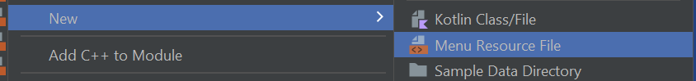

#### Tampilan membuat *Resource File* pada folder menu

1. Kemudian berikan identitas *Menu Resource File* seperti pada gambar dibawah ini.

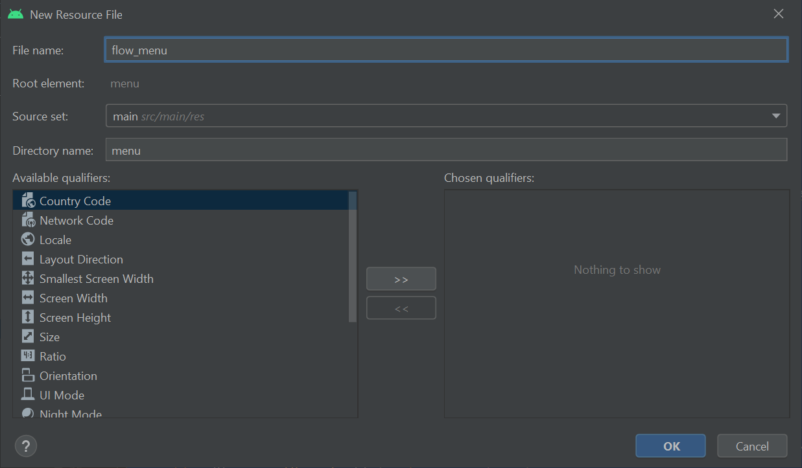

#### Tampilan membuat *flow_menu*

1. Langkah selanjutnya buka *file flow_menu.xml* pada folder *menu*, kemudian  
   tambahkan source code berikut.

|  |
| --- |
| <?xml version="1.0" encoding="utf-8"?>  <menu xmlns:android="http://schemas.android.com/apk/res/android">  <item android:title="Edit"  android:id="@+id/edit_menu"/>  <item android:title="Delete"  android:id="@+id/delete_menu"/>  </menu> |

1. Kemudian tambahkan source code berikut pada *activity_main3.xml*.

|  |
| --- |
| <?xml version="1.0" encoding="utf-8"?>  <androidx.constraintlayout.widget.ConstraintLayout  xmlns:android="http://schemas.android.com/apk/res/android"  xmlns:app="http://schemas.android.com/apk/res-auto"  xmlns:tools="http://schemas.android.com/tools"  android:layout_width="match_parent"  android:layout_height="match_parent"  android:orientation="vertical"  tools:context=".MainActivity3">  <androidx.drawerlayout.widget.DrawerLayout  xmlns:android="http://schemas.android.com/apk/res/android"  xmlns:app="http://schemas.android.com/apk/res-auto"  xmlns:tools="http://schemas.android.com/tools"  android:id="@+id/dl"  android:layout_width="match_parent"  android:layout_height="match_parent"  android:orientation="vertical">  <LinearLayout  xmlns:android="http://schemas.android.com/apk/res/android"  xmlns:app="http://schemas.android.com/apk/res-auto"  xmlns:tools="http://schemas.android.com/tools"  android:layout_width="match_parent"  android:layout_height="match_parent"  android:orientation="vertical"  tools:context=".MainActivity3">  <ImageView  android:layout_marginTop="14dp"  android:layout_gravity="center"  android:layout_width="150dp"  android:layout_height="150dp"  android:src="@mipmap/ic_launcher"  android:id="@+id/edtimage"/>  <EditText  android:id="@+id/edtname"  android:layout_width="match_parent"  android:layout_height="wrap_content"  android:layout_marginTop="10dp"  android:hint="Name"  android:inputType="text" />  <EditText  android:id="@+id/edtstar"  android:layout_width="match_parent"  android:layout_height="wrap_content"  android:layout_marginTop="10dp"  android:hint="Star"  android:inputType="text" />  <EditText  android:id="@+id/edtprice"  android:layout_width="match_parent"  android:layout_height="wrap_content"  android:layout_marginTop="10dp"  android:hint="Price"  android:inputType="text" />  <LinearLayout  android:layout_width="match_parent"  android:layout_height="wrap_content"  android:orientation="horizontal"  android:layout_margin="10dp">  <Button  android:layout_width="wrap_content"  android:layout_height="wrap_content"  android:layout_weight="1"  android:id="@+id/btn_submit"  android:text="Submit"/>  <Button  android:layout_width="wrap_content"  android:layout_height="wrap_content"  android:id="@+id/btn_edit"  android:visibility="gone"  android:text="Edit"  android:layout_weight="1"/>  <Button  android:layout_width="wrap_content"  android:layout_height="wrap_content"  android:text="Display"  android:id="@+id/btn_display"  android:layout_weight="1"/>  </LinearLayout>  </LinearLayout>  <com.google.android.material.navigation.NavigationView  android:id="@+id/nav_view"  android:layout_width="wrap_content"  android:layout_height="match_parent"  android:layout_gravity="start"  app:headerLayout="@layout/nav_header"  app:menu="@menu/navigation_menu">  </com.google.android.material.navigation.NavigationView>  </androidx.drawerlayout.widget.DrawerLayout>  </androidx.constraintlayout.widget.ConstraintLayout> |

1. Kemudian tambahkan source code berikut pada *activity_display_data.xml.*

|  |
| --- |
| <?xml version="1.0" encoding="utf-8"?>  <RelativeLayout  xmlns:android="http://schemas.android.com/apk/res/android"  xmlns:app="http://schemas.android.com/apk/res-auto"  xmlns:tools="http://schemas.android.com/tools"  android:layout_width="match_parent"  android:layout_height="match_parent"  tools:context=".DisplayData">  <Button  android:layout_marginTop="10dp"  android:layout_marginLeft="10dp"  android:layout_marginBottom="10dp"  android:layout_width="wrap_content"  android:layout_height="wrap_content"  android:id="@+id/btn_create"  android:text="Create" />  <androidx.recyclerview.widget.RecyclerView  android:id="@+id/rv"  android:layout_width="match_parent"  android:layout_height="1000dp"  android:layout_marginTop="75dp" />  </RelativeLayout> |

1. Kemudian tambahkan source code berikut pada *MyAdapter.java.*

|  |
| --- |
| package com.example.a2018067_tugas5;  import static com.example.a2018067_tugas5.DBMain.TABLENAME;  import android.annotation.SuppressLint;  import android.content.Context;  import android.content.Intent;  import android.database.sqlite.SQLiteDatabase;  import android.graphics.Bitmap;  import android.graphics.BitmapFactory;  import android.os.Bundle;  import android.view.LayoutInflater;  import android.view.MenuItem;  import android.view.View;  import android.view.ViewGroup;  import android.widget.ImageButton;  import android.widget.ImageView;  import android.widget.PopupMenu;  import android.widget.TextView;  import android.widget.Toast;  import androidx.annotation.NonNull;  import androidx.recyclerview.widget.RecyclerView;  import java.util.ArrayList;  public class MyAdapter extends RecyclerView.Adapter<MyAdapter.ViewHolder> {  Context context;  int singledata;  ArrayList<Model> modelArrayList;  SQLiteDatabase sqLiteDatabase;  //generate constructor  public MyAdapter(Context context, int singledata, ArrayList<Model> modelArrayList, SQLiteDatabase sqLiteDatabase) {  this.context = context;  this.singledata = singledata;  this.modelArrayList = modelArrayList;  this.sqLiteDatabase = sqLiteDatabase;  }  @NonNull  @Override  public MyAdapter.ViewHolder onCreateViewHolder(@NonNull ViewGroup parent, int viewType) {  LayoutInflater inflater = LayoutInflater.from(context);  View view = inflater.inflate(R.layout.singledata, null);  return new ViewHolder(view);  }  @Override  public void onBindViewHolder(@NonNull MyAdapter.ViewHolder holder, @SuppressLint("RecyclerView") int position) {  final Model model = modelArrayList.get(position);  byte[] image = model.getProavatar();  Bitmap bitmap = BitmapFactory.decodeByteArray(image, 0, image.length);  holder.imageavatar.setImageBitmap(bitmap);  holder.txtname.setText(model.getUsername());  holder.txtstar.setText(model.getUserstar());  holder.txtprice.setText(model.getUserprice());  //flow menu  holder.flowmenu.setOnClickListener(new View.OnClickListener() {  @Override  public void onClick(View v) {  PopupMenu popupMenu = new PopupMenu(context, holder.flowmenu);  popupMenu.inflate(R.menu.flow_menu);  popupMenu.setOnMenuItemClickListener(new PopupMenu.OnMenuItemClickListener() {  @Override  public boolean onMenuItemClick(MenuItem item) {  switch (item.getItemId()) {  case R.id.edit_menu:  //edit operation  Bundle bundle = new Bundle();  bundle.putInt("id", model.getId());  bundle.putString("name", model.getUsername());  bundle.putString("star", model.getUserstar());  bundle.putString("price", model.getUserprice());  bundle.putByteArray("avatar", model.getProavatar());  Intent intent = new Intent(context, MainActivity3.class);  intent.putExtra("userdata", bundle);  context.startActivity(intent);  break;  case R.id.delete_menu:  //delete operation  DBMain dBmain = new DBMain(context);  sqLiteDatabase = dBmain.getReadableDatabase();  long recdelete = sqLiteDatabase.delete(TABLENAME, "id=" + model.getId(), null);  if (recdelete != -1) {  Toast.makeText(context, "Data Deleted", Toast.LENGTH_SHORT).show();  //remove positon afterdeleted  modelArrayList.remove(position);  //update data  notifyDataSetChanged();  }  break;  default:  return false;  }  return false;  }  });  //display menu  popupMenu.show();  }  });  }  @Override  public int getItemCount() {  return modelArrayList.size();  }  public class ViewHolder extends RecyclerView.ViewHolder {  ImageView imageavatar;  TextView txtname, txtstar, txtprice;  ImageButton flowmenu;  public ViewHolder(@NonNull View itemView) {  super(itemView);  imageavatar = (ImageView) itemView.findViewById(R.id.viewavatar);  txtname = (TextView) itemView.findViewById(R.id.txt_name);  txtstar = (TextView) itemView.findViewById(R.id.txt_star);  txtprice = (TextView) itemView.findViewById(R.id.txt_price);  flowmenu = (ImageButton) itemView.findViewById(R.id.flowmenu);  }  }  } |

1. Kemudian tambahkan source code berikut pada *MainActivity3*.*java.*

|  |
| --- |
| package com.example.a2018067_tugas5;  import static com.example.a2018067_tugas5.DBMain.TABLENAME;  import androidx.annotation.NonNull;  import androidx.annotation.Nullable;  import androidx.appcompat.app.ActionBarDrawerToggle;  import androidx.appcompat.app.AppCompatActivity;  import androidx.core.content.ContextCompat;  import androidx.drawerlayout.widget.DrawerLayout;  import android.Manifest;  import android.content.ContentValues;  import android.content.Intent;  import android.content.pm.PackageManager;  import android.database.sqlite.SQLiteDatabase;  import android.graphics.Bitmap;  import android.graphics.BitmapFactory;  import android.graphics.drawable.BitmapDrawable;  import android.net.Uri;  import android.os.Bundle;  import android.view.MenuItem;  import android.view.View;  import android.widget.ImageView;  import android.widget.Toast;  import com.google.android.material.navigation.NavigationView;  import com.squareup.picasso.Picasso;  import com.theartofdev.edmodo.cropper.CropImage;  import com.example.a2018067_tugas5.databinding.ActivityMain3Binding;  import java.io.ByteArrayOutputStream;  public class MainActivity3 extends AppCompatActivity {  private ActivityMain3Binding binding;  private DrawerLayout dl;  private ActionBarDrawerToggle abdt;  DBMain dBmain;  SQLiteDatabase sqLiteDatabase;  int id = 0;  public static final int MY_CAMERA_REQUEST_CODE = 100;  public static final int MY_STORAGE_REQUEST_CODE = 101;  String cameraPermission[];  String storagePermission[];  @Override  protected void onCreate(Bundle savedInstanceState) {  super.onCreate(savedInstanceState);  binding =ActivityMain3Binding.inflate(getLayoutInflater());  setContentView(binding.getRoot());  dBmain = new DBMain(this);  insertData();  editData();  binding.edtimage.setOnClickListener(new View.OnClickListener() {  @Override  public void onClick(View v) {  int avatar = 0;  if (avatar == 0) {  if (!checkCameraPermission()) {  requestCameraPermission();  } else {  pickFromGallery();  }  } else if (avatar == 1) {  if (!checkStoragePermission()) {  requestStoragePermission();  } else {  pickFromGallery();  }  }  }  });  dl = (DrawerLayout) findViewById(R.id.dl);  abdt = new ActionBarDrawerToggle(this, dl, R.string.Open, R.string.Close);  abdt.setDrawerIndicatorEnabled(true);  dl.addDrawerListener(abdt);  abdt.syncState();  getSupportActionBar().setDisplayHomeAsUpEnabled(true);  NavigationView nav_view = (NavigationView) findViewById(R.id.nav_view);  nav_view.setNavigationItemSelectedListener(new NavigationView.OnNavigationItemSelectedListener() {  @Override  public boolean onNavigationItemSelected(@NonNull MenuItem item) {  int id = item.getItemId();  if (id == R.id.nav_home) {  Intent a = new Intent(MainActivity3.this, MainActivity.class);  startActivity(a);  } else if (id == R.id.nav_kontak) {  Intent a = new Intent(MainActivity3.this, MainActivity2.class);  startActivity(a);  } else if (id == R.id.nav_database) {  Intent a = new Intent(MainActivity3.this, MainActivity3.class);  startActivity(a);  }  return true;  }  });  }  private void editData() {  if (getIntent().getBundleExtra("userdata")!= null){Bundle bundle = getIntent().getBundleExtra("userdata");  id = bundle.getInt("id");  //for set name  binding.edtname.setText(bundle.getString("name"));  binding.edtstar.setText(bundle.getString("star"));  binding.edtprice.setText(bundle.getString("price"));  //for image  byte[]bytes = bundle.getByteArray("avatar");  Bitmap bitmap = BitmapFactory.decodeByteArray(bytes, 0, bytes.length);  binding.edtimage.setImageBitmap(bitmap);  //visible edit button and hide submit button  binding.btnSubmit.setVisibility(View.GONE);  binding.btnEdit.setVisibility(View.VISIBLE);  }  }  private void requestStoragePermission() {  requestPermissions(storagePermission, MY_STORAGE_REQUEST_CODE);  }  private boolean checkStoragePermission() {  boolean result = ContextCompat.checkSelfPermission(this, Manifest.permission.WRITE_EXTERNAL_STORAGE) == (PackageManager.PERMISSION_GRANTED);  return result;  }  private void pickFromGallery() {  CropImage.activity().start(this);  }  private void requestCameraPermission() {  requestPermissions(cameraPermission,  MY_CAMERA_REQUEST_CODE);  }private boolean checkCameraPermission() {  boolean result = ContextCompat.checkSelfPermission(this, Manifest.permission.WRITE_EXTERNAL_STORAGE) == (PackageManager.PERMISSION_GRANTED);  boolean result1 = ContextCompat.checkSelfPermission(this, Manifest.permission.CAMERA) == (PackageManager.PERMISSION_GRANTED);  return result && result1;  }  private void insertData() {  binding.btnSubmit.setOnClickListener(new View.OnClickListener() {  @Override  public void onClick(View v) {  ContentValues cv = new ContentValues();  cv.put("name", binding.edtname.getText().toString());  cv.put("star", binding.edtstar.getText().toString());  cv.put("avatar", imageViewToBy(binding.edtimage));  cv.put("price", binding.edtprice.getText().toString());  sqLiteDatabase = dBmain.getWritableDatabase();  Long rec = sqLiteDatabase.insert("tradisional", null, cv);  if (rec != null) {  Toast.makeText(MainActivity3.this, "Data Inserted", Toast.LENGTH_SHORT).show();  binding.edtname.setText("");  binding.edtimage.setImageResource(R.mipmap.ic_launcher);  binding.edtstar.setText("");  binding.edtprice.setText("");  } else {  Toast.makeText(MainActivity3.this, "Something Wrong", Toast.LENGTH_SHORT).show();  }  }  });  //for view display  binding.btnDisplay.setOnClickListener(new View.OnClickListener() {  @Override  public void onClick(View v) {  startActivity(new Intent(MainActivity3.this, DisplayData.class));  }  });  //for storing new data or update data  binding.btnEdit.setOnClickListener(new View.OnClickListener() {  @Override  public void onClick(View v) {  ContentValues cv = new ContentValues();  cv.put("name", binding.edtname.getText().toString());  cv.put("star", binding.edtstar.getText().toString());  cv.put("price", binding.edtprice.getText().toString());  cv.put("avatar", imageViewToBy(binding.edtimage));  sqLiteDatabase = dBmain.getWritableDatabase();  long recedit = sqLiteDatabase.update(TABLENAME, cv, "id=" + id, null);  if (recedit != -1) {  Toast.makeText(MainActivity3.this, "Update Succesfully", Toast.LENGTH_SHORT).show();  //clear data adfte submit  binding.edtname.setText("");  binding.edtstar.setText("");  binding.edtprice.setText("");  binding.edtimage.setImageResource(R.mipmap.ic_launcher);  //edit hide and submit visible  binding.btnEdit.setVisibility(View.GONE);  binding.btnSubmit.setVisibility(View.VISIBLE);  Intent a = new Intent(MainActivity3.this, DisplayData.class);  startActivity(a);  }  }  });  }  public static byte[] imageViewToBy(ImageView avatar) {  Bitmap bitmap = ((BitmapDrawable) avatar.getDrawable()).getBitmap();  ByteArrayOutputStream stream = new ByteArrayOutputStream();  bitmap.compress(Bitmap.CompressFormat.JPEG, 50, stream);  byte[] bytes = stream.toByteArray();  return bytes;  }  @Override  public void onRequestPermissionsResult(int requestCode, @NonNull String[] permissions, @NonNull int[] grantResults) {  super.onRequestPermissionsResult(requestCode, permissions, grantResults);  switch (requestCode) {  case MY_CAMERA_REQUEST_CODE: {  if (grantResults.length > 0) {  boolean camera_accepted = grantResults[0] == PackageManager.PERMISSION_GRANTED;  boolean storage_accepted = grantResults[1] == PackageManager.PERMISSION_GRANTED;  if (camera_accepted && storage_accepted) {  pickFromGallery();  } else {  Toast.makeText(this, "enable camera and storage permission", Toast.LENGTH_SHORT).show();  }  }  }break;  case MY_STORAGE_REQUEST_CODE: {  boolean storage_accepted = grantResults[0] == PackageManager.PERMISSION_GRANTED;  if (storage_accepted) {  pickFromGallery();  } else {  Toast.makeText(this, "please enable storage permission", Toast.LENGTH_SHORT).show();  }  }  break;  }  }  @Override  protected void onActivityResult(int requestCode, int  resultCode, @Nullable Intent data) {  super.onActivityResult(requestCode, resultCode, data);  if(requestCode  ==CropImage.CROP_IMAGE_ACTIVITY_REQUEST_CODE){  CropImage.ActivityResult result = CropImage.getActivityResult(data);  if(resultCode == RESULT_OK){  Uri resultUri = result.getUri();  Picasso.with(this).load(resultUri).into(binding.edtimage);  }  }  }  @Override  public boolean onOptionsItemSelected(@NonNull MenuItem item) {  return abdt.onOptionsItemSelected(item) || super.onOptionsItemSelected(item);  }  } |

1. Kemudian tambahkan source code berikut pada *DisplayData.java.*

|  |
| --- |
| package com.example.a2018067_tugas5;  import static com.example.a2018067_tugas5.DBMain.TABLENAME;  import androidx.appcompat.app.AppCompatActivity;  import androidx.recyclerview.widget.LinearLayoutManager;  import androidx.recyclerview.widget.RecyclerView;  import android.content.Intent;  import android.database.Cursor;  import android.database.sqlite.SQLiteDatabase;  import android.os.Bundle;  import android.util.Log;  import android.view.View;  import com.example.a2018067_tugas5.databinding.ActivityDisplayDataBinding;  import java.util.ArrayList;  public class DisplayData extends AppCompatActivity {  DBMain dBmain;  SQLiteDatabase sqLiteDatabase;  RecyclerView recyclerView;  MyAdapter myAdapter;  private ActivityDisplayDataBinding binding;  @Override  protected void onCreate(Bundle savedInstanceState) {  super.onCreate(savedInstanceState);  binding = ActivityDisplayDataBinding.inflate(getLayoutInflater());  setContentView(binding.getRoot());  findId();  dBmain = new DBMain(this);  displayData();  recyclerView.setLayoutManager(new LinearLayoutManager(this, RecyclerView.VERTICAL,false));  binding.btnCreate.setOnClickListener(new View.OnClickListener() {  @Override  public void onClick(View v) {  Intent a = new Intent(DisplayData.this,  MainActivity3.class);  startActivity(a);  }  });  }  private void displayData() {  sqLiteDatabase = dBmain.getReadableDatabase();  Cursor cursor = sqLiteDatabase.rawQuery("select * from "+TABLENAME,null);  ArrayList<Model> models = new ArrayList<>();  while (cursor.moveToNext()){  int id = cursor.getInt(0);  String name = cursor.getString(1);  byte[]avatar = cursor.getBlob(4);  String star = cursor.getString(2);  String price = cursor.getString(3);  models.add(new Model(id,avatar,name,star,price));  Log.e("data : ",cursor.getString(1));  }  cursor.close();  myAdapter = new MyAdapter(this, R.layout.singledata,models,sqLiteDatabase);  recyclerView.setAdapter(myAdapter);  }  private void findId() {  recyclerView = findViewById(R.id.rv);  }  } |

1. Terakhir hasil tampilan program setelah di *run.*

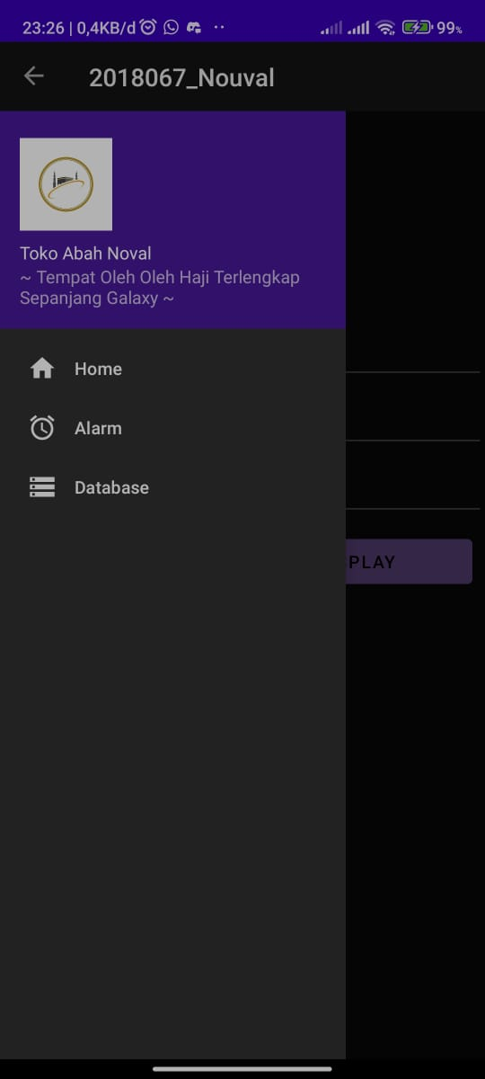

#### Tampilan menu action bar

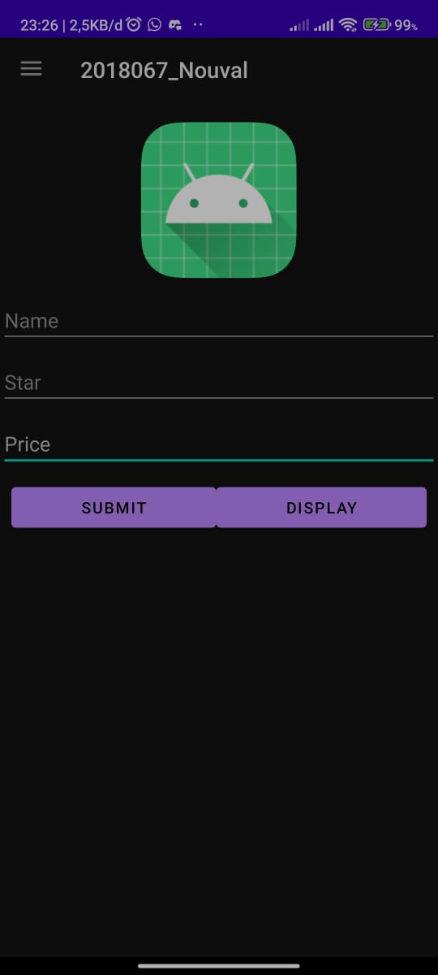

#### Tampilan pertama Sql

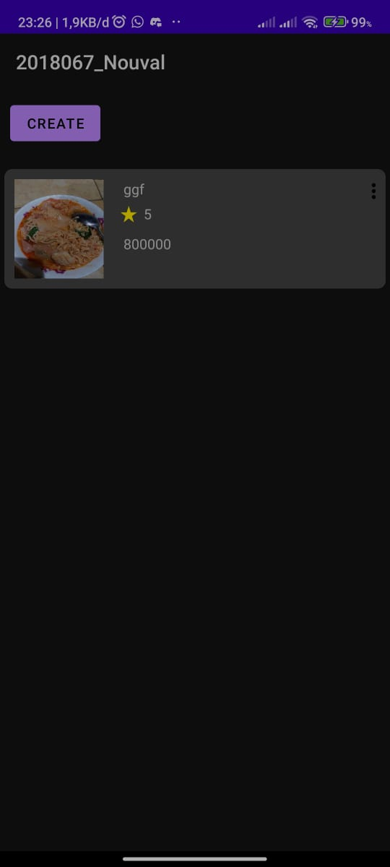

#### Tampilan display data

1. **Link repository github**

<https://github.com/IbadSetiawan/Tugas5_2018061.git>