Tugas Data Mining Pertemuan 7

Nama : Novan Nurrohim

Nim : A11.2018.11367

Kelompok : A11.4624

Soal 1

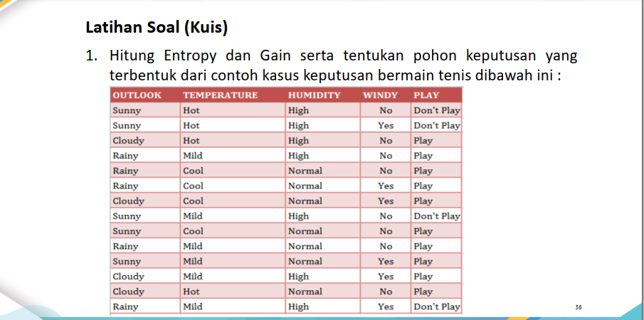

Entropy(S) = $\sum_{i=1}^{n}{- pi*\log_{2}{pi}}$

Node 1

|  |  |  |  |  |  |  |
| --- | --- | --- | --- | --- | --- | --- |
| Total |  | jum Kasus (S) | Don’t play (S1) | Play (S2) | Entropy | Gain |
|  | 14 | 4 | 10 | 0,86312 |  |
| outlook |  |  |  |  |  | 0,258521 |
|  | cloudy | 4 | 0 | 4 | 0 |  |
|  | rainy | 5 | 1 | 4 | 0,72193 |  |
|  | sunny | 6 | 3 | 2 | 0,97095 |  |
| temp |  |  |  |  |  | 0,1838509 |
|  | cold | 4 | 0 | 4 | 0 |  |
|  | hot | 4 | 2 | 2 | 1 |  |
|  | mild | 6 | 2 | 4 | 0,9183 |  |
| humidity |  |  |  |  |  | 0,3705065 |
|  | high | 7 | 4 | 3 | 0,98523 |  |
|  | normal | 7 | 0 | 7 | 0 |  |
| windy |  |  |  |  |  | 0,0059777 |
|  | yes | 8 | 2 | 6 | 0,81128 |  |
|  | no | 5 | 4 | 2 | 0,9183 |  |

Entropy(total) = $\left(-\frac{4}{14}*\log_{2}{(\frac{4}{14})}\right)+ \left(-\frac{10}{14}*\log_{2}{(\frac{4}{14})}\right)$

= 0,86312

Gain(total,outlook)=Entropy(total) – Entropy(outlook)

= 0,86312 - $\left(-\frac{4}{14}*0\right)+ \left(-\frac{5}{14}*0,723\right)+\left(-\frac{5}{14}*0,97\right)$

= 0,23

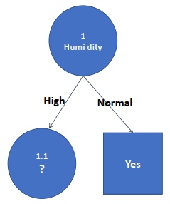

Node 1.1

|  |  |  |  |  |  |  |
| --- | --- | --- | --- | --- | --- | --- |
|  |  | jum Kasus (S) | Don’t play (S1) | Play(S2) | Entropy | Gain |
| Humidity(High) |  |  |  |  | 0,98523 |  |
| outlook |  |  |  |  |  | 0,258521 |
|  | cloudy | 4 | 0 | 4 | 0 |  |
|  | rainy | 5 | 1 | 4 | 0,72193 |  |
|  | sunny | 6 | 3 | 2 | 0,97095 |  |
| temp |  |  |  |  |  | 0,1838509 |
|  | cold | 4 | 0 | 4 | 0 |  |
|  | hot | 4 | 2 | 2 | 1 |  |
|  | mild | 6 | 2 | 4 | 0,9183 |  |
| windy |  |  |  |  |  | 0,0059777 |
|  | yes | 8 | 2 | 6 | 0,81128 |  |
|  | no | 5 | 4 | 2 | 0,9183 |  |

Node 1.1.2

|  |  |  |  |  |  |  |
| --- | --- | --- | --- | --- | --- | --- |
| Node 1.1.2 | | jum Kasus (S) | Don’t play (S1) | Play (S2) | Entropy | Gain |
| Humidity (High) dan oulook(rainy) | | 2 | 2 | 1 |  |  |
| temp |  |  |  |  |  | 0 |
|  | cold | 0 | 0 | 0 | 0 |  |
|  | hot | 0 | 0 | 0 | 0 |  |
|  | mild | 2 | 1 | 1 | 1 |  |
| windy |  |  |  |  |  | 1 |
|  | yes | 1 | 0 | 1 | 0 |  |
|  | no | 1 | 1 | 0 | 0 |  |

No

Yes

Yes

No

Yes