TEAM ID : NM2023TMID36871
S.Novaraj(Bruar2022k2661)
K.Venugopal(Bruar2022k2659)
S.Babu(Bruar2022k2662)
S.Kavin(Bruar2022k2669)

THYROID DISEASE CLASSIFICATION USING MACHINE LEARNING

ABSTRACT:
There are many thyroid diseases affecting people all over the world. Many diseases affect the thyroid gland, like hypothyroidism, hyperthyroidism, and thyroid cancer. Thyroid inefficiency can cause severe symptoms in patients. Effective classification and machine learning play a significant role in the timely detection of thyroid diseases.
This timely classification will indeed affect the timely treatment of the patients. Automatic and precise thyroid nodule detection in ultrasound pictures is critical for reducing effort and radiologists’ mistake rate. Medical images have evolved into one of the most valuable and consistent data sources for machine learning generation.
In this paper, various machine learning algorithms like decision tree, random forest algorithm, KNN, and artificial neural networks on the dataset create a comparative analysis to better predict the disease based on parameters established from the dataset.
Also, the dataset has been manipulated for accurate prediction for the classification. The classification was performed on both the sampled and unsampled datasets for better comparison of the dataset. After dataset manipulation, we obtained the highest accuracy for the random forest algorithm, equal to 94.8% accuracy and 91% specificity.

Introduction:
Approximately about 4.6 percent of the population of ages 12 and greater suffers from hypothyroidism, and 1.2 percent of people in the USA have hyperthyroidism, equal to 1 out of 100 people. Machine learning is implemented in many fields today. But most significant improvements are made in the field of medicine.
To detect thyroid disease, blood tests and medical imaging are performed (ultrasound). Awareness about thyroid disease is necessary as it will play a significant role in the early detection and curing of this problem. The thyroid is an organ in the human body. It produces the hormone required by the human body.
The hormones travel in the bloodstream, and it affects the metabolism and growth of humans. It is located below Adam’s apple. Thyroid functionality is used for the interpretation and diagnosis of the disease. The thyroid gland produces hormones that control the growth and metabolism used for the body’s energy purposes.
The thyroid gland also contributes to development in children and adults. The thyroid gland also maintains body temperature. Minor issues with the gland can cause a problem all over the body. The functionality of the thyroid gland and the test results conducted after taking a blood sample are used to signify if the thyroid gland is working correctly.
This hormone’s secretion tells whether the thyroid is producing too much hormone or too little hormone for proper function. The condition in which little thyroid hormone is produced is called hypothyroidism. When the hormone is too much, it is referred to as hyperthyroidism. The thyroid gland produces two main hormones—triiodothyronine (T3) and thyroxine (T4).
Thyroid disorder is one of the most frequent illnesses among women. Thyroid illness can manifest itself as hypothyroidism. Female patients are more likely to develop hypothyroidism.
The conditions that thyroid disease causes are very similar to other diseases, so distinguishing is sometimes difficult. Another type of hormone produced is called calcitonin. An appropriate amount of iodine is essential for the gland to produce these hormones.
Because it produces hormones, the thyroid gland impacts the human body’s metabolic processes. An increase in thyroid hormone production causes hyperthyroidism. The use of an online ensemble of decision trees to detect thyroid-related disorders is proposed in this research. This study is aimed at increasing thyroid illness diagnosis accuracy.
Thyroid dysfunction is a classification problem and can be solved using data mining techniques. The symptoms of thyroid disease include high cholesterol, high blood pressure, and an unusual pulse rate.

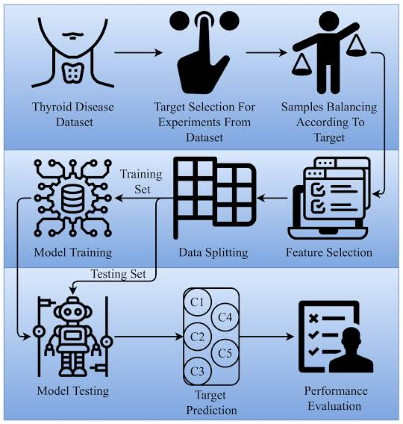

Proposed technique:
The proposed framework will take input in the form of dataset and then forward to the preprocessing module. In the preprocessing module, the normalization of images is performed in this module. After preprocessing the images, augmentation is performed. In augmentation, the dataset is divided into two parts: the training dataset and the testing dataset.
After the augmentation process, import Alex Net and compare it with the customized Alex Net, and meet the criteria and store it in a trained model as shown in Figure 1. The missing values will be checked in the preprocessing steps. If we detect a missing value, the mean value will replace the value in that column. As the missing value had a data loss of about 91%, that parameter is removed from the dataset. We have adapted the dataset to be better processed with the chosen models. Initially, only two columns are removed.
In the second step of the methodology, we performed dataset manipulation by under sampling the classes. Classes 0 and 1 are highly different in size: class 0 has 2870 samples, while class 1 only contains 293 values. The uneven class representation will cause the accuracy to be very high as machine learning algorithms are sensitive to skewed values.

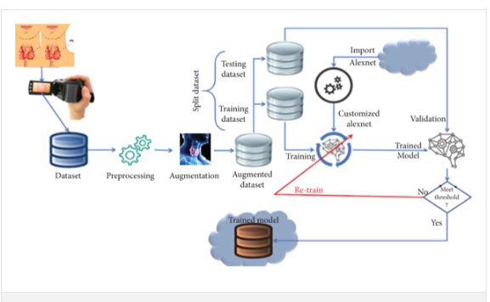

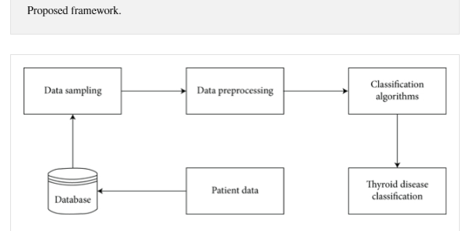

Literature Review:
Few studies have been performed on thyroid disease, and the authors have evaluated many of the studies to create a proper background on the disease classification. Gou and Du proposed a system that consists of a Generalized Discriminant Analysis and Wavelet Support Vector Machine System (GDA_WSVM) approach for the analysis of thyroid illnesses which incorporates three phases. Yang et al.’s targets are diagnosing thyroid illnesses with a professional system. These are featuring extraction – feature reduction phase, classification phase, and test of GDA_WSVM for correct diagnosis of thyroid diseases phase.
In the proposed system, fuzzy regulations are incorporated via the fuzzy neuron technique.
proposed that information benefit primarily based on a synthetic immune popularity system (IG-AIRS) might help diagnose thyroid characteristics primarily based totally on laboratory tests and might open the manner to numerous unwell diagnoses aided by the use of the latest scientific exam data. Parkavi centered on ant primarily based clustering algorithms. The category used distinct dissimilarity metrics like Euclidean, cosine, and Gower measures. The category used is distance primarily based category systems.

Preprocessing Steps:

(1) Data cleansing
(2) Data processing
(3) Data elimination
(4) Data wrangling

Preprocessing is arranged to overcome the different processing issues involving noisy data, redundant information, and missing values. The high quality of data will produce high-quality results according to the measuring metrics. The cost of computations will also reduce.

Experimental Results and Analysis:
After the implementation of the algorithm, we conducted a comparison of all the classifier results. We evaluated the results based on the true positive and true negative rates. True positive rates are the patients who do have the disease, and true negative rates are those who do not have the disease.
This proposed system is evaluated in the comparative results based on whether the person has the disease or not. Sensitivity and specificity are used to display the results. KNN is the least impressive model that can be used to classify the disease. It produced 59% and 91% specificity results. On the other hand, random forest produced the best results with 94.8% and 91% on the dataset. Naïve Bayes performed at 93% and 78%, and ANN produced 94% and 81%, respectively.

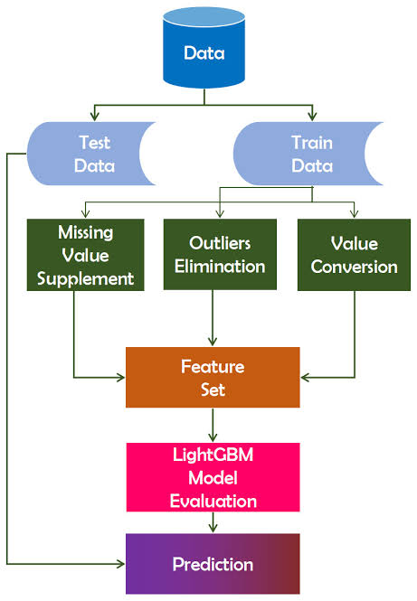

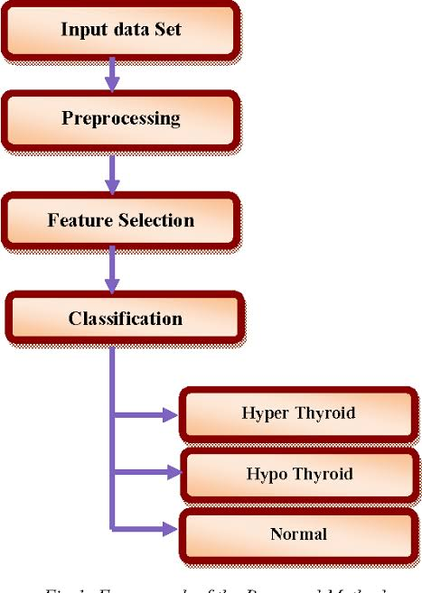

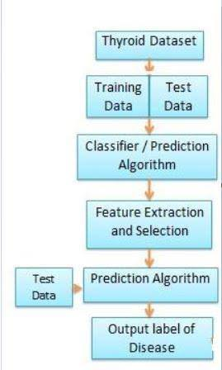

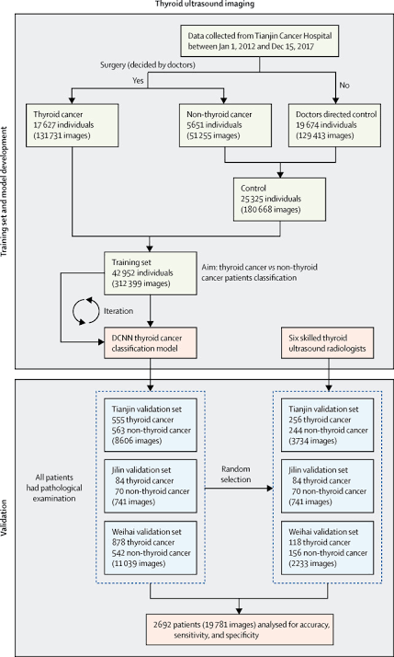

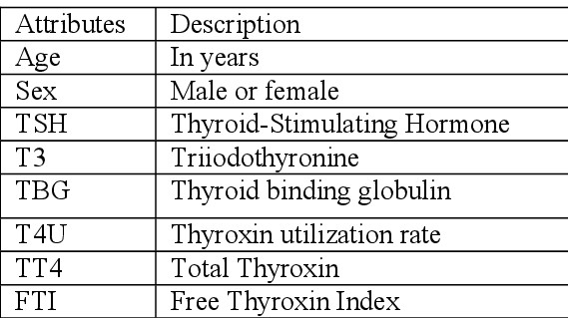

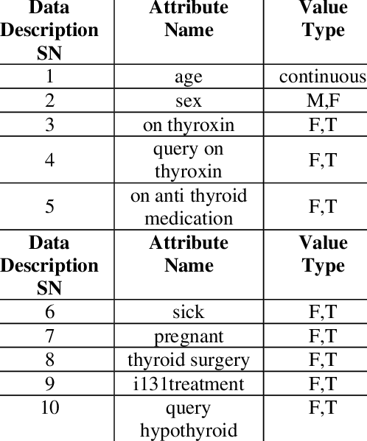

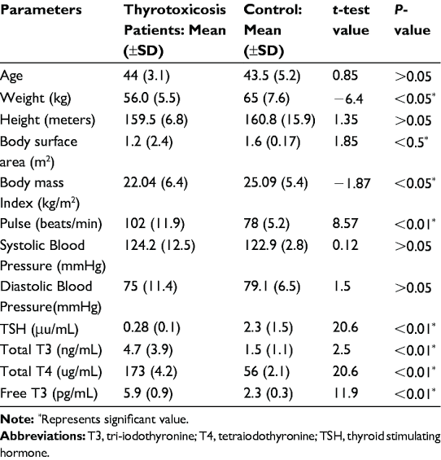

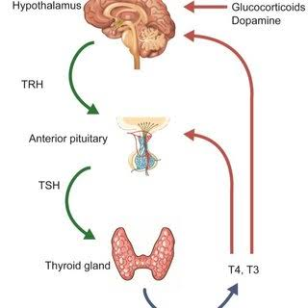

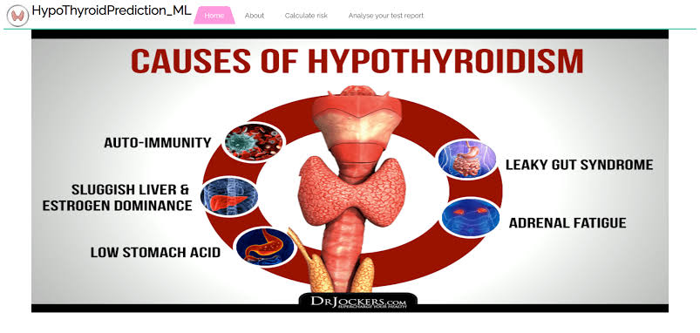

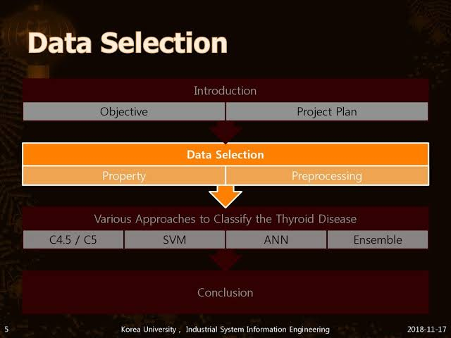

Overall Result System:
Compared to the overall results with four classifiers on the same dataset, KNN and random forest showed better results with 94.8% system accuracy.

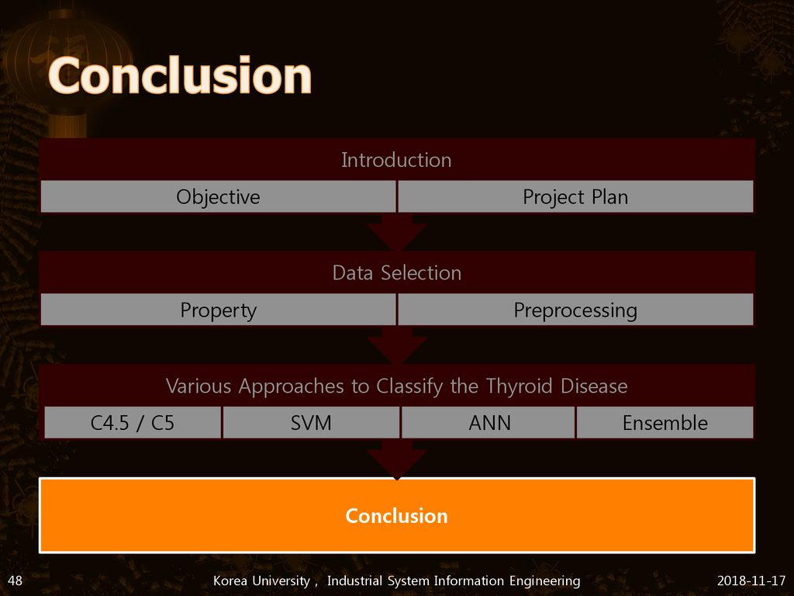

Conclusion:
This study signifies machine learning and data mining techniques to benefit the medical field and healthcare system. According to the regular protocol, this study will help the doctors use this as a supplementary system. We have evaluated the dataset based on precision and recall. Random forest was performed to be 94.8 percent accurate on average. Random forest is the most efficient in classification, and KNN is the least efficient.

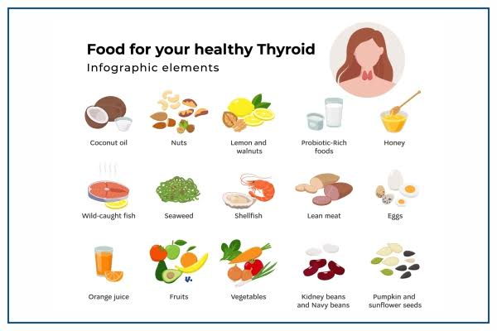

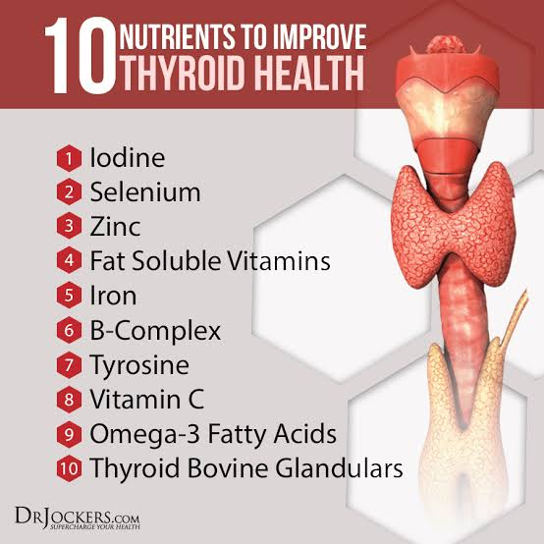

THANK YOU

