Generic Report Title

Department

Study title

Study number

**Document status:** Draft/Final

**Document version:** v0

**Date:** DD-Mmm-YYYY

*Business Classification*

Table of Contents

1 Section example 2

2 Analysis 2

2.1 A section of the analysis 2

2.2 Another section of the analysis 4

2.3 Last section of the analysis 5

3 Interpretation 6

3.1 One random section 6

List of Figures

Figure 2‑1. Data Point Distribution in Sample Set A 4

Figure 2‑2. Comparative Analysis of Categories X and Y 4

Figure 2‑3. Comparative Analysis of Categories X and Y 5

Figure 2‑4. Trend Analysis Over Time (Yearly Data) 6

Figure 2‑5. Trend Analysis Over Time (Yearly Data) 6

Figure 3‑1. Trend Analysis Over Time (Monthly Data) 7

List of Tables

Table 2‑1. Summary of Sample Statistics 3

Table 2‑2. Breakdown of Category X by Subcategory 5

Table 3‑1. Yearly Performance Metrics 7

# Section example

This document serves as a comprehensive sample, illustrating the creation of a structured document with multiple sections. Each section contains content that showcases different elements such as paragraphs, figures, and tables. The purpose of this document is to demonstrate proper formatting, organization, and presentation of information within a professional document.

The document is divided into several key sections, including an introduction, analysis, and data representation. In the data representation section, both figures and tables are provided with detailed captions to offer context for each data point.

# Analysis

In this section, we perform a basic analysis of the sample data presented later in the document. The purpose of this analysis is to provide insights into the dummy data, which is represented through figures and tables in the subsequent sections.

The analysis focuses on key trends and patterns observed in the data. For instance, Figure 1 highlights the distribution of data points, while Table 1 provides a detailed breakdown of sample statistics.

## A section of the analysis

Table 2‑1. Summary of Sample Statistics

| **Statistic** | **Sample_A** | **Sample_B** | **Sample_C** |
| --- | --- | --- | --- |
| Mean | 0.02 | 0.04 | 12.38 |
| Median | 0.01 | 0.05 | 12.37 |
| Standard Deviation | 0.99 | 1.01 | 2.54 |
| Min | -2.81 | -3.05 | 8.19 |
| Max | 3.24 | 3.39 | 16.53 |

Figure 2‑1. Data Point Distribution in Sample Set A

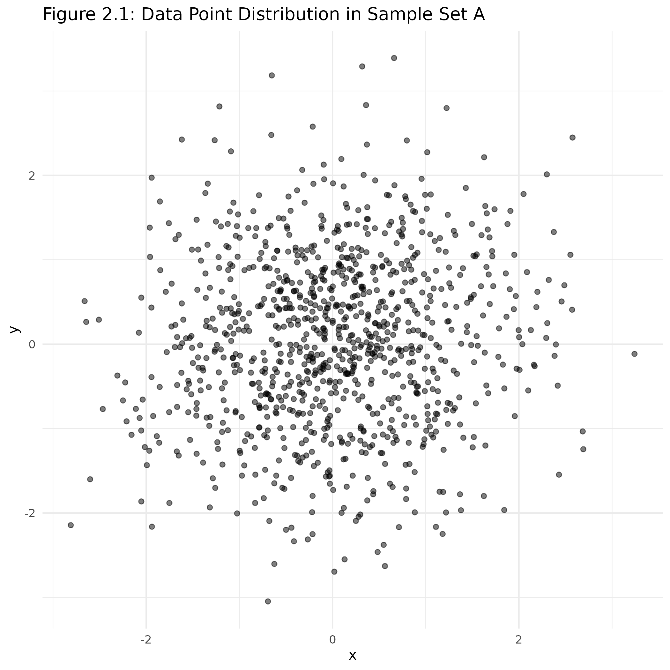

Figure 2‑2. Comparative Analysis of Categories X and Y

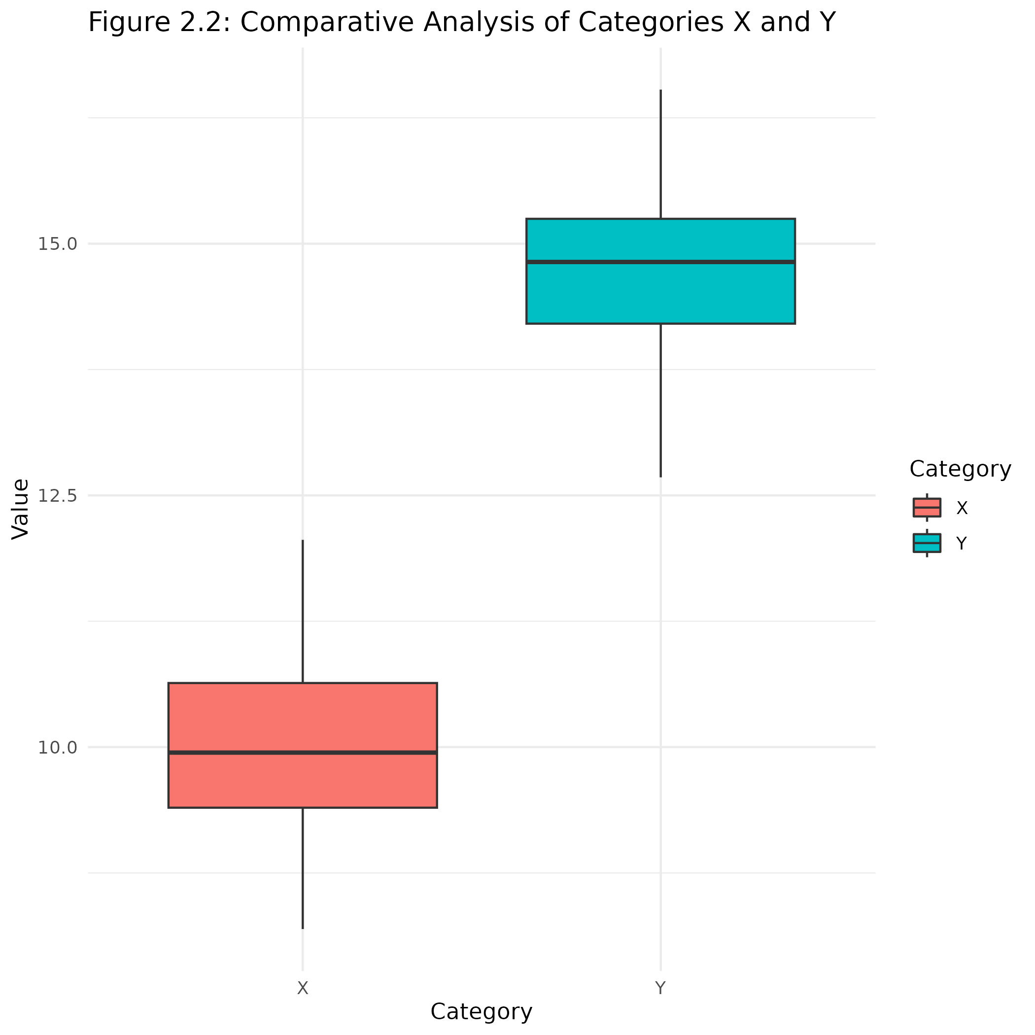

## Another section of the analysis

This is a Figure example.

Figure 2‑3. Comparative Analysis of Categories X and Y

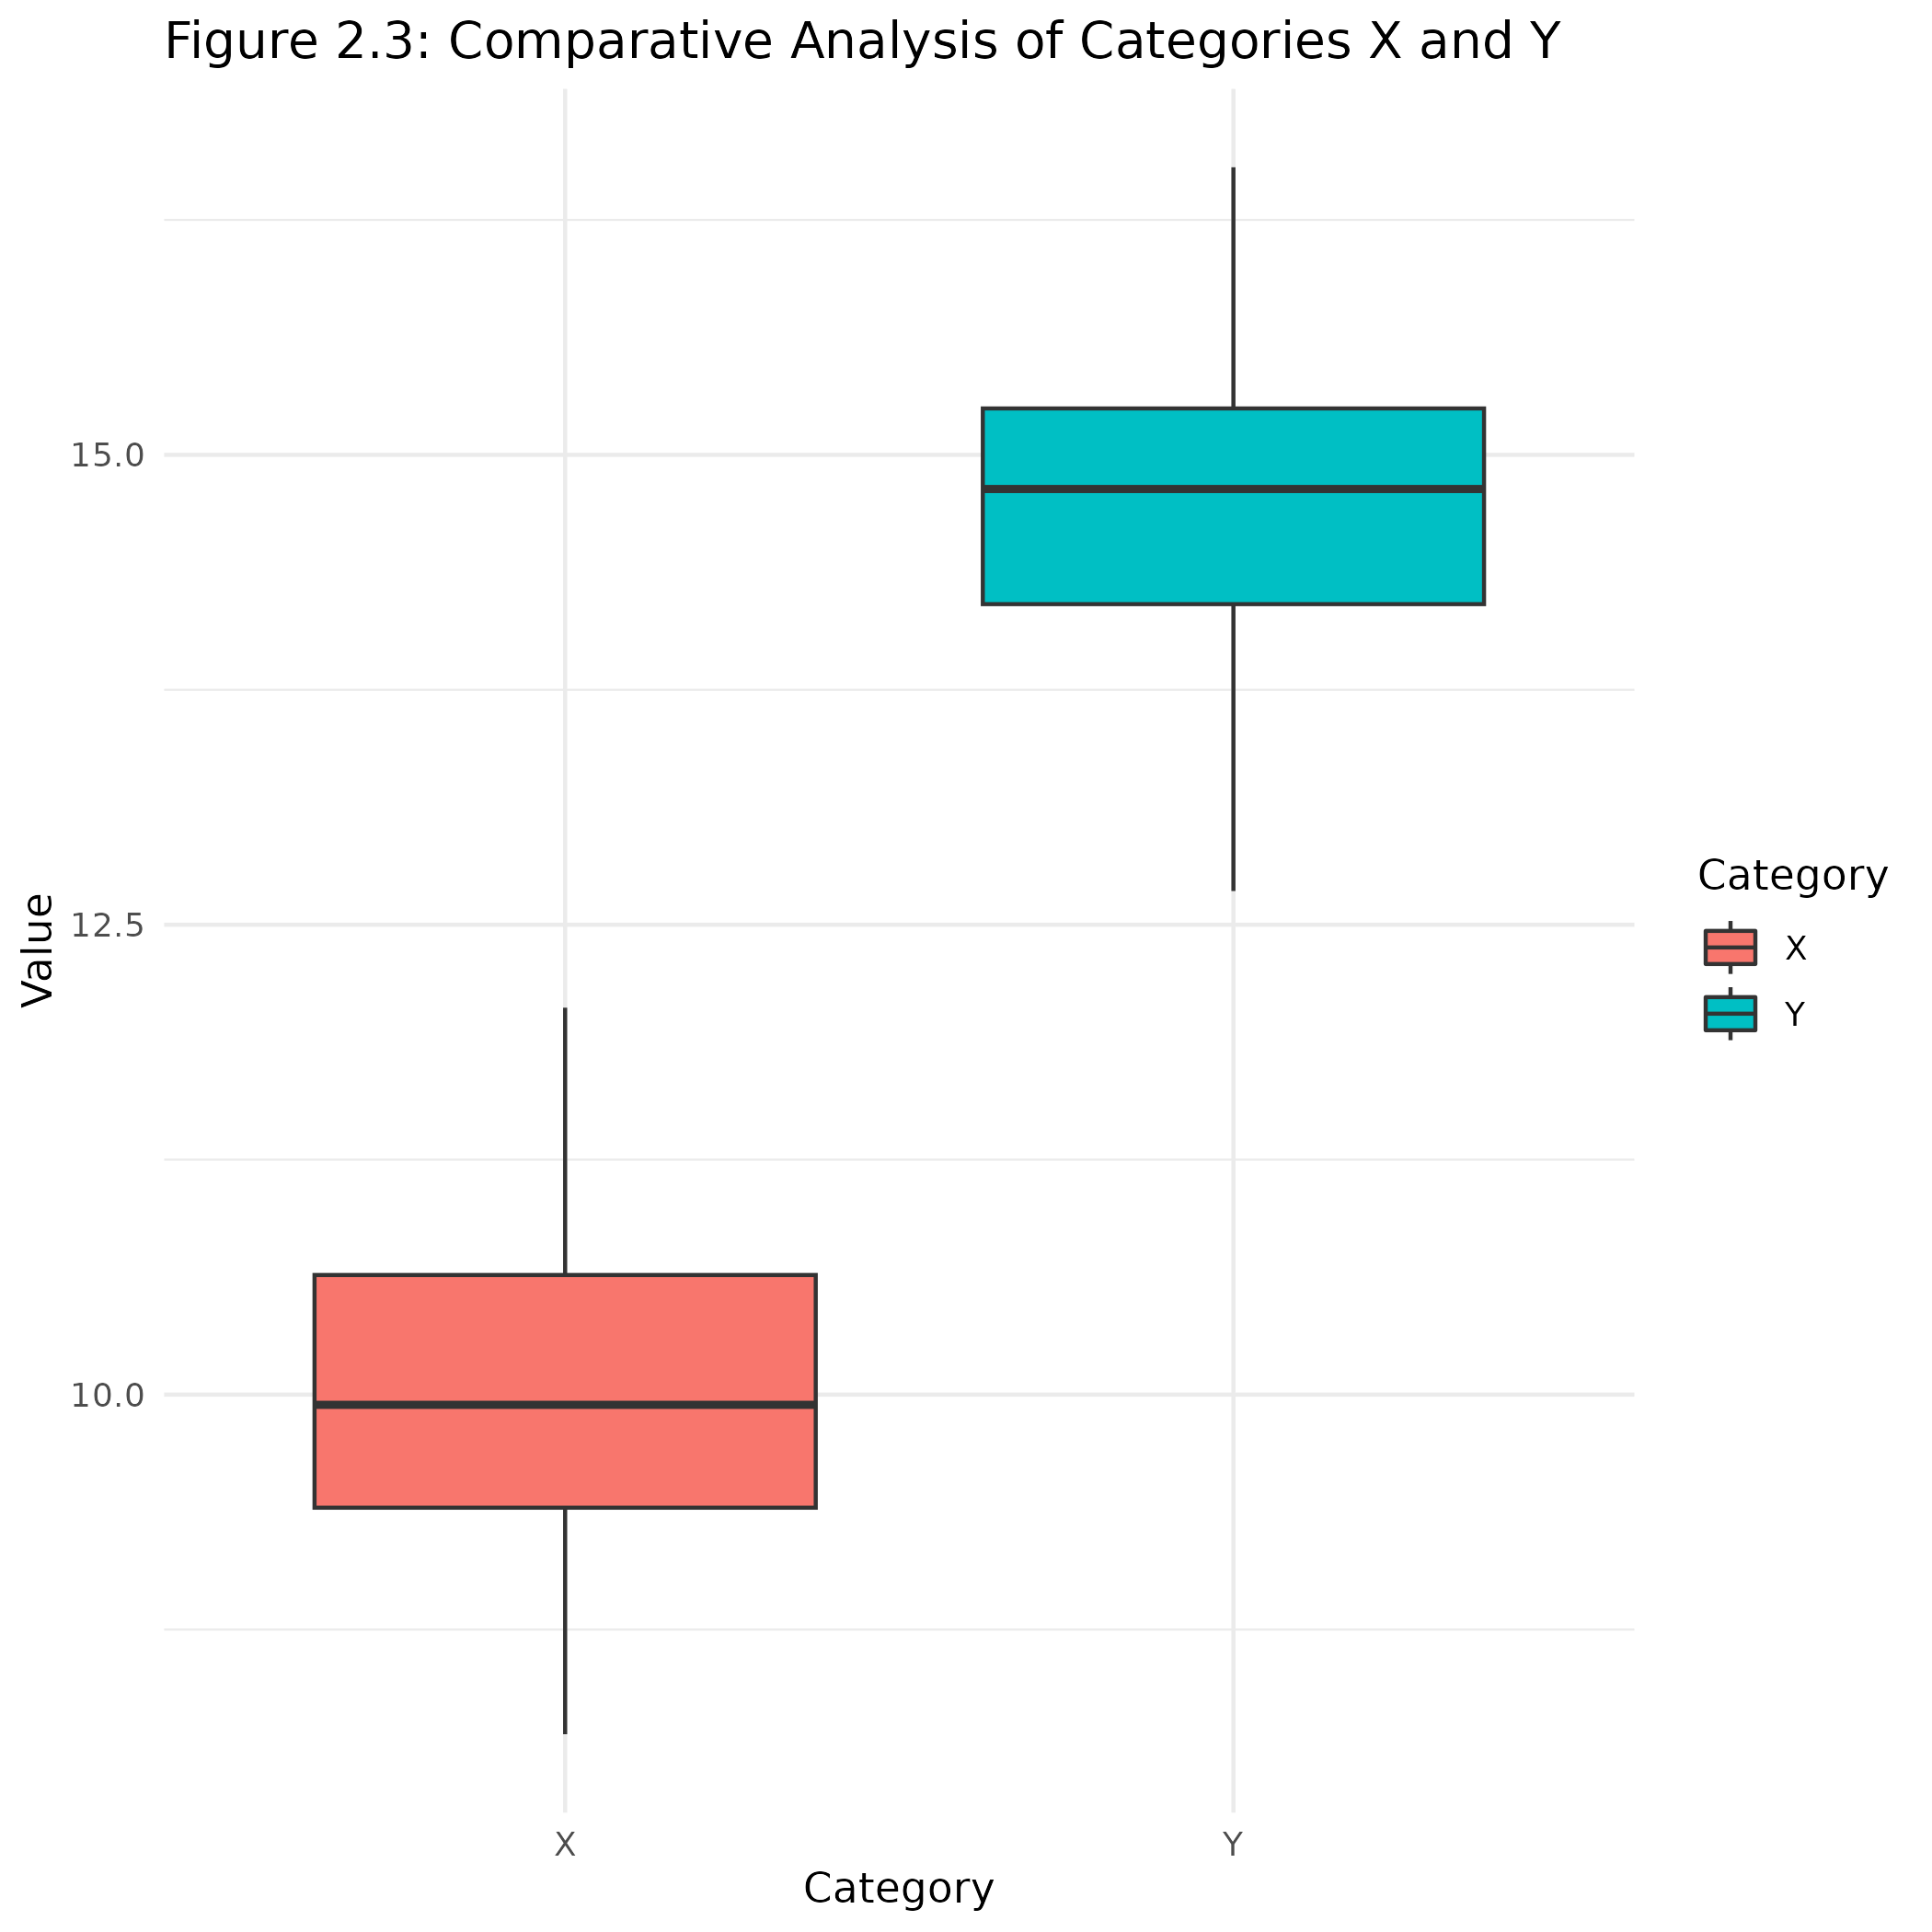

Table 2‑2. Breakdown of Category X by Subcategory

| **Subcategory** | **Count** | **Percentage** |
| --- | --- | --- |
| Sub-X1 | 10 | 20 |
| Sub-X2 | 20 | 40 |
| Sub-X3 | 30 | 60 |

Figure 2‑4. Trend Analysis Over Time (Yearly Data)

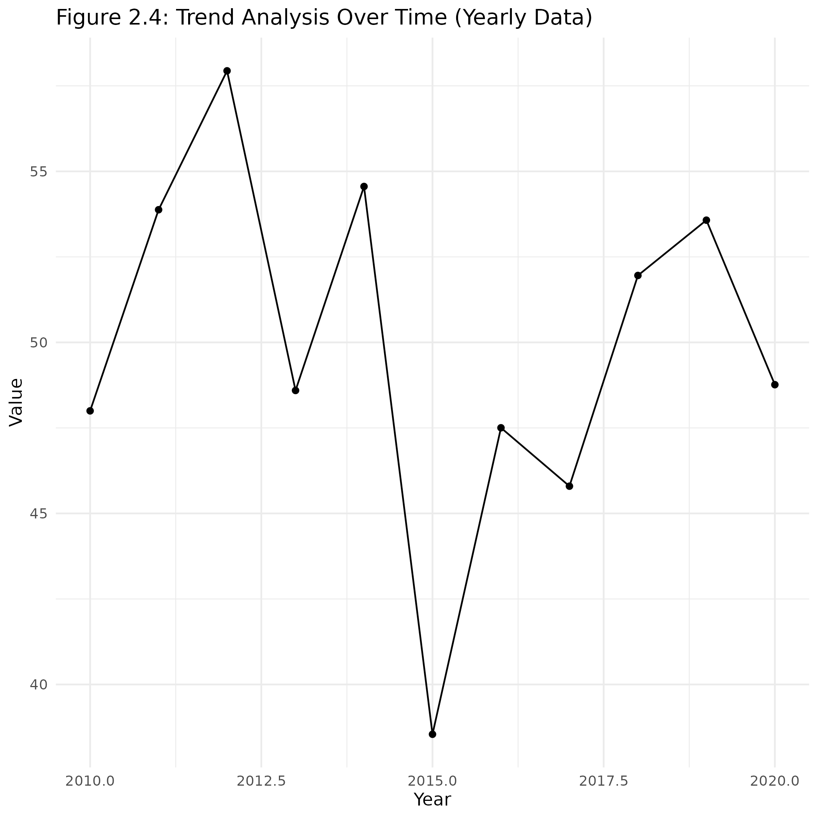

## Last section of the analysis

This is a Figure example.

Figure 2‑5. Trend Analysis Over Time (Yearly Data)

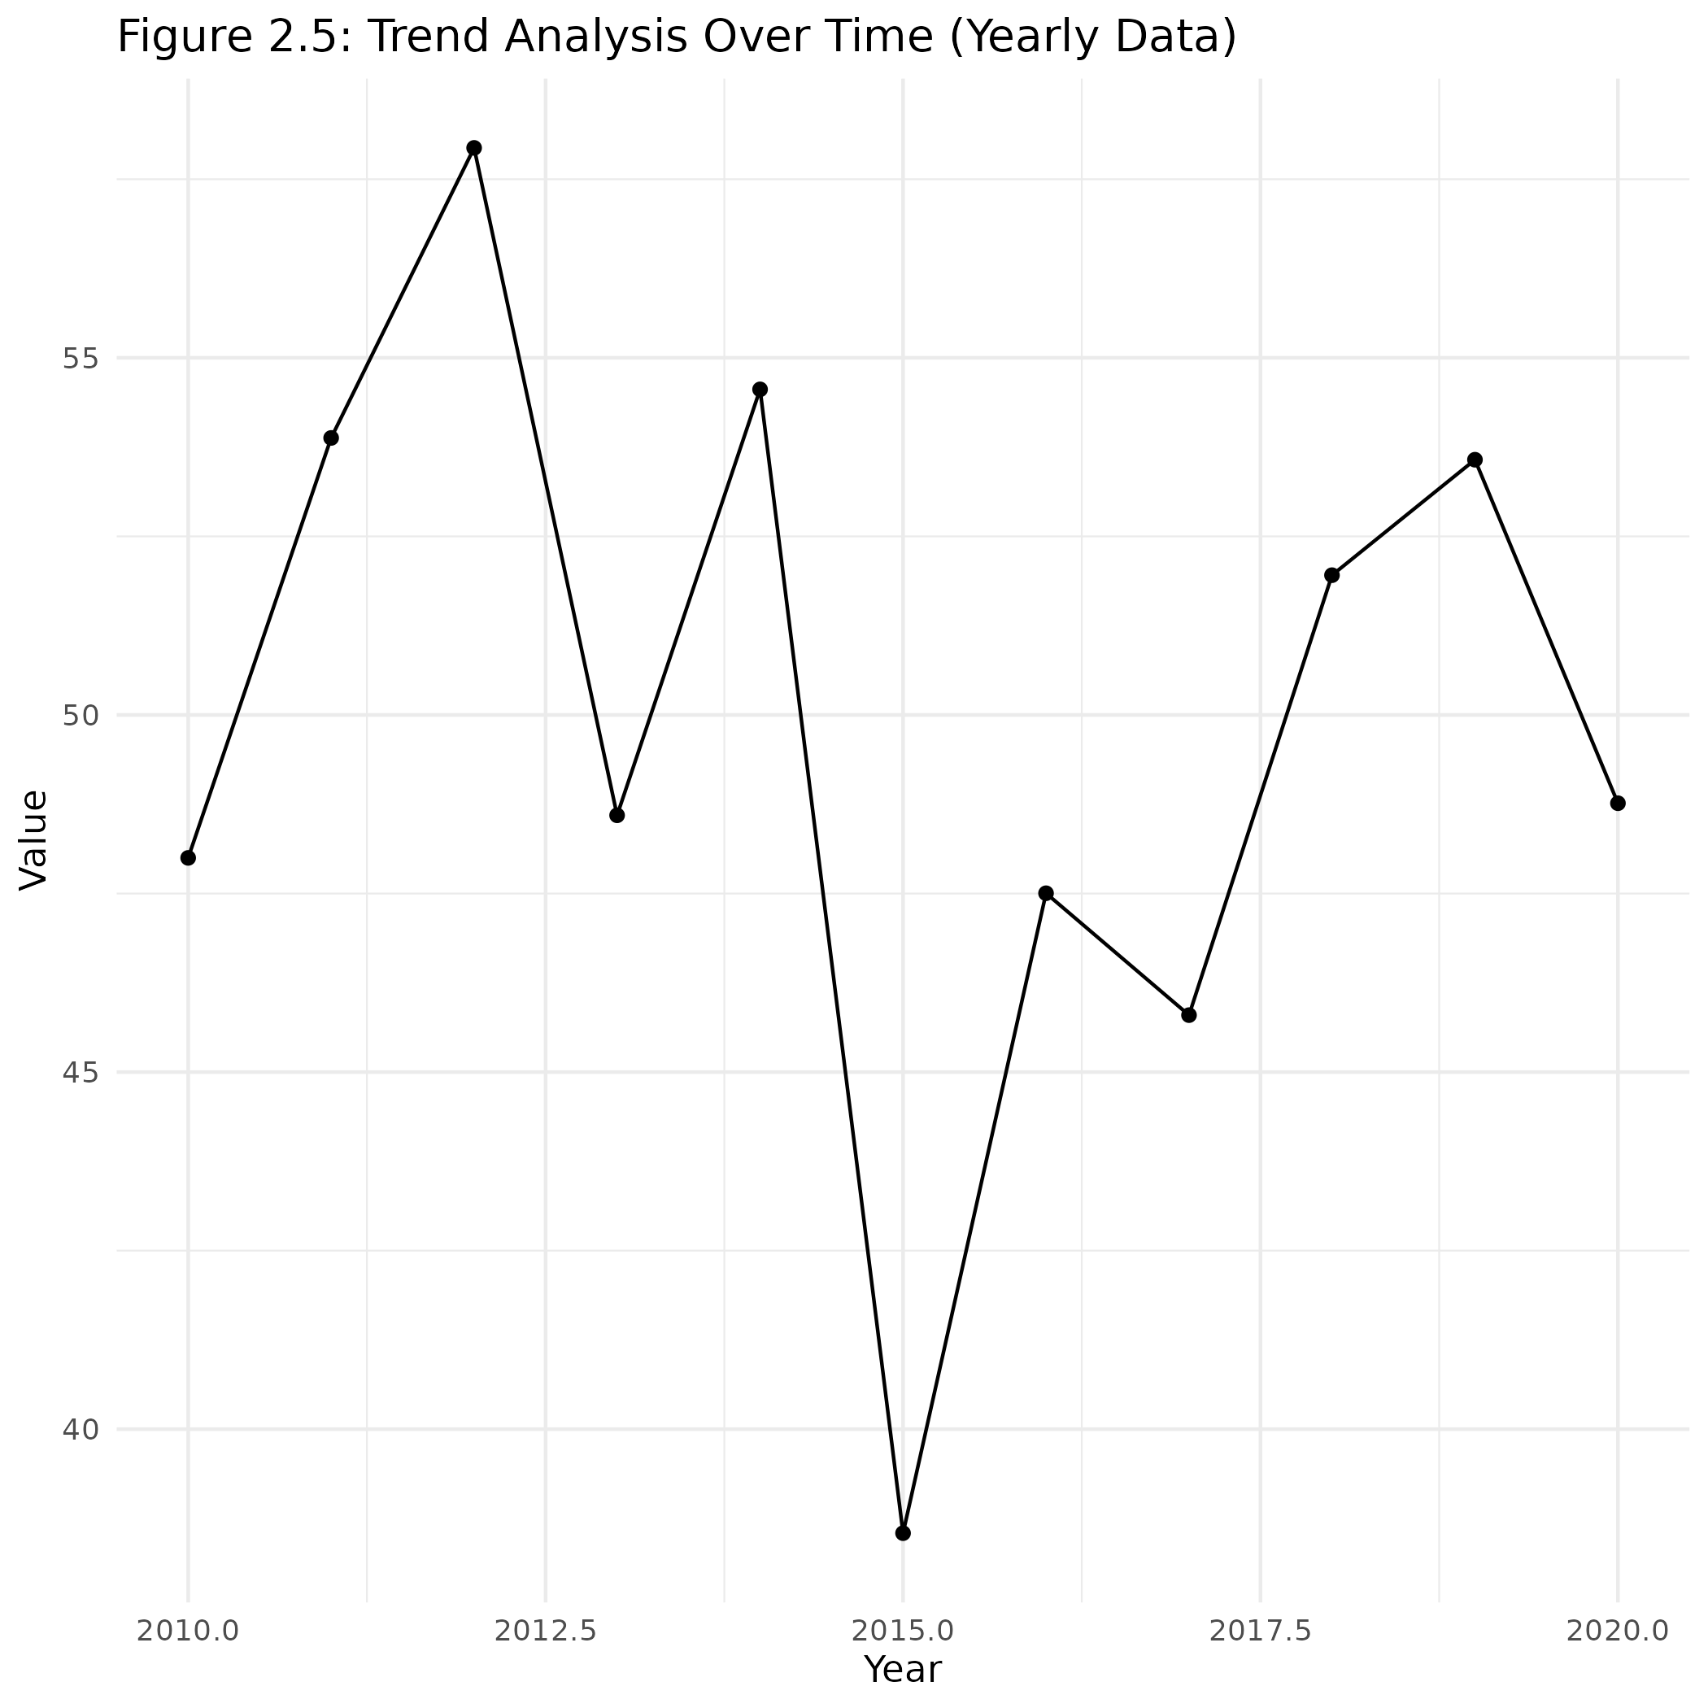

# Interpretation

## One random section

Table 3‑1. Yearly Performance Metrics

| **Year** | **Metric_A** | **Metric_B** | **Metric_C** | **Metric_D** |
| --- | --- | --- | --- | --- |
| 2,010 | 84.23 | 52.44 | 56.09 | 71.95 |
| 2,011 | 85.12 | 68.83 | 56.64 | 80.20 |
| 2,012 | 86.34 | 70.27 | 62.00 | 87.45 |
| 2,013 | 77.47 | 62.58 | 53.65 | 95.70 |
| 2,014 | 77.68 | 72.70 | 59.48 | 87.42 |
| 2,015 | 81.31 | 56.23 | 62.99 | 94.35 |
| 2,016 | 83.15 | 76.68 | 69.80 | 81.49 |
| 2,017 | 78.30 | 58.36 | 62.88 | 87.81 |
| 2,018 | 77.88 | 54.58 | 70.29 | 91.74 |
| 2,019 | 76.91 | 64.66 | 62.72 | 87.12 |
| 2,020 | 87.41 | 71.13 | 59.98 | 90.90 |

Figure 3‑1. Trend Analysis Over Time (Monthly Data)

