**Giving Feedback** Modified from Toastmasters: Evaluate to Motivate

* Advice vs Feedback
  + **Advice:** Avoid giving advicewhich tells a person what they should do. Avoid “you sentences” such as:
    - “You didn’t...”
    - “You should have...”
    - “You failed to...”
  + **Feedback** is more objective in that it is about what you observed or felt. Use “I/me/my” phrases like:
    - “I believe...”
    - “I suggest that…”
    - “My reaction was...”
* The purpose is to help and encourage the speaker.
  + Evaluate the presentation, not the person
  + Provide honest and sincere praise.
  + Give positive reinforcement when improvements occur.
  + Give constructive feedback when needed.
  + If you see symptoms of fear or insecurity, consider your next words carefully
* Avoid being disingenuous
* Always end your evaluation positively.

**Brene Brown Feedback Thoughts**

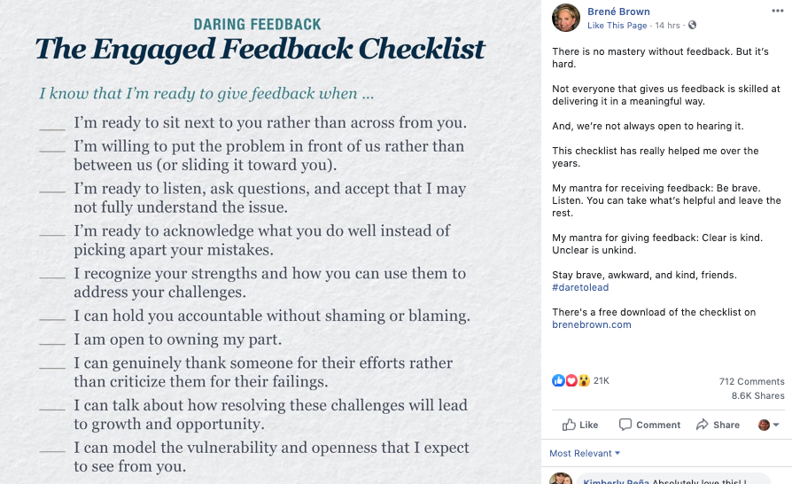

**Receiving Feedback**

Consider what state you are in at the time you receive feedback (SARAH)

* **S**hocked: “What, really, did I hear you right?  After all the work I put in?
* **A**nnoyed: “No way, others obviously just don’t get it”
* **R**esistant: “I get it, but I just don’t buy it”
* **A**ccepting: “What do I need to consider?  Can you give me an example?”
* **H**elpful: “What would you suggest that I do differently?”  This is how we grow!

Reasons feedback may be difficult to hear

* **Truth:** you may feel the feedback is incorrect
* **Relationship:** the feedback is hard to receive because of the person giving it
* **Identity:** The feedback may not align with your personal self-image

Working toward agreement

* Focus on the other person and what they are saying.
* Ask questions to understand the other person’s perspective
* Communicate information, as needed, to offer your point of view
* Identify potential areas for change and actions
* Come to an agreement and commit to the action plan of change
* Thank the other person for their time