DEDICATION
This SIWES Technical report is dedicated to the Almighty God for sustaining and protecting me throughout the period of my six month industrial attachment in Abuja.
ACKNOWLEDGMENT
My immense gratitude goes to the Almighty God who made my industrial attachment programme to be successful.
My gratitude also goes to my brother Chuks Akobundu who took care of me during my stay in Abuja.
I thank my father Mr. M. O Akobundu for supporting me financially during the programme.
I also thank the staff and management of Telnet Nigeria Limited, Reinsurance building, plot 748A, Herbert Macaulay way, central business district, Abuja.
I must express my sincere gratitude to Mr. and Mrs. Emeka Iweala for getting a place of attachment for me.
I also wish to extend my gratitude to my siblings: chimere, UD, Onyii.
I also thank the organizers of the SIWES programme especially the SIWES director for giving me the opportunity to know more about my course of study.
I will not fail to acknowledge the following friends: Chizoba Onwuegbuna, Chibuzo Okoye, Blessing Tinglocha, Chika Chime, who stayed and worked with me at Telnet.
CHAPTER ONE
COMPANY PROFILE
INTRODUCTION
The student Industrial Work Experience Scheme (SIWES) formed in 1973 is a skill training programme whose aim is to express and prepare students of tertiary institution for the industrial work situation they are likely to meet after graduation. The programme is an effort to bridge the gap existing between theoretical and practical work in the University.
The programme, also provides students the opportunity of familiarizing and exposing them to the needed experience in handling equipment and machines which are usually not available in their institutions.
This practical report shows the experience and training I gained during my Industrial attachment at Telnet Nigeria Limited, Reinsurance building, plot 748A, Herbert Macaulay way, central business district, Abuja.
ABOUT THE FIRM
Telnet Nigeria Limited was founded in 1985 with headquarters in Nigeria. Telnet group is an information and communication technology enabled business solutions provider that helps organization plan, build and support their business needs for efficient service delivery.
Over the past twenty years, Telnet have attained tremendous growth through personnel skill development and from strategic alliances and partnership with world-class organizations like Cisco Systems, Hughes Network Systems etc. to ensure quality of service.
Telnet has its head office in Lagos with regional offices in PortHarcourt and Abuja and an operational office in Warri.
Due to its professionalism, Telnet has been delivering best-in-class technology enabled business solutions to diverse industry sectors including Oil and Gas, Financial services, Manufacturing, Telecommunication, Government, Utilities, Health and Education.
Its services and technology include:
- Telecommunication infrastructure and network services.
- Enterprise network, E-security solutions and intelligent building solutions.
- Business communication and collaboration solutions.
- E-business and related software solutions.
- Outsourcing, training and consultancy services.
Telnet Nigeria limited operates three subsidiaries namely:
- iTeco Nigeria limited
- Telnet Network services Limited (TNS).
- SoftWorks Limited.
MEMBERS OF TELNET NIGERIA LIMITED
Telnet Nigeria Limited is made up of three members as mentioned earlier which include:
1. TELNET NETWORK SERVICES LIMITED (TNS): They provide the skill and expertise required to support businesses, including Telecommunication operators, to put in place network transport infrastructure (VSAT, Radios, Fibre, Copper and Integration) that will enable them to exploit the advantage of new technologies and maximize the use of corporate networked resources thereby enable businesses reduced cost and increase productivity.
TNS services include:
- Network planning and design.
- System engineering and integration.
- Equipment supply and installation.
- Network operation and maintenance.
In summary, they handle the Wide Area Network (WAN) solutions and partners with the following world class vendors and manufacturers which include Hughes Network Systems (HNS), ComTech EF Data, Telenetics, Proxim, Telenor etc.
2. iTECO NIGERIA LIMITED: iTeco is a leading provider of Enterprise networking infrastructure and security solutions. Its team comprises of seasoned solution architects, implementation engineers, project managers and logistics experts who have been trained to deliver the best in line with customer requirements.
iTeco has strategic partnership with the following companies: Cisco Systems, IBM, Commscope (formerly Avaya), Checkpoint, Netforensics, Realsecure, Fluke Networks, Stratus, Axis Communication etc.
iTeco Services covers:
- Enterprise Networking: which include Local Area Networking (LAN) solutions for Voice, Data, and Video Unified Communications and Internet Solutions using Switches, PABX etc.
- Information Security and Services: which include; Data Encryption, Firewall protection from the Internet, Intrusion Detection and Protection Systems, Network Admission and control systems, Antivirus scanning systems and E-security Information Management systems.
- Data Centre Solutions: which includes Fire Alarms and protection systems, Cooling Systems, Equipment racks, Raised floor, Uninterruptible Power Supply (UPS), Stabilizers, Security doors etc.
- Intelligent Building Solutions: This includes IP Video Surveillance System (CCTV).
- Technical support services.
3. SOFTWORKS LIMITED: SoftWorks specializes in the provision of world class software and has assisted clients gain and sustain competitive advantage through the provision of innovative software-based technology solutions that enable them achieve their overall business objectives and strategy.
Softworks has positioned itself as a “one-stop” software solution shop providing value added service and solutions in the following areas:
- Electronic Payment Solutions: which include;
  - Electronic Funds Transfer (EFT) solutions.
  - Automated Teller Machine (ATM) deployment.
  - Point of Sale (POS) devices.
- Enterprise Solutions: which includes;
  - Banking and financial industry application.
  - Web business solution.
  - Enterprise security solutions.
  - Software infrastructure solutions.
  - E-commerce portals and Enterprise portals.
  - Customer Relation Management (CRM) etc.
Softworks partners with the following companies; IBM/Lotus, Microsoft Business Solutions, Veritas, Frontrange, RSA (Enterprise security), Citrix, Novell etc.
CHAPTER TWO
INTRODUCTION
As an Electrical/Electronics Engineering student doing my industrial attachment in Telnet, I was posted to iTeco Nigeria Limited which specializes in enterprise networking due to its relevance to my course of study.
Even duo the services of all the members of Telnet Nigeria limited are relevant to my course of study, I was posted to iTeco due to the number of projects it was handling, and inadequate staff.
PROJECTS CARRIED OUT
During my stay in Telnet Nigeria Limited, a lot of projects were handled by iTeco Nigeria limited were I was posted and by Telnet as a group.
The various projects include:
- Nigeria Agip Oil Company (NAOC) project.
- National Health Insurance Scheme (NHIS) project.
- Federal Inland Revenue Service (FIRS) project.
- Integrated Personnel Payroll Information System (IPPIS) project.
All the above mentioned projects involves building of Network infrastructure from Laying of Cables to installation of active devices or an upgrade of existing network infrastructure (eg NHIS project).
OVERVIEW OF NETWORKING
A network is basically all of the components (hardware and software) involved in connecting computers and applications across small and large distances. Networks are used to provide easy access to information, thus increasing productivity for users.
Resources that are commonly shared in a network include data and applications, printers, network storage components (shared disk space), and backup storage components.
NETWORK CLASSIFICATION
Scale
Based on their scale, networks can be classified as Local Area Network (LAN), Wide Area Network (WAN), Metropolitan Area Network (MAN), Virtual Private Network (VPN) etc.
Connection method
Computer networks can also be classified according to the hardware and software technology that is used to interconnect the individual devices in the network, such as Optical fiber, Ethernet, Wireless LAN.
Ethernet uses physical wiring to connect devices. Frequently deployed devices include hubs, switches, bridges and/or routers.
Wireless LAN technology is designed to connect devices without wiring. These devices use radio waves or infrared signals as a transmission medium.
TYPES OF NETWORK
Local Area Network
Local area networks (LANs) are used to connect networking devices that are in a very close geographic area, such as a floor of a building, a building itself, or within a campus environment. In a LAN, you’ll find PCs, file servers, hubs, bridges, switches, routers, multilayer switches, voice gateways, firewalls, and other devices.
The media types used in LANs include copper and fiber cabling. Ethernet (IEEE 802.2 and 802.3 protocols), Fast Ethernet (FE), Gigabit Ethernet (GE), Wireless (IEEE 802.11a, 802.11b, and 802.11g protocols).
Wide Area Network
Wide area networks (WANs) are used to connect LANs together. Typically, WANs are used when the LANs that must be connected are separated by a large distance.
Whereas a corporation provides its own infrastructure for a LAN, WANs are leased from carrier networks, such as telephone companies and Internet service providers (ISPs).
Metropolitan Area Network (MAN)
A Metropolitan Area Network is a network that connects two or more Local Area Networks together but does not extend beyond the boundaries of the immediate town/city. Routers, switches and hubs are connected to create a Metropolitan Area Network.
NETWORK TOPOLOGIES
Point-to-point
A point-to-point topology has a single connection between two components. In this topology, two components can directly communicate without interference from other components. These types of connections are not common when many components need to be connected together. An example of a point-to-point topology is two routers connected across a dedicated WAN circuit.

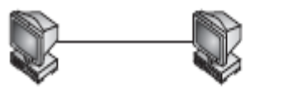
Point-to-point
Bus topology
In a bus topology, all components are connected to and share a single wire.
Certain media types, such as 10Base5 and 10Base2 Ethernet, use a bus topology.
Typically, special types of connectors or transceivers are used to connect the cables to provide the bus topology. In 10Base5, for example, each device connects to a single strand of coaxial cable via a vampire tap. This device taps into the single strand of coaxial cable and provides the physical connection from a networking device to the single strand of cable.

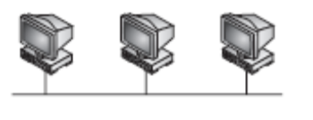
Bus topology
Star topology
In a star topology, a central device has many point-to-point connections to other components. Star topologies are used in environments in which many components need to be connected. An example of a media type that uses a star topology is 10BaseT Ethernet.
When connecting components together, you connect your computers to a hub or switch (the center of the star). The main problem with a star topology is that if the center of the star fails, no components can communicate with each other.

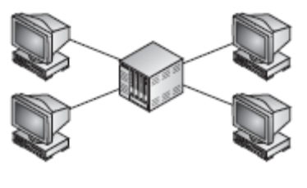
Star topology
Ring topology
In a ring topology, device one connects to device two, device two connects to device three, and so on to the last device, which connects back to the first device. Ring topologies can be implemented with a single ring or a dual ring.
Dual rings are typically used when you need redundancy. For example, if one of the components fails in the ring, the ring can wrap itself, as shown, to provide a single, functional ring. Single ring topologies lack this type of redundancy feature.

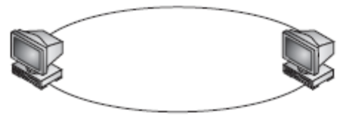
Single ring
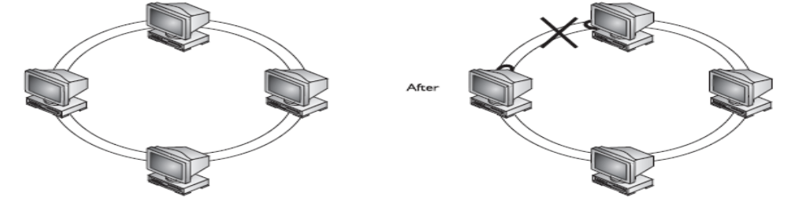
Dual ring (before) after
This network overview is the basics upon which every network operates- ranging from large scale to small scale networks. But in a contract environment, before a network infrastructure is completely installed, the following processes are undertaken:
- Site survey.
- Preparation of necessary documents.
- Laying of cables (UTP Cat 6 cables).
- Installation of Active equipment.
- Commissioning of the network.
CHAPTER THREE
SITE SURVEYING AND CABLING
Before a network infrastructure installation project is carried out, site surveying activities are conducted in order to quantify the amount of materials (cabling equipment and Active devices) needed to satisfy the network requirement of the client.
It is usually done with a representative of the client so that he/she will provide the necessary information needed.
During a site surveying operation, the following information is gathered:
- The number of Data/Voice points needed by the clients.
- The trunking type (either conduit or surface).
- The various location the Data/Voice points can be best situated.
- The plan of the site.
- The number of switches needed depending on the number of Data/Voice points (in many cases, it is a fixed number contained in the contract document.)
The following information gathered during site surveying operation is an important tool used to prepare valuable pre-installation and post-installation documents. Such documents include:
- Bill of Quantities (BOQ)
- Quotation.
- Purchase Order (PO).
- Microsoft Visio diagram for planning etc.
LAYING OF TRUNKS AND CABLING
After the preparation of the above mentioned documents and the equipment supplied, the next operation carried out is the laying of trunks, pipes and cabling. Two methods adopted are:
- Conduit cabling.
- Surface cabling.
The choice is made by the client.
The following materials are needed for trunking and cabling;
MATERIAL | FUNCTION
Trunking & PVC Pipes (100*100, 75*100, 50*50, 25*25 etc.) | To case (contain) the cables for good finishing. PVC pipes is mostly used for conduit cabling.
Cables  (UTP Cat 5e and Cat 6) | For networking the different devices, Data points and to the active devices.
Face plates & base plate  (backbox). | Provides casing for the Data points.
IDC | For termination of the cables.
LF80 | Closing the IDC
LF00 | Closing of unused spaces on the face plate.
RJ-45 | For cable crimping.
Fishing Tape | To draw cables during conduit operation.
Fishers and Screws | To hold the backbox to the wall.
Tangit gum | To hold the trunks to the wall.
Punch down tool and crimping tool. | For crimping and termination.
TERMINATION OF CABLES
After the laying of the cables, the next operation carried out is to terminate the cables at the patch panels (in the rack) for connectivity to switches, routers and other active devices and at the user-end for connectivity to PCs, Printers and other user devices.
Termination at the patch panel and user-end involves the use of punch down tool and color standard.
Another form of termination carried out during cabling is Crimping using crimping tool and color standard. The color standard is as follows:
568 A 568 B
Pin1 white of green white of orange
Pin2 green orange
Pin3 white of orange white of green
Pin4 blue blue
Pin5 white of blue white of blue
Pin6 orange green
Pin7 white of brown white of brown
Pin8 brown brown
CABLING TYPES
With today’s implementation of Ethernet over copper, two components make up the connection: an RJ-45 connector and a Category 5, 5E, or 6 UTP cable. As mentioned earlier, the UTP cable has eight wires in it (four pairs of wires). Two types of implementations are used for the pinouts of the two sides of the wiring:
- Straight-through cabling.
- Crossover cabling.
Straight-through cabling
A straight-through Ethernet UTP cable has pin 1 on one side connected to pin 1 on the other side, pin 2 to pin 2, and so on. A straight-through cable is used for DTE-to-DCE (data termination equipment to data communications equipment) connections. The terms DTE and DCE are typically used in WAN connections. However, in LAN terms, a DTE is a router, PC, or file server, and a DCE is a hub or a switch.
Use straight-through for the following connections:
- A hub to a router, PC, or file server.
- A switch or bridge to a router, PC, or file server.
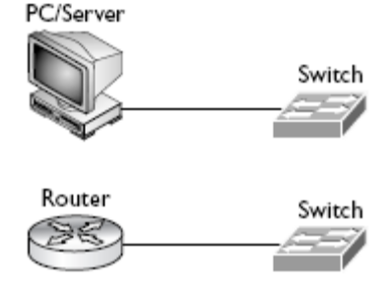
Straight-through
Crossover cabling
A crossover UTP Ethernet cable crosses over two sets of wires: pin 1 on one side is connected to pin 3 on the other and pin 2 is connected to pin 6. Crossover cables should be used when you connect a DTE device to another DTE device or a DCE to another DCE. Use it for the following:
- A hub to another hub.
- A switch to another switch.
- A hub to a switch.
- A PC, router, or file server to another PC, router, or file server.
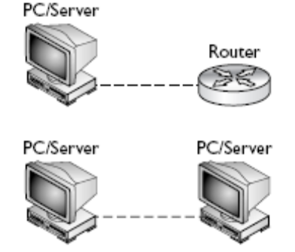
Crossover
Fiber cabling
Fiber-optic cabling is typically used to provide very high speeds and to span connections across very large distances. For example, speeds of 100 Gbps and distances greater than 10 kilometers are achievable through the use of fiber—copper cannot come close to these feats. However, fiber-optic cabling does have its disadvantages: it is expensive to implement, difficult to troubleshoot, and difficult to install.
The link between the primary Datacenter (OAGF) and the secondary Datacenter (Min. of Finance) in the IPPIS project carried out during my stay in Telnet is done with Fiber-Optic cable.
Also we usually use fiber-optics for uplink connection because of speed and reliability.
CHAPTER FOUR
ACTIVE DEVICES
In a network installation project, after the whole cabling and termination is completed, the rack (cabinet) set up, the next thing is to install your active devices which include; Switches Routers, Adaptive Security Appliance, and sometimes IP Phones.
All the above mentioned Active devices help to provide connectivity among the workgroup, to the file server, and to WAN and Internet if any. Due to our partnership with Cisco, all of our projects are executed with Cisco devices.
CISCO SWITCHES.
In general, Switches are layer 2 devices (Data link layer) that are used to learn and forward packets of data and also remove loops. They make their switching decisions based on the destination MAC addresses.
Switches are used to expand networks. Depending on the number of ports, a particular switch can interconnect a fixed number of work group devices but when interconnected or connected in clusters, a large scale network of devices can be achieved.

Models
During my stay in Telnet, we work with various models of Cisco switches in different projects. This models include; Cisco catalyst 1900 series, 3500 series (3560 etc), 2960, 4500, and 6500 series multilayer switches. This report is based on Cisco catalyst 2960 and 3560 switches which are the most frequent switches that I worked with during my IT period.
Description
The catalyst 3560 and 2960 series of switches are Cisco’s current desktop and workgroup switching solution; they replace the 1900 and 2950 switches. The new switches support Fast Ethernet and Gigabit Ethernet interfaces.
They come with the LAN-based software image (IOS), which provides advanced quality of service, rate limiting, access control list (ACL), and many other features. They also come with different port number- 24 ports or 48 ports.
Chassis
Before connecting any cables to your Cisco switches, you should become familiar with their chassis and interfaces. First, you should understand how to turn on your Cisco device, what interfaces it has, and the meanings of the various LEDs (light-emitting diodes) on the chassis.

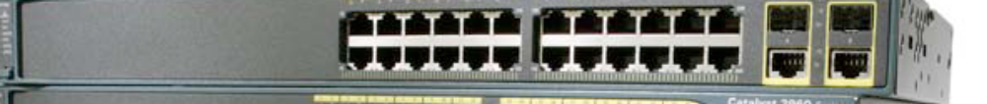
Cisco catalyst 2960 switch (24-port)

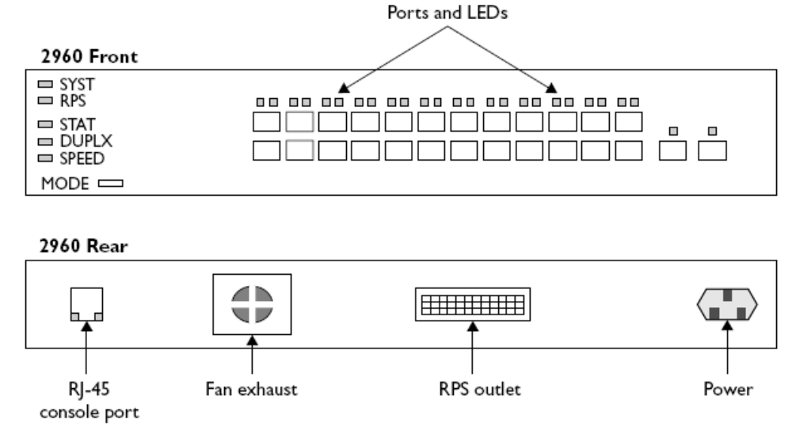
2960 24-port switch diagram

The above diagram shows illustrations of the front and rear views of a 2960-24port switch. For the front view, the ports on the left are the 10/100 BaseTX ports and the two on the right are the two 10/100/1000 BaseTX ports. For the 10/100 ports, the ports are numbered in the first column, 1 at the top and 2 at the bottom; in the second column, 3 at the top and 4 at the bottom; and so on. The front of the chassis contains the MODE button as well as the LEDs.
The rear of the chassis has the management connections. Notice that no toggle switch is included to turn the switch on or off (there is one for 3560). To turn the switch on, plug one end of the power cable into the back of the switch and the other into a power outlet. To turn the switch off, unplug the power cable from either end. The 2960 supports an RJ-45 console interface, which uses a rollover cable for connectivity to a terminal or terminal emulation device for console access.
Troubleshooting and management
Unlike Cisco routers, the ports of Cisco switches are active by default. Because of this feature, switches can be installed on a flat mode. Since there no much configuration on a switch, any malfunction can be isolated to the hardware and IOS. This is evident on the behavior of the port and system LEDs. The system LED behavior is shown below:
LED | Color | Description
System | Green | The system is up and operational.
 | Amber | The system experienced a malfunction.
FIGURE 12-1 | Off | The system is powered down.
System LED behaviour
LED Color | LED Meaning
Green | A powered-up physical layer connection to the device is attached to the port.
Flashing green | Traffic is entering and/or leaving the port.
Flashing green and amber | An operational problem is occurring with the port—perhaps excessive errors or a connection problem.
Amber | The port has been disabled manually (shut down), disabled because it is in a blocking STP state, or disabled because of a security issue.
Off | No powered-up physical layer connection exists on the port.

Status Mode and Port LEDs
Management of Cisco 2960 and 3560 switches is done through the console port using RJ-45 connector rollover cable or through remote access using telnet access.
When using the console port, plug the RJ-45 end into the console port and the serial end into a DB-9 or DB-25 serial port on the PC. If the PC has no serial port, plug the PC end to a USB-to-Serial converter and then to the USB port of the PC. Then use terminal emulator software (like HyperTerminal) to access the switch. For Windows do the following:
- Click on Start menu.
- Click on All programs.
- Click on Accessories.
- Go to Communications.
- Click on HyperTerminal.
- Fill the Dialog boxes by giving a name to your HyperTerminal program, selecting the communication port you are using, and then setting the software parameters to default settings.
- Then access the switch.
Remote access is done using telnet command from a remote PC on the network. For Windows, the following is done:
- Click on start menu.
- Click on All programs.
- Go to Accessories.
- Click on Command Prompt.
- In the command prompt, enter the following command:
telnet ip address of switch
- Enter any telnet password if configured.
- Access the switch.

CISCO ROUTERS
Generally, a router is an intermediary device that connects a LAN to a larger LAN or to a WAN by interpreting protocol information and selectively forwarding packets to different LAN or WAN connection through the most efficient route available.
Over the years, Cisco Systems has been producing different models of intelligent routers which include the following; Cisco 700 series, 1700 series, 2600 series, 2800 series, and 3500 series. During my stay in Telnet we work extensively with the 2600 and 2800 series routers precisely 2611 and 2811 routers.
Description
Cisco routers are made up of the following hardware components:
Ports
- Console: For connecting your PC via HyperTerminal.
- Ethernet: For connecting to a hub or a switch using a straight-through cable. Use a cross-over cable if going directly between Ethernet ports on two routers.
- Serial: If going directly between two routers, connect one port via the DTE cable and the other via the DCE cable.
Memory
- NVRAM: Nonvolatile RAM- doesn’t “wipe” when router is powered down. It holds the startup configuration file.
- RAM: Like regular RAM- it wipes when the router is powered down. It holds the running (current) configuration file.
- ROM: like regular ROM-it doesn’t wipe during a power down cycle. It holds the power-on diagnostics, and a minimal (basic) IOS image.
- FLASH: A type of EEPROM-it doesn’t wipe during a power down, but can be updated through software. It the entire IOS image.
Management of Cisco routers
Cisco routers can be managed the way switches are managed as discussed earlier by using tools like console access and remote access like telnet.
Router configuration
Unlike Cisco switches, the ports of Cisco routers and other features are not active by default. Due to this feature, Cisco routers cannot be connected on a flat mode. Some basic configurations for the routers is as follows:

Requirement | Cisco Command
Set a console password to cisco | Router(config)#line con 0  Router(config-line)#login  Router(config-line)#password cisco
Set a telnet password | Router(config)#line vty 0 4  Router(config-line)#login  Router(config-line)#password cisco
Stop console timing out | Router(config)#line con 0  Router(config-line)#exec-timeout 0 0
Set the enable password to cisco | Router(config)#enable password cisco
Set the enable secret password to peter.  This password overrides the enable password and is encypted within the config file | Router(config)#enable secret peter
Enable an interface | Router(config-if)#no shutdown
To disable an interface | Router(config-if)#shutdown
Set the clock rate for a router with a DCE cable to 64K | Router(config-if)clock rate 64000
Set a logical bandwidth assignment of 64K to the serial interface | Router(config-if)bandwidth 64  Note that the zeroes are not missing
To add an IP address to a interface | Router(config-if)#ip addr 10.1.1.1 255.255.255.0

CHAPTER FIVE
WIRELESS ACTIVE DEVICES
During my stay in Telnet, a lot of projects carried out involved the installation of Wireless LAN facilities. In achieving this, the active devices used are Cisco Access Points and Cisco Wireless LAN Solution Engine (WLSE).
CISCO ACCESS POINTS
Access points (APs) are used to provide coverage for WLAN clients. Cisco has different models of Aironet Access Points which include the 1100 series, 1400 series and 1500 series.
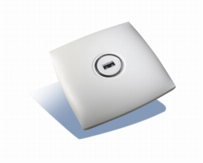
Cisco Aironet 1130AG AP
I worked with Cisco Aironet 1130AG Access Point meaning it is of the 1100 series and running IEEE 802.11a and 802.11g wireless protocols.
The characteristics of IEEE wireless protocols are listed below:

 | 802.11a | 802.11b | 802.11g
Data rate | 54 Mbps | 11 Mbps | 54 Mbps
Frequency | 5 GHz | 2.4 GHz | 2.4 GHz
Compatibility | None | With 802.11g | With 802.11b
Range (meters) | 35-120 | 38-140 | 38-140

Configuring Cisco Access Points
Cisco Access Points is best configured using its web interface facilities. But to do that, you first need to configure an IP address on it using the following commands:
Config t
Interface bvi1
Ip address address mask
After assigning an IP address and mask (this is done through the Command Line Interface-CLI), the next thing is to open a web browser (eg Explorer) and browse the assigned IP address to display the web interface so that the various configurations can be carried out.

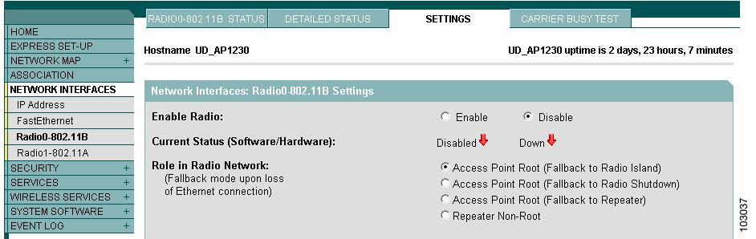
Web interface for configuring Access Points
Management
Cisco APs can be managed as discussed for switches and routers, but a more centralized and easy management is achieved with Cisco Wireless Solution Engine (WLSE).

CISCO WIRELESS LAN SOLUTION ENGINE (WLSE)
Cisco Wireless LAN Solution Engine (WLSE) is a centralized management console for managing the entire Cisco Aironet WLAN infrastructure. Cisco WLSE provide comprehensive device-management capabilities in ways that simplify deployments, reduce operational complexity, and provide administrators visibility into the WLAN.
It has the following features:
- Configuration—Allows you to apply configuration changes to access points.
- Fault and policy monitoring—Monitors device fault and performance conditions
- Reporting—Allows you to track device, client and security information.
CHAPTER SIX
CONCLUSION AND GENERAL APPRAISAL OF THE PROGRAMME
The SIWES programme is a good programme designed for the students benefit. The SIWES programme is beneficial to students in the sense that it equips the students with both technical and practical knowledge of their course of study. Also the students acquires experiences that will help them to thrive in the labour market after graduation from the University.
For me, I will say that the SIWES programme has exposed me to some methods, principles and techniques involved in the handling of some ICT equipment. In addition, the SIWES programme gave me the opportunity to handle some of the equipment that are not in school laboratory.
Though the programme is rewarding to the students, there is still need for the improvement of the standard of the programme. For the programme to improve, I suggest that the school authorities should embark on a sustained enlightenment of both public and private establishments on the reasons why students should go for industrial attachment. This will make the establishments create chances for prospective students for the SIWES programme. This is because most private establishments think that students are coming to look for money only.
On the part of future participants, I will advice them to take the SIWES programme very serious, because it is a course of its own. Also, I will like them to be respectful, honest, obedient, friendly, punctual, hardworking and to avoid absenteeism at their place of attachment. Equally they should look for places they will get real experience rather than looking for a place that pays big money. At last, they should strictly adhere to the rules and regulations of their firm of attachment.
Also to improve the programme, students should be strictly supervised to know whether they are really doing things relevant to their course of study.
In conclusion, the six months SIWES programme is a rewarding programme that should be encouraged in all Universities, so as to widen the scope and knowledge of students on their course of study.

