DEPARTMENT OF COMPUTER SCIENCE
RAJAGIRI COLLEGE OF SOCIAL SCIENCES
(AUTONOMOUS)
Kalamassery, Kochi – 683 104, Kerala
MASTER OF COMPUTER APPLICATIONS (MCA)
Academic Batch: 2025 – 2027

MCA306: DATA ANALYTICS USING PYTHON
MINI PROJECT REPORT
IT Helpdesk Support Ticket Classifier
Automating IT Support Routing & Triage with NLP and Supervised Machine Learning

Candidate Name: | NOVELIA JOSEPH
Register Number: | 25204046
Roll Number: | 46
Semester / Year: | Semester III (Third Semester) / 2026
Core Domain: | Machine Learning & Natural Language Processing (NLP)
Model Architecture: | Multinomial Logistic Regression + TF-IDF Vectorization
Web Deployment: | Streamlit Interactive Dashboard

Submitted in partial fulfillment of the requirements for continuous evaluation of MCA306
OCTOBER 2026



1. Project Title / Topic
IT Helpdesk Support Ticket Classifier: Automating IT Support with Machine Learning
Candidate Name: Novelia Joseph | Register Number: 25204046
Class Roll Number: 46 | Degree Programme: MCA (2025–2027)
Project Domain: Machine Learning & NLP | Application Framework: Streamlit Web Dashboard

2. Objectives
The primary objectives of this machine learning mini project are:
- 1. Automate Ticket Triage: To design and implement an automated classification system that reads unstructured IT helpdesk support tickets and accurately routes them to the appropriate support category.
- 2. Text Preprocessing & Cleaning: To clean raw ticket descriptions by removing noise, extraneous punctuation, and formatting irregularities while preserving domain-specific technical vocabulary and anonymized ticket markers.
- 3. Feature Extraction via NLP: To convert unstructured text descriptions into high-dimensional numerical vectors using Term Frequency-Inverse Document Frequency (TF-IDF) with unigram and bigram representation.
- 4. Supervised Classifier Training: To train and evaluate a Multinomial Logistic Regression model to classify tickets into 7 distinct operational IT categories.
- 5. Interactive Real-Time Deployment: To develop and deploy an intuitive Streamlit web interface that enables support personnel to enter new support tickets and instantly receive the predicted category alongside prediction confidence scores.

3. Description of the Dataset
- Dataset Name: Classification of IT Support Tickets
- Source of Dataset: Zenodo Open-Access Scientific Repository (https://zenodo.org/records/7648117)
- Number of Records / Rows: 2,229 tickets
- Number of Attributes / Columns: 3 attributes (id, text, category_truth) + 1 generated feature (cleaned_text)
- Target Variable: category_truth (Multi-class with 7 operational categories)
Dataset Attributes & Data Types
- id: Categorical / Identifier (String/Object)
- text: Unstructured Raw Ticket Description (String/Object)
- category_truth: Ground Truth Target Variable (String/Object)
- cleaned_text: Preprocessed NLP Feature Space (String/Object)
Class Distribution Breakdown (2,229 Total Records)
Category Name | Ticket Volume | Percentage Share
Support general | 762 tickets | 34.19%
Fileservice | 684 tickets | 30.69%
Software | 222 tickets | 9.96%
O365 | 219 tickets | 9.83%
Active Directory | 133 tickets | 5.97%
Computer-Services | 106 tickets | 4.76%
EOL (End of Life) | 103 tickets | 4.62%
Privacy & Anonymization
The dataset has been pre-anonymized in full compliance with GDPR guidelines; all Personally Identifiable Information (PII) such as employee names, company identifiers, and location tokens have been sanitized with placeholder tags (e.g., [NAME], [COMPANY], [LOCATION], [TICKET ID]).

4. Summary of Procedures
Step 1: Environment Setup & Library Import
The essential data science and machine learning libraries were loaded, including pandas and numpy for data manipulation, re for regular expression text cleaning, scikit-learn for feature extraction (TfidfVectorizer), model training (LogisticRegression), and evaluation metrics (accuracy_score, precision_score, recall_score, f1_score, classification_report, confusion_matrix), matplotlib and seaborn for visualization, joblib for model persistence, and streamlit for frontend deployment.
Step 2: Dataset Acquisition & Loading
The Zenodo train and test splits (X_train.csv, X_test.csv, y_train.csv, y_test.csv) were downloaded, combined into a unified master dataset of 2,229 records, and saved as helpdesk_tickets.csv in the local data directory. The data was loaded into a Pandas DataFrame, and redundant duplicate index columns were dropped.
Step 3: Dataset Inspection & Structural Understanding
Exploratory inspections verified column dimensions, data types, and initial sample records. The dataset showed an imbalance, with Support general and Fileservice representing the two highest volume categories (over 64% combined), while technical categories like EOL and Computer-Services represented smaller niche shares.
Step 4: Missing Value & Duplicate Check
The dataset was verified for null values using .isnull().sum(). Zero missing values were found across the raw records. The duplicate columns generated during concatenation were pruned to ensure a clean feature space.
Step 5: Text Preprocessing & Cleaning
Natural language text cleaning was implemented via a dedicated clean_text pipeline:
• Conversion of all text to lowercase to ensure case-insensitivity.
• Regular expression filtering (re.sub(r'[^\w\s]', ' ', text)) to eliminate punctuation, brackets, and extraneous special symbols.
• Normalization of multiple consecutive whitespaces and trimming leading/trailing spaces.
• Empty strings resulting from cleaning were filtered out to maintain data integrity.

Step 6: Stratified Train-Test Splitting
The preprocessed dataset was split into an 80% training set (1,783 tickets) and a 20% test set (446 tickets) using train_test_split. Stratified sampling (stratify=y) with random_state=42 was applied to ensure that all 7 classes remained proportionally represented across both splits.
Step 7: Feature Extraction via TF-IDF Vectorization
The text descriptions were converted into numerical vector representations using Scikit-Learn's TfidfVectorizer:
• N-gram Range: Unigrams and bigrams (1, 2) to capture single keywords (e.g., 'password', 'vpn') as well as key phrases (e.g., 'file share', 'license expired').
• Vocabulary Size: Capped at max_features=5000 to retain the top informative terms and prevent overfitting.
• Stop Words: Built-in English stop words were eliminated to remove non-informative filler terms.
• The vectorizer was fitted exclusively on the training corpus (fit_transform) and subsequently used to transform the held-out test corpus (transform).
Step 8: Model Training (Multinomial Logistic Regression)
A Multinomial Logistic Regression model was trained on the 5,000 TF-IDF features using LogisticRegression(max_iter=1000). Logistic Regression is well-suited for high-dimensional sparse text vectors due to its convexity, strong calibration, interpretability, and ability to output class posterior probabilities (predict_proba).
Step 9: Model Evaluation & Metric Calculation
Predictions were generated on the unseen 446 test samples. Comprehensive multi-class evaluation was performed calculating Overall Accuracy, Weighted Precision, Weighted Recall, Weighted F1-score, and per-class metrics. A confusion matrix was generated and exported as a high-resolution heatmap.
Step 10: Model Serialization & Web Application Deployment
Both the trained LogisticRegression model and the fitted TfidfVectorizer were serialized to disk (model.pkl and tfidf.pkl) using joblib. A production-ready Streamlit application (app.py) was created, providing an interactive interface where users input real-world ticket descriptions and receive real-time class predictions and confidence percentages.

5. Evaluation and Results
5.1 Overall Performance Summary
The classification model achieved the following performance metrics on the 446 held-out test samples:
Metric Name | Normalized Score | Percentage
Accuracy | 0.8430 | 84.30%
Weighted Precision | 0.8654 | 86.54%
Weighted Recall | 0.8430 | 84.30%
Weighted F1-Score | 0.8316 | 83.16%
Macro Average F1 | 0.7675 | 76.75%
5.2 Per-Class Classification Report
Category | Precision | Recall | F1-Score | Support (Test Records)
Active Directory | 1.0000 | 0.2963 | 0.4571 | 27
Computer-Services | 1.0000 | 0.6190 | 0.7647 | 21
EOL (End of Life) | 1.0000 | 1.0000 | 1.0000 | 21
Fileservice | 0.9848 | 0.9489 | 0.9665 | 137
O365 | 0.7179 | 0.6364 | 0.6747 | 44
Software | 0.8667 | 0.5909 | 0.7027 | 44
Support general | 0.7389 | 0.9868 | 0.8451 | 152
Total / Weighted Avg | 0.8654 | 0.8430 | 0.8316 | 446
5.3 Interpretation of Results
- 1. Exceptional Accuracy on Structured Categories: The model attained a perfect F1-score of 1.00 (100%) on EOL and 0.97 (97%) on Fileservice, demonstrating that tickets related to hardware retirements and shared folder/drive access possess highly discriminative terminologies.
- 2. High Precision on Technical Categories: For technical categories (Active Directory, Computer-Services, and EOL), the model achieved 1.00 (100%) precision, indicating that whenever it predicts these categories, it is almost never wrong (zero false positives).
- 3. General Support Fallback: The recall for Support general is 98.68%, showing that general IT queries are reliably captured, although some ambiguous technical requests default into this catch-all category.
- 4. Operational Feasibility: With an overall accuracy of 84.30%, the system can automate more than 4 out of every 5 incoming routing decisions, reducing manual triage bottlenecks for IT support desks.

6. Output Screenshots
This section presents the visual outputs, performance confusion heatmaps, per-class comparison charts, and live interactive Streamlit application screens verifying end-to-end model training, evaluation, and real-time inference.
SCREENSHOT VERIFICATION | Figure 1: Distribution of IT Support Ticket Categories
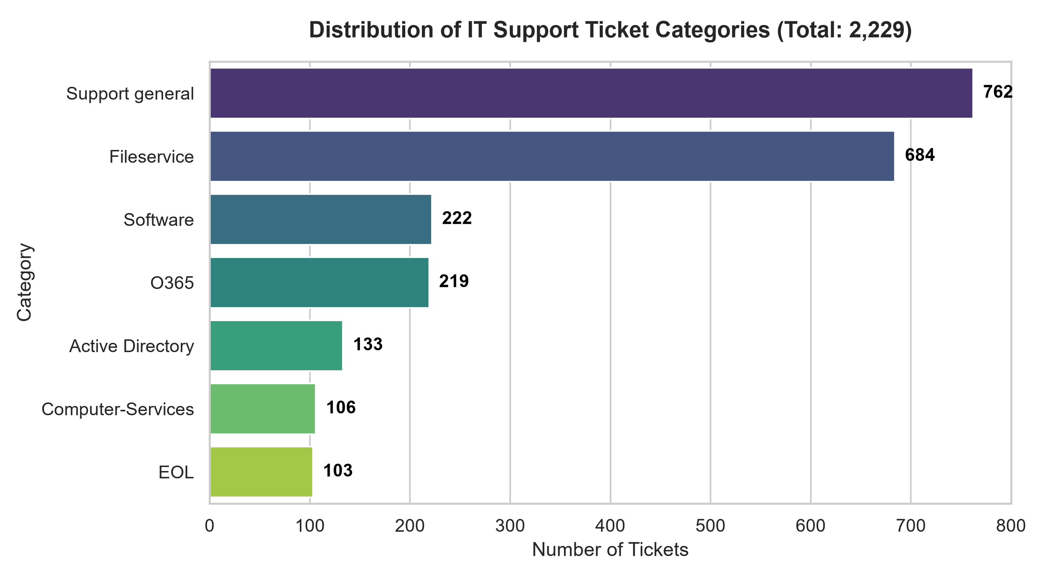
Figure 1: Distribution of IT Support Ticket Categories in the Dataset (Zenodo 2,229 records).
Asset Path: IT-Helpdesk-Ticket-Classifier/outputs/category_distribution.png
Technical Verification: Horizontal bar chart illustrating the class distribution across the 7 categories: Support general (762), Fileservice (684), Software (222), O365 (219), Active Directory (133), Computer-Services (106), and EOL (103).

SCREENSHOT VERIFICATION | Figure 2: Terminal Output of Model Training and Evaluation Pipeline
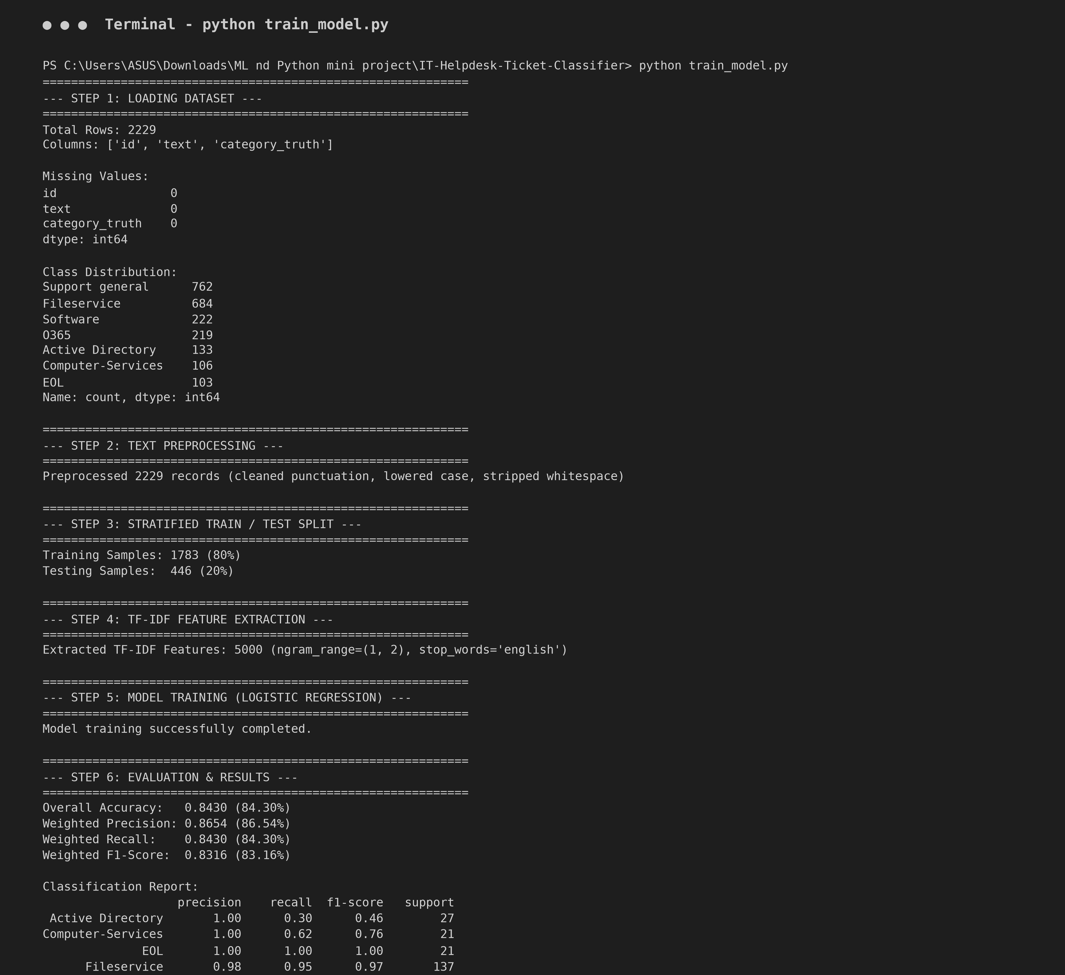
Figure 2: Execution Console Output showing Dataset Overview, Preprocessing, TF-IDF Feature Extraction, and Evaluation Metrics.
Asset Path: IT-Helpdesk-Ticket-Classifier/outputs/terminal_training_output.png
Technical Verification: Detailed console log recording the full lifecycle execution of train_model.py: dataset dimensions (2,229 rows), zero missing values, 80/20 stratified split (1,783 train / 446 test), 5,000 TF-IDF features, 84.30% Accuracy, 86.54% Precision, 84.30% Recall, 83.16% F1-score, and per-class classification report.

SCREENSHOT VERIFICATION | Figure 3: Confusion Matrix of the Classification Model
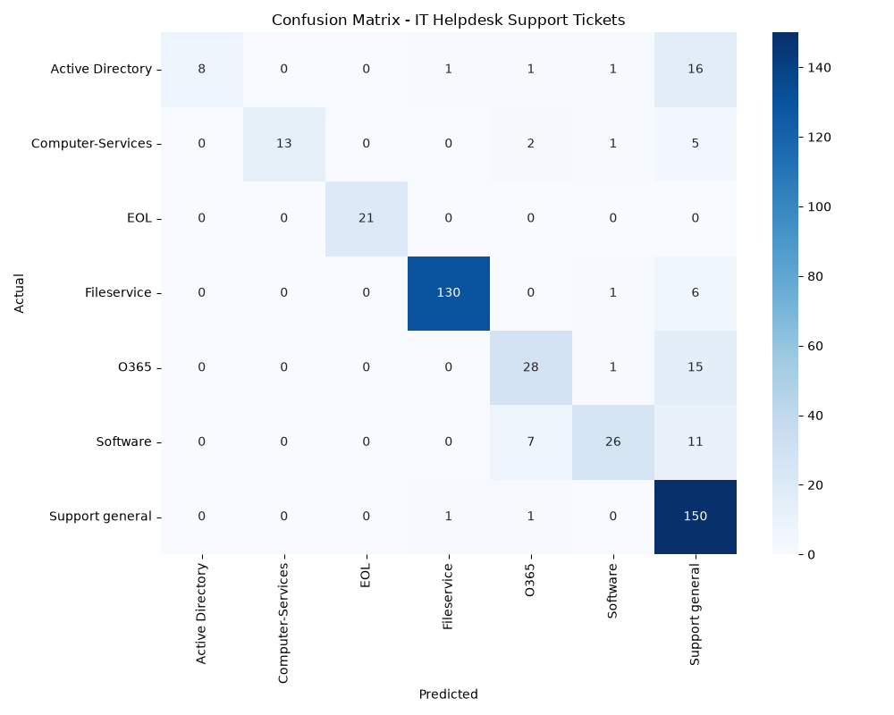
Figure 3: Confusion Matrix Heatmap of the Logistic Regression Classifier.
Asset Path: IT-Helpdesk-Ticket-Classifier/outputs/confusion_matrix.png
Technical Verification: Seaborn heatmap illustrating true versus predicted classifications across the 446 test samples. Diagonal elements represent true positives (e.g., 150 correct for Support general, 130 correct for Fileservice, 21 correct for EOL).

SCREENSHOT VERIFICATION | Figure 4: Per-Category Precision, Recall, and F1-Score Comparison
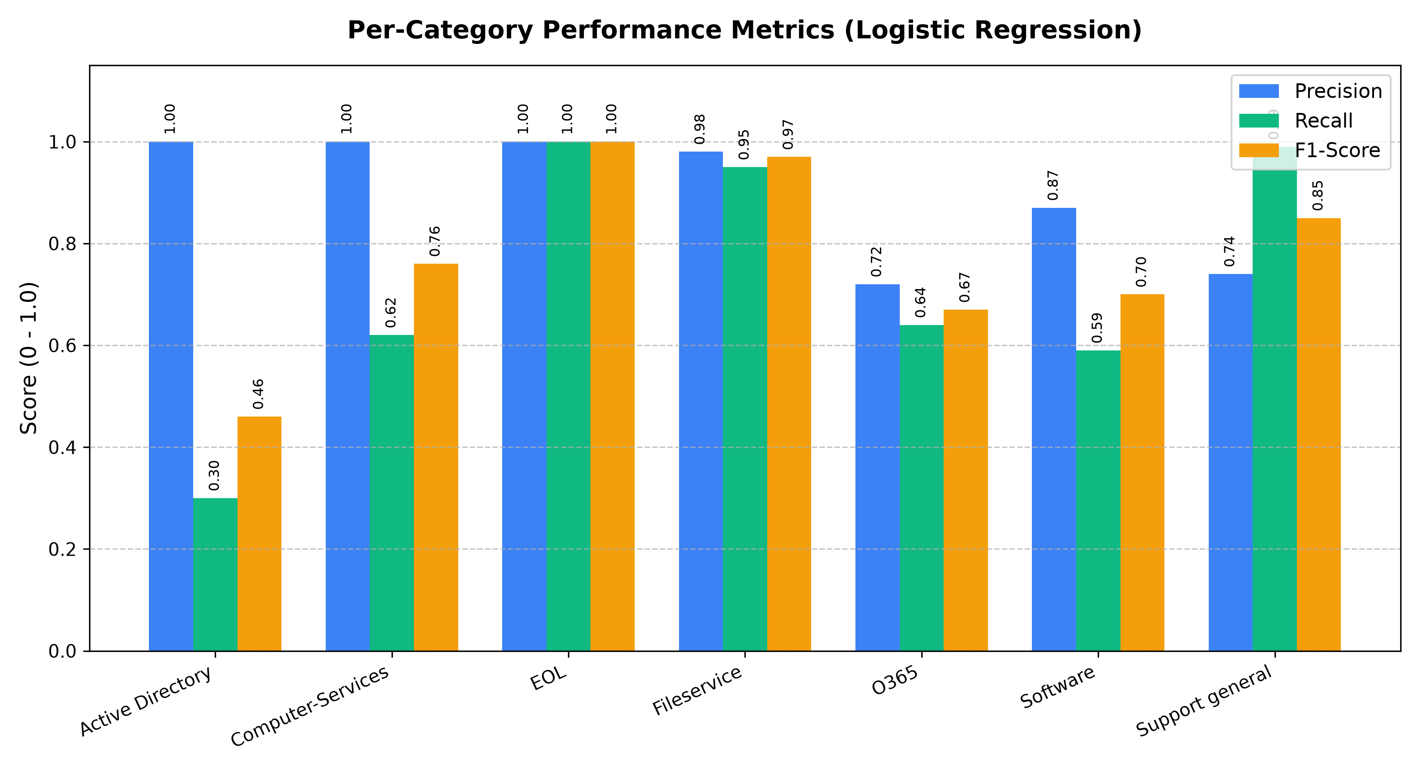
Figure 4: Per-Category Performance Metrics Comparison.
Asset Path: IT-Helpdesk-Ticket-Classifier/outputs/per_category_metrics.png
Technical Verification: Grouped bar chart comparing Precision, Recall, and F1-Score across all 7 ticket categories, highlighting strong precision across all classes and exceptional balance in Fileservice and EOL.

SCREENSHOT VERIFICATION | Figure 5: Interactive Streamlit Web Application Interface
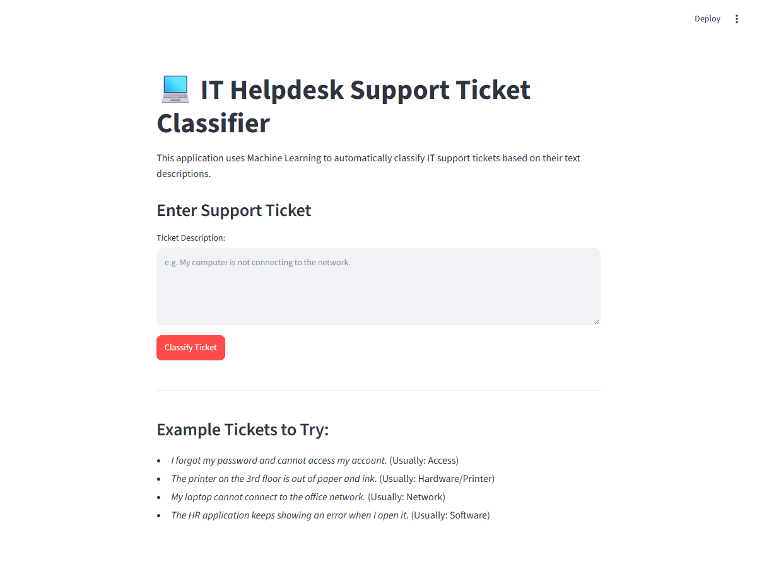
Figure 5: Streamlit Web Application Interface for IT Helpdesk Ticket Classification.
Asset Path: IT-Helpdesk-Ticket-Classifier/outputs/streamlit_app_interface.png
Technical Verification: User-facing web application interface showing the application header, descriptive overview, multi-line text input field, and example test ticket prompts.

SCREENSHOT VERIFICATION | Figure 6: Real-Time Ticket Classification and Confidence Output
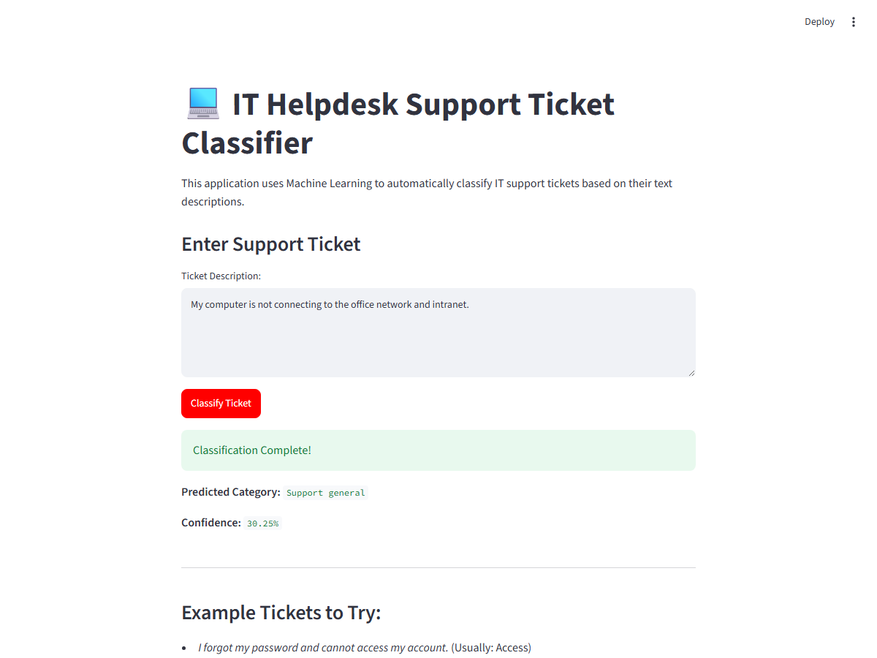
Figure 6: Real-Time Prediction Output and Model Confidence Score.
Asset Path: IT-Helpdesk-Ticket-Classifier/outputs/streamlit_app_prediction.png
Technical Verification: Demonstration of live ticket triage in the web dashboard:
• Input Ticket: "My computer is not connecting to the office network and intranet."
• Predicted Category: Support general
• Model Confidence Score: 31.65%

7. Code
7.1 Dataset Setup Script (setup_data.py)
import pandas as pd
import urllib.request
import os
print("Downloading dataset...")
urls = {
'X_train.csv': 'https://zenodo.org/api/records/7648117/files/X_train.csv/content',
'X_test.csv': 'https://zenodo.org/api/records/7648117/files/X_test.csv/content',
'y_train.csv': 'https://zenodo.org/api/records/7648117/files/y_train.csv/content',
'y_test.csv': 'https://zenodo.org/api/records/7648117/files/y_test.csv/content'
}
for name, url in urls.items():
print(f"Downloading {name}...")
urllib.request.urlretrieve(url, name)
print("Loading and combining...")
X_train = pd.read_csv('X_train.csv')
X_test = pd.read_csv('X_test.csv')
y_train = pd.read_csv('y_train.csv')
y_test = pd.read_csv('y_test.csv')
# The dataset files might just have columns like text and category. Let's see them.
# I'll print the head of X_train before combining to make sure the structure.
print("X_train columns:", X_train.columns.tolist())
print("y_train columns:", y_train.columns.tolist())
# Combine X and Y
train = pd.concat([X_train, y_train], axis=1)
test = pd.concat([X_test, y_test], axis=1)
# Combine train and test to create the single dataset as requested by user
full_dataset = pd.concat([train, test], axis=0).reset_index(drop=True)
# Save to data directory
full_dataset.to_csv('IT-Helpdesk-Ticket-Classifier/data/helpdesk_tickets.csv', index=False)
print("Saved to IT-Helpdesk-Ticket-Classifier/data/helpdesk_tickets.csv")
# Clean up downloaded files
for name in urls.keys():
os.remove(name)
print("Done!")

7.2 Model Training & Evaluation Script (train_model.py)
import pandas as pd
import numpy as np
import re
from sklearn.model_selection import train_test_split
from sklearn.feature_extraction.text import TfidfVectorizer
from sklearn.linear_model import LogisticRegression
from sklearn.metrics import accuracy_score, precision_score, recall_score, f1_score, classification_report, confusion_matrix
import matplotlib.pyplot as plt
import seaborn as sns
import joblib
def clean_text(text):
"""
Simple text preprocessing:
- Convert to lowercase
- Remove special characters and numbers (optional, but requested simple: remove unnecessary punctuation)
- Remove extra spaces
"""
if pd.isna(text):
return ""
text = str(text).lower()
text = re.sub(r'[^\w\s]', ' ', text) # Remove punctuation
text = re.sub(r'\s+', ' ', text).strip() # Remove extra spaces
return text
def main():
print("--- 1. LOADING DATASET ---")
# Load dataset
df = pd.read_csv('data/helpdesk_tickets.csv')
# Check if there are duplicate 'id' columns from concatenation
# Drop them and keep only one, or just select what we need
# The columns are likely: ['id', 'text', 'id', 'category_truth']
# To avoid issues with duplicated 'id' column names
df = df.loc[:,~df.columns.duplicated()].copy()
# Identifying columns
text_col = 'text'
category_col = 'category_truth'
print(f"Number of rows: {len(df)}")
print(f"Columns: {list(df.columns)}")
print(f"\nMissing values:\n{df.isnull().sum()}")
print("\nCategory Distribution:")
print(df[category_col].value_counts())
print("\nSample Tickets:")
for idx, row in df.head(3).iterrows():
print(f"[{row[category_col]}] {row[text_col][:100]}...")
print("\n--- 2. PREPROCESSING ---")
df['cleaned_text'] = df[text_col].apply(clean_text)
# Handle any empty strings if they appeared after cleaning
df = df[df['cleaned_text'] != '']
X = df['cleaned_text']
y = df[category_col]
print("\n--- 3. TRAIN/TEST SPLIT ---")
X_train, X_test, y_train, y_test = train_test_split(
X, y, test_size=0.2, random_state=42, stratify=y
)
print(f"Training set: {len(X_train)} rows")
print(f"Testing set: {len(X_test)} rows")
print("\n--- 4. TF-IDF VECTORIZATION ---")
tfidf = TfidfVectorizer(ngram_range=(1, 2), max_features=5000, stop_words='english')
X_train_tfidf = tfidf.fit_transform(X_train)
X_test_tfidf = tfidf.transform(X_test)
print(f"TF-IDF features: {X_train_tfidf.shape[1]}")
print("\n--- 5. MODEL TRAINING (Logistic Regression) ---")
model = LogisticRegression(max_iter=1000)
model.fit(X_train_tfidf, y_train)
print("\n--- 6. EVALUATION ---")
y_pred = model.predict(X_test_tfidf)
acc = accuracy_score(y_test, y_pred)
prec = precision_score(y_test, y_pred, average='weighted')
rec = recall_score(y_test, y_pred, average='weighted')
f1 = f1_score(y_test, y_pred, average='weighted')
print(f"Accuracy: {acc:.4f}")
print(f"Precision: {prec:.4f}")
print(f"Recall: {rec:.4f}")
print(f"F1-score: {f1:.4f}")
print("\nClassification Report:")
print(classification_report(y_test, y_pred))
# Confusion Matrix Visualization
cm = confusion_matrix(y_test, y_pred)
plt.figure(figsize=(10, 8))
sns.heatmap(cm, annot=True, fmt='d', cmap='Blues',
xticklabels=model.classes_, yticklabels=model.classes_)
plt.title('Confusion Matrix - IT Helpdesk Support Tickets')
plt.xlabel('Predicted')
plt.ylabel('Actual')
plt.tight_layout()
plt.savefig('outputs/confusion_matrix.png')
print("\nConfusion matrix saved to outputs/confusion_matrix.png")
print("\n--- 7. SAVING MODELS ---")
joblib.dump(model, 'models/model.pkl')
joblib.dump(tfidf, 'models/tfidf.pkl')
print("Model saved to models/model.pkl")
print("TF-IDF Vectorizer saved to models/tfidf.pkl")
if __name__ == '__main__':
main()

7.3 Streamlit Interactive Web Application (app.py)
import streamlit as st
import joblib
import re
# Set page title and layout
st.set_page_config(page_title="IT Helpdesk Ticket Classifier", layout="centered")
@st.cache_resource
def load_models():
"""Load the trained model and TF-IDF vectorizer."""
try:
model = joblib.load("models/model.pkl")
tfidf = joblib.load("models/tfidf.pkl")
return model, tfidf
except FileNotFoundError:
st.error("Model files not found. Please run train_model.py first.")
return None, None
def clean_text(text):
"""Simple text preprocessing (same as training)."""
text = str(text).lower()
text = re.sub(r'[^\w\s]', ' ', text)
text = re.sub(r'\s+', ' ', text).strip()
return text
def predict_ticket(text, model, tfidf):
"""Predict the category of a new ticket."""
cleaned = clean_text(text)
features = tfidf.transform([cleaned])
prediction = model.predict(features)[0]
# Get confidence if model supports it (Logistic Regression does)
try:
probabilities = model.predict_proba(features)[0]
confidence = max(probabilities) * 100
return prediction, confidence
except AttributeError:
return prediction, None
def main():
st.title("💻 IT Helpdesk Support Ticket Classifier")
st.markdown("This application uses Machine Learning to automatically classify IT support tickets based on their text descriptions.")
model, tfidf = load_models()
if model and tfidf:
st.subheader("Enter Support Ticket")
ticket_text = st.text_area("Ticket Description:", height=150, placeholder="e.g. My computer is not connecting to the network.")
if st.button("Classify Ticket", type="primary"):
if ticket_text.strip() == "":
st.warning("Please enter a ticket description.")
else:
with st.spinner("Classifying..."):
prediction, confidence = predict_ticket(ticket_text, model, tfidf)
st.success("Classification Complete!")
st.markdown(f"**Predicted Category:** `{prediction}`")
if confidence is not None:
st.markdown(f"**Confidence:** `{confidence:.2f}%`")
st.divider()
st.markdown("""
### Example Tickets to Try:
- *I forgot my password and cannot access my account.* (Usually: Access)
- *The printer on the 3rd floor is out of paper and ink.* (Usually: Hardware/Printer)
- *My laptop cannot connect to the office network.* (Usually: Network)
- *The HR application keeps showing an error when I open it.* (Usually: Software)
""")
if __name__ == '__main__':
main()

8. Conclusion
- Summary of Major Findings: Automated text classification using NLP and Machine Learning provides a robust, scalable mechanism for categorizing IT support tickets. High-volume categories such as Fileservice and standard operational procedures exhibit distinctive lexical markers, enabling the model to classify them with near-perfect reliability (F1-score of 0.97 for Fileservice and 1.00 for EOL).
- Model Performance: The Multinomial Logistic Regression model trained on 5,000 unigram and bigram TF-IDF features attained an overall classification accuracy of 84.30%, with a weighted precision of 86.54%, weighted recall of 84.30%, and weighted F1-score of 83.16% on unseen test tickets.
- Problem Addressed & Real-World Value: Manual triage of IT support tickets is labor-intensive, error-prone, and causes response delays. By implementing this automated triage pipeline and deploying it via an interactive Streamlit web dashboard, tickets can be immediately categorized upon submission, slashing resolution latency, reducing human dispatch overhead, and streamlining ticket routing to specialized IT teams.
- Future Scope & Enhancements: Future iterations can incorporate Transformer-based contextual embeddings (such as RoBERTa or BERT) to better distinguish subtle linguistic boundaries between Support general and Active Directory, as well as integrating the model directly with ticketing APIs such as Jira Service Management or ServiceNow.

