1. How can a player interact with the game? What are the possible actions? Please include necessary parts of the Object Model to explain.

Object model:

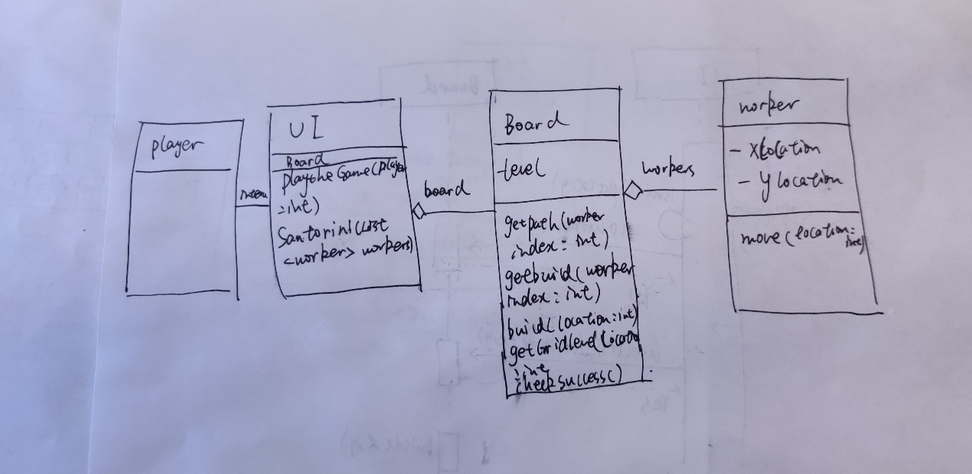

Object Model I

The players use the UI to interact with the game. Before each action, the UI will ask the player to choose a worker to act. Then the UI will tell the user the current action is move or build. Then give all the possible grid that the two workers can move to/build to the player. Then the player input one integer to select the worker to act. Then the UI will print out all the worker’s move ability location. Then the player input a destination with [x, y] format. Then the UI analysis the input and call the function of board to move. Then the UI will tell whether the move is valid or not. If it’s valid, the UI will test whether the game is finished. If so, UI will tell the winner. If not, the UI will give the player that all the possible location to build of the worker he just moved. The player input one location to build with [x, y] format, then the UI will test the format validation and pass it to the board. The board will determine whether the build action is valid. If so, the game will go into next round to the other player.

1. What state does the game need to store? And where should is be stored? Please include necessary parts of the Object Model to explain.

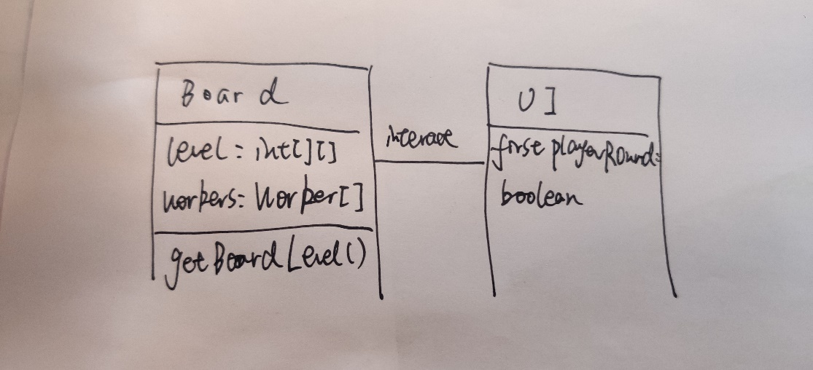

Object model II

The game needs to store a grid and the level in the grid. Those states are stored in the board of UI. In the board, there will be integers to represent level in the grid. The board will also store four workers in a worker array. The first two worker is belongs to the first player, the last two worker belongs to the second player The UI should also store a tag to represent different players. We assume the first player always first to act.

1. How does the game determine what is a valid build (either a normal block or a dome) and how does the game perform the build? Please include necessary parts of an object-level Interaction Diagram and the Object Model to explain.

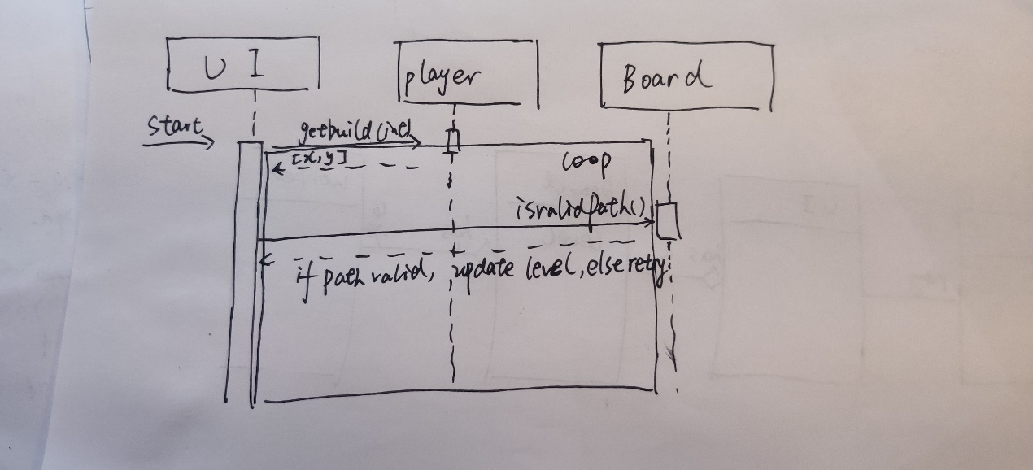

Interaction diagram

After the player give a input, the UI will first determine whether the input style is correct. If so, it will pass the input to the board. The board will determine whether there is a worker in the grid and the level of the grid is less than 4. If so, the board will build a level in the grid.