Name of student to review my work:

1. Yutian Wang
2. Yihang Liu

Previous model and system sequence before received feedback

Domain model:

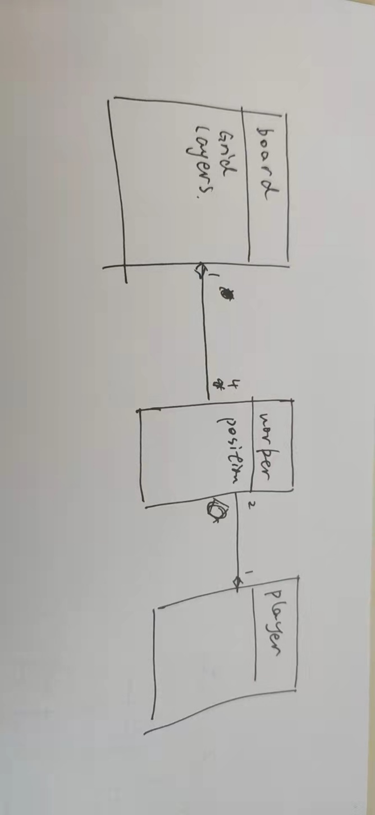

system sequence:

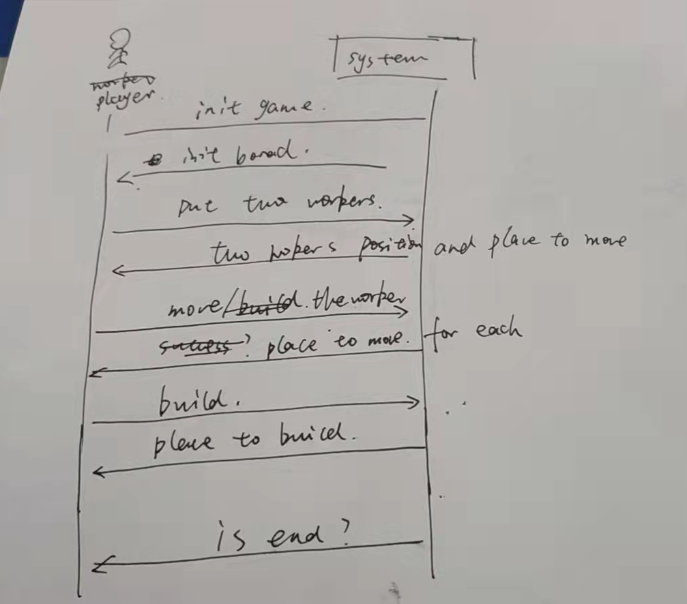

1. The feed back is mainly on two:
   1. The domain model should have a class to interact with player. So I add UI class in the domain model.
   2. The place to build/move in sequence model is not clear. That is all the possible grid of a worker can go/move. Every action begin the board will give this information to UI to help player determine the action.