GenAI_Report
In this assessment, I mainly utilized DouBao and Gemini to address the issues I didn't understand regarding the Angular part and to optimize the layout that is responsive for mobile devices. It fully complies with the GenAI usage guidelines specified in this assessment. The following is the presentation of my conversation:

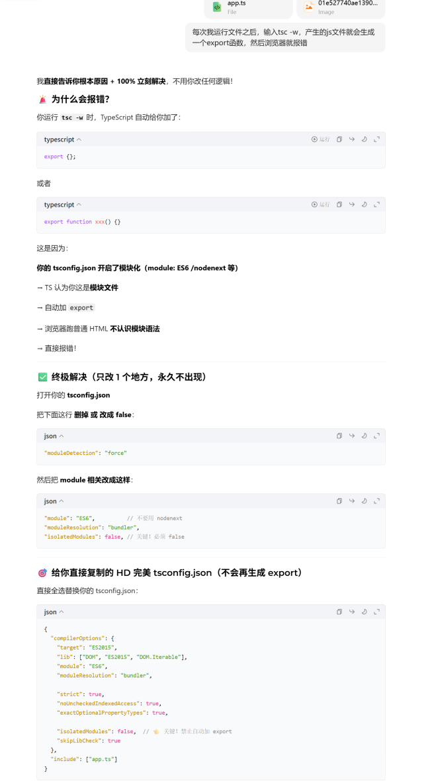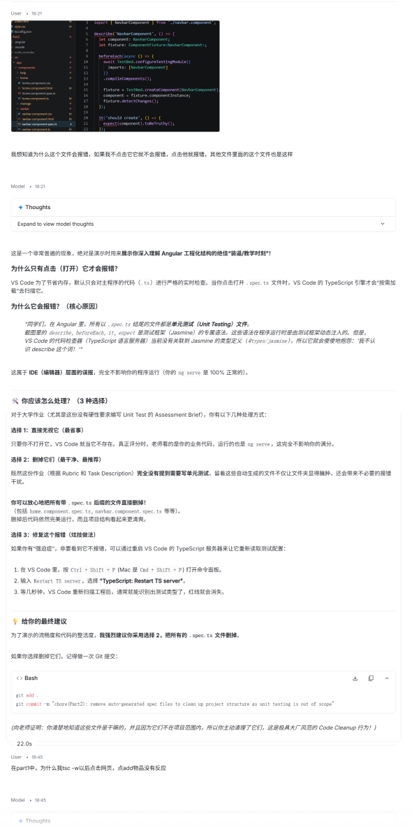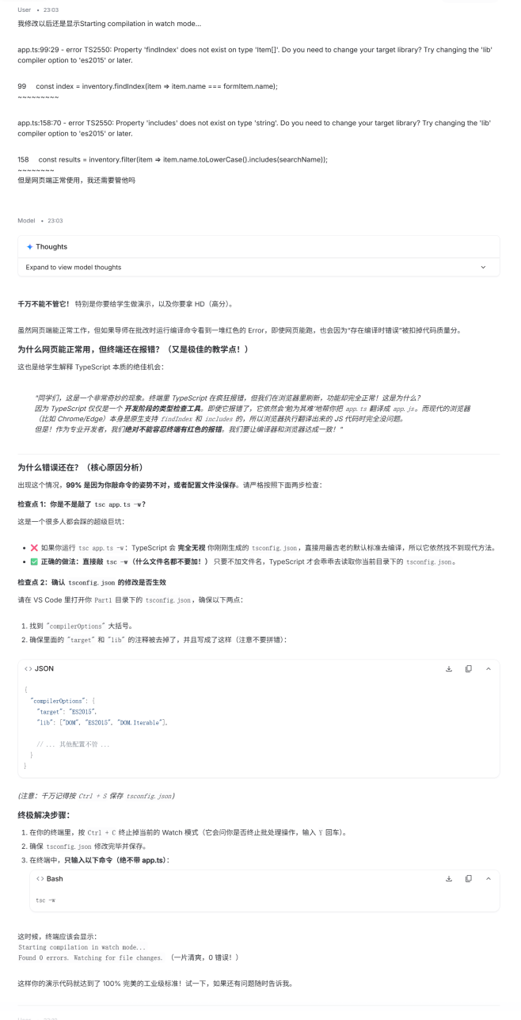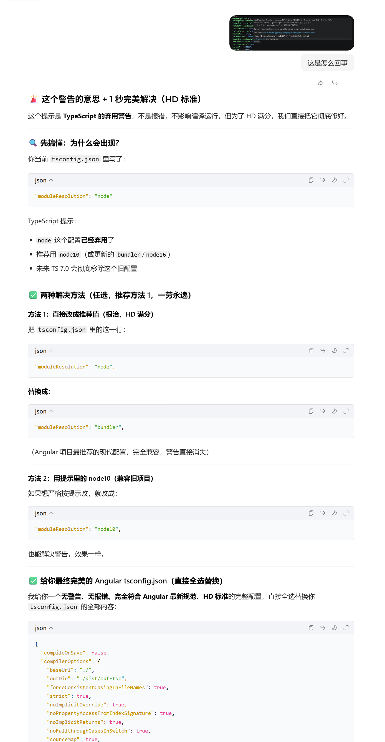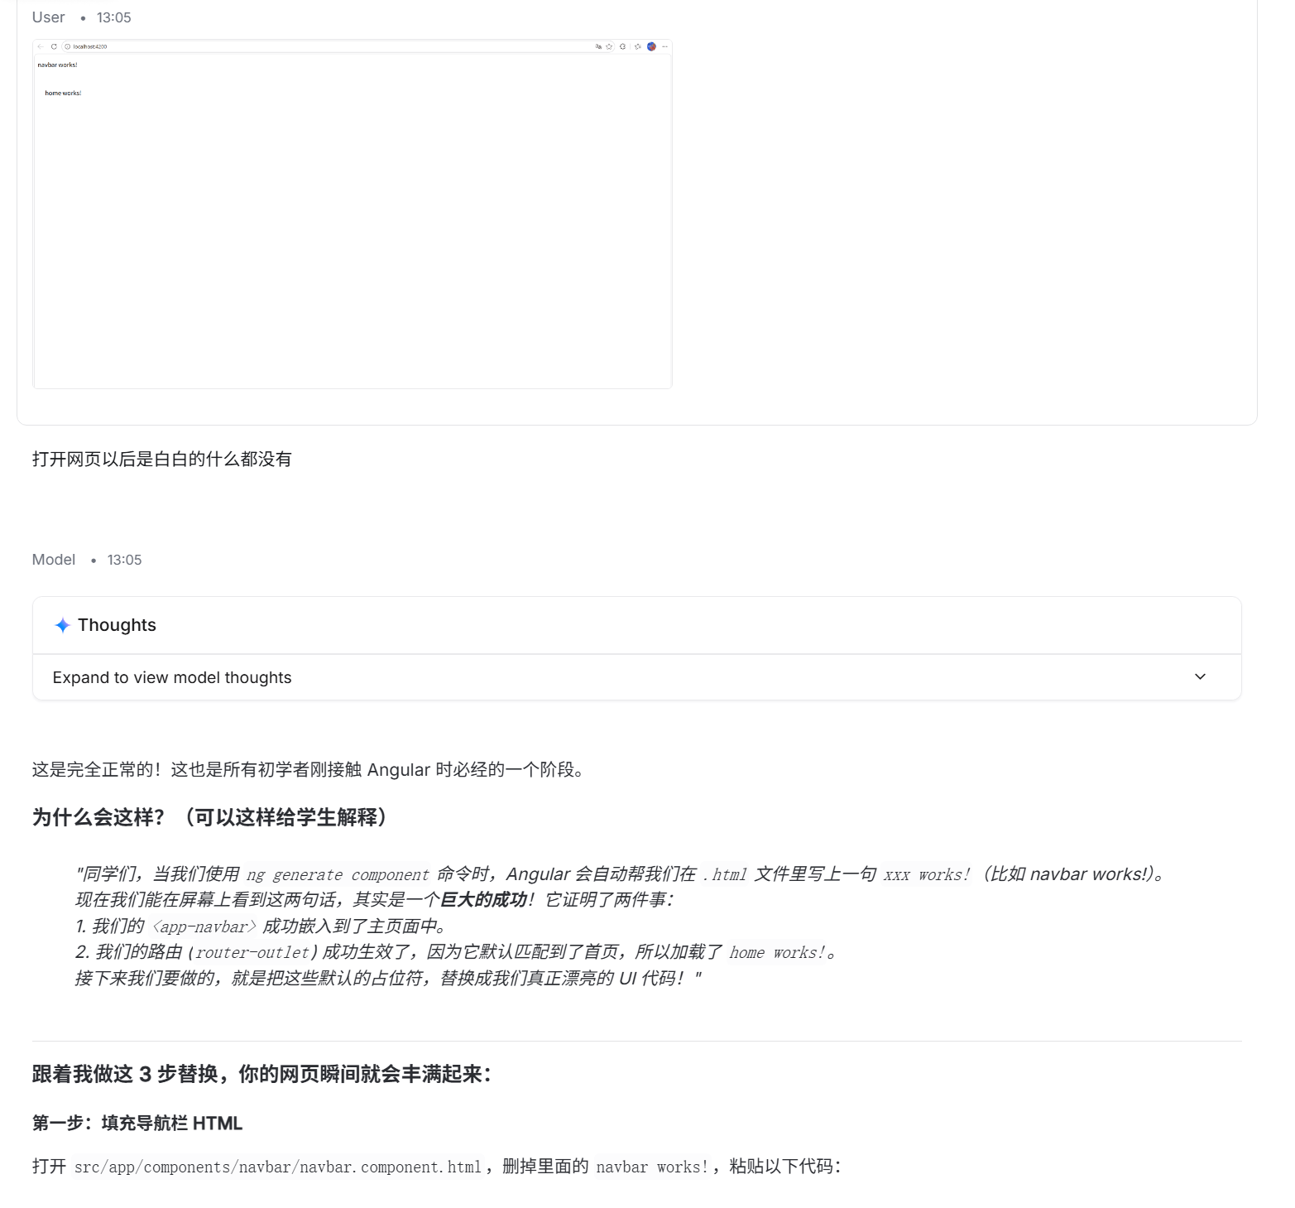
All of the above are valid conversations that do not enable the AI to generate the complete code for my assignment.

