**FSM_Homework Report**

**Anupam Rawat  
22B3982  
WEL – 2 || FR - 2 / T – 2**

RTL Viewer:

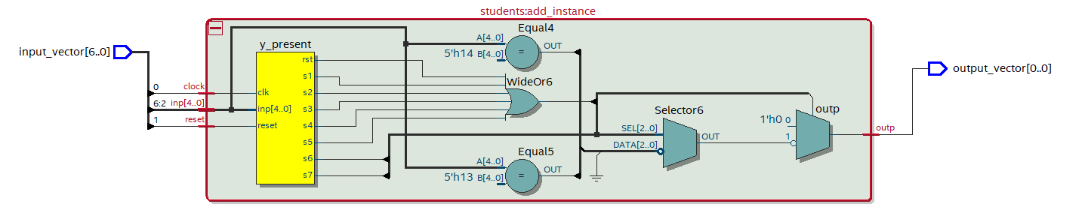  
RTL Simulation:

