**Lab 2 Report**

**Anupam Rawat  
22B3982  
WEL – 2 || FR - 2 / T – 2**

1). PART A : 2x1 MUX   
 Circuit Diagram , Truth Table and Boolean Expression:

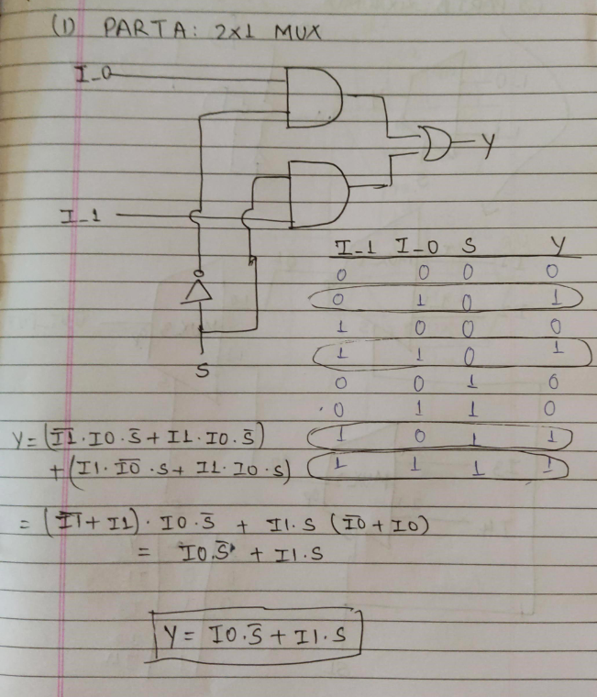

RTL View:

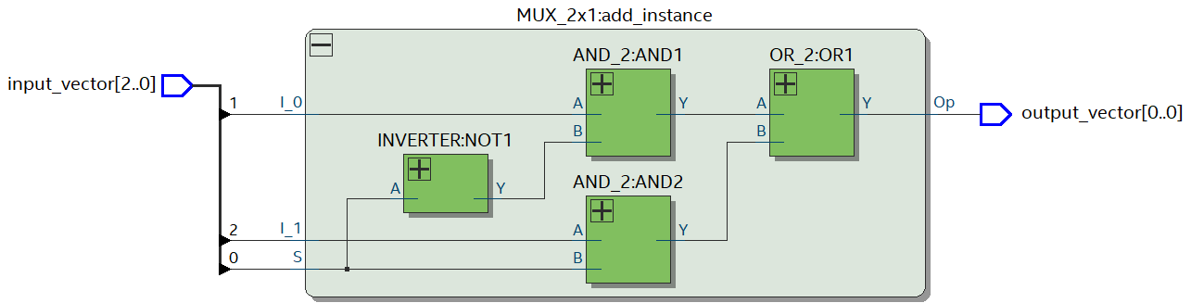

RTL Simulation:

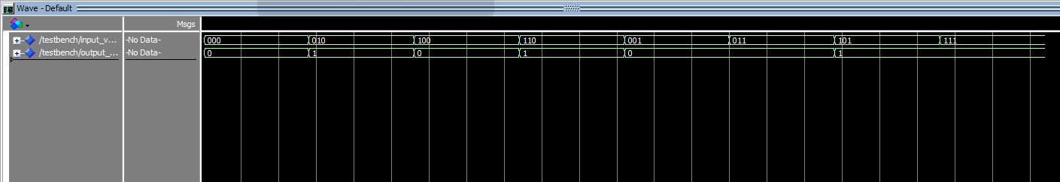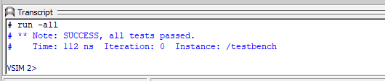

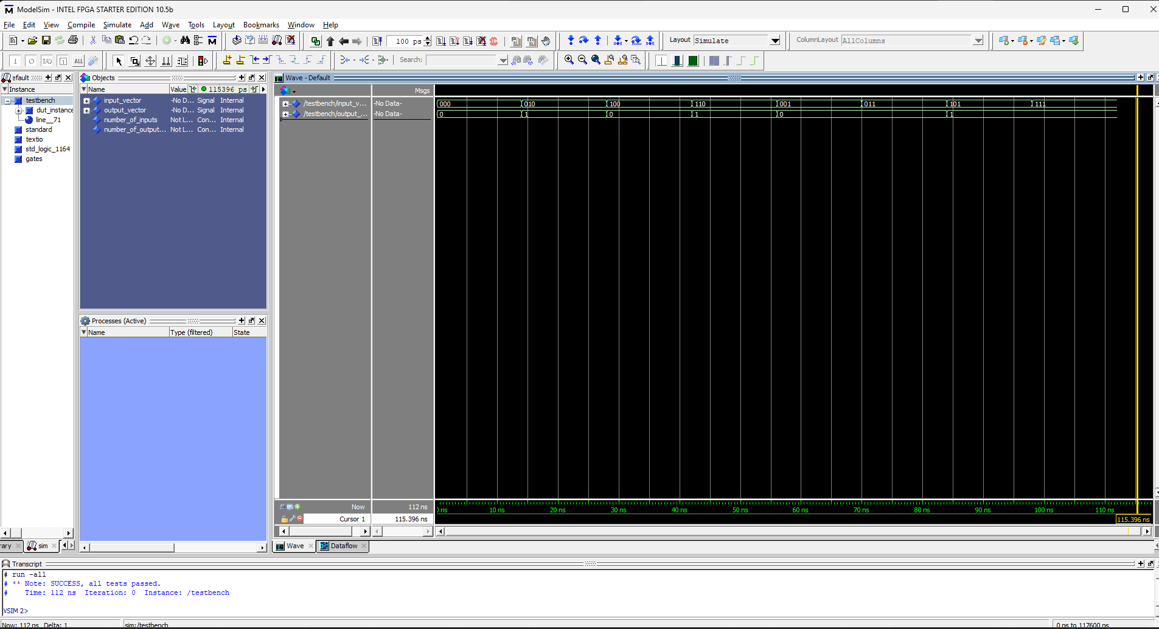

2). PART B : 4x1 MUX   
 Circuit Diagram , Truth Table and Boolean Expression:

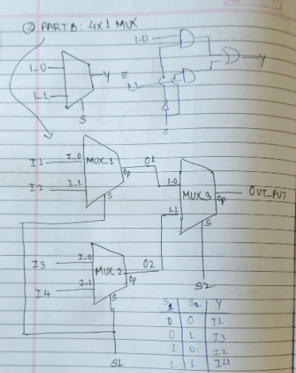

RTL View:

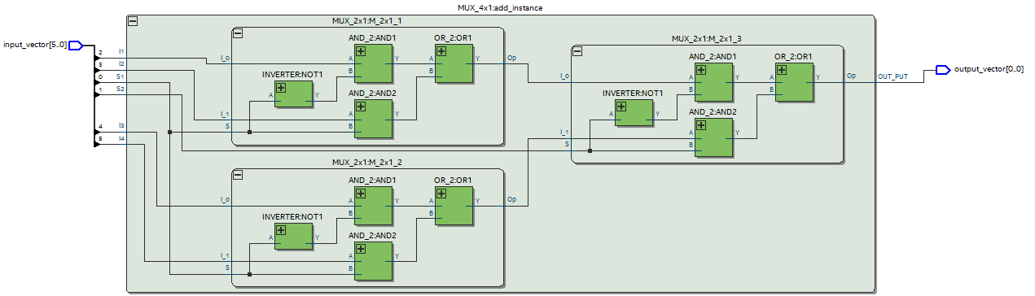

RTL Simulation:

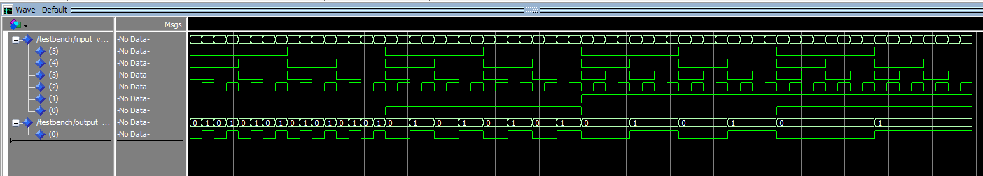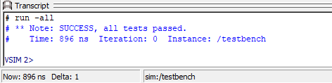

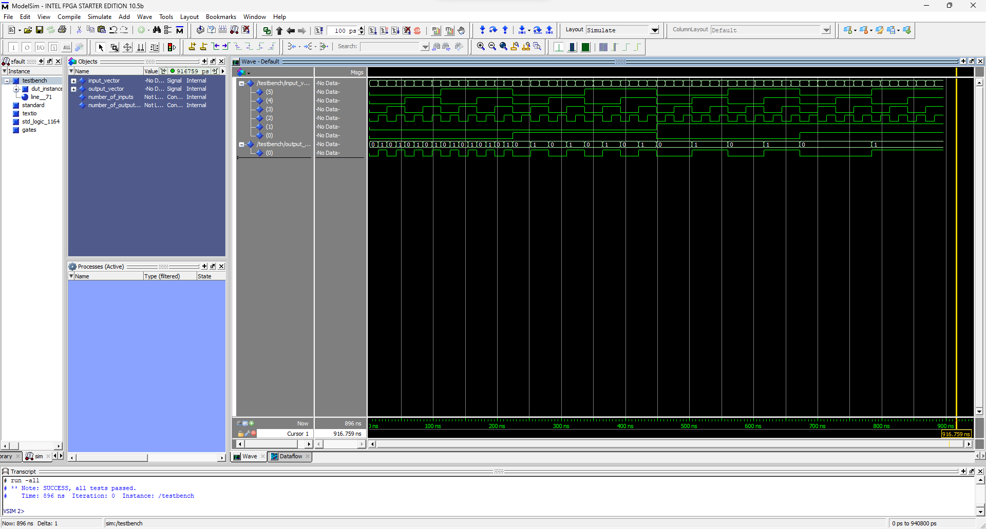

3). PART C : 4 bit 4x1 MUX   
 Circuit Diagram , Truth Table and Boolean Expression:

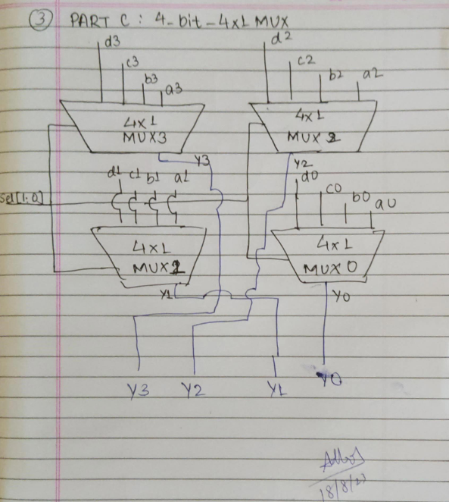

RTL View:

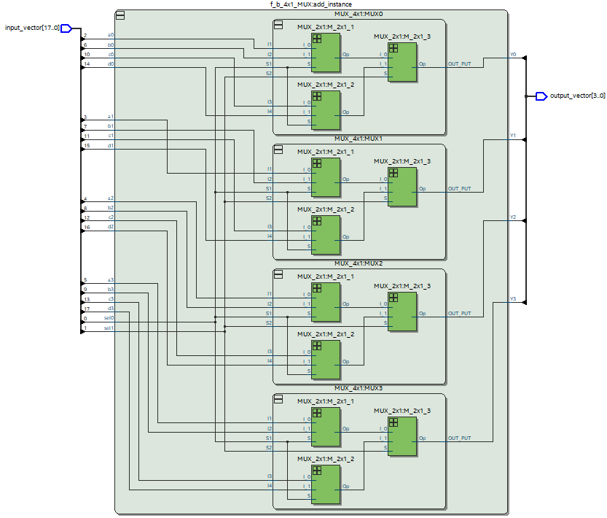

RTL Simulation:

