**Lab 3 Report**

**Anupam Rawat  
22B3982  
WEL – 2 || FR - 2 / T – 2**

Fibonacci Detector

Lab Notebook:

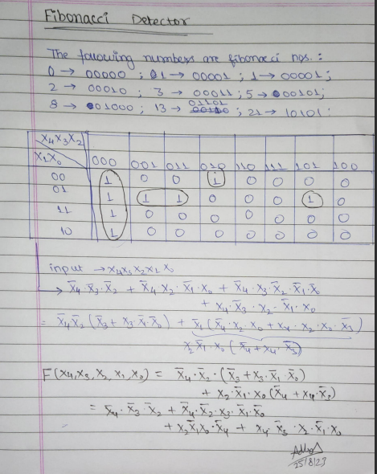

RTL Viewer:

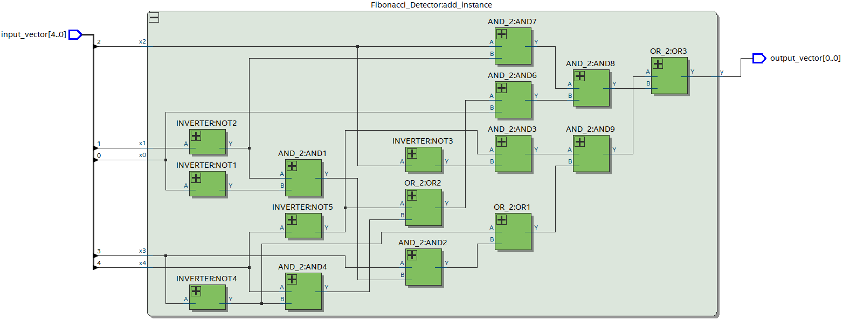

RTL Simulation:

