**Lab 4 Report / 01st September, 2023  
Anupam Rawat  
22B3982  
WEL – 2 || FR - 2 / T – 2**

BCD Adder

Lab Notebook:

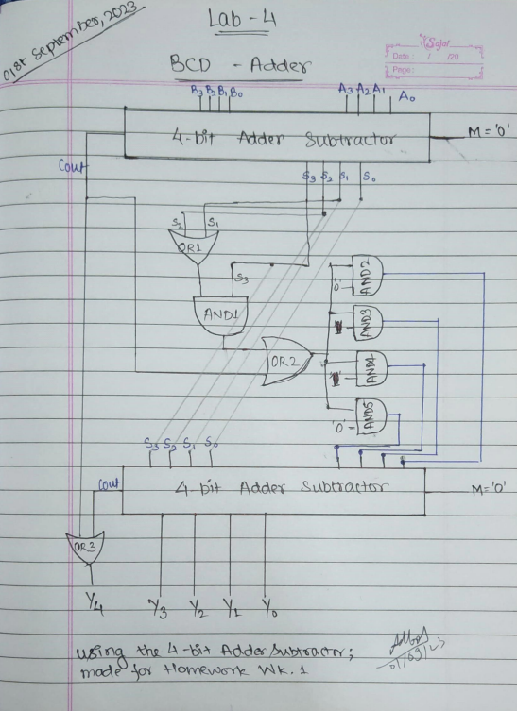

RTL Viewer:

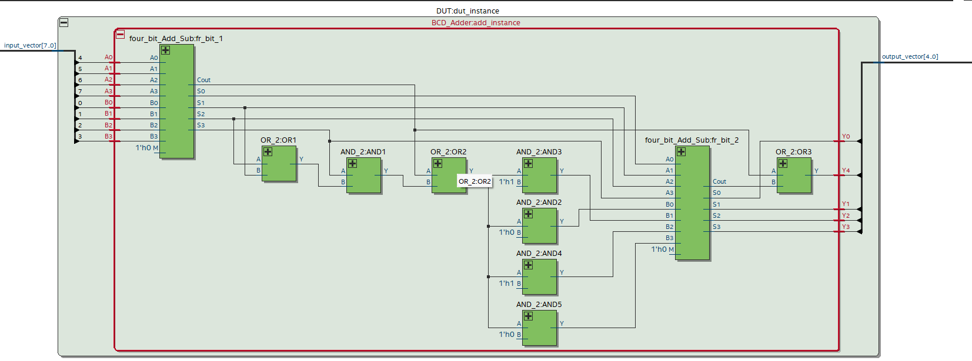

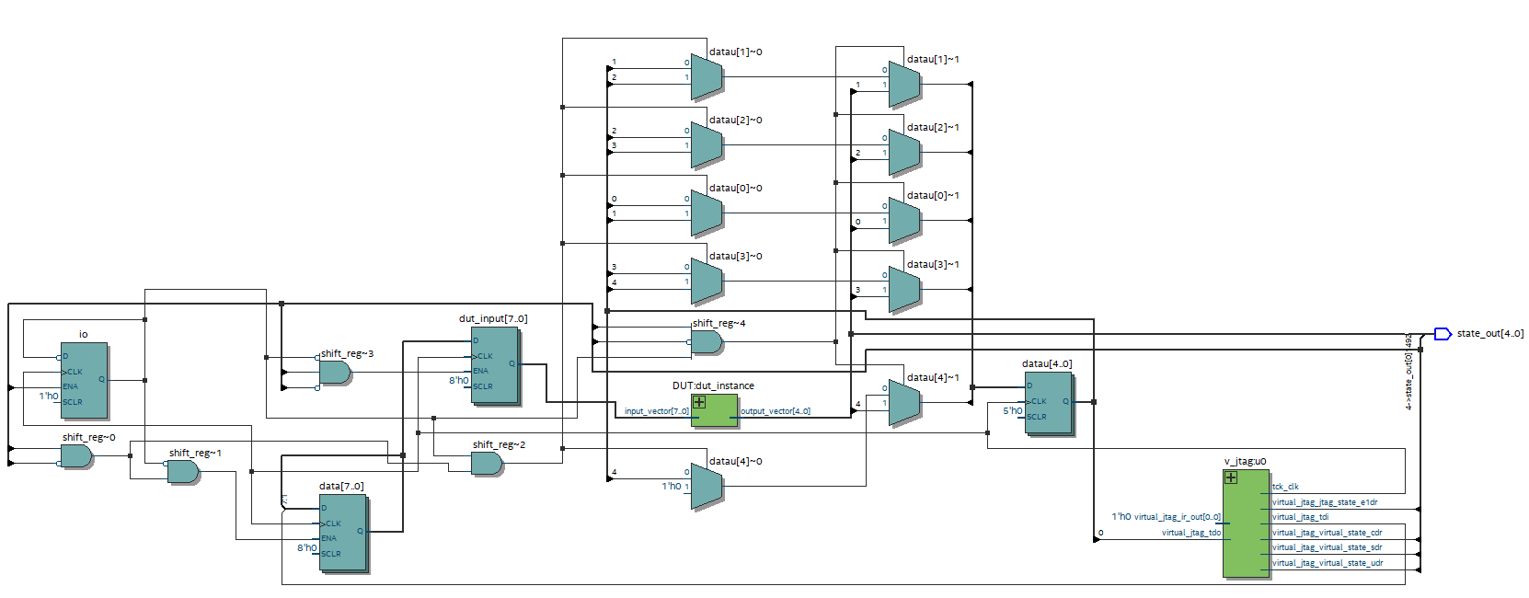

Four_bit_Adder_Subtractor:

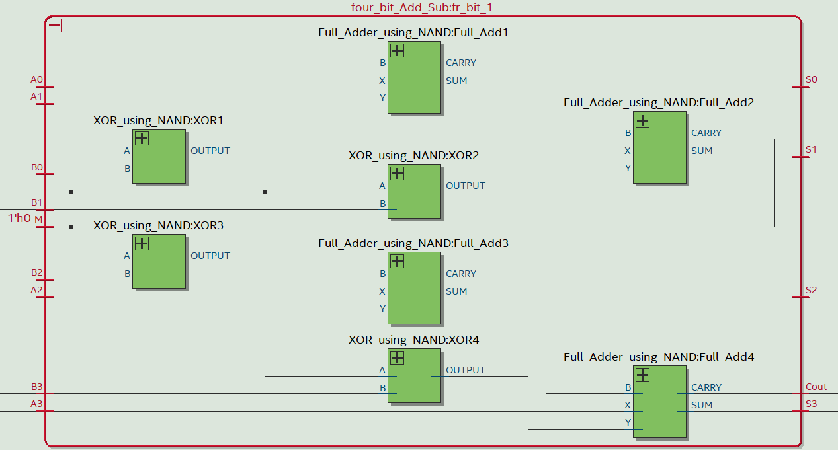

RTL Simulation:

