**Lab 9 Report**

**Anupam Rawat  
22B3982  
WEL – 2 || FR - 2 / T – 2**

Lab Notebook:

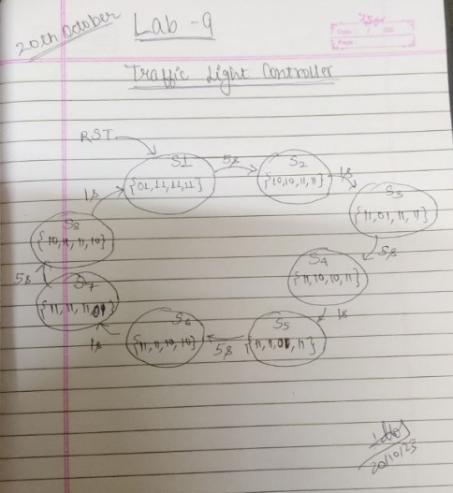

RTL Viewer: RTL Simulation:

