可能的辅助数据

1. 植被

*Generating daily high-resolution and full-coverage XCO2 across China from 2015 to 2020 based on OCO-2 and CAMS data*

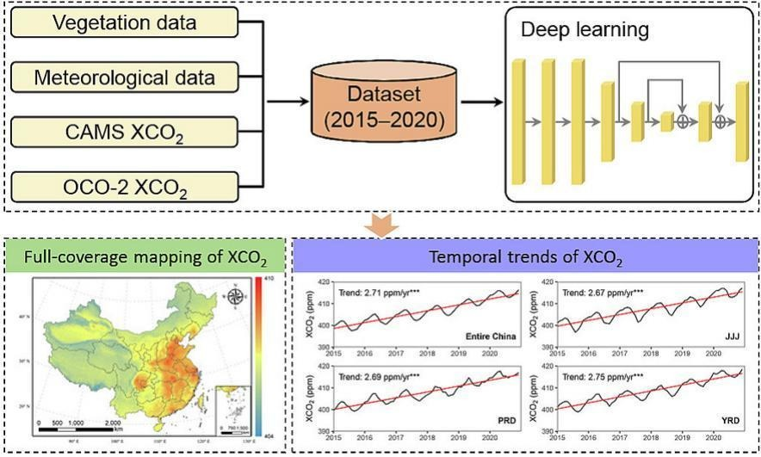

1. To be continued