Anomaly Detection Auto-Report

（Version: 0.1）

Center of Structural Monitoring and Control

14-Jan-2017

This is an auto-report test.

Panorama

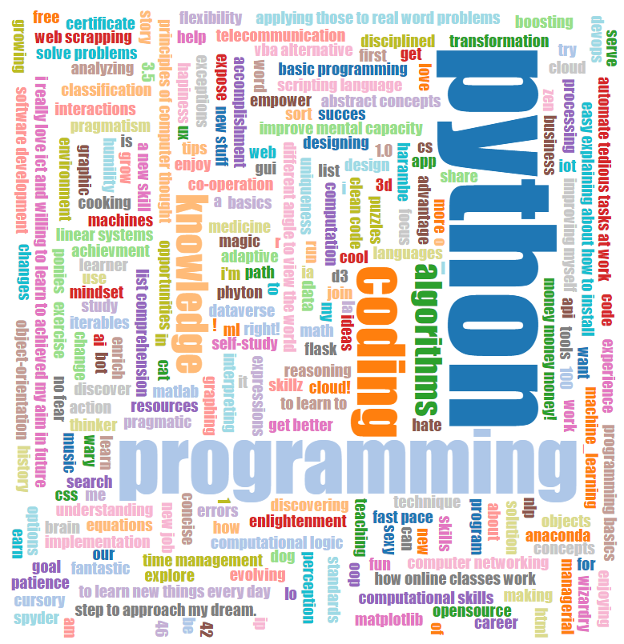

|  |  |
| --- | --- |
| Col1 | Col2 |
| data11 | data12 |

Statistics by sensor

|  |  |
| --- | --- |
|  | Col2 |
| data11 | data12 |

End of Panorama.