Hello World!

This is a paragraph.

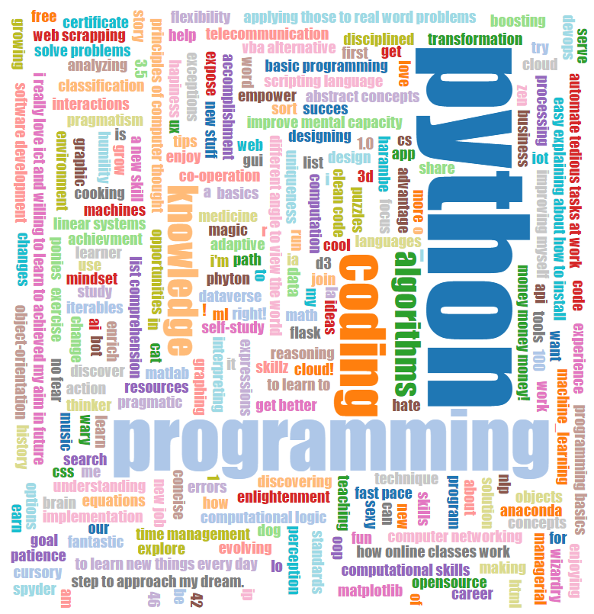

|  |  |  |  |  |  |
| --- | --- | --- | --- | --- | --- |
| 35 | 1 | 6 | 26 | 19 | 24 |
| 3 | 32 | 7 | 21 | 23 | 25 |
| 31 | 9 | 2 | 22 | 27 | 20 |
| 8 | 28 | 33 | 17 | 10 | 15 |
| 30 | 5 | 34 | 12 | 14 | 16 |
| 4 | 36 | 29 | 13 | 18 | 11 |