**MNisterul Educaţiei, Culturii și cercetării al Republicii Moldova**

**Universitatea Tehnică a Moldovei**

**Facultatea Calculatoare, Informatică şi Microelectronică**

**Departamentul Microelectronică și Inginerie Biomedicală**

**RAPORT**

**la lucrarea de laborator nr.1**

**Disciplina:** „**Programare Web”**

**A elaborat s*t. gr. FAF193, Novitchii Nichita***

**A verificat *conf. univ., Alexei Șerșun***

**Chisinau 2022**

**1. Task 3**

**2. Result 3**

*1. Opening home page where i suggest user to log in.* 3

*2. User is passing his Name and Surname.* 3

*3. User can choose the quizzes and see how many questions it has.* 4

*4. Passing the test* 4

*5. Showing final score* 5

**3. Conclusion 5**

# 1. Task

1. Choose framework  
2.Create web application  
2.1. Hacking quizzes  
3. Choosing different quizzes  
4. Showing score

# 2. Result

This laboratory work was interesting and not so easy for me because it is my first experience in working with NextJs and other new libraries. I created a web application where user can pass quizzes. However now I understand the logic of how functions and pages work.

## *1. Opening home page where i suggest user to log in.*

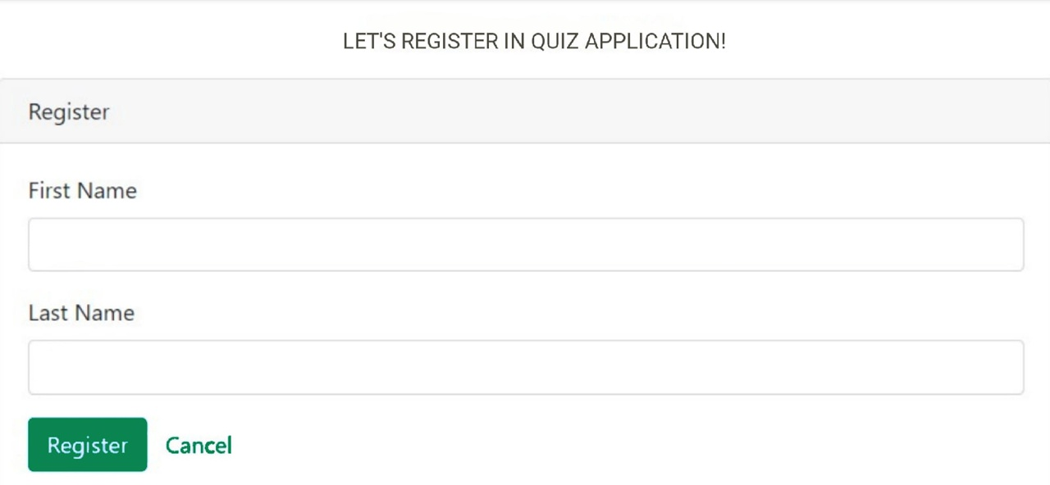

Home Page

## *2. User is passing his Name and Surname.*

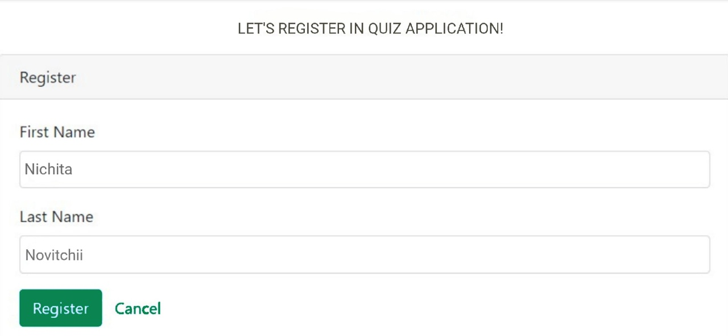

Registration

## *3. User can choose the quizzes and see how many questions it has.*

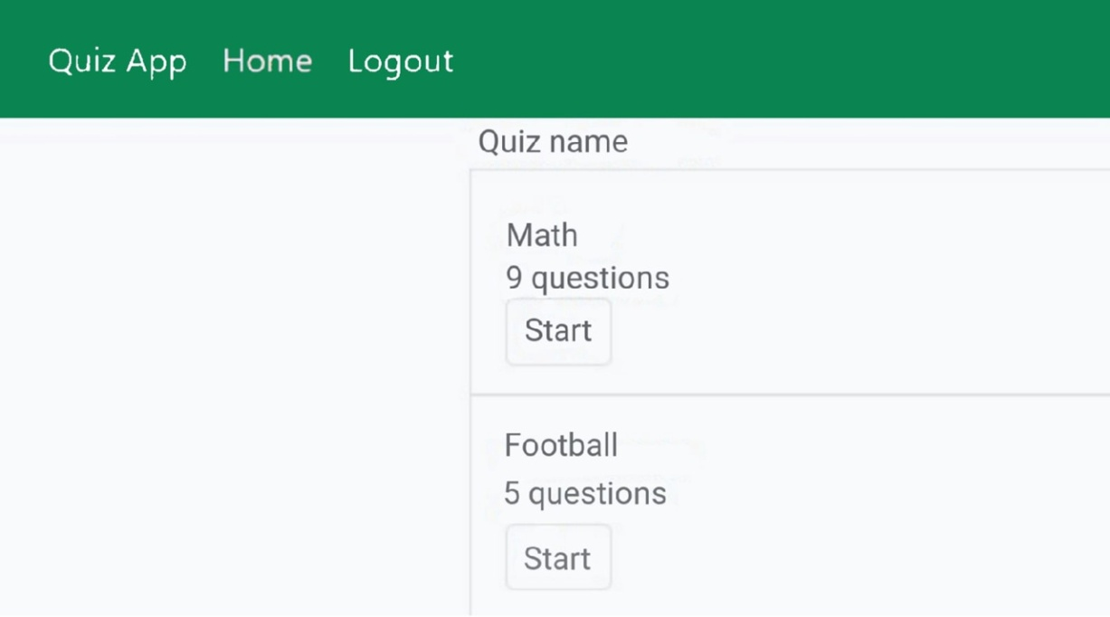

Choosing test

## *4. Passing the test, if user chooses correct answer, then correct answer is highlighted with green else: red*

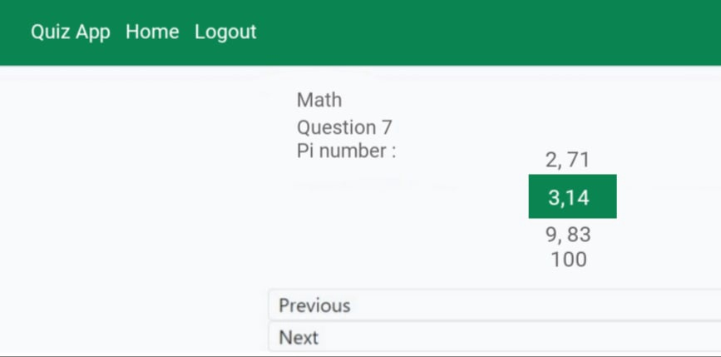

Correct answer

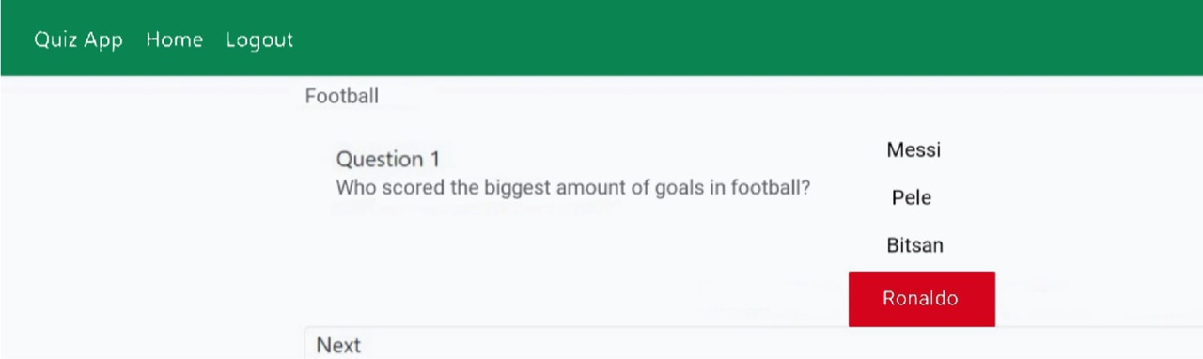

Incorrect answer

## *5. Showing final score*

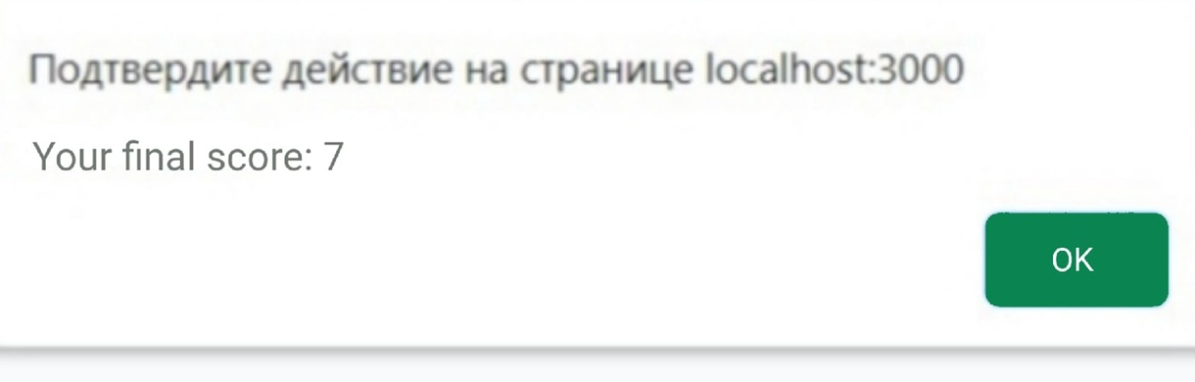

Final score

# 3. Conclusion

Results of my job from my point on view are good because personally I am not fete good in web but with my passion to pass the course I have learned new things and made application by using NextJs and also working nu writing functions, HTML elements and CSS selectors.