Champlain College - Lennoxville
Final game project: Game Design Prototype
Team
Team members:
Name: Samantha Jones | Role:
Name: Sigourney | Role:
Name: Micah | Role:
Name: | Role:

Final project – Game Design Document
Name of your game: | Dino Game
tentative – it can change later
The idea
Inspiration (optional)
If your game is inspired from an existing game, link it here. Add some screenshots to guide the design.
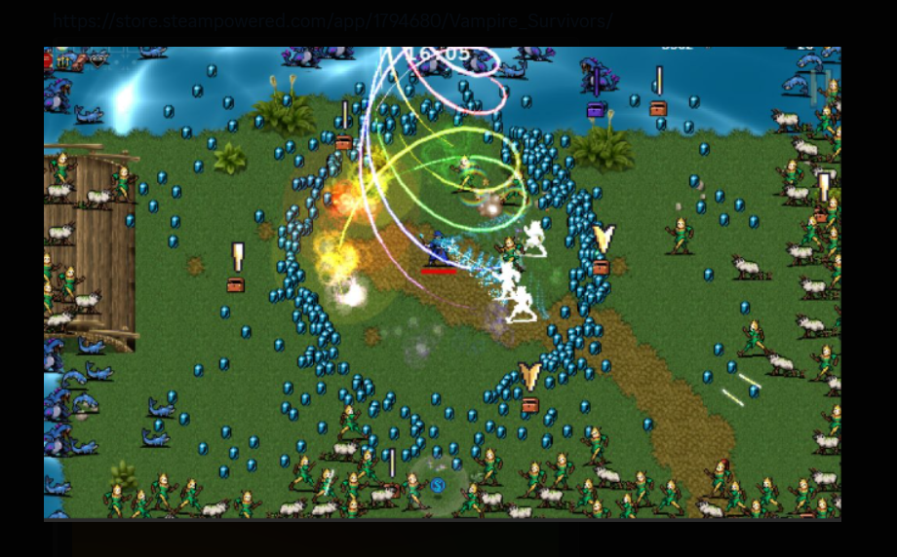
Genre (& subgenres?)
Action, roguelike,
Characters & story
Who do we control? Is there a story/lore to consider? Who are the enemies?
Control player
Theme & art style
Which asset library will you use? Provide images if need be.
Our own, music:
Gameplay
Goals
What is the main goal?
Complete three levels
Save town
Pass through the 3 levels
Difficulty & user skills
What prevents you from reaching your goal? What are the skills required to win?
Enemies and tickets that allow you to progress to next level with enough coin
Win/lose
How can one win the game? How can one lose? Do we have more than one attempt (life)?
You can win by passing the third level, and lose by loosing all your lives
Game mechanics
What is your core game mechanic? What are secondary game mechanics?
Shooting enemies, pick up collectables
Agency (optional)
Will the user be offered choices? What are the choices and options?
Choice of weapons
Inventory, items, pickups & upgrades
How can we modify our character and progress?
Choose what guns the character has
Level and world design
How many levels are there? How can we go from one level to another? Can we reach any part of the level at any moment?
3 levels, to get to next level you need to purchase a ticket
Other ideas
Any other ideas

Technical description (DO NO EDIT)
The game engine used will be Godot 4.4.
The game will be designed to be played on Windows computer.
A web version or a mobile version will also be available.
The Windows game will be built and executed as an .exe file. The web version will be accessible through a public endpoint. The mobile version is available in an .apk file.

Demographics (DO NO EDIT)
The game is not intended for any specific audience.
The game is suited for kids and adults as well.
The game does not contain any gore, mature or sexual content of any sort.

Marketing and Funding (DO NO EDIT)
This project will not be monetized. It is used for learning purposes.

Localization (DO NO EDIT)
The game will support two languages for now: - English and French.

