INPLAY GLOBAL

MESSAGING HOUSE — SPORTS INVESTING
Internal & Confidential • v2.0 (Final) • July 31, 2026 • Owner: Edwin Johnson
Purpose: the single source of truth for how InPlay talks about itself — for the founder, the corporate channels, and every agency or contractor who touches the brand. If copy conflicts with this document, this document wins. All public materials receive legal review (testing-the-waters) before publication.
THE HOUSE AT A GLANCE
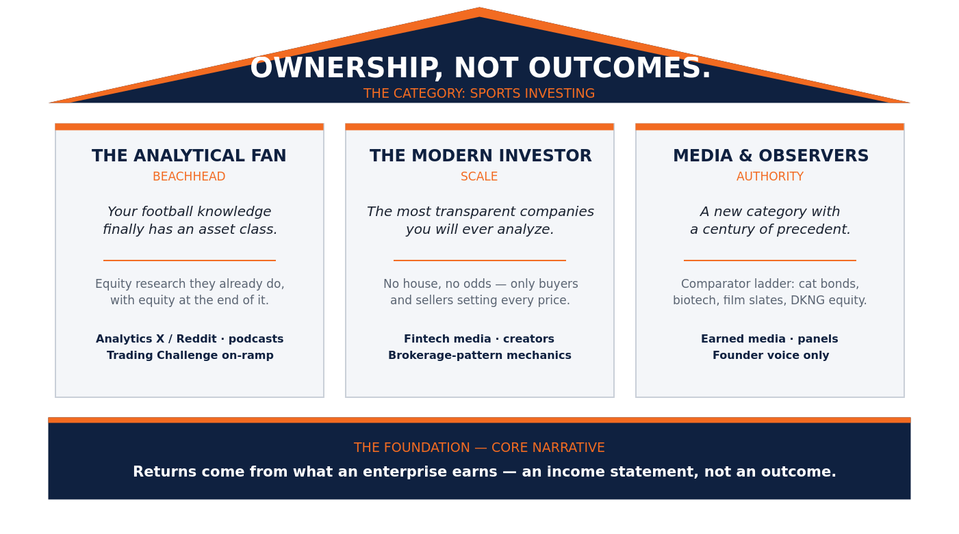
THE ROOF — MASTER IDEA
OWNERSHIP, NOT OUTCOMES.
The category we are creating: sports investing. Not a better bet. Not a legal alternative to anything. A new asset class — defined on its own terms, in its own vocabulary.
POSITIONING STATEMENT
For people who analyze the game, InPlay is the sports investing market where you own shares in operating companies that earn real revenue — because a share is a claim on what a business earns, not a position on a result.
BOILERPLATE — USE VERBATIM
InPlay Global operates a sports investing market: exchange-style trading in shares of operating companies built around professional and college football — real businesses with income statements, priced by buyers and sellers. Ownership, not outcomes.
THE FOUNDATION — CORE NARRATIVE
A bettor’s return has one source: the outcome. A shareholder’s return comes from what an enterprise earns — revenue built across an entire schedule of play and the commercial business around it, aggregated in an income statement, priced continuously by buyers and sellers. That is why a team can lose on Sunday and its stock can trade up on Monday: the price reflects the earning power of the business, not the last final score. InPlay is built on the earnings side of that line.
Usage rule: this passage never appears in consumer copy — the category is defined on its own terms there. Deploy in founder commentary, analyst briefings, and press conversations only, and always as product structure, never as a claim about anyone’s legality.

THREE PILLARS — AUDIENCE, MESSAGE, PROOF
PILLAR 1 — THE ANALYTICAL FAN (beachhead)
Promise: Your football knowledge finally has an asset class.
Message: You have been doing equity research your whole life — film, stats, roster construction — with no equity at the end of it. Now the analysis ends in ownership.
- Proof: team-company income statements; public listings you can buy and sell; research-grade transparency — the revenue drivers play on national television.
- Channels: football-analytics X and Reddit, podcasts, founder threads, the InPlay Trading Challenge as the on-ramp.
Voice applied (sample post): “You’ve been charting efficiency stats for a decade for free. Now the same film study is research on a company whose revenue drivers play on Sunday. Ownership, not outcomes.”
Never write: “Get in before kickoff and cash out big when your team covers.”
PILLAR 2 — THE MODERN INVESTOR
Promise: The most transparent companies you will ever analyze.
Message: Real operating companies, market-priced shares, and a business you can watch operate every single week.
- Proof: exchange-style pricing — no house, no odds, no one on the other side of your money but another investor; fractional access; a brokerage-shaped experience end to end.
- Channels: fintech media, investing creators, app-store presence, referral-share mechanics (brokerage-style, never bonus-shaped).
Voice applied (sample line): “Real operating companies, priced by buyers and sellers. No house, no odds — no one on the other side of your money but another investor.”
Never write: “A risk-free way to win money on football every Sunday.”
PILLAR 3 — MEDIA & SOPHISTICATED OBSERVERS
Promise: A new category with a century of precedent.
Message: Securities markets have always housed instruments whose economics ride uncertain events — catastrophe bonds, biotech equity, film financing, even DraftKings stock. The category test has never been certainty of revenue; it is what the holder owns.
- Proof: founder commentary (ex-CBOT market structure), the comparator ladder, the structure described factually and without legal conclusions.
- Channels: earned media, founder LinkedIn and X, conference panels, analyst briefings. This pillar is founder-voice only.
Voice applied (sample founder line): “Catastrophe bonds ride hurricanes and they’re securities. The category test was never certainty of revenue — it’s what the holder owns.”
Never write: “Unlike the gambling platforms in the news, InPlay is fully approved and legal.”

PROOF-POINT BANK (IN ORDER OF USE)
- Sunday/Monday — the hero. A team can lose the game and its stock can trade up, because the price reflects the earning power of the enterprise, not the last score. At launch, show it live: clip + thread + explainer the first time it happens.
- A claim on a business. Shareholders hold transferable equity in operating companies with income statements — many games, many contracts, many revenue lines. No game result triggers a payment to any shareholder.
- No house. Buyers and sellers set every price. No book, no odds, no vig — the market matches investors with each other.
- Built to earn on the field and off. Performance revenue across an entire schedule plus commercial revenue by design. Use design language until commercial results exist; every signed sponsorship graduates this from design to fact — announce each one loudly.
- The comparator ladder (sophisticated audiences only). Catastrophe bonds, biotech equity, film-slate financing, DraftKings stock: securities whose economics hinge on uncertain events. What the holder owns — not certainty of revenue — has always defined the category.

LEXICON — VOCABULARY IS COMPLIANCE
Our marketing corpus is discoverable. Every word below is a rule, not a preference.
ALWAYS SAY | NEVER SAY
Investors, shareholders, owners  Shares, listings, positions, portfolio  Buy, sell, hold, trade  Earnings, revenue, income statement, dividends  Market price, order book, buyers and sellers  Analyze, research, invest  “Own the economics of the season”  Sports investing (the category name) | Users, players, bettors  Bets, wagers, picks, action, entries  Odds, lines, parlays, sweat  Win money, payout, cash out  “Play” (as the product verb)  “Own your team” (equity is in team companies, never the franchise)  Risk-free, guaranteed, approved, vetted, endorsed  “Prediction market” as a self-description; any settlement or “longer bet” framing

RED LINES — NON-NEGOTIABLE
- Never state or imply regulator approval or endorsement. Qualification is not approval.
- No claims about current revenue mix ahead of the income statement. Design language (“built to earn on the field and off”) until commercial results exist.
- Shareholders own equity in team companies — never the franchise, never league IP, no implied league affiliation.
- No betting-shaped promotions: no deposit-match bonuses, no “risk-free” mechanics, no free-bet analogs. Brokerage-pattern mechanics — referral shares, fractional-share promotions — are the approved shape.
- No named competitors and no legal conclusions in public copy. Reference the moment obliquely: “as regulators draw lines around prediction markets…”
- No performance promises, return expectations, or outcome guarantees. Ever.
- Skill-versus-chance is not our argument. Never lead with “sports is skill.” Our line: it is not about how skilled the participant is — it is about what the participant owns.
- All public materials use official IPG logos and brand colors, and receive legal review before publication.

CAMPAIGN PHASING
PHASE 1 — DEFINE (now → qualification). Founder-led category education: weekly market-structure commentary, the “Ownership, not outcomes” series, corporate channel runs a measured educational cadence. Build the waitlist and the vocabulary before there is anything to sell. KPIs: waitlist growth; share of voice on “sports investing.”
PHASE 2 — DEMONSTRATE (launch). Analytical-fan beachhead. The hero demo is the first live Sunday/Monday divergence — packaged same-day. Trading Challenge as the on-ramp. KPIs: funded accounts; first-trade activation.
PHASE 3 — PROVE (commercial ramp). Every sponsorship signing is a dual-purpose announcement — marketing content and fact pattern. The “on the field and off” message goes loud only as deals sign. KPIs: commercial revenue share of narrative; earned-media adoption of the category term.

VOICE
Founder voice: first person, floor-trader’s authority, market-structure commentary. Carries the category argument and the comparator ladder. Confident, never defensive — sides with regulators drawing lines, never argues with them.
News posture (all spokespeople): “We don’t comment on litigation involving other companies. What I can tell you is what shareholders in InPlay’s team companies own: actual equity in operating businesses with income statements.” Then bridge to the core narrative. Never name competitors; never characterize anyone’s legality — including our own beyond the factual description of the structure.
Corporate voice: cool, precise, educational. Never argues with anyone; explains the category as if it were already obvious. One tagline, everywhere: OWNERSHIP, NOT OUTCOMES.
If InPlay is named directly (regulator, journalist, or platform inquiry): no one responds in real time. Acknowledge, take contact details, route to counsel and the founder the same day. One holding line only: “We’ll make sure the right person gets back to you.” InPlay-specific legal questions are answered by the founder alone, with counsel’s guidance — never by any other spokesperson and never improvised.

APPENDIX — OBJECTION HANDLING & PRODUCT CONTRAST
Audience gate: internal, founder commentary, analyst briefings, and press conversations only. This material never appears in consumer copy — the category is defined on its own terms there — and is always deployed as product structure, never as a claim about anyone’s legality.
A fair word on prediction markets, because the contrast defines the category: a sharp trader can make money in them. The product simply caps what the work is worth. Every contract is binary — right or wrong, a dollar or zero — so the maximum payout is fixed before the trade is ever placed. Fees and spreads are charged against edges that thin. Every event must be underwritten again from scratch — the analysis never compounds. And the market is only alive while the question is open: the moment an outcome becomes obvious, the price pins near certainty and the other side of the trade disappears — you can be exactly right and unable to exit at fair value. Equity inverts all of it. A share’s value has no predetermined ceiling, because it tracks what the enterprise earns. One piece of research covers an entire operating business, not a single question. And certainty doesn’t kill the market — a decided game simply posts to the income statement as earned revenue, and the market moves on to pricing the rest of the business. Skilled analysis deserves a product without a lid on it.
Mirror question (counsel sign-off required before any external use): “Doesn’t your market thin out when a team’s season is decided?” Directional answer only: a decided game becomes booked revenue rather than a dead contract, and shares keep their claim on everything the company has already earned. Do not improvise mechanics — no statements about price convergence, distributions, or market-maker obligations.

