SYSTEM DESIGN · TECHNOLOGY STACK
HRMS Platform
Multi-tenant HR platform and public API: architecture, technology stack and delivery plan
Version: 1.1 (review findings applied)
Date: 21 September 2026
Status: Ready for review and approval
Source: SURAJ Group HRMS Business Requirements v2.0 (17 Sep 2026)
Scope: All modules except Performance/KPI (§16)
Classification: Confidential

Document control
Table 1. Version history
Version | Date | Change
0.1 | 21 Sep 2026 | Requirements analysis and multi-tenant architecture (design system artifact)
1.0 | 21 Sep 2026 | First complete system design (web page)
1.1 | 21 Sep 2026 | This document. Applies all 39 findings of the design review: a launch architecture separate from the target, an identity proof of concept, master-data ownership, a worker-level API identity, the isolation fixes and honest disaster-recovery tiers. Consolidates the technology stack.

Table 2. Approvals (fill in on sign-off)
Role | Name | Decision | Date
Product owner
Head of engineering or architecture lead
Security and compliance lead
HR business owner (SURAJ Group)
Finance (cost, pricing, billing)

How to use this document
- Sections 1 and 14 give the decisions and the technology stack. Read these first.
- Sections 2 to 13 are the design: requirements, capability map, architecture, data, identity, workflows, integrations, the API product and infrastructure.
- Sections 15 and 16 are the delivery plan, proofs of concept, open decisions and risks.
- References such as §12 point to sections of the requirements document. Recommended marks a decision awaiting approval. Proposed marks a target to confirm.
- Legal and statutory statements are guidance, not legal advice. Confirm them with counsel and the compliance owner.
Contents
Document control 2
How to use this document 2
1. Executive summary 5
1.1 What we are building 5
1.2 Design principles 5
1.3 Key decisions 5
1.4 Technology stack at a glance 6
1.5 What changed after the design review 7
2. Scope and requirements 8
2.1 Goals and non-goals 8
2.2 Product surfaces 8
2.3 System context 9
2.4 Non-functional requirements (proposed targets) 9
3. Capability map 11
4. Architecture overview 13
4.1 Launch architecture 13
4.2 Target architecture 14
4.3 Growth triggers 15
5. Tenancy and isolation 16
5.1 Isolation rules 16
6. Application architecture 18
7. Data architecture 19
7.1 Worker, employment and assignment 19
7.2 Core data model 20
7.3 Effective dating and history 21
7.4 Sensitive data 21
7.5 Audit 21
7.6 Stores and retention 21
8. Master data ownership and integration mode 23
9. Identity and access 24
9.1 Sign-in 24
9.2 What Keycloak does, and what we build 24
9.3 Authorization 25
10. Workflows, rules and obligations 26
10.1 Approval engine 26
10.2 Configuration layers 27
10.3 Obligations and exceptions 27
11. Events and integrations 28
11.1 Events 28
11.2 Attendance ingestion 29
11.3 Payroll input contract 30
11.4 Integration catalogue 30
12. The API product 31
12.1 Buyers and packaging 31
12.2 API platform 32
12.3 One API call 33
12.4 Design standards 33
12.5 Contract-first lifecycle and versioning 34
12.6 API security 34
12.7 API catalogue 35
12.8 Webhooks and the change feed 36
12.9 Developer experience 36
12.10 Metering, limits and billing 36
13. Infrastructure and operations 38
13.1 AWS deployment 38
13.2 Accounts and network 39
13.3 Environments and delivery 39
13.4 Observability 40
13.5 Disaster recovery 40
13.6 Security and compliance 40
13.7 Capacity and cost 41
14. Technology stack 42
14.1 Paid services and licences 45
14.2 Portability 45
15. Delivery plan 46
15.1 Teams 46
15.2 Roadmap (indicative) 46
15.3 Proofs of concept (Phase 0a) 47
15.4 Testing strategy 47
16. Decisions, checks and risks 48
16.1 Open decisions 48
16.2 Verification checklist 48
16.3 Risks 48
Appendix A. Glossary 50

1. Executive summary

1.1 What we are building
The HRMS Platform is two products on one codebase:
- A multi-tenant HR application for organisations of 10 to 200,000 employees, across industries and locations.
- A public API product that customers, software vendors and integration platforms build on.
SURAJ Group is the first tenant, not the shape of the product. Every SURAJ-specific rule becomes configuration, and every capability in the requirements is reachable through a documented, versioned and metered API.
The design starts small and grows by trigger. At launch it runs in one AWS cell in Mumbai: a modular Java application on PostgreSQL, with S3, a cache and queues. Heavier components (Kafka, Temporal, OpenSearch, ClickHouse, extra cells) are added only when a stated trigger is reached. The data model, tenancy, APIs and events are designed for the target from day one, so growth does not mean a rewrite.

1.2 Design principles
- Tenant context everywhere. Every request, job, event, cache key, file path and log line carries the tenant, and a missing tenant fails loudly.
- Configuration, not customisation. Tenant differences are data (settings, packs, custom fields, workflow definitions), never code branches.
- Two clocks. Every business fact has an effective date, and every change is audited with who, when and why.
- One worker record for life in a tenant, with employments and dated assignments under it. Information is entered once.
- Access is decided centrally and enforced in the data layer (rows and fields) for screens, APIs, reports, search, exports and messages.
- Complexity is opt-in. A 20-person tenant sees a simple product; a 50,000-person tenant switches on entity groups, positions and matrix reporting.
- Packs, not forks. Country rules (India PF/ESIC first) and industry defaults are versioned packs.
- API-first and event-first. Our own apps use the same contracts that customers use.
- Start small, grow by trigger. Every heavy component has a launch substitute and a written trigger.

1.3 Key decisions
Table 3. Architecture decisions
ID | Decision | At launch | At scale | Status
ADR-01 | Tenancy: pooled PostgreSQL with row-level security; dedicated tiers use the same schema | One pooled cell | Dedicated databases and cells | Recommended
ADR-02 | Deployment: cells on AWS, Mumbai primary, Hyderabad for DR | One cell; pilot-light DR | N cells; warm regional tier | Recommended
ADR-03 | Application: modular monolith (Java 21, Spring Boot, Spring Modulith) | One deployable plus workers | Plus satellite services | Recommended
ADR-04 | Data: Aurora PostgreSQL, effective-dated, with history for assignment and compensation | Multi-AZ cluster | Read replicas, Global Database | Recommended
ADR-05 | Async events: transactional outbox | Relay to Amazon SQS | Debezium to Kafka (MSK) | Recommended
ADR-06 | Workflows: in-house approval engine | PostgreSQL + db-scheduler | Temporal, if triggered | Recommended
ADR-07 | Identity: Keycloak plus our installation service | Chosen by proof of concept | Same | Pending PoC
ADR-08 | Authorization: roles × data scopes × data classes × conditions, compiled to SQL; synchronous revocation | Same | Same | Recommended
ADR-09 | API: REST, OpenAPI 3.1, contract-first, worker-level IDs; Kong gateway | Kong OSS + our plugin | Kong Enterprise, if needed | Pending PoC
ADR-10 | Sync: thin signed webhooks, opt-in directory fields, change feed | In-house dispatcher | Svix, if needed | Recommended
ADR-11 | Clients: React SPA behind a BFF; React Native app | Same | White-label builds | Recommended
ADR-12 | Analytics: one set of metric definitions | Replica, views, snapshots | ClickHouse + Cube | Recommended
ADR-13 | Observability: OpenTelemetry | AWS managed Prometheus and Grafana | Self-hosted Grafana stack | Recommended
ADR-14 | Delivery: GitHub Actions, Argo CD and Rollouts, Terraform | Same | Same | Recommended
ADR-15 | Billing: Chargebee + Razorpay; usage from gateway logs | Same | AWS Marketplace | Recommended
ADR-16 | Master data: ownership per field group; integration mode | HRMS-owned by default | Per tenant | Recommended
ADR-17 | Portability: every cell dependency has a portable equivalent | Kept in adapters | Private cells | Recommended

1.4 Technology stack at a glance
Table 4. Stack summary (full detail in section 14)
Layer | Use at launch | Add when triggered
Cloud | AWS Mumbai (ap-south-1); DR in Hyderabad (ap-south-2) | More cells; other regions for residency
Backend | Java 21 LTS, Spring Boot, Spring Modulith, jOOQ, Flyway | Satellite services on the same stack
Database | Aurora PostgreSQL 16+ with RLS; PgBouncer | Dedicated clusters; warm Global Database
Async and jobs | Outbox → Amazon SQS; db-scheduler; in-house approval engine | Amazon MSK (Kafka) + Debezium; Temporal
Search | PostgreSQL full-text + pg_trgm | Amazon OpenSearch Service
Identity | Keycloak 26+ (Organizations) + our installation service (PoC first) | None
API | Kong Gateway OSS + tenant plugin; OpenAPI 3.1; Redocly | Kong Enterprise/Konnect; Svix
Web and mobile | React + TypeScript + Vite; React Native (Expo) | White-label mobile builds
Analytics | Read replica, materialized views, daily snapshots | ClickHouse + Cube
Observability | OpenTelemetry → Amazon Managed Prometheus/Grafana; CloudWatch; Sentry | Self-hosted Grafana LGTM
Delivery | GitHub Actions, Argo CD, Argo Rollouts, Terraform + Terragrunt | None
Billing | Chargebee + Razorpay | AWS Marketplace listing

1.5 What changed after the design review
Table 5. Review findings and their resolution
Review finding | Change in this version
C1 Launch footprint too big | Separate launch and target architectures, with triggers (section 4)
C2 Identity assumptions | Keycloak limits stated; installation service specified; proof of concept before commitment (sections 9, 15.3)
C3 No system-of-record model | Master-data ownership per field group and an integration action mode (section 8)
C4 Isolation contradictions | Control plane receives aggregates only; regional shared tier made explicit (sections 5, 4.2)
H1 Browser tokens, first-party quotas | Web BFF with httpOnly cookies; first-party client class (sections 9.2, 12.10)
H2 Employee versus employment | Stable wrk_ worker ID; employments and assignments under it (sections 7.1, 12.7)
H3 App data scopes | Installations carry data scopes and field classes (section 9.3)
H4 Device reality | Hardened device edge for HTTP-only devices; site agent as default (section 11.2)
H5 Revocation lag | Revocations are synchronous (section 9.3)
H6 Audit bottleneck | Batched Merkle sealing per minute (section 7.5)
H7 Optimistic RTO | DR tiers with honest targets; no contractual RTO before rehearsal (section 13.5)
H8 Bitemporal effort | Temporal storage approach specified (section 7.3)
H9 Field encryption | Named encrypted fields; data-key caching; compensation in a restricted schema (section 7.4)
H10 Metrics cardinality | Tenant in traces and logs, not in metric labels (section 13.4)
H11 Divergent documents | This document supersedes the earlier drafts
M1 to M17, L1 to L7 | Applied throughout: change feed and erasure events, naming, enum tolerance, break-glass, explainability, device integrity, custom domains, subprocessors, team size, durations, licence list

2. Scope and requirements

2.1 Goals and non-goals
Goals:
- One codebase and schema for every tenant, industry and region.
- Tenant isolation that can be demonstrated to enterprise security reviewers.
- An API good enough to sell on its own.
- Operable by a team of about 15 engineers.
Non-goals for the first releases:
- Performance/KPI management.
- An in-house payroll engine. Payroll inputs are in scope; the engine waits for decision D10.
- Direct filing on government portals. The requirements (§20) ask for links and evidence only.
- Cross-tenant features such as shared talent pools or benchmarks.

2.2 Product surfaces
Surface | Users | Platform
HR console | HR, managers, Accounts/Payroll, Admin/IT, management | Web SPA, 16:9 desktop (§38), behind the web BFF
Employee app | Employees and managers | iOS and Android (React Native) plus responsive web; OTP login
Admin console | Tenant administrators | Web: configuration, roles, integrations, API apps, audit log
Careers and pre-joining portal | Candidates | Web: applications, offers, pre-joining documents
Developer portal and console | Integration developers, ISVs | Public docs; signed-in console for apps, keys, usage, webhooks
Public API and webhooks | Customer systems, ISVs, iPaaS | REST/JSON, OAuth 2.0, signed webhooks, change feed
Ops console | Our SRE, support, finance | Internal: tenants, cells, releases, just-in-time support access

2.3 System context
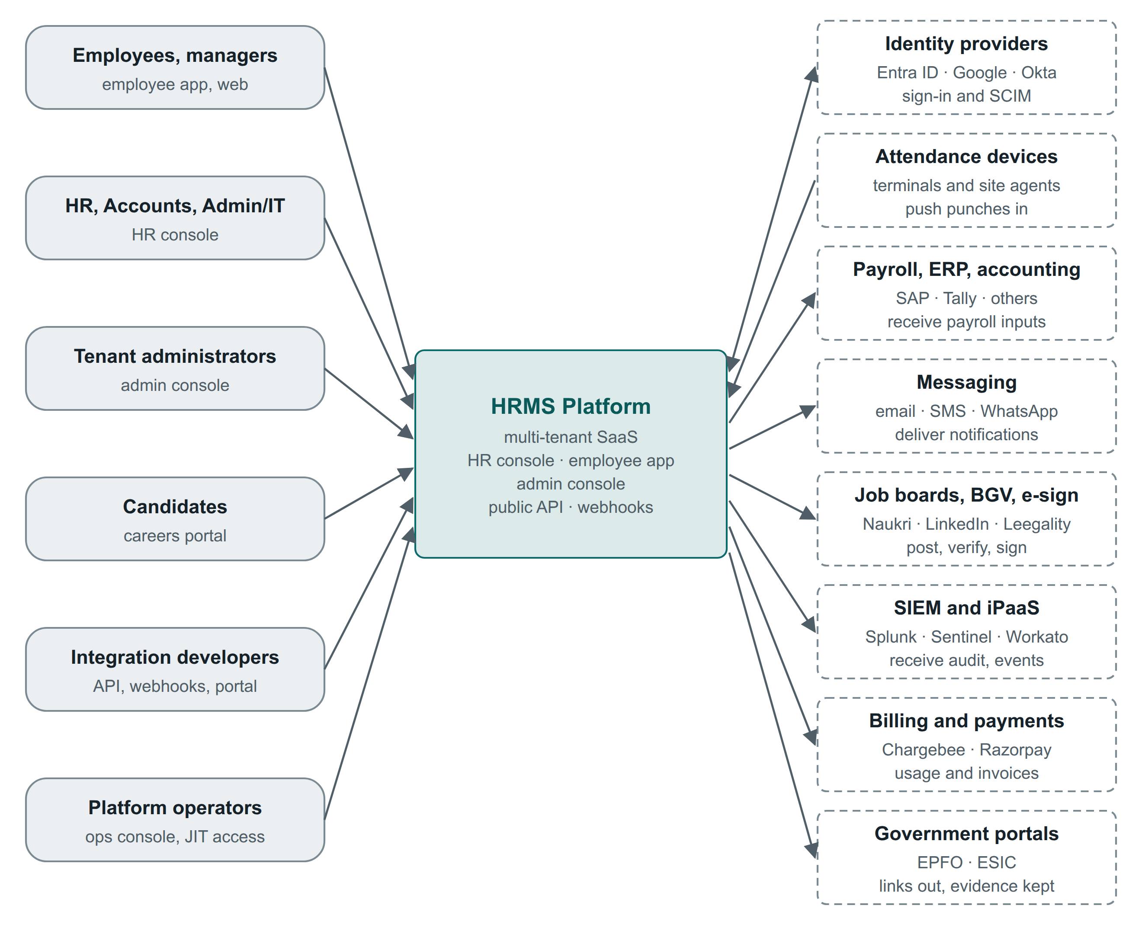
Figure 1. The people who use the platform, and the external systems it exchanges data with. Identity providers exchange data both ways; attendance devices push into the platform.

2.4 Non-functional requirements (proposed targets)
ID | Quality | Target | How it is met
NFR-01 | Availability | 99.9% monthly for pooled tenants; 99.95% for Enterprise dedicated cells | Multi-AZ; cells limit blast radius; ring deployments
NFR-02 | Punch ingestion | 99.95%; devices and agents buffer offline | Separate ingestion path; idempotent retries
NFR-03 | Data loss (RPO) | ≤ 5 minutes for every tier | Aurora Global Database (typically ~1 s); S3 replication
NFR-04 | Recovery (RTO) | Standard ≤ 4 h; Enterprise warm ≤ 1 h. Not contractual until rehearsed. | DR tiers in section 13.5
NFR-05 | API latency | p95 ≤ 300 ms reads, ≤ 600 ms writes; p99 ≤ 1 s | Scoped indexed queries; replicas; caching
NFR-06 | Webhook latency | p95 ≤ 60 s from commit to first attempt | Outbox relay; queue; dispatcher
NFR-07 | Search | p95 ≤ 500 ms for scoped employee search | PostgreSQL full text, then OpenSearch
NFR-08 | Cell throughput (design point) | 500 API req/s sustained, 2,000 burst; 5 M punches/day, 2,000/s peak | Horizontal pods; partitioned tables
NFR-09 | Batch window | Month-end close for every tenant in a cell within 4 h | Per-tenant jobs; fair queues
NFR-10 | Cell capacity | Up to 2,000 tenants or 1 M employees; > 20,000-employee tenant gets a dedicated DB; > 100,000 gets a dedicated cell | Placement rules; tenant mobility
NFR-11 | Security | OWASP ASVS L2 (L3 for authentication); pen test before GA and yearly; critical fixes ≤ 7 days | Section 13.6
NFR-12 | Privacy | DPDP-ready: purpose, retention, data-principal requests, breach support | Retention engine; DSR workflow
NFR-13 | Audit | Tamper-evident; 7-year default retention, tenant-configurable | Sealed audit log; S3 Object Lock
NFR-14 | Accessibility | WCAG 2.2 AA on web and mobile | Design system rules; axe in CI
NFR-15 | Localisation | English at launch; Indic languages next; RTL-ready layout | ICU messages; Noto fonts

3. Capability map
Each row traces a capability in the requirements to the module that owns it, the data it owns, the API resources that expose it, the events it publishes, and the delivery phase (section 15.2).
Capability (§) | Owning module | Owns (key data) | API resources | Key events | Phase
Organisation (§2, §32) | Organisation | Legal entities, registrations, locations, org units, jobs, grades, positions, cost centres, dimensions | /v1/legal-entities, /v1/locations, /v1/org-units, /v1/jobs, /v1/positions | org_unit.changed, location.changed | 0–1
Users and access (§3, §33) | Kernel: identity, authorization | Users, roles, data scopes, class grants, installations | /v1/admin/users, /v1/admin/roles, /scim/v2 | access.role_assigned, access.role_revoked | 0
Employee Master, 360 (§7, §8) | People | Worker, employment, assignment, identifiers, contacts | /v1/workers, /v1/employments | employment.started, worker.updated | 1
Lifecycle changes (§7, §14) | People: personnel actions | Actions, reason codes, letters | /v1/personnel-actions, :bulk | personnel_action.*, employment.assignment_changed, employment.status_changed | 1–2
Onboarding (§9) | Talent | Onboarding cases, checklists | /v1/onboarding-cases | onboarding.completed | 1
Manpower (§10) | Talent | Headcount plans, requisitions | /v1/requisitions | requisition.approved | 3
Recruitment (§11) | Talent | Vacancies, candidates, applications, interviews, offers | /v1/vacancies, /v1/candidates, /v1/offers | candidate.stage_changed, offer.accepted | 3
Attendance (§12) | Time | Shifts, rosters, punches, days, corrections, periods | /v1/punches:batch, /v1/attendance-days | attendance_period.closed | 2
Leave (§13) | Absence | Leave types, policies, ledger, requests, holidays | /v1/leave-requests, /v1/leave-balances | leave_request.*, leave_balance.changed | 2
Training (§15) | Learning | Programmes, sessions, enrolments, feedback | /v1/learning-sessions | enrolment.completed | 3
Payroll and salary (§17) | Compensation, payroll inputs | Structures, revisions, pay groups, input snapshots | /v1/payroll-periods/{id}/inputs | payroll_inputs.published | 2 inputs; 5 engine
Assets (§18) | Assets | Register, assignments, returns | /v1/assets | asset.assigned, asset.returned | 3
Exit (§19) | Separation | Exit cases, clearance items, F&F inputs | /v1/separations | employment.ended, clearance.completed | 1 basic; 4
Statutory compliance (§20) | Compliance | Registrations, obligations, evidence, statutory profiles | /v1/compliance-obligations | compliance_obligation.due, .overdue | 4
Documents (§21) | Kernel: documents | Documents, versions, templates, letters | /v1/documents | document.verified, document.expiring | 1
HR requests (§22) | Service desk | Requests, SLA clocks | /v1/hr-requests | hr_request.created, hr_request.resolved | 2
Policies (§23) | Policies | Policies, versions, acknowledgements | /v1/policies | policy.published, policy.acknowledged | 2
Dashboard, reports (§6, §24) | Analytics, Experience | Metric definitions, snapshots | /v1/metrics, /v1/bulk-exports | None | 1 → 5
Self-service, mobile (§25, §35) | Experience (BFF) | None of its own | Uses the public API contracts | None | 1–2
Notifications (§26) | Kernel | Templates, preferences, deliveries | Internal | obligation.due, obligation.overdue | 0
Approvals (§27) | Kernel: approval engine | Definitions, instances, tasks, delegations | /v1/tasks | task.created, task.completed | 0
History, audit (§28) | Kernel: audit | Audit entries, seals, sensitive-read log | /v1/admin/audit-events | Streamed to SIEM | 0
Exceptions (§29) | Kernel | Exception records | /v1/exceptions | exception.approved, exception.expired | 0
Settings and masters (§32) | Kernel: configuration | Config objects, packs, bundles | /v1/admin/config-bundles | config.published (internal) | 0
Integrations (§34) | Integration hub | Connections, mappings, runs | /v1/integrations, /v1/bulk-imports | integration_run.failed | 1 → 5
Search (§31) | Kernel: search | Search index (derived) | /v1/search | None | 1

4. Architecture overview

4.1 Launch architecture
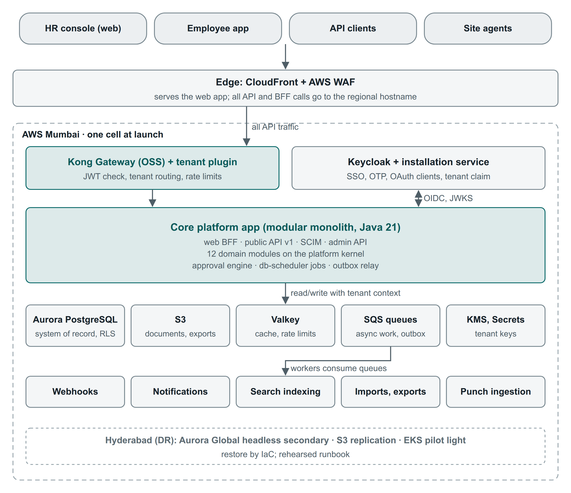
Figure 2. Launch architecture: one cell in Mumbai. All traffic passes the gateway; the core application holds the web BFF, public API and every module; workers take work from queues.
- One cell runs everything that holds tenant data: the core application, workers, Aurora PostgreSQL, S3, Valkey and SQS.
- Events are written to an outbox table in the same transaction as the change. A relay in the application forwards them to SQS queues for workers (webhooks, notifications, search indexing, imports and exports, punch ingestion).
- Jobs and timers (reminders, escalations, scheduled effective dates, month close) run on a PostgreSQL-backed scheduler (db-scheduler). Approvals run on our own engine over PostgreSQL state.
- Search uses PostgreSQL full-text and trigram indexes over the permitted population.
- Reports read from an Aurora read replica, materialized views and daily headcount snapshots.
- Disaster recovery: Aurora Global Database with a headless secondary in Hyderabad (storage replicates; instances are added when promoting), S3 replication, and an EKS cluster kept ready at zero nodes.

4.2 Target architecture
At scale the same design gains more cells, a regional shared tier (identity, gateway, analytics, observability; multi-AZ with its own error budget) and satellite services. The control plane receives aggregates only (tenant, date, active count), never employee events.
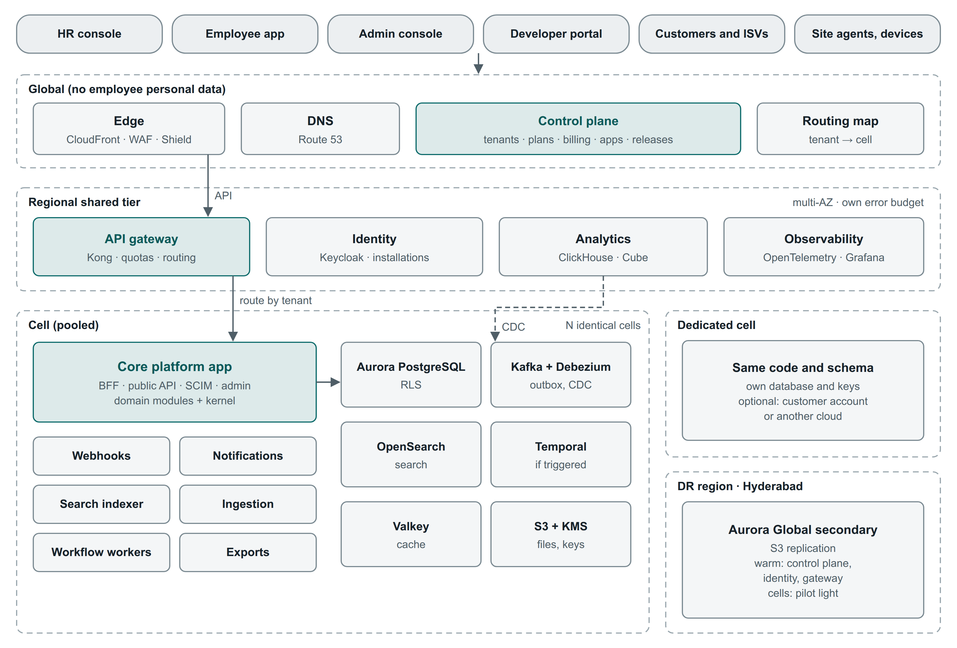
Figure 3. Target architecture: a global layer without employee data, a regional shared tier, N identical pooled cells, dedicated cells and a Hyderabad DR region. Kafka, OpenSearch and Temporal appear here only once their triggers are met.

4.3 Growth triggers
Table 6. Components added by trigger
Component | Launch substitute | Add when | Why wait
Amazon MSK (Kafka) + Debezium | Outbox + SQS | > 3 consumers need replay, CDC to analytics is needed, Enterprise event streaming is sold, or > ~500 events/s sustained | A production MSK cluster needs three brokers per cell
Temporal | Approval engine + db-scheduler | Long cross-system orchestrations (payroll runs, multi-step connectors) or scheduler lag under load | Another stateful system, or usage-priced cloud
OpenSearch | PostgreSQL full text + pg_trgm | Document search, > ~500,000 employees in a cell, or search p95 > 500 ms | Cost and reindex operations
ClickHouse + Cube | Replica + views + snapshots | Analytics API sold, or dashboards p95 > 2 s | CDC pipeline and a shared regional store
Svix | In-house dispatcher | > ~1 M deliveries a day, or a customer-facing endpoint portal | Extra service; feature parity to verify
Kong Enterprise / Konnect | Kong OSS + our plugins | Need for gateway-side OpenAPI validation, advanced analytics or its portal | Licence cost
AWS Shield Advanced | Shield Standard + WAF | First Enterprise SLA contract, or a DDoS incident | Fixed fee of about USD 3,000 a month
AWS Network Firewall | Security groups, NAT, egress allowlist proxy | Enterprise egress audit requirement | Charged per AZ-hour plus traffic
Second pooled cell | None | Cell at 70% of its design point (NFR-08, NFR-10) | Fixed cost per cell
Dedicated database or cell | Pooled | Tenant > 20,000 or > 100,000 employees, residency, or contract | Priced to cover its fixed cost
Self-hosted Grafana stack | AWS managed Prometheus/Grafana, CloudWatch | Observability bill passes an agreed threshold | Operational effort

5. Tenancy and isolation
A tenant is one customer organisation under one contract. It is the isolation boundary, the configuration root, the identity boundary and the billing account. Inside a tenant sit legal entities (optionally grouped), locations, org units and the other dimensions of section 7. SURAJ Group is one tenant with several legal entities. Its group dashboards, inter-company transfers and group-unique IDs need that.
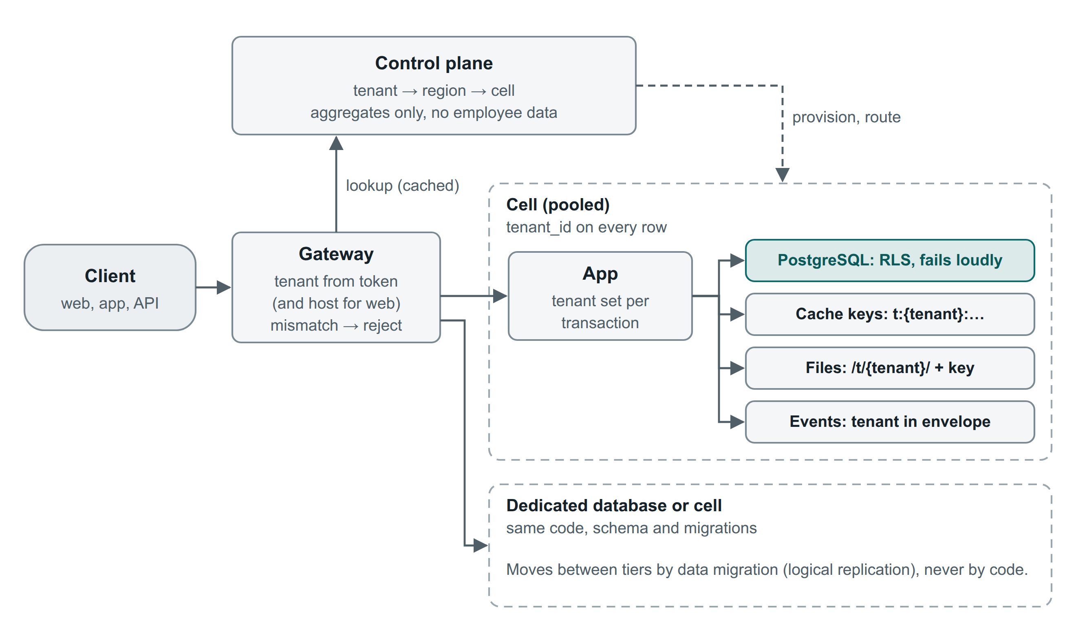
Figure 4. How a request finds its tenant and carries that tenant into every store.
Table 7. Isolation tiers (same code, schema and migrations)
Tier | Data | Compute | Typical tenant
Pooled | Shared Aurora cluster; tenant_id on every row; RLS | Shared cell | SMB and mid-market; trials
Pooled + dedicated database | Own Aurora cluster | Shared cell | > 20,000 employees; heavy batch; strict review
Dedicated cell | Full stack; optionally the customer's AWS account or another cloud | Own | > 100,000 employees; regulated; private deployment

5.1 Isolation rules
- Tenant from the verified token only. The gateway strips inbound tenant headers; for web it also checks the host against the token.
- Every statement runs inside a transaction that sets the tenant (set_config('app.tenant_id', …, true)). The data layer rejects autocommit reads. RLS uses FORCE ROW LEVEL SECURITY and fails loudly (a cast error) if the setting is missing, never returning silently empty results.
- Keys include tenant_id. Primary keys, unique constraints and composite foreign keys all include it, so rows cannot reference another tenant.
- Everywhere else too: tenant-prefixed cache keys, per-tenant S3 prefixes and KMS data keys, tenant in every event envelope, per-tenant background jobs.
- Control plane gets aggregates only. Cells send daily counts per tenant for billing; no employee events leave the cell.
- Tenant moves between tiers use logical replication and a short cutover. There is no long write freeze.
- A cross-tenant leakage suite runs in CI: two tenant fixtures, every route and event consumer called with the other tenant's IDs.

6. Application architecture
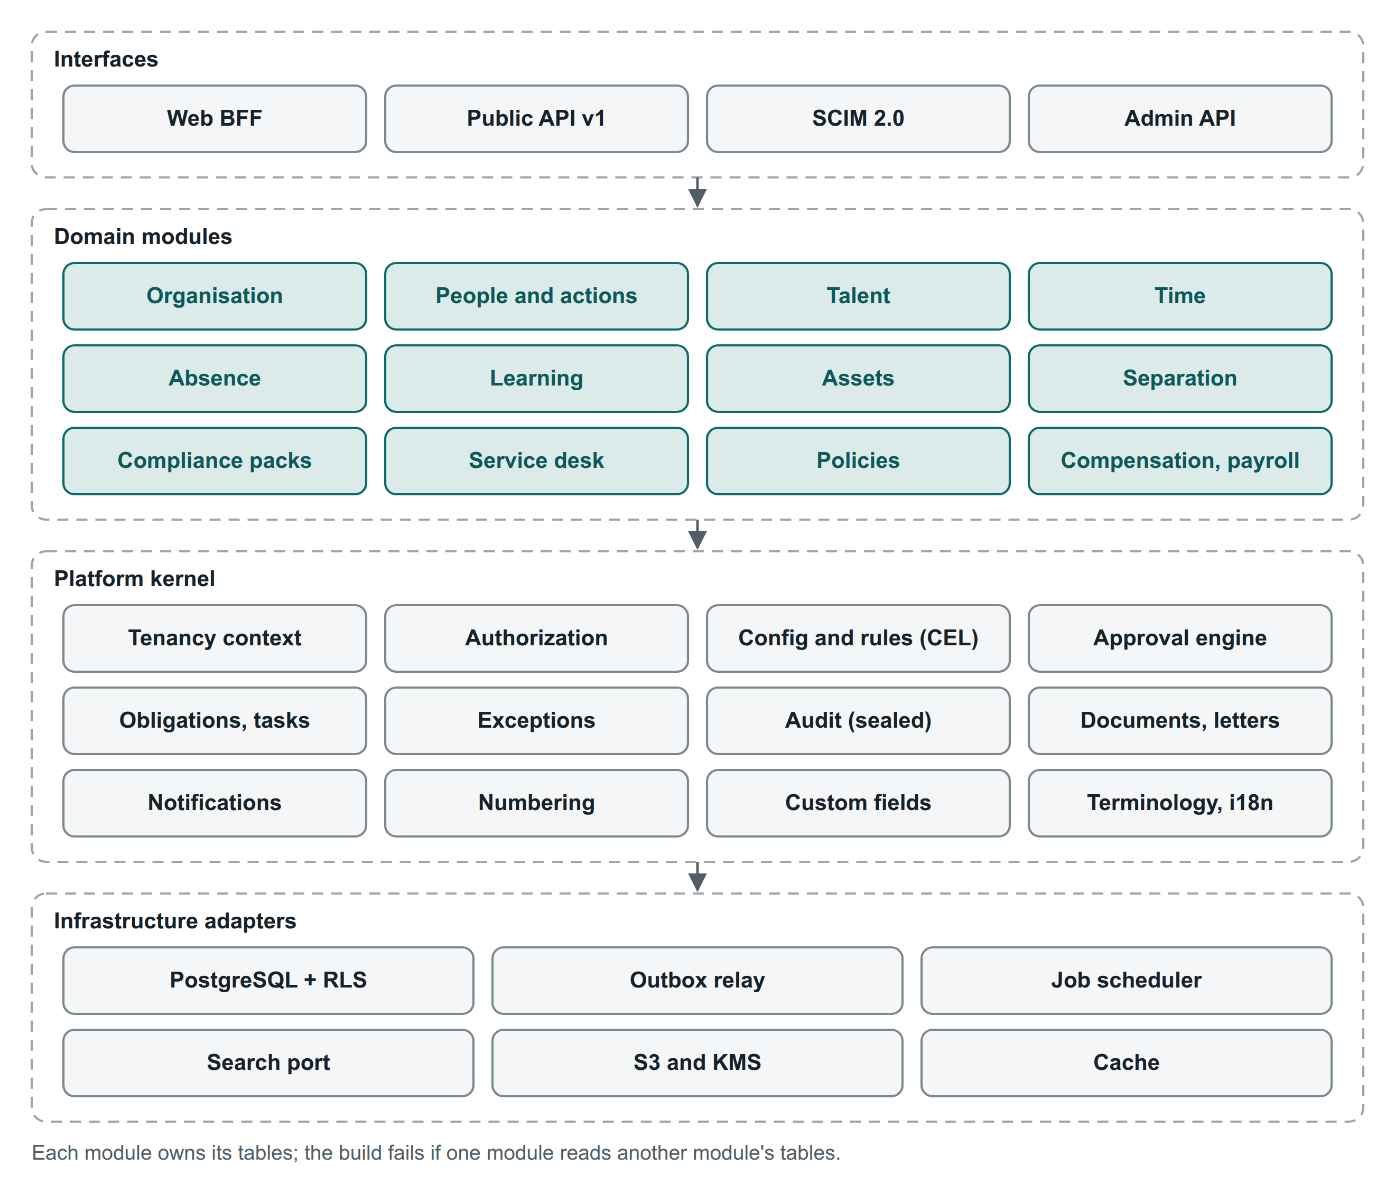
Figure 5. Inside the core platform application: interfaces, twelve domain modules, the platform kernel and infrastructure adapters.
- Java 21 LTS, Spring Boot, Spring Modulith. Each module has a published API package and an internal package. Spring Modulith and ArchUnit fail the build if a module reaches into another module's tables or internals.
- Persistence: Spring Data JPA (Hibernate 6) for aggregates, jOOQ for temporal and reporting SQL, Flyway migrations per module.
- Rules: CEL (cel-java) with a curated function library and cost limits; no tenant-authored code.
- Contract-first interfaces: the OpenAPI 3.1 documents generate server interfaces, validators, TypeScript types and SDKs.
- Module contract: each module declares its entities and data classes, permissions, configuration types, obligation types, events, API routes, dashboard cards, report datasets and migrations. New modules (rostering, payroll, performance) plug in the same way.
- Satellite services start as worker deployments of the same codebase and split out only when their load profile demands it.

7. Data architecture

7.1 Worker, employment and assignment
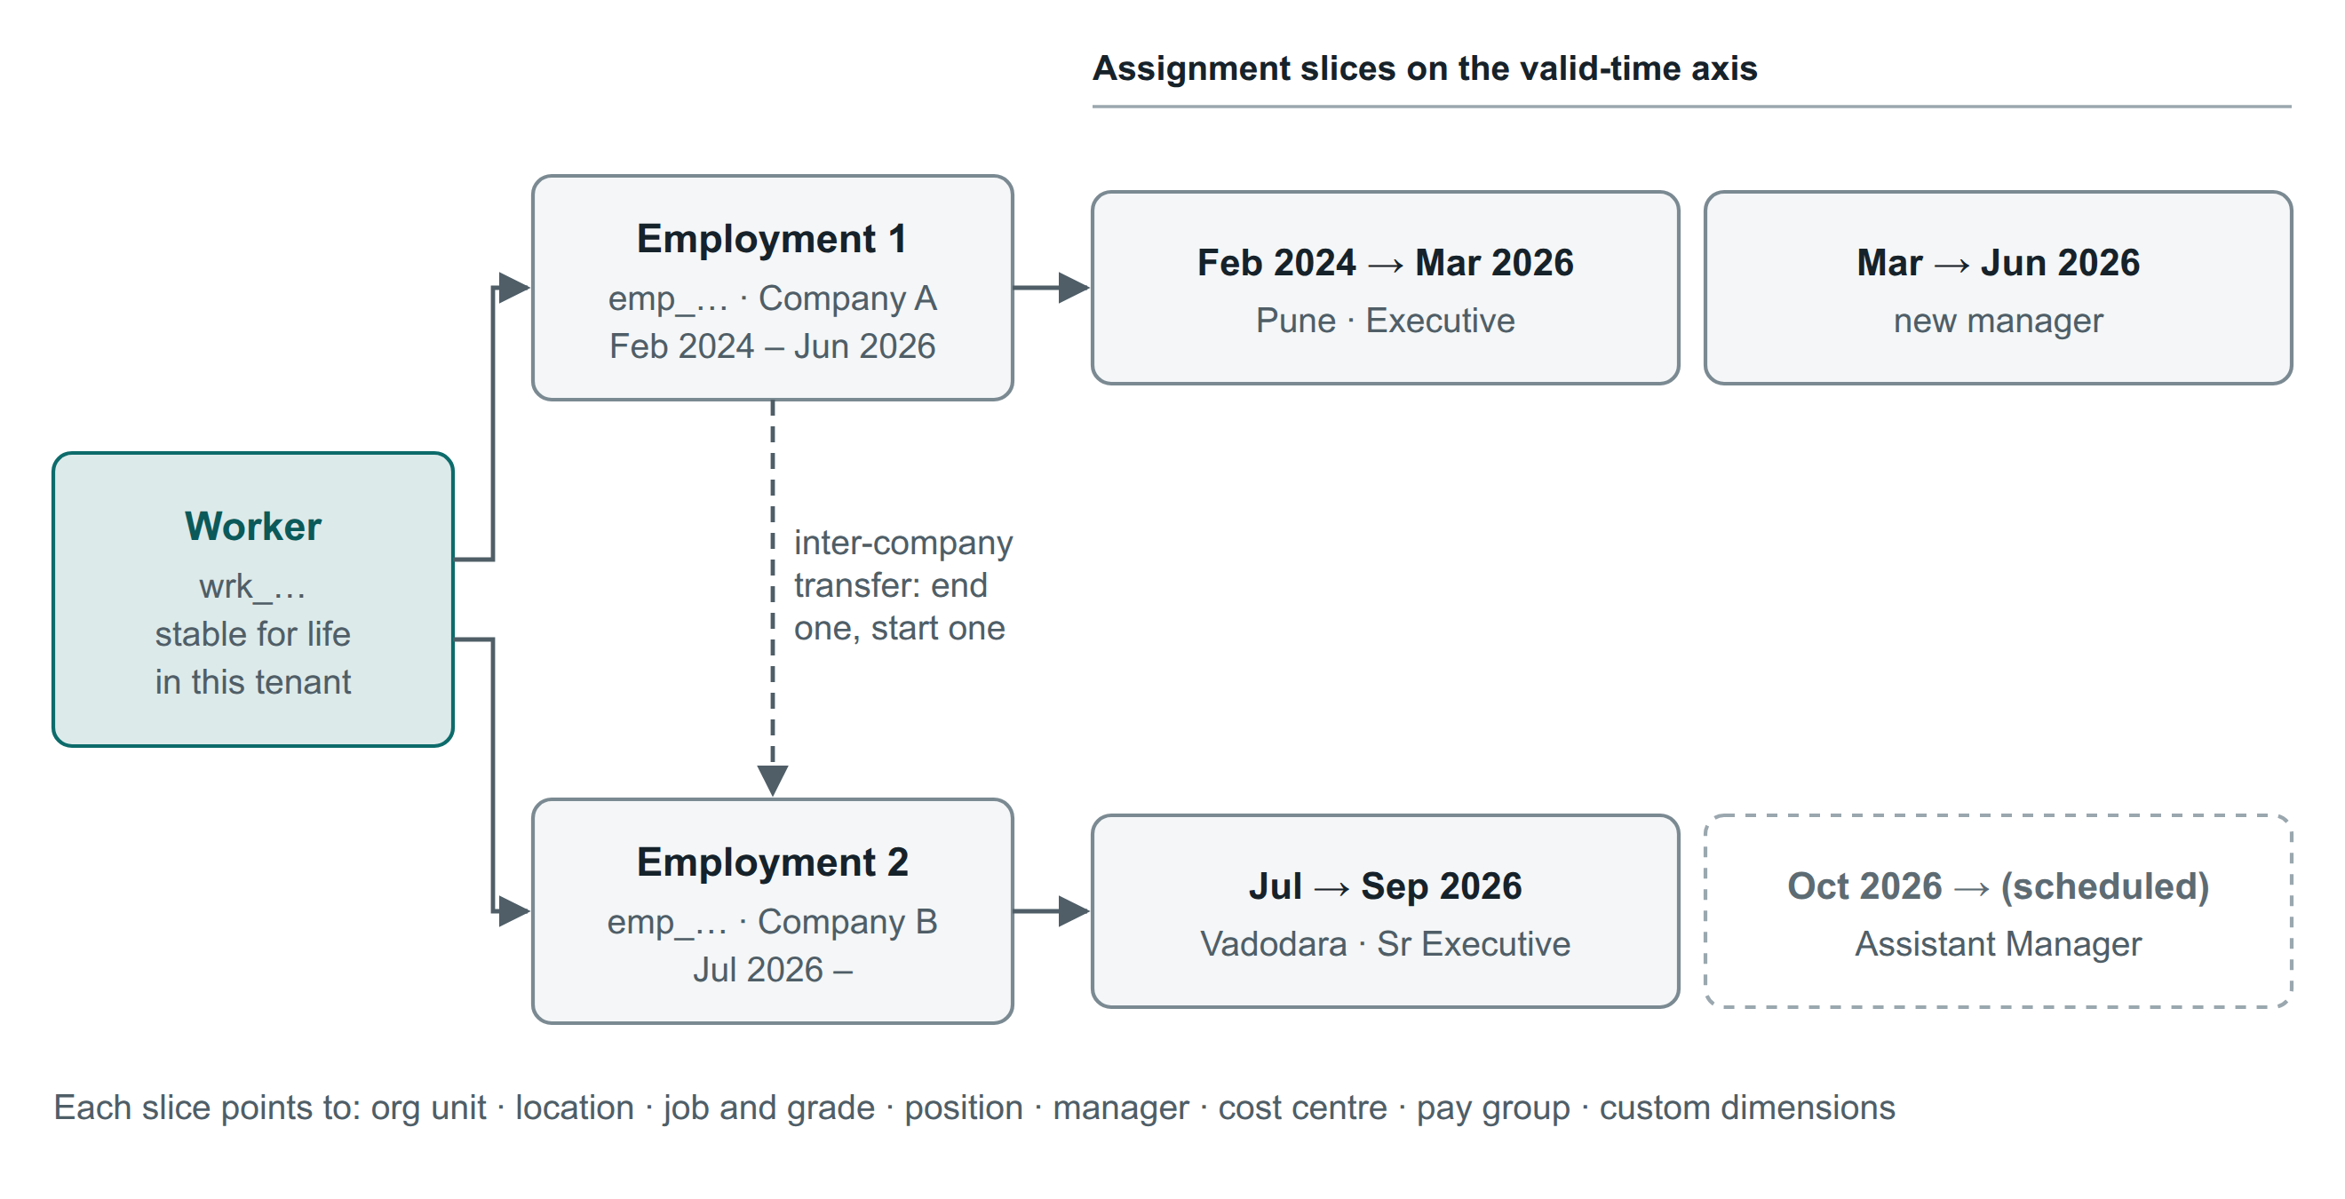
Figure 6. One worker for life in a tenant; one employment per legal entity; effective-dated assignment slices, including scheduled ones.
- Worker (`wrk_…`): identity and personal data. One per human per tenant; never shared across tenants; stable across rehire and inter-company transfer.
- Employment (`emp_…`): the work relationship with one legal entity. It holds the hire date, employee number, worker type, employment state (pre-hire, active, on notice, hold, separated) and service stage (probation, confirmed, contract). State and stage are separate fields, so "on notice during probation" can be represented.
- Assignment: effective-dated slices of org unit, location, job, grade, position, managers, cost centre, pay group and custom dimensions.
- An inter-company transfer ends one employment and starts a linked one. This matches its legal meaning: a new employer, a new appointment letter and a PF transfer.

7.2 Core data model
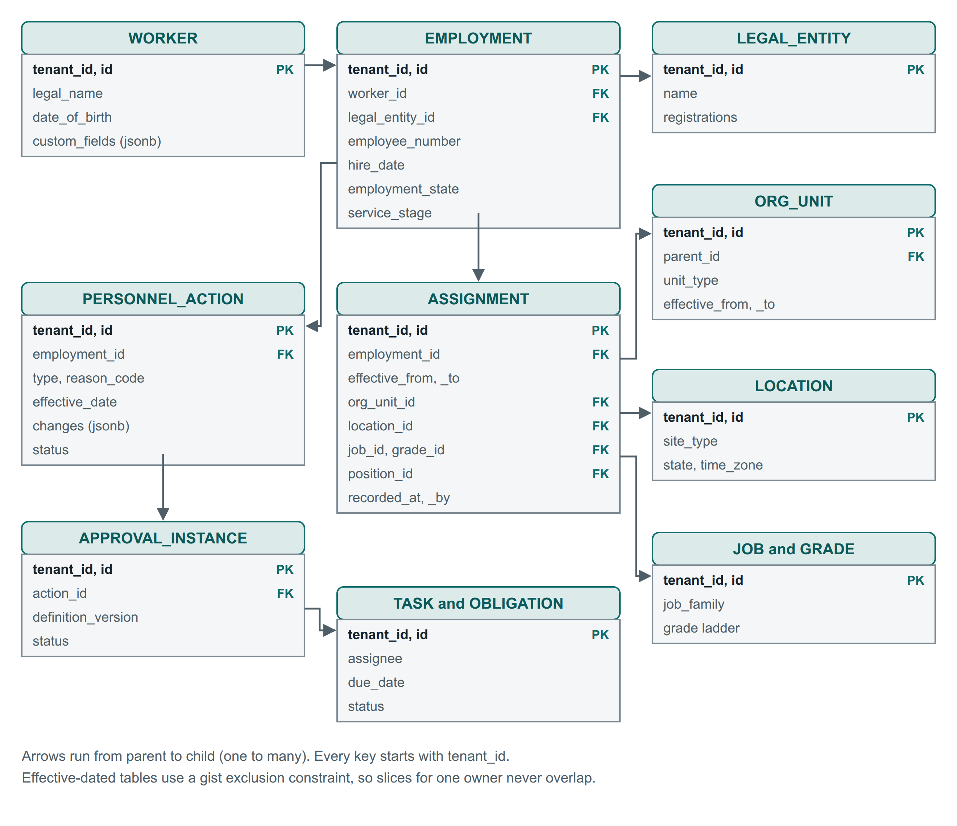
Figure 7. Core entities for Phases 0 and 1. Arrows run from parent to child.
Table 8. Table conventions
Convention | Rule
Keys | (tenant_id, id) primary keys; UUIDv7 ids; foreign keys include tenant_id
Public IDs | Typed opaque prefixes in the API (wrk_, emp_, pa_, loc_); internal keys never exposed
Effective dating | effective_from inclusive, effective_to exclusive (null = open); gist exclusion constraint per owner
Concurrency | version column for optimistic locking, exposed as the API ETag
Classification | Every column has a data class (Directory, Personal, Financial, Identity, Case) in module metadata
Deletion | archived_at for business records; physical purge only by the retention engine or a verified erasure
Custom fields | custom_fields jsonb with a metadata registry and GIN index; flattened into a typed side table for analytics
Partitioning | Monthly partitions for punches, attendance days, audit, notifications and outbox

7.3 Effective dating and history
- Valid time (effective_from, effective_to) on employment, assignment, compensation, statutory profile, org structure and configuration. Overlaps are blocked with EXCLUDE USING gist (tenant_id WITH =, owner_id WITH =, daterange(effective_from, effective_to, '[)') WITH &&). This works on current PostgreSQL; the newer WITHOUT OVERLAPS syntax is not required.
- Transaction time for assignment and compensation only: the application writes history rows in the same transaction (no trigger magic, no extension dependency). Everything else relies on the audit log.
- One temporal library in the kernel owns as-of reads, slice splitting and corrections versus changes. Property-based tests (jqwik) cover backdated, future-dated and overlapping edits.
- A daily headcount snapshot per tenant serves trend reports cheaply.

7.4 Sensitive data
Table 9. Data classes
Class | Examples | Storage and protection
Directory | Name, photo, designation, department, official email, location | Standard; visible across the tenant (tenant can narrow)
Personal | Personal contacts, address, date of birth, family, emergency contact | Standard; changes audited; managers see a limited set
Identity | PAN, UAN, ESIC IP, passport; Aadhaar masked only | Field-level envelope encryption with the tenant data key; blind index (HMAC) for exact-match duplicate checks; masked display
Financial: bank | Bank account number | Field-level encryption; masked; reveal logged; step-up MFA
Financial: compensation | Salary structure, CTC, revisions | Not field-encrypted, so it can be aggregated in SQL. Kept in a restricted schema that only the Compensation module's database role can read; every read goes to the sensitive-read log
Case | Exit-interview notes, grievance, POSH, disciplinary, medical | Separate access lists; never inherited through managers; excluded from search and exports

Decryption uses cached data keys (the AWS Encryption SDK caching pattern), so reads do not hit KMS request quotas. Aadhaar is stored masked unless the tenant has a legal basis to keep more.

7.5 Audit
- Audit entries are written freely (append-only, partitioned): who, on behalf of whom, what, before and after (restricted values tokenised), when, where, channel, reason, action ID.
- Sealing: every minute a job computes a Merkle root per tenant over the new entries and anchors it in S3 Object Lock (compliance mode). This is tamper-evident without serialising writes.
- A sensitive-read log records every reveal or read of Identity, Financial and Case data, and every export. Tenant administrators can search it, and it can be streamed to their SIEM.

7.6 Stores and retention
Store | Holds | Rebuildable | Retention
Aurora PostgreSQL | System of record: business data, configuration, outbox, recent audit | No; backed up and replicated | Per data class and tenant policy
S3 | Documents, letters, exports, audit archive, tenant snapshots | No; versioned and replicated | Per document type; legal hold overrides
SQS (launch) / Kafka (scale) | Events and work items | Yes, from the outbox | Days
Search index | Employee and document search | Yes, reindex from PostgreSQL | Follows source
Analytics | Snapshots, facts | Yes, from snapshots and CDC | Per contract
Valkey | Cache, rate-limit counters, BFF sessions | Yes | Minutes to hours

8. Master data ownership and integration mode
Many enterprise customers keep SAP, Oracle or Workday as their employee master and buy this platform for attendance, leave, compliance or self-service. The platform therefore records who owns each group of fields for each tenant.
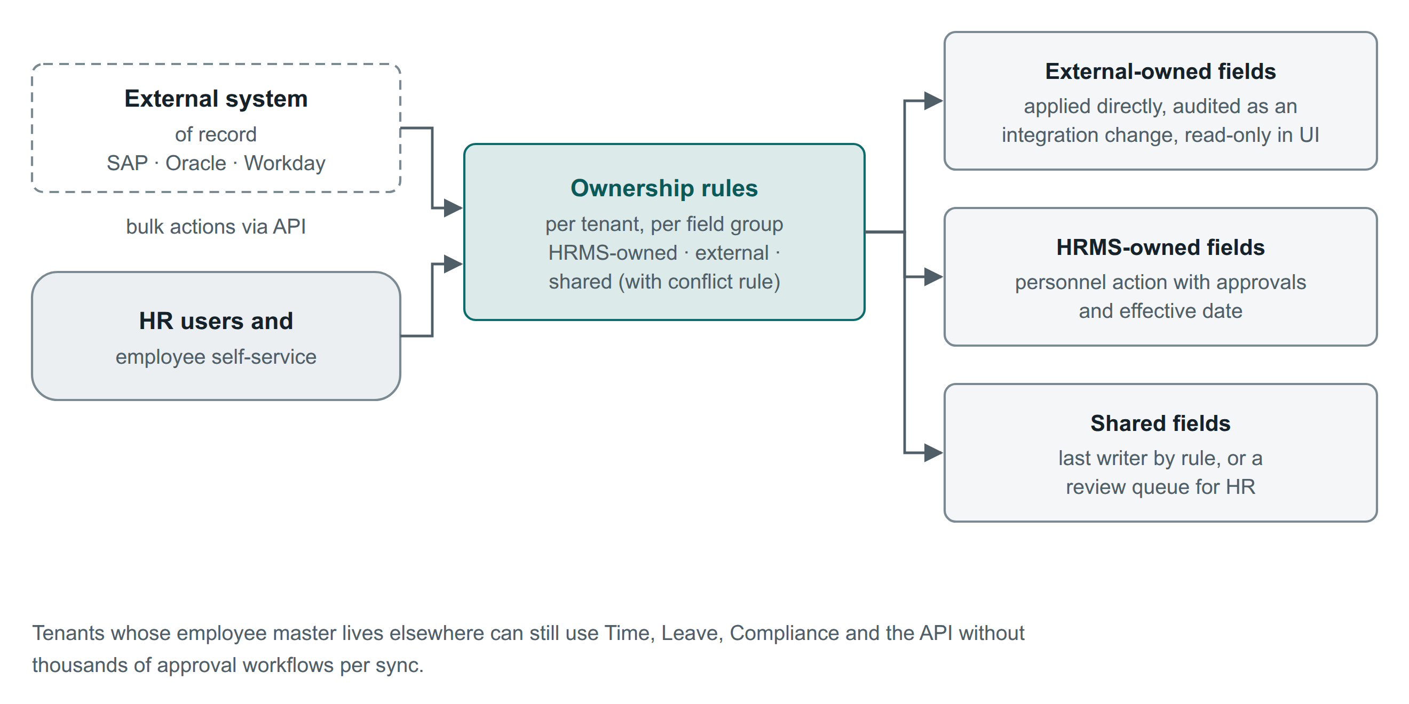
Figure 8. Ownership rules decide whether a change arrives as an audited integration change or as an approvable personnel action.
Mode | Behaviour | Typical tenant
HRMS-owned (default) | Changes go through personnel actions with effective dates, approvals and letters | SURAJ Group; most SMB and mid-market tenants
Externally owned | Changes arrive through POST /v1/personnel-actions:bulk in integration mode: applied directly, audited as integration changes, read-only in the UI | Enterprises with an ERP-based HR master
Shared | Per-field conflict rule: last writer by source priority, or a review queue for HR | Transitional periods, migrations

- Ownership is set per tenant and per field group (identity, contacts, job and organisation, compensation, bank, statutory) and is effective-dated.
- Integration mode is a tenant-approved exception, recorded once for the integration rather than once per change.
- Bulk actions also serve reorganisations: one request moves many employees with one effective date.

9. Identity and access

9.1 Sign-in
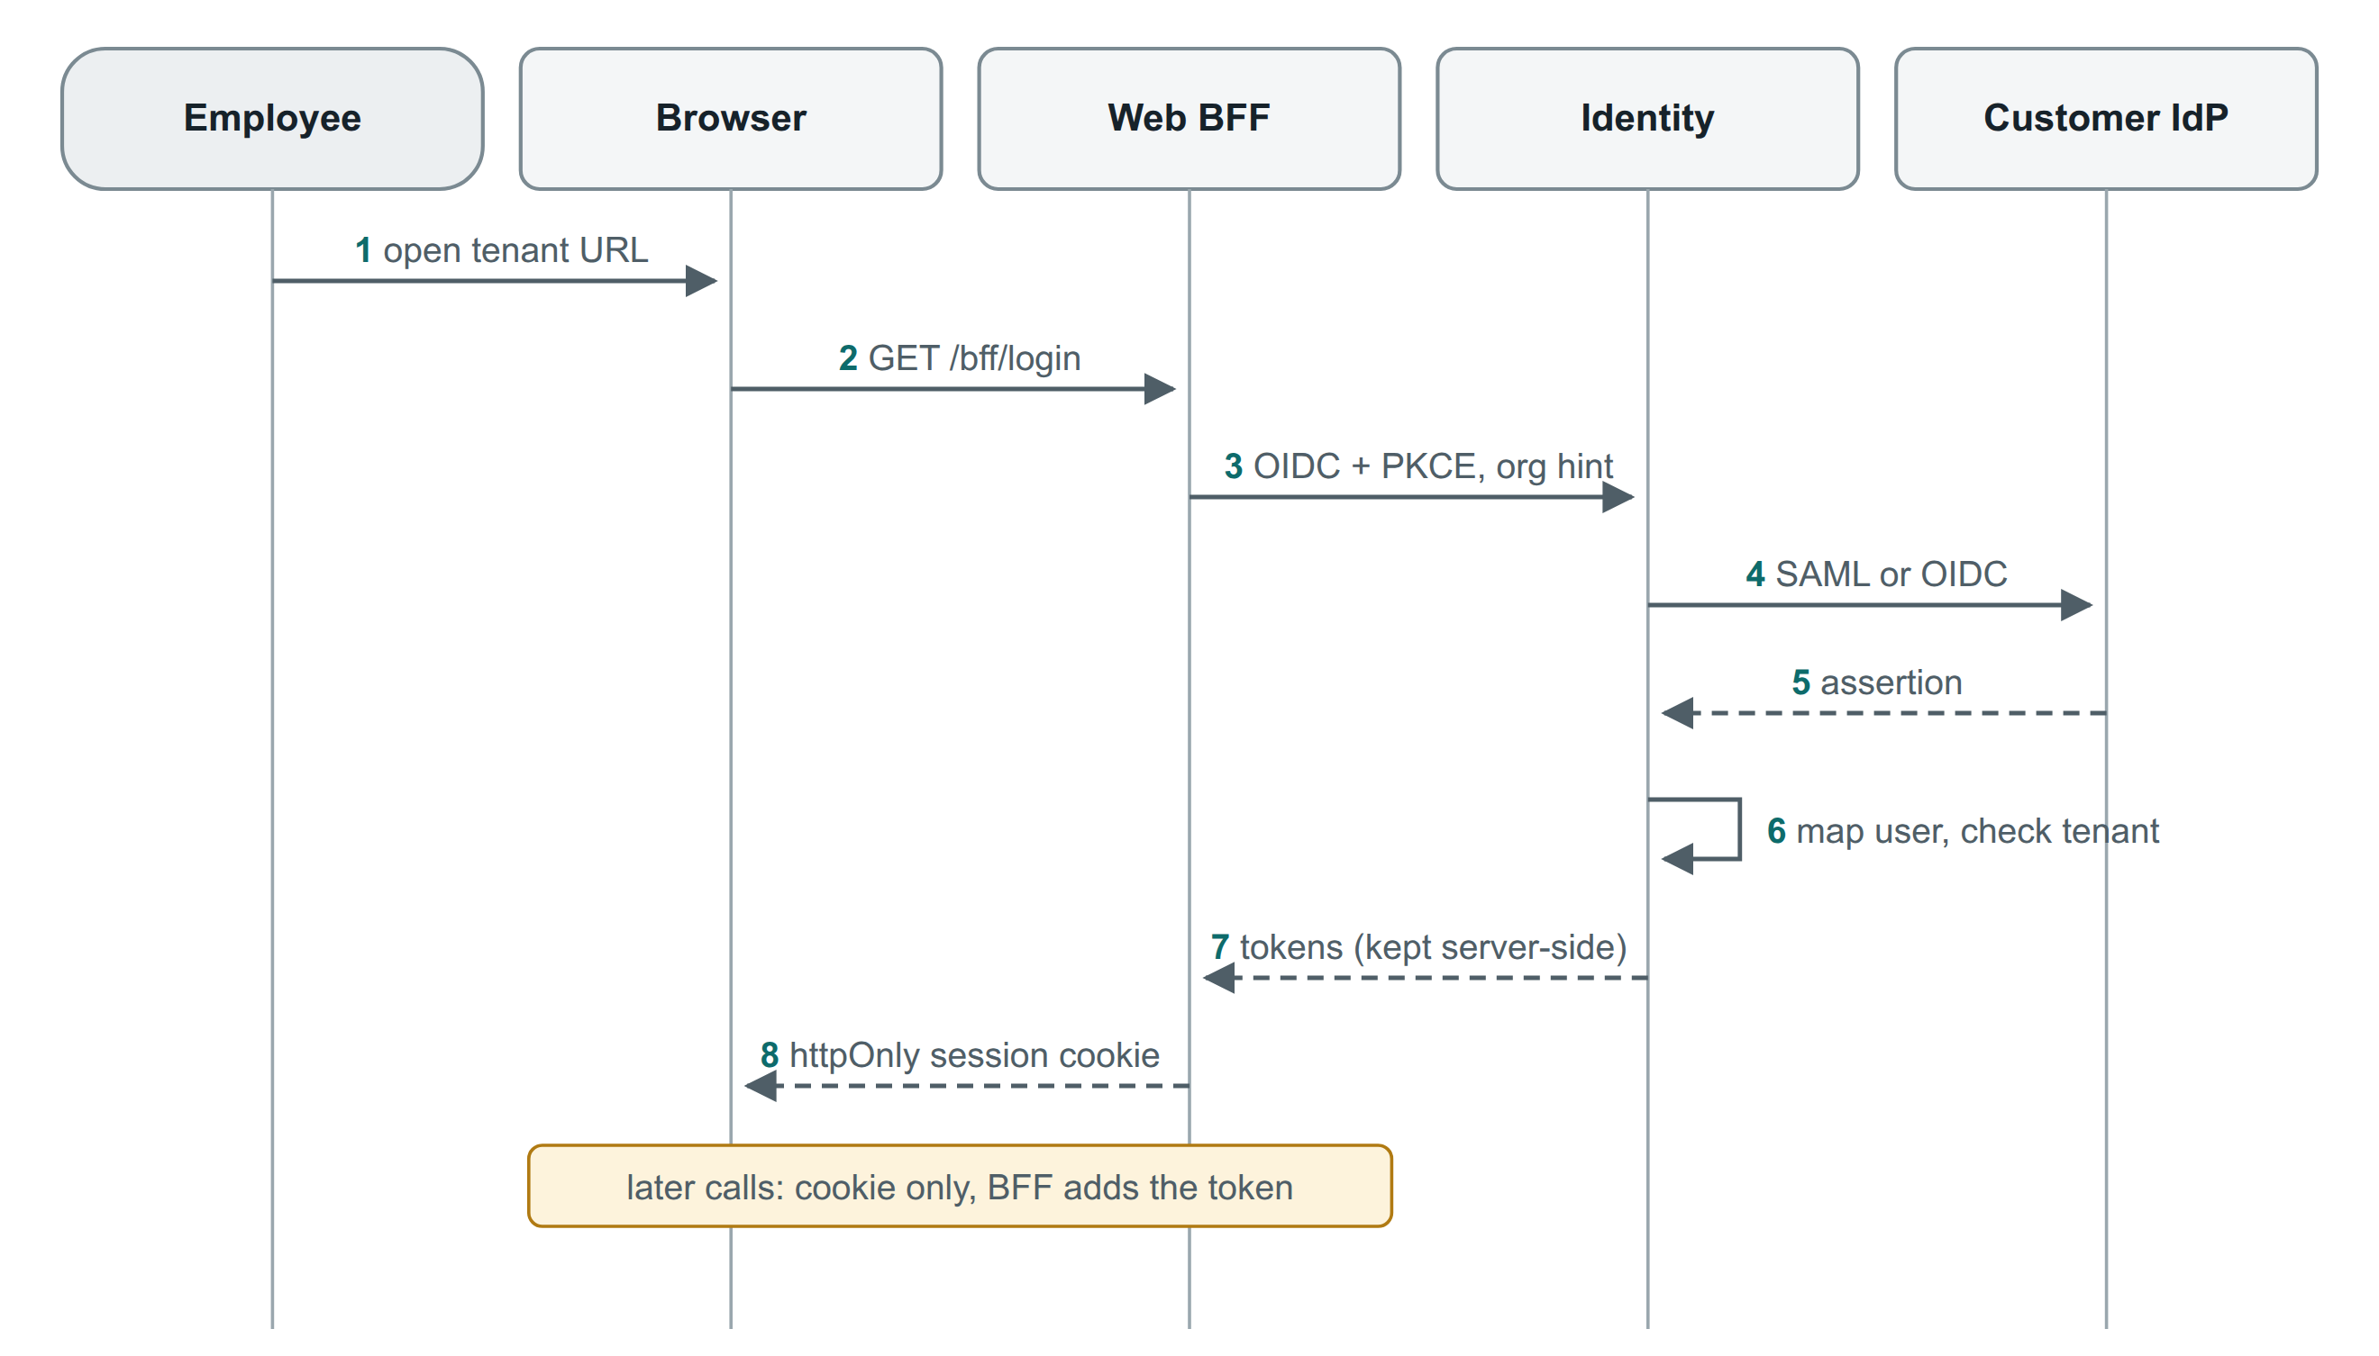
Figure 9. Web sign-in through the customer's identity provider. Tokens stay on the server; the browser holds only an httpOnly session cookie.
- Methods per tenant: SSO through SAML 2.0 or OIDC (just-in-time creation); password plus MFA (TOTP, WebAuthn, passkeys); employee code plus mobile OTP for staff without email (device binding, rate limits); kiosk mode later.
- Web uses a backend-for-frontend (BFF): the core application completes OIDC with PKCE, keeps tokens server-side (session in Valkey) and gives the browser an httpOnly, SameSite cookie. The mobile app uses OIDC with PKCE and platform secure storage.
- Provisioning: SCIM 2.0 endpoints for directory tools that pull; push connectors to Microsoft Entra ID, Okta and Google Workspace for joiners, movers and leavers. This automates IT clearance on exit.

9.2 What Keycloak does, and what we build
Need | Keycloak 26+ | We build
Tenant login boundary and SSO per customer | Organizations inside one realm per region, with a linked IdP per organisation | Proof of concept at 2,000 organisations (section 15.3)
Tenant-bound API tokens | Clients are realm-level, not organisation-level | A tenant attribute on each client and a protocol mapper that adds the tenant claim; tests that reject mismatches
Partner app installation with admin consent | Consent is per user and client only | An installation service: admin consent screen, granted scopes and data scope per tenant, revocation that revokes every token the installation issued
First-party versus third-party clients | Generic clients | A client class attribute used by the gateway for quotas

Decision gate. If the proof of concept fails at the target organisation count, the same interfaces are tested against Zitadel and one managed CIAM before a decision (ADR-07).

9.3 Authorization
Layer | Question | Mechanism
Entitlement | Is the module licensed for this tenant? | Control-plane plan, cached as feature flags
Permission | May this role do this action? | Catalogue module.resource.action; roles bundle permissions
Data scope | On which people and records? | Self, direct or all reports, org units, locations, legal entities, dynamic groups; compiled into SQL predicates
Data class | Which fields? | Class grants per role; one serialiser trims API responses, exports, notifications and search documents
Conditions | Under what circumstances? | CEL rules: no self-approval, maker ≠ checker, closed periods, delegation windows

- Apps are scoped like people. A client-credentials app or partner installation carries OAuth scopes and a data scope (legal entities, locations, groups) and class limits, shown on the consent screen and enforced by the same compiled predicates.
- Revocation is synchronous. Removing a role, scope or installation invalidates the caches in the same transaction (version stamp checked per request). Granting access may propagate within seconds.
- Visibility sets for hierarchies come from closure tables and are refreshed by events. Search filters by allowed org-unit and location IDs at query time, so a reorganisation needs no reindex.
- Access reviews: quarterly certification of roles and scopes per tenant. The access matrix is tenant data, and changing it is an approvable action.
Table 10. Default role templates (SURAJ Group sign-off becomes the default)
Role template (§3) | Default data scope | Data classes
Management | Entity group or legal entities | Directory; aggregates only for Financial
HR Head / Manager | Legal entities | Directory, Personal, Identity, Financial (read), named Case
HR Executive | Assigned locations or org units | Directory, Personal, Identity
Department Manager | All reports | Directory, limited Personal
Employee | Self | All own data (read); corrections by request
Accounts / Payroll | Legal entities or pay groups | Directory, Financial, Identity
Admin / IT | Locations | Directory; assets and clearance items
Tenant administrator | Configuration | No employee data by default

10. Workflows, rules and obligations

10.1 Approval engine
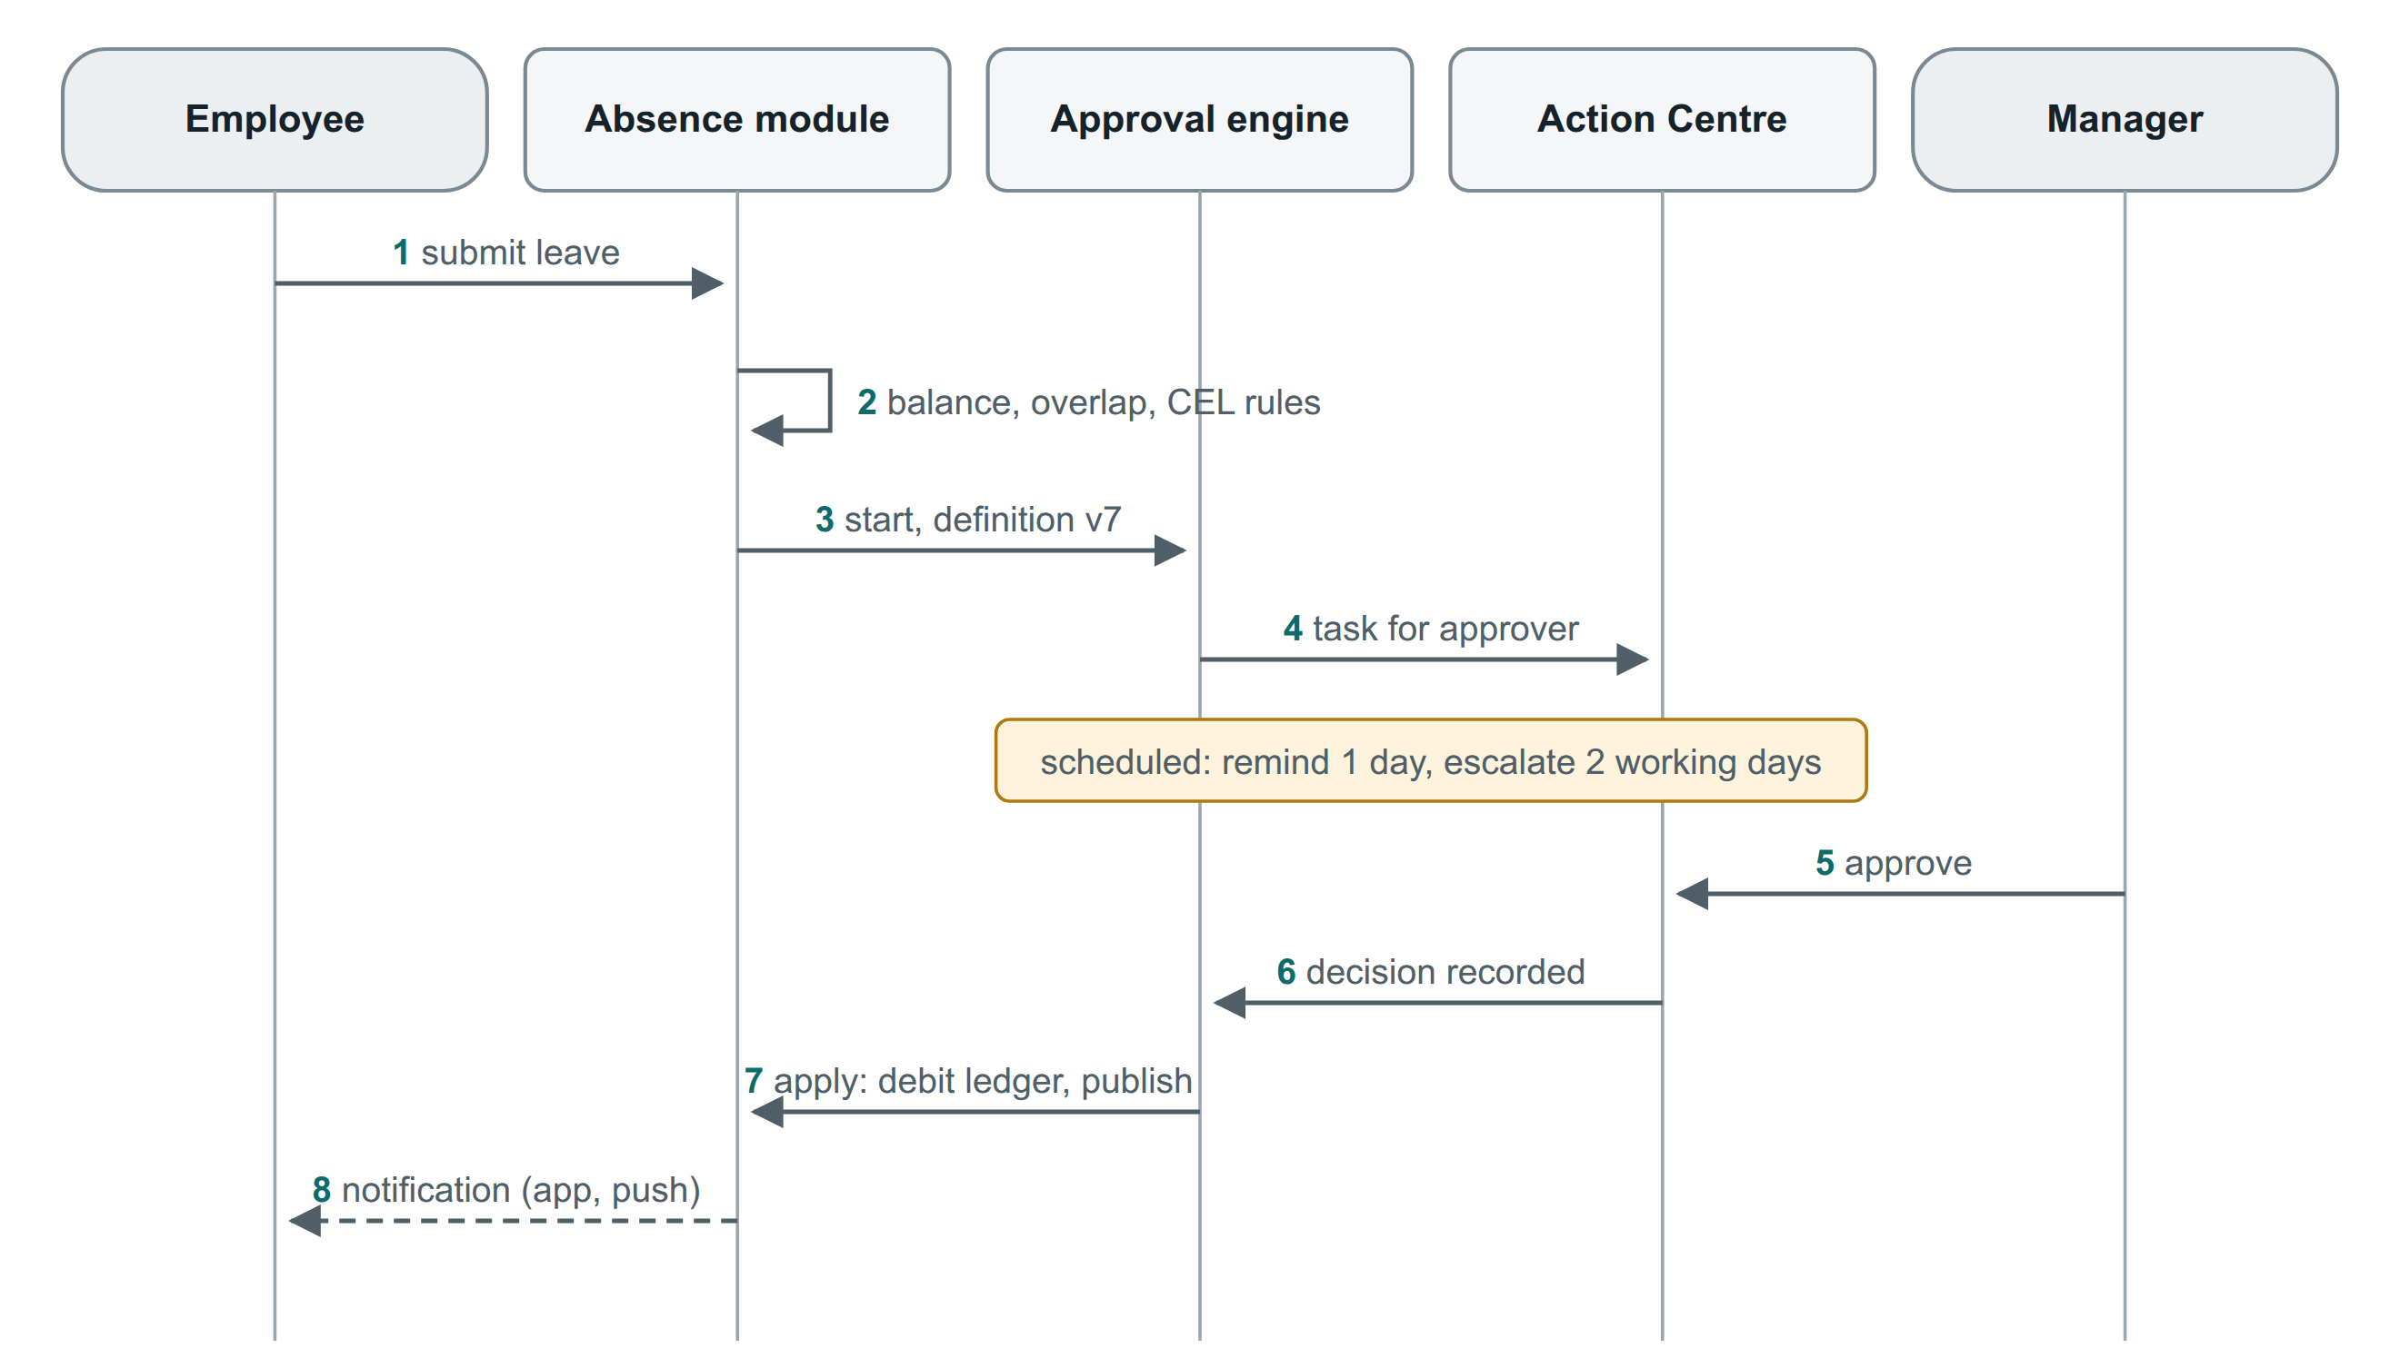
Figure 10. A leave approval. Every approvable process follows the same path: definition, task, timers, decision, apply.
- Definitions are data, versioned per tenant and process: steps (sequential or parallel), approver resolvers (line manager, n-th manager, unit head, role within scope, named user, expression), conditions, SLAs, escalation, delegation and segregation-of-duties rules. In-flight instances stay on the version they started with.
- Runtime: instance state in PostgreSQL; reminders, escalations and scheduled effective dates run on db-scheduler; tasks appear in the Action Centre and the mobile app.
- Edge cases handled: approver leaves (re-resolve), no manager (fallback to HR plus an early data-quality alert), reorganisation in flight (resolve as of decision date), email approvals (signed, single-use, never for Financial items).

10.2 Configuration layers
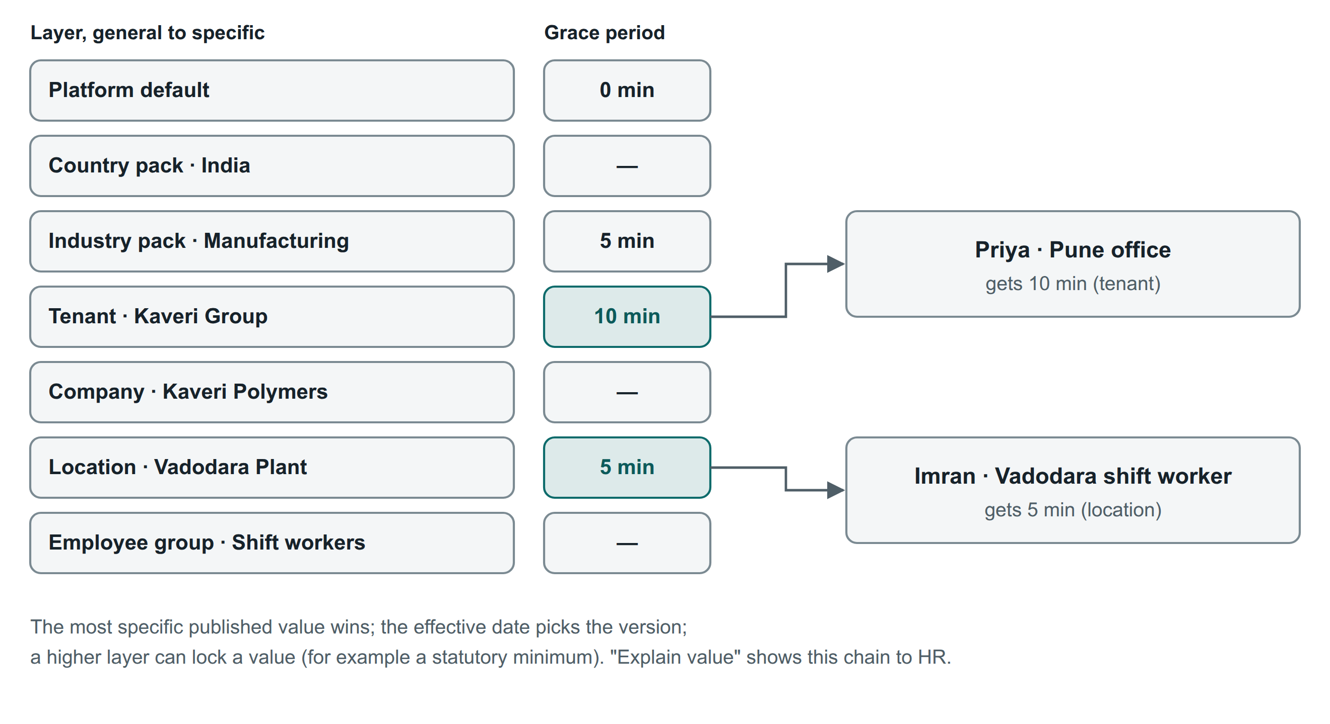
Figure 11. Configuration resolves from general to specific; the most specific published value wins.
- Layers: platform default → country pack → industry pack → tenant → entity group → legal entity → location → org unit → employee group.
- Every configuration object is typed, scoped, effective-dated, versioned (draft, published, retired), audited and optionally approved. A higher layer can lock a value.
- Simulation before publishing shows the impact on sample employees.
- "Explain value" shows HR the chain that produced any value, for example why an employee gets 5 minutes' grace.
- Configuration regression tests: before each release, every tenant's published configuration is replayed through the policy test suite.
- Configuration moves between sandbox and production as versioned bundles.

10.3 Obligations and exceptions
- Obligations (probation due, contract end, document expiry, notice end, clearance item, compliance filing, request SLA) are generated by rules from data and recomputed on events. For example, when the last working day changes, clearance dates move.
- Reminders use configurable offsets (the 30/15/7-day defaults of §14 and §26), recipients by role within scope, channels and escalation. Overdue items stay until done or closed by an approved exception.
- Exceptions are one platform record (rule bypassed, reason, evidence, approver, expiry), used by compliance, clearance, onboarding, leave and period corrections.

11. Events and integrations

11.1 Events
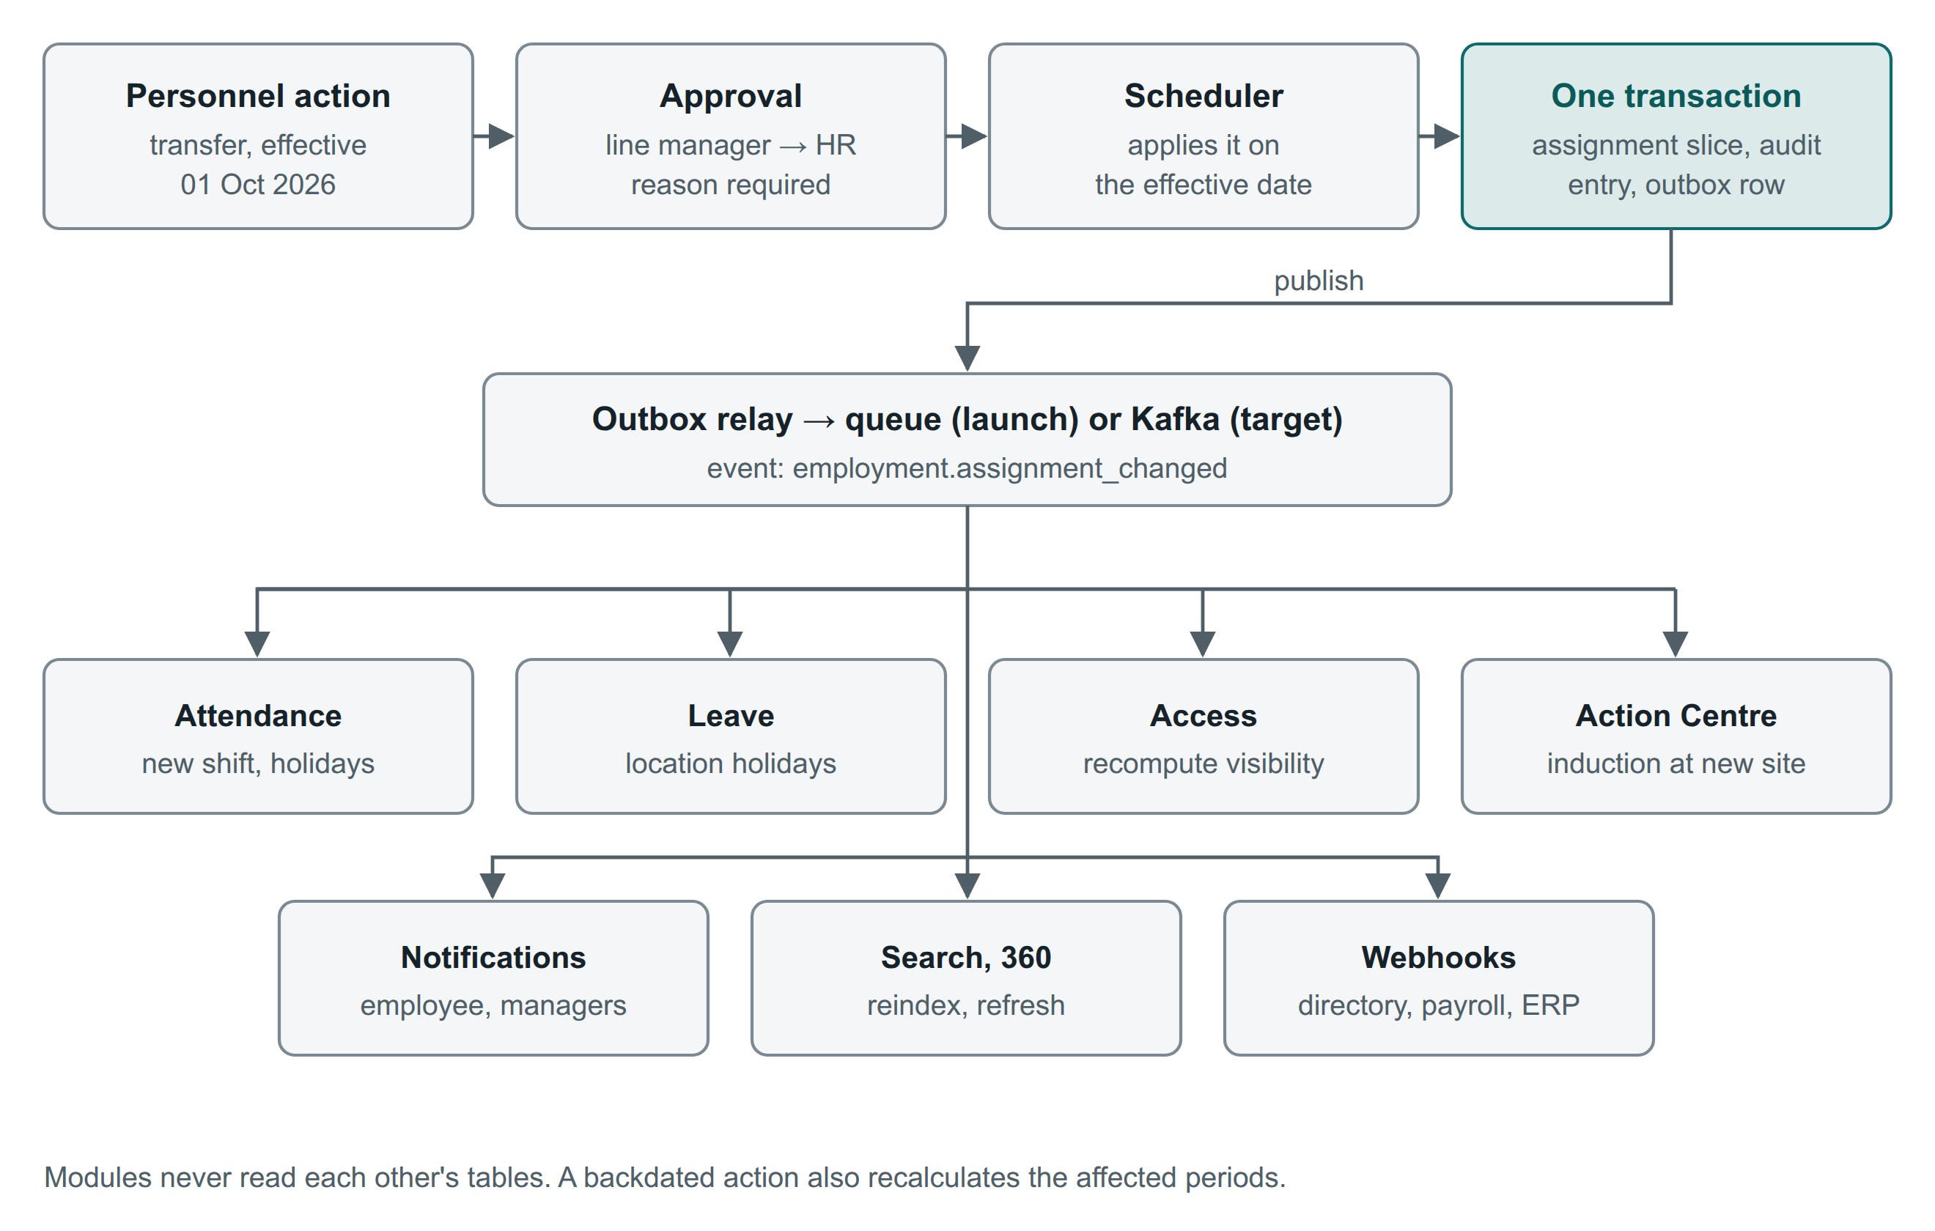
Figure 12. One approved change, one transaction, one event; every module updates itself.
- Envelope: CloudEvents 1.0 with extensions tenantid, cellid, traceparent and actionid. Partition or message-group key = tenant plus aggregate, so one employee's events stay in order.
- Naming: event types are <resource>.<past_tense> in snake_case (employment.assignment_changed); topics are <module>.<resource>.v<major> (people.employment.v1); API paths are kebab-case plurals (/v1/leave-requests).
- Schemas: JSON Schema in a registry; backward-compatible evolution checked in CI.
- Public events are thin: IDs, what changed, the effective date and a per-employment sequence. Tenants may opt in to Directory-class fields per webhook endpoint. Restricted classes are never included.
Table 11. Event catalogue (excerpt)
Event | Producer | Consumers | Webhook
employment.started (hire, rehire, transfer in) | People | Time, Absence, Learning, Assets, Compliance, Search, Notifications | Yes
employment.assignment_changed | People | Time, Absence, Access, Obligations, Search | Yes
employment.status_changed (confirmed, notice, hold) | People | Obligations, Access, Payroll inputs | Yes
employment.ended | Separation | Assets, Payroll inputs, Compliance, Identity (deprovision) | Yes
worker.updated / worker.erased | People | Search, Analytics, connected systems (erasure propagates) | Yes
personnel_action.submitted / approved / rejected / applied | People | Notifications, Documents (letters) | Yes
leave_request.* / leave_balance.changed | Absence | Time, Payroll inputs, Notifications | Yes
attendance_period.closed | Time | Payroll inputs, Compliance | Yes
payroll_inputs.published (versioned) | Payroll inputs | Compliance, Analytics | Yes
compliance_obligation.due / overdue / completed | Compliance | Action Centre, Notifications | Yes
task.created / task.completed | Kernel | Action Centre, chat and approval integrations | Yes
punch.received | Ingestion | Attendance computation | No (use the API)

11.2 Attendance ingestion
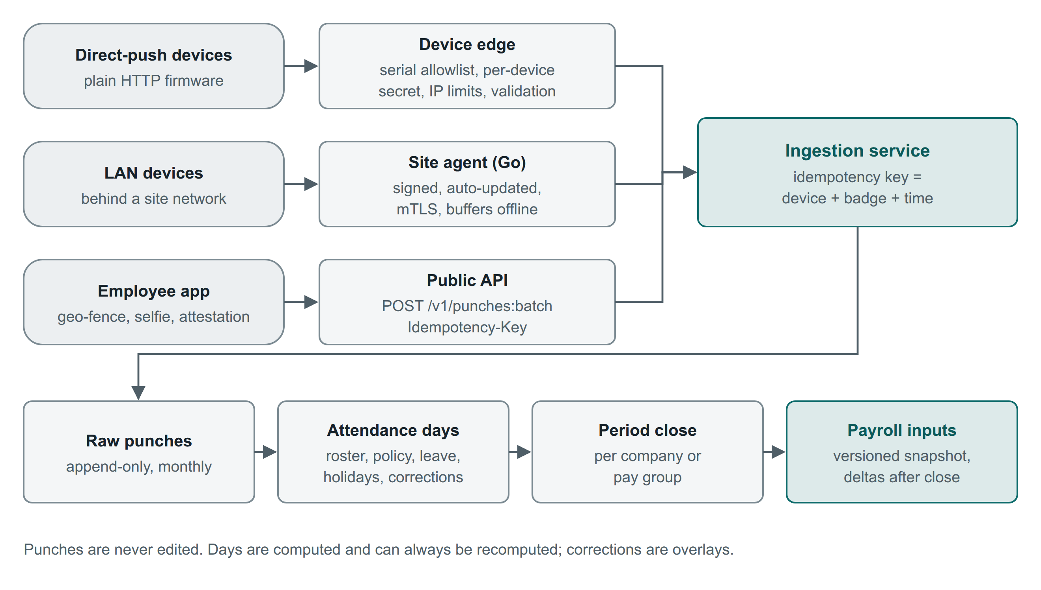
Figure 13. Three ingestion paths into one idempotent service; punches are append-only and attendance days can always be recomputed.
- The site agent is the default for devices on a customer network. It is a signed Go binary with automatic updates, certificate rotation, mTLS and offline buffering.
- Direct-push devices that only speak plain HTTP go to a separate hardened device edge: serial-number allowlist, per-device secret where the firmware supports one, IP restrictions, strict payload validation and its own rate limits. It is never the main API endpoint.
- Mobile punches use the public API with Play Integrity or App Attest, geo-fence and optional selfie. Time is taken from the server receive time plus a monotonic device clock, so a changed phone clock cannot backdate punches.
- Supported device models are listed per protocol once SURAJ Group's devices are known (decision D11).

11.3 Payroll input contract
- A pay-period snapshot per legal entity and pay group containing:
  - joiners and leavers
  - paid days, loss of pay, overtime and shift allowances
  - leave encashment
  - arrears from backdated actions
  - variable pay
  - recoveries
  - statutory applicability (PF, ESIC, PT state, LWF)
  - the compensation structure in effect
- Locked when the attendance period closes and versioned: corrections produce deltas, never silent changes. Exposed through the API and in vendor file formats; an internal payroll engine consumes the same contract later.

11.4 Integration catalogue
Integration (§34) | Pattern | Tools
Attendance devices | Site agent; hardened device edge; CSV fallback | Go agent; ingestion workers
Payroll | Versioned payroll input snapshots via API and files | /v1/payroll-periods/{id}/inputs; vendor mappings
Accounting and ERP | Journal and voucher exports for F&F and recoveries | Connectors (Tally XML, SAP APIs)
HR master in another system | Integration mode with bulk personnel actions | Section 8
Legacy file exchange | Scheduled SFTP both ways, optional PGP | AWS Transfer Family
Identity and directory | SAML/OIDC; SCIM in; push connectors out | Keycloak; platform identity service
Email and calendar | Notifications; interview and training invites | Amazon SES; Microsoft Graph; Google Calendar
Messaging | SMS with DLT templates, WhatsApp templates, push | MSG91 or Gupshup; Meta Cloud API; FCM/APNs
Recruitment, verification, e-sign | Connectors with consent capture | Job boards, BGV vendors, Leegality / Digio / eMudhra
Customer iPaaS and SIEM | Webhooks, change feed, audit stream | Section 12
Government portals | Links and evidence; file generation later (PF ECR, ESIC) | Country pack outputs

Connectors run as jobs with per-tenant configuration and credentials encrypted with the tenant data key, mappings, schedules, retries, a dead-letter queue, run history and alerts to the tenant admin.

12. The API product

12.1 Buyers and packaging
Buyer | Builds | Needs most
Customer IT | Sync with ERP, payroll, directory, BI; approvals in Teams or Slack | Stable contracts, bulk APIs, change feed, webhooks
ISVs and partners | Apps sold to many tenants (payroll, benefits, BGV, LMS) | Multi-tenant OAuth apps, sandbox, listing
iPaaS vendors and consultants | Connectors in MuleSoft, Boomi, Workato, Zapier | Consistent patterns, OpenAPI, webhooks
HR outsourcing partners | Operate many client tenants | Partner API with delegated access

Table 12. Suggested plans (validate with design partners, decision D17)
 | Starter | Growth | Enterprise
API families | Read: organisation, worker directory, leave balances; webhooks; change feed; SCIM | Plus all module APIs, personnel actions, time, payroll inputs, bulk | Plus analytics, admin APIs, event streaming
Rate limit per tenant | 60 req/min; 10,000/day | 600 req/min; 250,000/day | From 3,000 req/min; custom
Webhook endpoints | 2 | 10 | 50
Sandboxes | 1 shared | 1 dedicated | 3, plus a masked production copy
Connectivity | Public TLS | + IP allowlist | + mTLS, AWS PrivateLink
API SLA | Best effort | 99.9% | 99.95% with credits

First-party traffic (our web BFF and mobile app) uses its own client class and limits, and never consumes a customer's API quota.

12.2 API platform
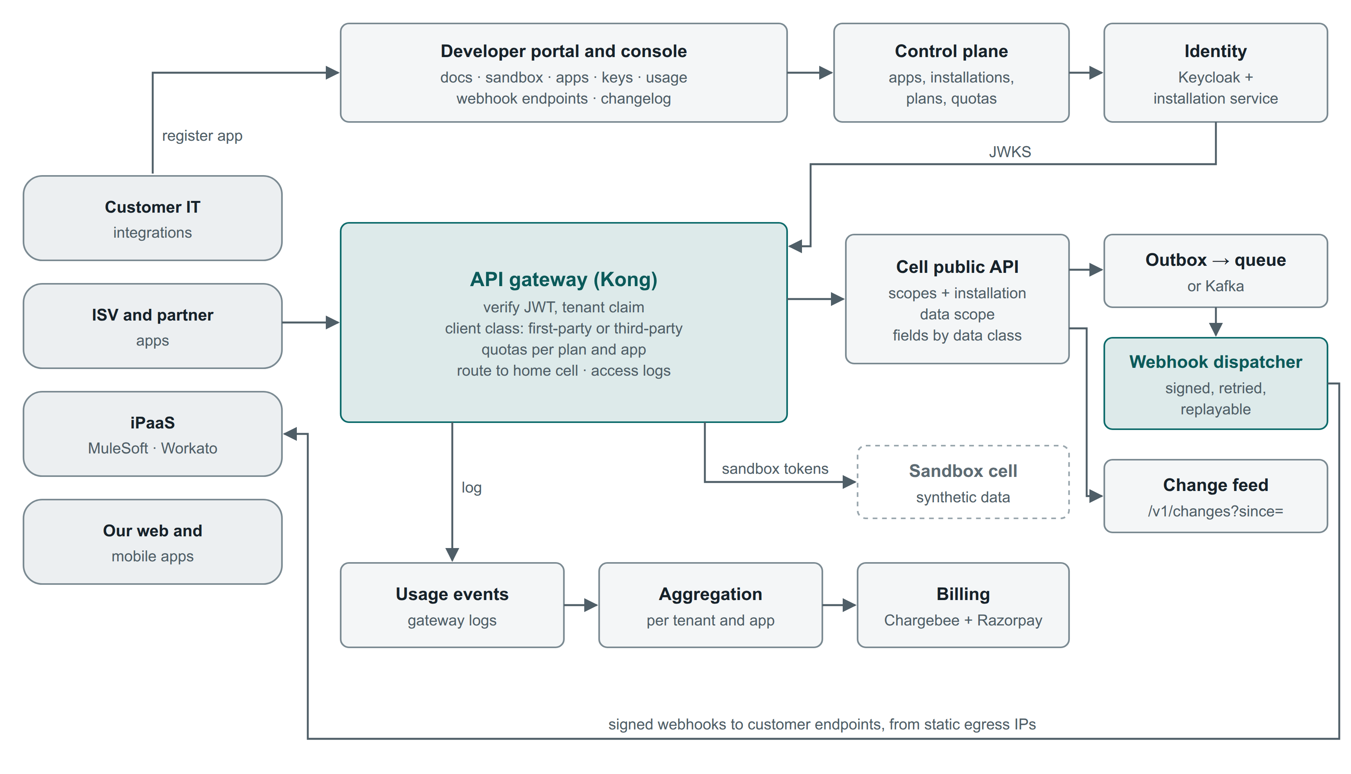
Figure 14. Developers register apps; identity issues tenant-bound tokens; the gateway enforces client class, quotas and routing; cells emit events to the webhook dispatcher and the change feed; gateway logs feed metering and billing.

12.3 One API call
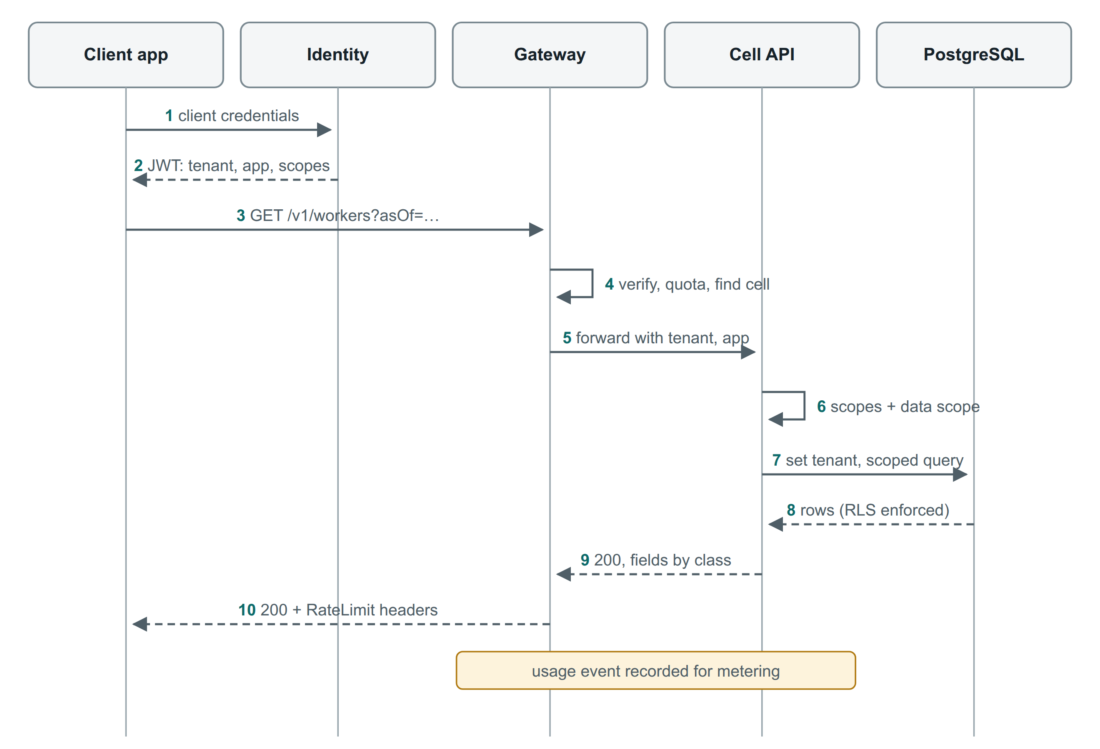
Figure 15. An API call from token to response, with usage recorded for metering.

12.4 Design standards
Topic | Standard
Style | REST over HTTPS, JSON (UTF-8), camelCase fields, kebab-case plural paths; commands as :verb (:approve, :cancel, :bulk)
Identity | wrk_ worker IDs are stable for life in a tenant; emp_ employment IDs change on rehire and inter-company transfer; every event carries both
Dates and money | Business dates YYYY-MM-DD; instants RFC 3339 UTC; money { "amount": "1250000.00", "currency": "INR" }
Temporal reads | asOf=YYYY-MM-DD on any effective-dated resource; timelines at /v1/employments/{id}/assignments
Changes to employment | POST /v1/personnel-actions (type, effective date, reason, changes) returns 202 with PENDING_APPROVAL, SCHEDULED or APPLIED; :bulk in integration mode
Pagination and filters | Cursor pagination (limit ≤ 200); filter[...]; fields=; capped expand=
Idempotency and concurrency | Idempotency-Key on every POST (kept 24 h); ETag with If-Match on updates
Errors | RFC 9457 Problem Details plus a stable code and requestId
Rate limits | 429 with Retry-After; RateLimit-Policy and RateLimit headers
Long work and files | 202 with a job resource; files through short-lived pre-signed URLs
Deprecation | Deprecation and Sunset headers; changelog; direct outreach to calling apps

12.5 Contract-first lifecycle and versioning
- Every change starts as an OpenAPI 3.1 pull request reviewed by the API review group.
- Spectral enforces the style guide; oasdiff blocks breaking changes to a published major version.
- Server interfaces, validators, TypeScript types and SDKs are generated from the same file.
- Contract tests and Schemathesis fuzzing run on every build, plus the tenant leakage suite on every route.
- The major version is in the path (/v1). Additive changes ship without a new version, and clients must ignore unknown fields. Generated SDKs tolerate unknown enum values.
- A breaking change means a new major version with at least 12 months of overlap.

12.6 API security
Flow | Used for | Details
OAuth 2.0 client credentials | A tenant's own server integrations | Client bound to one tenant (tenant claim); secret rotation; private_key_jwt or mTLS on Enterprise
Authorization code + PKCE | Partner apps installed by many tenants; user-delegated actions | Installation service with admin consent, data scope and revocation
SCIM bearer token | Directory tools | SCIM endpoints only; rotated
Partner token | HR outsourcing partners | Delegated, time-boxed grants per client tenant, logged in both audit logs

Scopes follow resource:action:
- Standard: org:read, workers:read, actions:write, time:read, time.punches:write, leave:write, changes:read, webhooks:manage, bulk:write.
- Restricted: workers.personal:read, workers.identity:read, workers.financial:read, payroll:read, cases:read. These need a confidential client, tenant admin approval with a stated purpose, periodic re-approval, and logging of every use.
OWASP API risk (2023) | Control
API1 Object-level authorization | Tenant from token only; RLS; compiled data scopes; leakage suite on every route
API2 Authentication | OAuth only; 10-minute tokens; mTLS or private_key_jwt on Enterprise
API3 Property-level authorization | Data-class scopes; serialiser trimming; write allowlists (no mass assignment)
API4 Resource consumption | Quotas, page caps, request size limits, expand depth cap, async bulk
API5 Function-level authorization | One scope per operation from OpenAPI; admin APIs separate
API6 Sensitive business flows | OTP and export limits per user and IP; large exports need approval and are watermarked
API7 SSRF | Webhook URLs HTTPS only, private ranges blocked, re-resolved per delivery, egress proxy
API8 Misconfiguration | Gateway and headers as code; TLS 1.2+; CORS allowlists
API9 Inventory | OpenAPI is the inventory; undocumented routes unreachable
API10 Unsafe consumption | Third-party responses schema-validated, time-limited

12.7 API catalogue
Family | Main resources | Plan
Organisation | /v1/legal-entities, /v1/locations, /v1/org-units (:move), /v1/jobs, /v1/grades, /v1/positions, /v1/cost-centres, /v1/dimensions | Read: all; write: Growth
Workers and employment | /v1/workers (search, asOf), /v1/workers/{id}/employments, /v1/employments/{id}/assignments, contacts | All
Personnel actions | /v1/personnel-actions, :bulk (integration mode), :cancel | Growth
Talent | /v1/requisitions, /v1/vacancies, /v1/candidates (:convert), /v1/applications, /v1/offers, /v1/onboarding-cases | Growth
Time | /v1/punches:batch, /v1/attendance-days, /v1/attendance-corrections, /v1/rosters, /v1/shifts, /v1/attendance-periods | Growth
Leave | /v1/leave-types, /v1/leave-balances (asOf), /v1/leave-requests (:cancel), /v1/holiday-calendars | Read: all; write: Growth
Payroll inputs | /v1/pay-groups, /v1/payroll-periods, /v1/payroll-periods/{id}/inputs (version, deltaFrom) | Growth (restricted)
Separation and others | /v1/separations, /v1/assets, /v1/learning-sessions, /v1/hr-requests, /v1/policies | Growth
Compliance | /v1/compliance-obligations, /v1/compliance-evidence, /v1/statutory-profiles (restricted) | Growth
Documents and tasks | /v1/documents (pre-signed upload), /v1/letters:generate, /v1/tasks (:approve, :reject, user tokens only) | Growth
Changes and events | /v1/changes?since=<cursor>, /v1/events (30-day replay), /v1/webhook-endpoints | All
Bulk | /v1/bulk-imports, /v1/bulk-exports, /v1/bulk-jobs/{id} | Growth
Analytics and admin | /v1/metrics, /v1/analytics:query; /v1/admin/... (users, roles, config bundles, audit events) | Enterprise
Directory and partner | /scim/v2/Users, /scim/v2/Groups; /partner/v1/... | All; partner program

12.8 Webhooks and the change feed
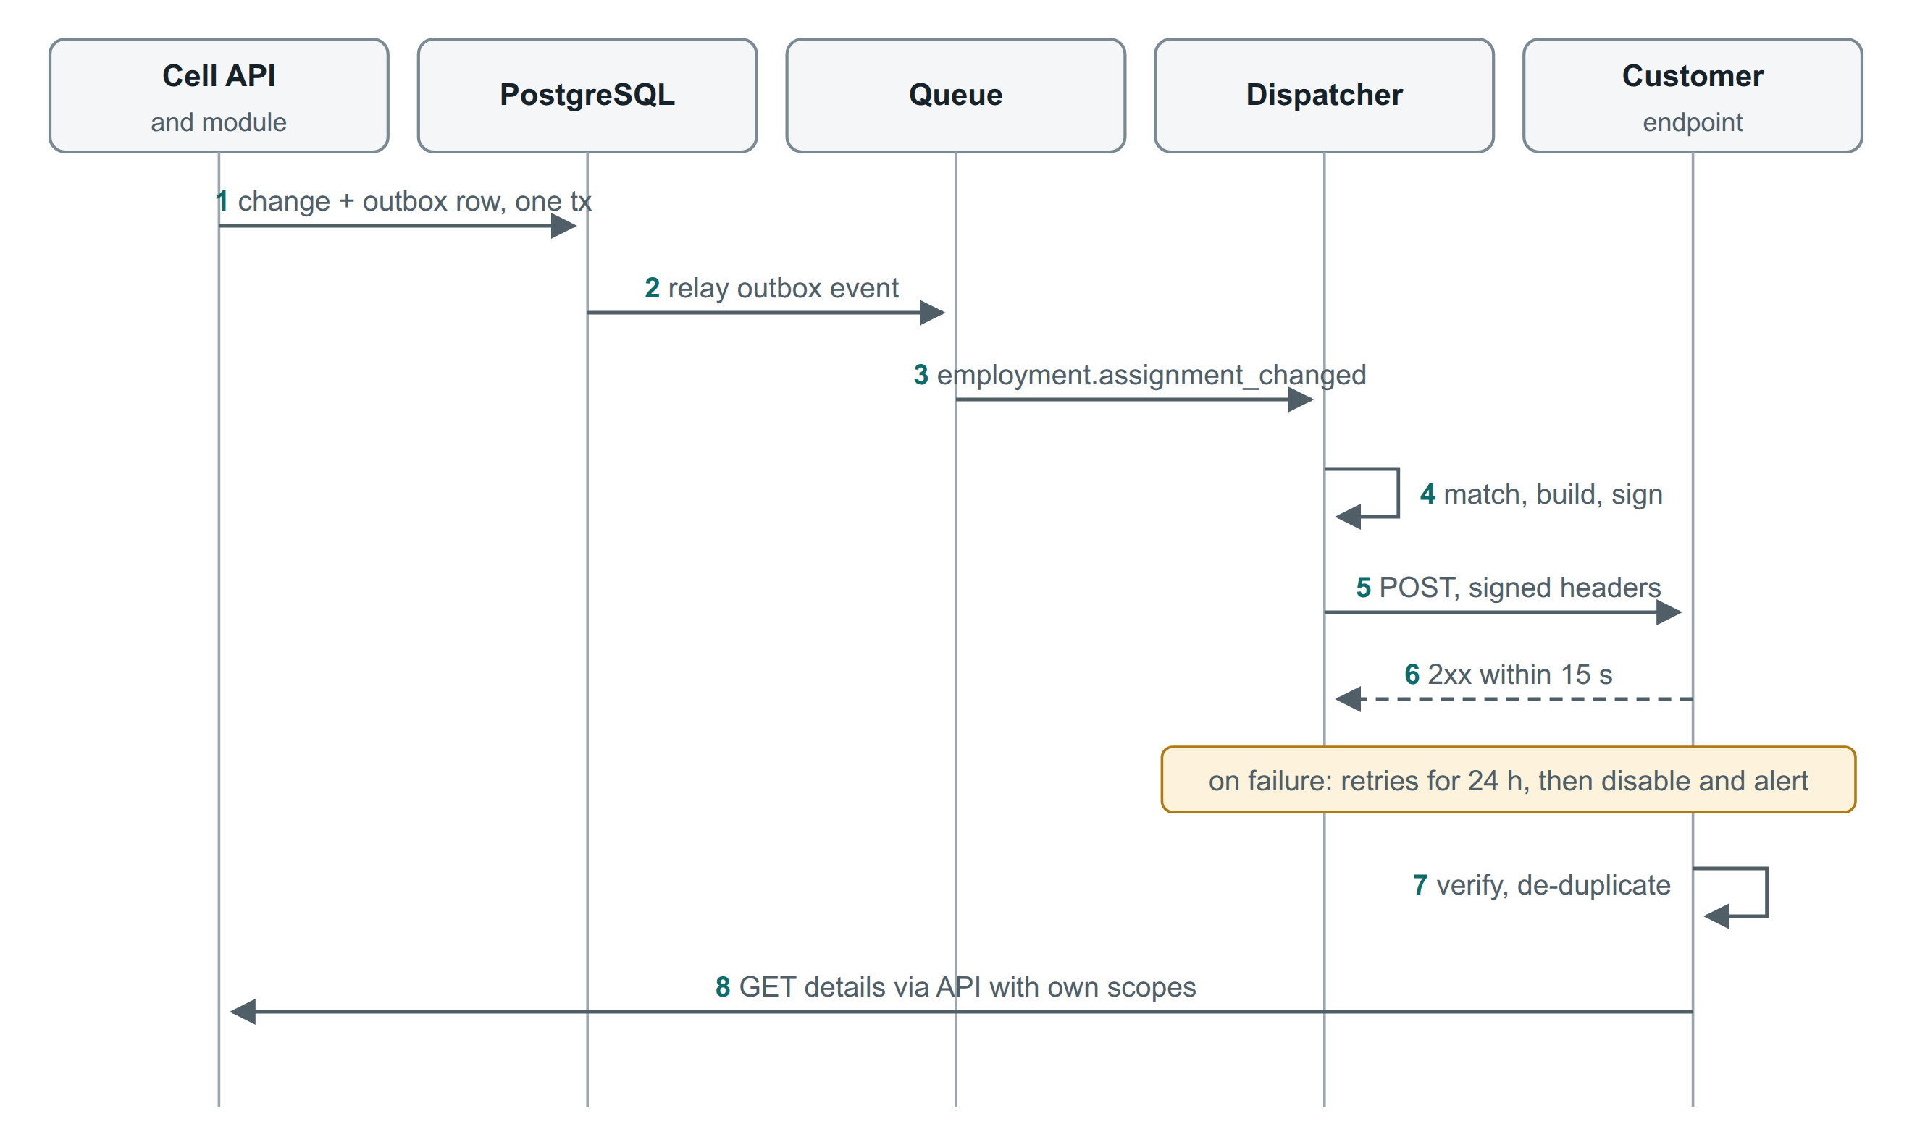
Figure 16. Webhook delivery is at-least-once and signed; receivers de-duplicate and fetch details through the API with their own scopes.
- Standard Webhooks signing with secret rotation; a 15-second timeout, then exponential backoff for up to 24 hours; failing endpoints are disabled and the tenant admin is alerted.
- Deliveries leave from static egress IPs; events can be replayed for 30 days.
- Change feed /v1/changes?since=<cursor> per resource family, for integrators who prefer polling or need to catch up.
- worker.erased propagates DPDP erasures to connected systems.

12.9 Developer experience
Element | Design
Docs | Guides by task (sync workers, push punches, read payroll inputs), full reference, error catalogue, changelog; docs-as-code with Redocly
Developer console | Sandbox signup, app registration, OAuth clients and secrets, installations, webhook endpoints, usage charts, 7-day request log (bodies redacted)
Sandbox | A separate cell with synthetic Indian organisation data, reset nightly, same API and limits
SDKs | TypeScript and Python first (generated, typed, with retries, pagination and webhook verification); Java and C# when demand is proven
Trust | Public status page per region and API; security page; subprocessor register; audit reports under NDA

12.10 Metering, limits and billing
- Metered: active employees per tenant per day (sent by cells as aggregates); API calls by tenant, app and route family (from gateway logs); webhook deliveries; bulk rows; SMS and WhatsApp messages (passed through).
- Usage is aggregated idempotently, pushed daily to Chargebee and invoiced with GST. Razorpay collects payments; enterprise customers can pay by invoice.
- The gateway enforces rate limits per tenant, app and client class. Daily quotas are soft (alerts at 80% and 100%, overage on Growth) except on Starter and sandbox.

13. Infrastructure and operations

13.1 AWS deployment
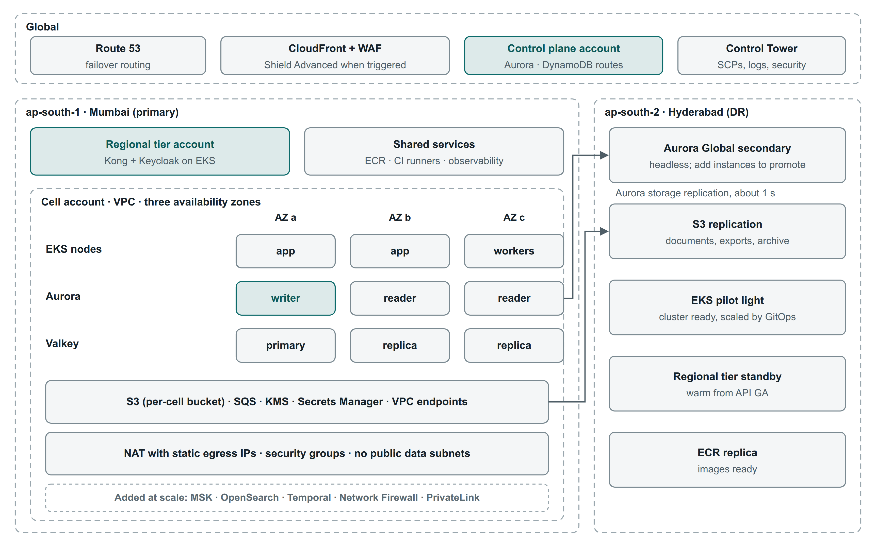
Figure 17. Launch deployment: a global layer, a Mumbai regional tier and cell across three availability zones, and a Hyderabad DR region fed by Aurora Global Database and S3 replication.

13.2 Accounts and network
Account (AWS Control Tower) | Purpose
Management | Organisation, SCPs, billing only
Security tooling and log archive | GuardDuty, Security Hub, Inspector, IAM Identity Center; organisation CloudTrail; audit archive with Object Lock
Shared services | ECR, CI runners, artifacts
Platform (prod, staging) | Control plane and regional tier (Kong, Keycloak) at launch; split into separate accounts at scale
Cell accounts | One per cell; everything that holds tenant data
Sandbox, staging, development | Synthetic or masked data only

- Each cell VPC spans three AZs: public subnets for load balancers and NAT only, private subnets for EKS, private data subnets for Aurora and Valkey.
- VPC endpoints for S3, KMS, STS, ECR, SQS and Secrets Manager.
- Webhooks and connectors leave through NAT with published static IPs and an egress allowlist proxy. AWS Network Firewall is added by trigger.
- Enterprise API customers can connect over AWS PrivateLink (target).
- Custom domains: a shared wildcard domain for every tenant; opt-in custom domains through CloudFront's multi-tenant distribution features, with certificates automated.

13.3 Environments and delivery
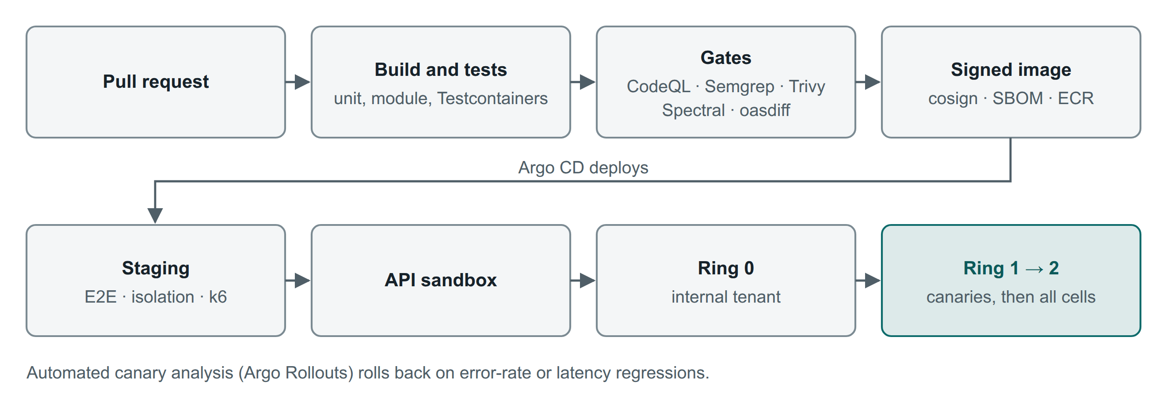
Figure 18. From pull request to every cell. A failed automated analysis at any ring rolls back without a human.
Environment | Data | Purpose
Development | Synthetic | Per-branch previews
Staging | Synthetic (masked by tenant opt-in) | E2E, isolation suite, performance smoke tests
API sandbox | Synthetic tenants | Public developer sandbox on the current release
Production rings 0 → 1 → 2 | Real | Internal tenant, then canary tenants per industry pack, then all cells

Infrastructure is Terraform (or OpenTofu) composed with Terragrunt per account and region; a new cell is a pull request. Kubernetes delivery is Helm, Argo CD and Argo Rollouts. Database changes follow expand, migrate, contract. Images are signed (cosign), carry SBOMs (Syft) and are admitted by Kyverno policy only if signed.

13.4 Observability
- Launch: OpenTelemetry (ADOT collector) → Amazon Managed Prometheus and Managed Grafana; logs in CloudWatch; traces in X-Ray; errors in Sentry with scrubbing. Everything stays in-region except scrubbed error events.
- Tenant ID goes in traces and logs, not metric labels. Per-tenant SLO series are aggregated separately, and per-tenant metric detail is limited to the top tenants by traffic, keeping metric cardinality bounded.
- SLOs per journey (sign-in, search, leave apply and approve, punch ingestion, API reads and writes, webhook delivery, month close) with burn-rate alerts.
- On-call and incidents through PagerDuty or incident.io, with a public status page per region and product.

13.5 Disaster recovery
Tier | Scope | RPO | RTO | How
Standard | Pooled cells | ≤ 5 min | ≤ 4 h | Aurora Global headless secondary; S3 replication; EKS pilot light; runbook rebuild by IaC
Regional tier | Control plane, identity, gateway | ≤ 1 min | ≤ 30 min | Warm standby in Hyderabad from API GA (Phase 2)
Enterprise (optional, priced) | Dedicated cells | ≤ 1 min | ≤ 1 h | Warm standby cell
Derived stores | Search, analytics | n/a | ≤ 24 h | Rebuilt from PostgreSQL; degraded service meanwhile

Rule. No RTO is written into a customer contract until a full regional failover has been rehearsed. Game days: AZ loss every quarter, one tenant restore every quarter, and a regional failover once a year.

13.6 Security and compliance
Table 13. Threat model summary
Threat | Controls
Tenant spoofing or cross-tenant reads | Tenant from verified token and host; RLS failing loudly; composite keys; leakage suite; isolation-focused penetration tests
Stolen API credentials | Short tokens, rotation, IP allowlists, mTLS or private_key_jwt, anomaly alerts per app
Over-privileged partner apps | Restricted scopes with admin approval and purpose; installation data scopes; app review; instant revocation
OTP abuse, proxy punching | Rate limits, device binding, attestation, geo-fence, selfie option, anomaly reports
Audit tampering | Merkle sealing per minute anchored in S3 Object Lock
Privilege escalation by a tenant admin | Role changes are approvable actions (maker-checker); alerts; quarterly access reviews
SSRF, injection, malicious uploads | Webhook URL controls and egress proxy; logic-less templates; CEL sandbox; quarantine and malware scan
Insider access by our staff | No standing access; just-in-time, tenant-approved and recorded. Break-glass for incidents: two-person approval, automatic tenant notification, post-incident review

- Compliance programme from Phase 1: ISO/IEC 27001 with 27701, then SOC 2 Type II. Evidence is collected continuously through Vanta or Drata.
- Privacy: India's DPDP Act 2023 and Rules. The tenant is the Data Fiduciary and the platform is the Processor. We provide processing records, a DPA template, a breach runbook and data-principal request tooling.
- Subprocessor register: in-region processing is the default; any service outside India is listed, and self-hosted where a customer contract promises in-country processing.
- Testing: a penetration test before GA, yearly, and before each major API version; bug bounty after GA.

13.7 Capacity and cost
- The cell is the unit of scale. At 70% of its design point, new tenants go to a new cell; large tenants move to dedicated tiers with the mobility tooling.
- Watch first:
  - scoped queries missing composite indexes
  - recompute storms after bulk corrections
  - Aurora writer IOPS at month end (use I/O-Optimized for busy cells)
  - slow webhook receivers (one queue per endpoint)
- Cost levers: Graviton instances, Savings Plans once base load is known, S3 lifecycle and Intelligent-Tiering, triggers instead of always-on services, and development environments shut down out of hours.
- A costed bill of materials needs the sizing numbers in D15. Build it per cell size with AWS Pricing Calculator, then derive unit economics per active employee.

14. Technology stack
The stack to use. Launch means from Phase 0; Trigger means added only when the trigger in section 4.3 is met. Types: OSS = open source we run; Managed = AWS or SaaS service; Licence = paid product.
Table 14. Technology stack
Layer | Use | When | Alternatives considered | Why this choice | Type
Cloud and regions | AWS ap-south-1 Mumbai; DR ap-south-2 Hyderabad | Launch | Azure (Pune, Chennai), GCP (Mumbai, Delhi) | Two Indian regions; broadest managed services; Marketplace | Managed
Containers | Amazon EKS + Karpenter on Graviton | Launch | ECS Fargate, AKS, GKE | Kubernetes keeps dedicated and private cells portable | Managed
Backend | Java 21 LTS, Spring Boot (current line), Spring Modulith | Launch | Kotlin; .NET with ABP; TypeScript/NestJS | Complex domain, verified module boundaries, mature libraries, hiring pool in India | OSS
Persistence | Spring Data JPA (Hibernate 6), jOOQ, Flyway | Launch | MyBatis, Liquibase | Aggregates in JPA; temporal and reporting SQL in jOOQ | OSS
Database | Aurora PostgreSQL 16+ (Multi-AZ), RLS; PgBouncer (transaction mode) | Launch | RDS PostgreSQL, AlloyDB | RLS, exclusion constraints, JSONB, Global Database | Managed
Cache | Amazon ElastiCache for Valkey | Launch | Redis Cloud | Sessions, rate limits, reference data | Managed
Async messaging | Transactional outbox → Amazon SQS | Launch | SNS + SQS, RabbitMQ | Zero-ops, reliable, cheap at launch volume | Managed
Event streaming | Amazon MSK (Kafka) + Debezium on MSK Connect | Trigger | Confluent Cloud, Redpanda | Replay, CDC, high fan-out | Managed + OSS
Jobs and timers | db-scheduler (PostgreSQL-backed) | Launch | JobRunr, Quartz | No extra infrastructure; transactional with business data | OSS
Workflows | In-house approval engine; Temporal later | Launch / Trigger | Camunda 8, Step Functions | HR-editable definitions; durable orchestration only when needed | OSS
Rules | CEL (cel-java) | Launch | Drools, JSONLogic | Sandboxed, typed, fast | OSS
Search | PostgreSQL full text + pg_trgm; later Amazon OpenSearch Service | Launch / Trigger | Elastic Cloud | Start without extra infrastructure | Managed
Files and malware | Amazon S3, GuardDuty Malware Protection for S3, KMS | Launch | ClamAV | Durable, scanned, per-tenant keys | Managed
Letters | Carbone (or docxtemplater) + Gotenberg | Launch | JasperReports | HR edits Word templates | OSS / Licence
E-signature | Leegality, Digio or eMudhra; DocuSign abroad | Phase 1–2 | SignDesk, Adobe Sign | Aadhaar eSign and DSC in India | Licence
Identity | Keycloak 26+ (Organizations) + our installation service | Launch (after PoC) | Zitadel, managed CIAM | Per-tenant SSO in-region; predictable cost | OSS
Authorization | In-house model compiled to SQL; Cedar for conditions (optional) | Launch | OpenFGA, SpiceDB, OPA | List queries need SQL predicates | Build
API gateway | Kong Gateway OSS + our tenant plugin; Enterprise/Konnect if triggered | Launch (after PoC) | Envoy, Apigee, Azure APIM, WSO2 | JWT, rate limits, routing; self-hosted per region | OSS / Licence
API docs, quality, SDKs | Redocly; Spectral, oasdiff, Schemathesis; OpenAPI Generator (Speakeasy or Stainless later) | Launch | Mintlify, ReadMe | Docs-as-code; breaking-change gate | Licence / OSS
Webhooks | In-house dispatcher (Standard Webhooks); Svix if triggered | Launch | Hookdeck | Simple at launch volume | Build
Web | React + TypeScript + Vite; TanStack Router, Query, Table; React Hook Form + Zod; FormatJS; design-system tokens | Launch | Angular, Next.js | Authenticated SPA behind a BFF | OSS
Mobile | React Native (Expo); SQLite offline; FCM/APNs | Phase 2 | Flutter, native | Shared TypeScript types and skills | OSS
Site agent | Go single binary (Windows service or Linux) | Phase 2 | .NET worker | Small footprint; signed updates | Build
Notifications | Amazon SES; MSG91 or Gupshup (SMS, DLT); Meta Cloud API or Gupshup (WhatsApp); FCM/APNs | Launch | SendGrid, Twilio | Indian SMS and WhatsApp compliance | Managed
Analytics | Read replica + materialized views + snapshots; ClickHouse + Cube later | Launch / Trigger | Redshift, Snowflake | One metric definition set for dashboards, reports and API | Managed / OSS
Observability | OpenTelemetry (ADOT) → Amazon Managed Prometheus + Grafana; CloudWatch; X-Ray; Sentry | Launch | Datadog, New Relic | In-region, managed, open standard | Managed
Security | AWS WAF, Shield Standard, GuardDuty, Security Hub, Inspector, KMS, Secrets Manager, IAM Identity Center | Launch | Third-party WAF | Native and auditable; Shield Advanced by trigger | Managed
AppSec | GitHub Advanced Security, Semgrep, Renovate, Trivy, ZAP, Syft, cosign, Kyverno | Launch | Snyk, Checkmarx | Gates on every pull request | Licence / OSS
CI/CD and IaC | GitHub Actions, Argo CD, Argo Rollouts, ECR; Terraform or OpenTofu + Terragrunt; Helm | Launch | GitLab CI, Flux, Pulumi | GitOps per cell; a cell is a module | OSS / Licence
Feature flags | OpenFeature + Unleash (self-hosted) | Launch | LaunchDarkly | Per-tenant flags in-region | OSS
Billing | Chargebee + Razorpay | Phase 2 | Stripe Billing, Zoho Billing | INR and GST invoicing | Licence
Testing | JUnit 5, Testcontainers, ArchUnit, jqwik, Playwright, k6, axe, Maestro; AWS FIS | Launch | Gatling, Cypress | Section 15.4 | OSS
Governance and support | Vanta or Drata; PagerDuty or incident.io; Instatus or Statuspage; Freshdesk or Zendesk | Phase 1–2 | Jira Service Management | Evidence, paging, status, support | Licence

14.1 Paid services and licences
Item | Needed from | Pricing basis
AWS (all managed services) | Phase 0 | Usage; Savings Plans after base load is known
GitHub (Team or Enterprise + Advanced Security) | Phase 0 | Per user
Redocly | Phase 1 | Per seat or plan
Sentry | Phase 0 | Per event volume
Vanta or Drata | Phase 1 | Annual plan
PagerDuty or incident.io; Instatus or Statuspage | Phase 1 | Per user or plan
Chargebee; Razorpay | Phase 2 | Revenue-based; per transaction
SMS, WhatsApp, e-sign, BGV providers | Phase 1–2 | Per message or transaction (passed through)
Carbone (if commercial features needed) | Phase 1 | Plan
Kong Enterprise/Konnect, Svix, Temporal Cloud, ClickHouse Cloud, Speakeasy or Stainless | By trigger only | Subscription or usage

14.2 Portability
Component | AWS (default) | Azure | GCP | Portable / on-premises
Kubernetes | EKS | AKS | GKE | Any conformant Kubernetes
PostgreSQL | Aurora PostgreSQL | PostgreSQL Flexible Server | AlloyDB / Cloud SQL | CloudNativePG / Patroni
Queues and streams | SQS; MSK | Service Bus; Event Hubs | Pub/Sub; Managed Kafka | RabbitMQ; Strimzi
Search | OpenSearch Service | OpenSearch self-hosted | Elastic Cloud | OpenSearch
Objects and keys | S3; KMS | Blob; Key Vault | GCS; Cloud KMS | MinIO; Vault or OpenBao
Identity, gateway, workflows | Keycloak, Kong, db-scheduler / Temporal | Same | Same | Same

Code reaches cloud services only through kernel adapters (Figure 5); domain modules never call cloud SDKs directly.

15. Delivery plan

15.1 Teams
Team | Owns | Size
A. Platform and Core HR | Tenancy, identity integration, authorization, configuration, approval engine, audit, documents, notifications; organisation, workers, personnel actions. Splits in Phase 1 into Core HR and Time/Absence/Compliance. | 6
B. API and integrations | Gateway, API standards, OpenAPI pipeline, webhooks, change feed, developer console, sandbox, connectors, site agent, metering | 3
C. Experience | Web console, BFF screens, mobile app, React component library from the design system | 3
Shared | Cloud/SRE (2), security and GRC (1), QA automation (1), product and design | 5

15.2 Roadmap (indicative)
Durations assume the teams above and are re-estimated after the Phase 0a proofs of concept.
Phase | Scope | API milestones | Exit criteria | Duration
0a Proofs | Identity, gateway, tenancy data layer, device ingestion, vendor checks | Decide ADR-07 and ADR-09 | PoC reports accepted | 6 weeks
0b Foundation | Accounts, one cell, kernel (tenancy, authz, config, approvals, obligations, audit, documents, notifications), import framework, app shell, React component library | Standards, OpenAPI pipeline, gateway, webhook dispatcher | Two synthetic tenants from different packs; zero leakage failures; an action flows end to end | 4 months
1 Core HR | Organisation, workers, Employee 360, onboarding, documents, self-service, transfers and promotions, basic separation; SURAJ Group migrated with history | Private beta: organisation, workers, actions, documents, SCIM, bulk import, change feed | SURAJ Group live; §42 items for employees, history and access pass | 4 months
2 Daily HR | Attendance (site agent, device edge), leave, due dates, HR requests, policies, SMS and WhatsApp, mobile app, payroll inputs | Public API v1 GA; developer console; sandbox; TypeScript and Python SDKs; billing | A month closed end to end; payroll inputs consumed by one external system | 5 months
3 Workforce | Manpower, recruitment, training, assets | Talent APIs; partner apps (authorization code) | Vacancy to joined employee with no re-entry | 3 months
4 Exit and compliance | Full exit, clearance, F&F inputs; India pack (PF, ESIC, PT, LWF) with evidence | Separation and compliance APIs; PF ECR file output | Monthly compliance evidence for one period | 3 months
5 Scale | Second cell, first dedicated tenant, analytics stack by trigger | Analytics API; AWS Marketplace | Dashboards and reports agree | 3 months

15.3 Proofs of concept (Phase 0a)
PoC | Question | Success criteria | Time
Identity | Can Keycloak Organizations serve our tenant model? | 2,000 organisations with per-org SAML/OIDC; OTP; tenant claim on client tokens; installation service prototype; login p95 < 1 s | 3 weeks
Gateway | Kong OSS + plugin, Kong Enterprise, or Envoy? | Tenant-claim rate limits; routing by cell; JWT; overhead p95 < 10 ms; licence cost known | 2 weeks
Tenancy data layer | Do RLS, PgBouncer, Hibernate and the temporal library work together? | Leakage suite passes; no statement outside a tenant transaction; exclusion constraints hold; fails loudly | 3 weeks
Device ingestion | Can we ingest SURAJ Group's devices safely? | Top three models via agent or device edge; idempotent; offline buffering; clock-drift detection | 3 weeks
Vendor and region checks | Are the assumed services available where we need them? | Written confirmation for each item in section 16.2 | 1 week

15.4 Testing strategy
Level | What it proves | Tools
Unit and property | Domain rules, CEL policies, effective dating, leave accrual | JUnit 5, jqwik
Module and architecture | Modules work alone and respect boundaries | Spring Modulith tests, ArchUnit
Integration | Real PostgreSQL with RLS, SQS, S3 | Testcontainers, LocalStack
Tenant isolation | No route, job, event or export crosses tenants | Two-tenant suite in CI and staging
Contract | Responses match OpenAPI; no breaking changes | Schema validation, oasdiff, Schemathesis
Configuration regression | Every tenant's published configuration still behaves | Policy test replay before each release
End to end | Key journeys | Playwright (web), Maestro (mobile)
Performance | NFR-05 to NFR-09 at the cell design point | k6; replayed punch storms
Security and accessibility | OWASP risks; WCAG 2.2 AA | ZAP, penetration tests; axe
Resilience | Failover and restore work | AWS FIS game days; DR and tenant-restore drills
Acceptance | Business completeness (§42, §43) | HR-run UAT scripts with real examples

16. Decisions, checks and risks

16.1 Open decisions
Table 15. Decisions still needed
# | Decision | Recommendation | Needed by
D2 | What a tenant is | One customer organisation; SURAJ Group is one tenant with several companies | Phase 0a
D4 | Cloud and regions | AWS Mumbai with DR in Hyderabad; decide residency promises before selling abroad | Phase 0a
D9 | Employee number on transfer and rejoin | A tenant setting; worker ID always stable | Phase 1
D10 | Payroll inside or outside | The payroll input API ships either way | Phase 2
D11 | Attendance devices | List SURAJ Group's models for the PoC | Phase 0a
D13 | Default access matrix | SURAJ Group sign-off becomes the default template | Phase 1
D15 | Scale targets and SLOs | Confirm section 2.4; then cost the bill of materials | Phase 0b
D17 | Pricing and API plans | Validate section 12.1 with design partners | Phase 2
D18 | Gateway edition | From the gateway PoC | Phase 0a
D20 | Identity platform | From the identity PoC | Phase 0a
D21 | Master-data ownership defaults | HRMS-owned by default; integration mode on request | Phase 1
D22 | Legal and statutory review | Counsel confirms Labour Codes (in force since 21 Nov 2025) and DPDP Rules timelines | Phase 0b

16.2 Verification checklist
- Service availability in ap-south-2 Hyderabad, and Aurora Global Database between Mumbai and Hyderabad.
- Amazon SES, MSK Serverless, OpenSearch and GuardDuty Malware Protection availability in the chosen regions.
- Temporal Cloud and ClickHouse Cloud regions in India (only needed when those triggers fire).
- Kong OSS plugin coverage versus Enterprise features we rely on; whether Svix's endpoint portal is available self-hosted.
- Chargebee INR and GST invoicing with Razorpay; AWS Marketplace listing terms for Indian sellers.
- The data residency of every subprocessor in the register.

16.3 Risks
Risk | Impact | Mitigation
Cross-tenant data leak | Critical | Layered isolation, fail-loud RLS, leakage suite, isolation pen tests
Anchor-tenant capture (SURAJ-only logic) | High | Tenant-neutrality review; every rule as configuration or pack
Over-configurability | High | Typed policies, CEL with limits, simulation, templates over designers
Effective-dating bugs | High | One temporal library; property-based tests; as-of report tests
Identity or gateway PoC fails | High | Alternatives tested on the same script before commitment
Breaking a customer integration | High | oasdiff gate, 12-month deprecation, usage-aware outreach
Over-privileged partner apps | High | Restricted scopes, installation data scopes, review, revocation
Tenant onboarding cost | High | Import framework with history and dry runs; packs
Statutory churn | Medium | Versioned packs with source and verification status
Device variety | Medium | Site agent default; device edge; per-model support list
Scope of twenty modules | High | Kernel first, thin modules, phase gates, §43 release principle

Appendix A. Glossary
Term | Meaning
Tenant | One customer organisation: isolation, configuration, identity and billing boundary
Cell | A complete, independent deployment that serves a set of tenants; the unit of scale and blast radius
Control plane | Global services for tenants, plans, routing, billing and releases; holds no employee data
Worker / Employment / Assignment | The person for life in a tenant / the work relationship with one legal entity / an effective-dated slice of job, place and team
Personnel action | The only way employment data changes: type, reason, effective date, approvals, letters
Effective date | The date from which a change applies (valid time); different from when it was recorded
RLS | PostgreSQL row-level security: the database filters rows by tenant
Outbox | A table written in the same transaction as a change, relayed to queues, so events are never lost
BFF | Backend-for-frontend: a server layer that keeps tokens out of the browser
CDC | Change data capture: streaming database changes to other stores
RPO / RTO | Maximum data loss / maximum time to recover after a disaster
DPDP | India's Digital Personal Data Protection Act, 2023
SCIM, SAML, OIDC, PKCE | Standards for user provisioning, single sign-on and secure OAuth flows
PF, ESIC, PT, LWF | Indian statutory schemes: Provident Fund, Employees' State Insurance, Professional Tax, Labour Welfare Fund

