BEST WORK AS A STUDENT

Embarking on the path of nursing education has been a profound and transformative journey, filled with moments of both challenge and triumph. As a student nurse, my experiences have shaped not only my professional skills but also my understanding of the profound impact that compassionate care can have on individuals in their most vulnerable moments.

Reflecting on the year and a half that I spent on nursing school, I would say that I do not have specific work that I would consider my best work so far, but I am very much looking forward to have one as I go on with my nursing career.

On the other hand, I always make sure to give my all to provide every person I come into contact with the greatest treatment possible during our rotations, whether they are in a community, academic, or clinical context. Throughout our RLEs or rotations, I always make sure to stop and consider all the lessons we had learnt in the classroom. It is challenging to maintain a healthy balance between three days of clinical duty and three days back in the classroom. But the thing that makes me feel the most fulfilled when we finish our shift and head home is knowing that I was able to ease my patient's burden in some small way.

Another thing that I would want to consider as one of best work as a student in the near future is the friendship and team that I had form during nursing school. I do believe that being in a right circle while studying is one of the best thing that we should have. Nursing is very tiring and sometimes always requires to have a collaborative effort within your colleagues to finish the task. So having a solid foundation while still in nursing school is very important in the long run.

With that, I just want to share below some pictures that we took together with the best people that I’ve met each time we are done with our duty or RLE.

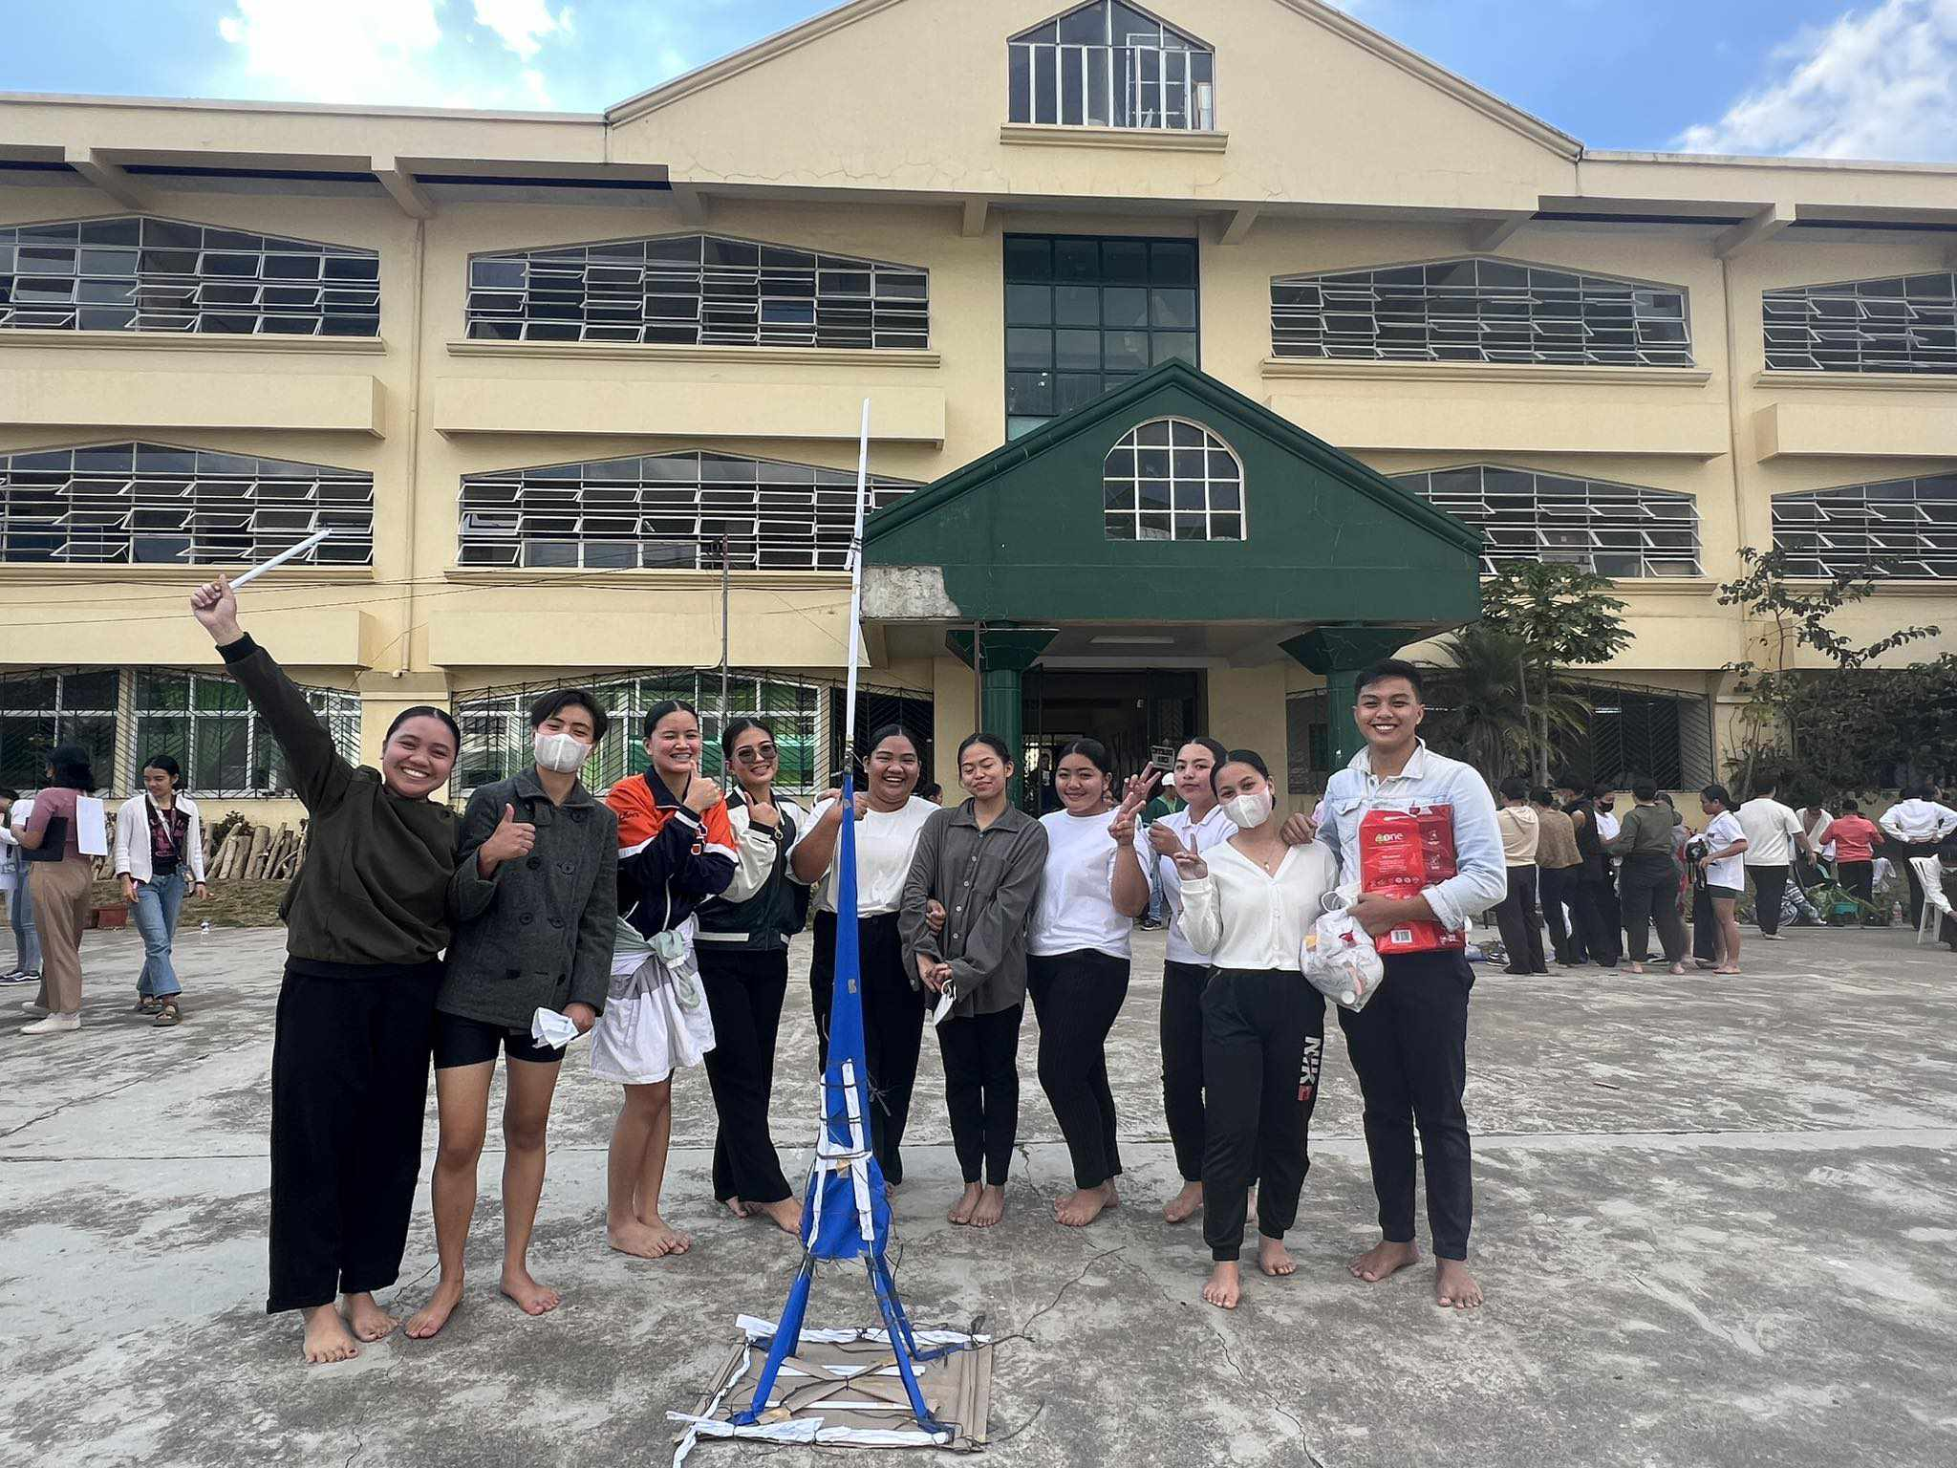

After our COPAR training which we won the tallest and strongest tower with limited resources and of course, with collborative effort with my team.

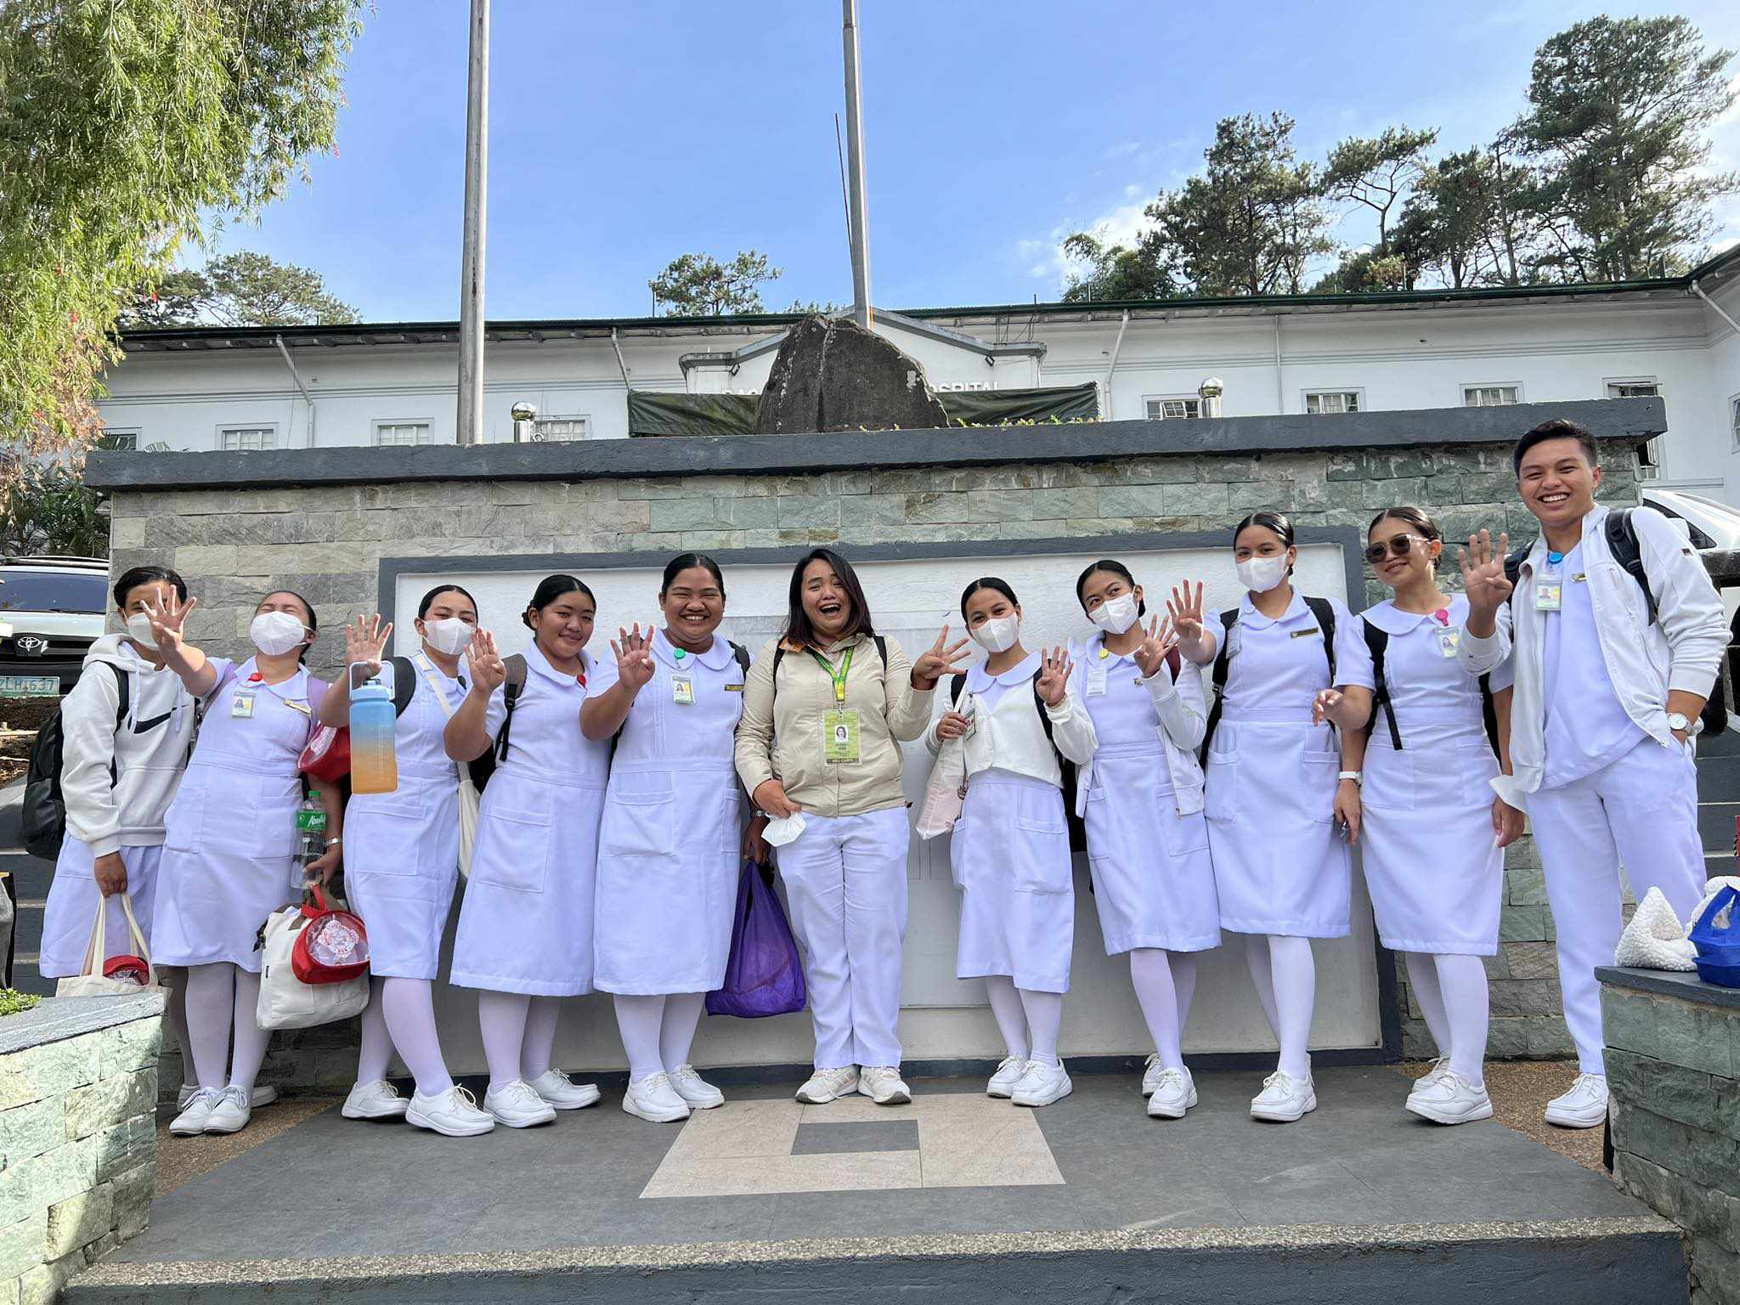

Medicine Ward duty, BGMC. 7-3 shift.

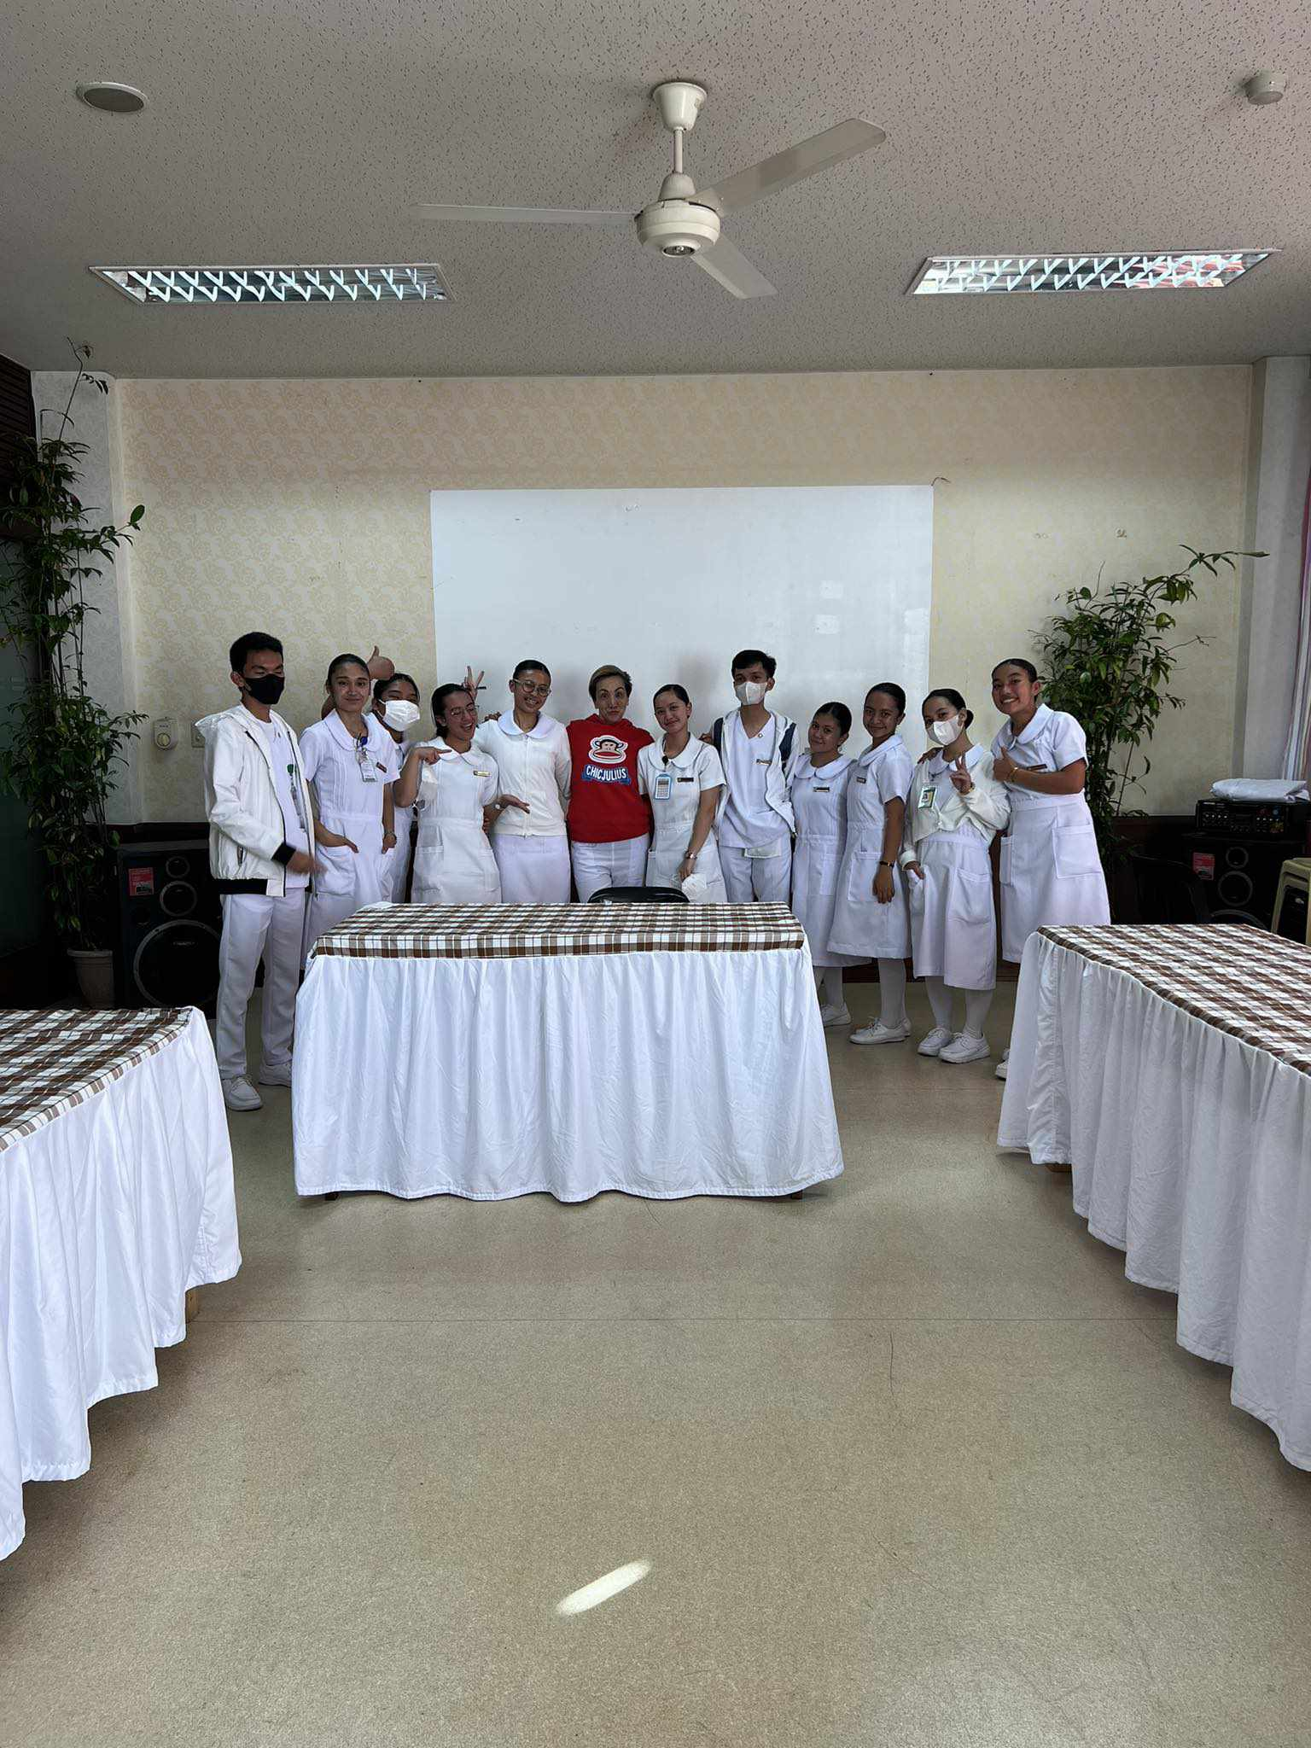Surgical Ward duty, BGHEE, 11-7 shift.

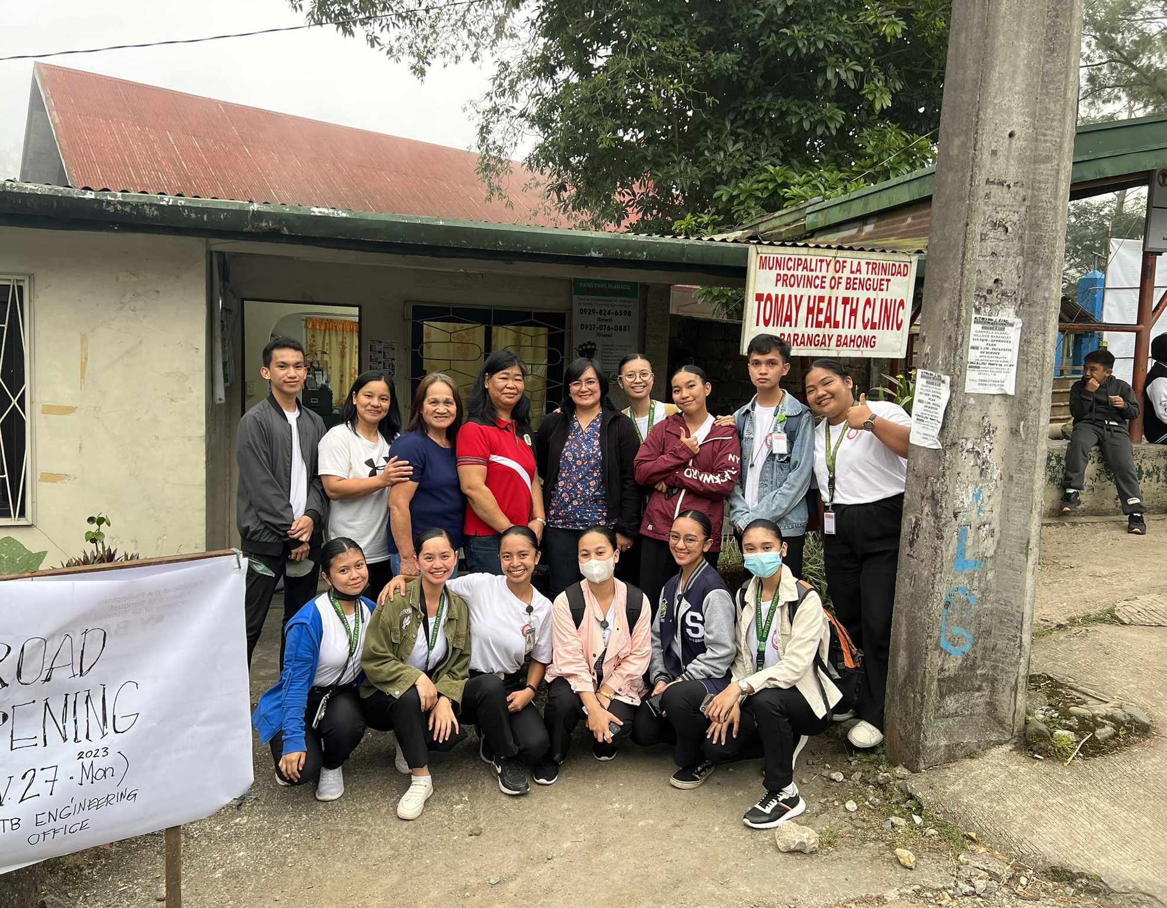Barangay Bahong deployment, RHU rotation.

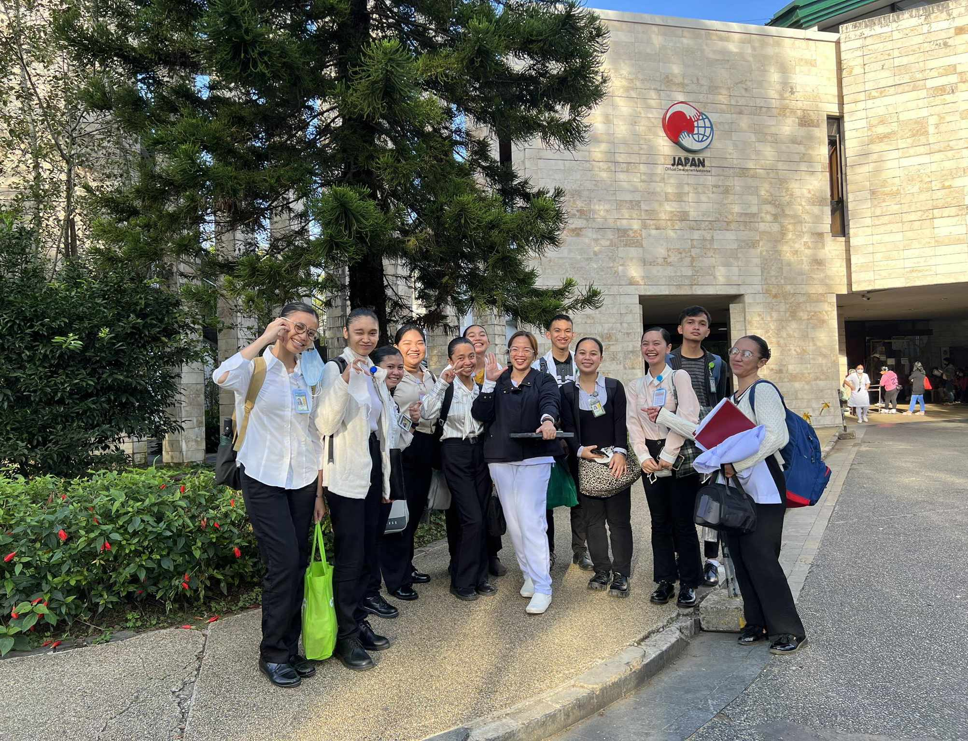

OB ward duty, BGHEE, 11-7 shift.

NURSING COMPETENCIES

In the ever-evolving landscape of healthcare, nursing competencies stand as the foundation upon which patient care excellence is built. As a student nurse, my journey has been an exploration of these competencies—acquiring skills, embracing knowledge, and fostering a commitment to compassionate care. This essay unravels the dimensions of my progression as I strive to embody and internalize the key competencies essential for nursing practice.

**Clinical Skills: The Art and Science of Patient Care**

* Handwashing, Patient’s positioning, Patient transfer from bed to stretcher, bed to wheelchair and vice versa. Bed making, occupied and unoccupied. Bed bath, Oral Care, Back Massage, Perennial Care, Shampooing, Tepid Sponge Bath.
* IM, ID and SubQ. IV insertion, Priming, IV push medications and oral. Charting and Documentation such as FDAR, I &O, NCP, TPR and such.

**Communication Proficiency: A Bridge to Holistic Care**

* In a busy medical-surgical unit, I was assigned to care for a patient with complex needs and a history of non-compliance with medications. Recognizing the potential complications, I initiated open communication with the patient, addressing their concerns, clarifying the importance of adherence, and exploring any barriers to following the prescribed regimen.
* Establishing rapport is a fundamental skill in nursing, facilitating trust, communication, and a positive patient experience.
* In some of our clinical rotations, I was assigned to care for a patient who arrived in distress, visibly anxious and reluctant to share details about their medical history. Recognizing the importance of building trust, I began by introducing myself, maintaining eye contact, and using open-ended questions to encourage the patient to express their concerns.

**Recognizing Ethical Dilemmas**

**Cultural Competence: Embracing Diversity in Patient Care**

* Cultural competence plays a pivotal role in providing holistic and patient-centered care. One notable experience during my clinical rotation highlighted the significance of embracing diversity in patient care.
* I was assigned to care for a patient from a culturally diverse background who spoke limited Pangasinense. Recognizing the potential challenges in communication, I collaborated with an interpreter to ensure accurate and culturally sensitive information exchange. Moreover, I took the initiative to learn about the patient's cultural preferences, including dietary restrictions and healthcare beliefs.

Interdisciplinary Collaboration: The Harmony of Healthcare

* Interdisciplinary collaboration is essential in healthcare, and a noteworthy experience during my clinical rotation exemplifies the harmony that can be achieved through effective teamwork.