Go to “Application Registry” and click on “New”

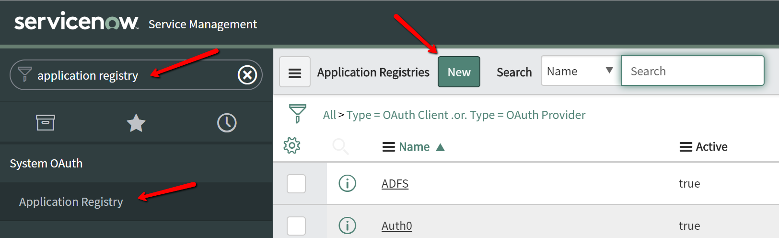

Select “Create an OAuth API endpoint for external clients”

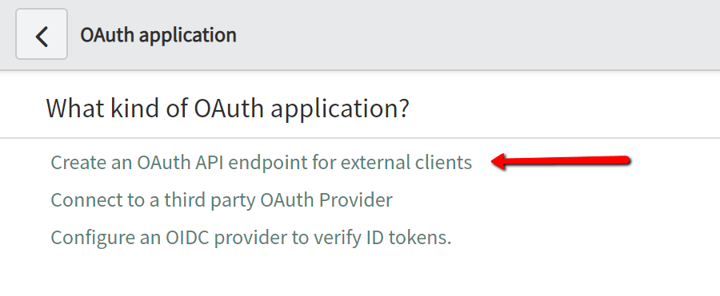

Enter Name “DigitalAssistant“ and Redirect URL „<https://zensar.digitalassistant.app/OAuth2ReturnURL>”

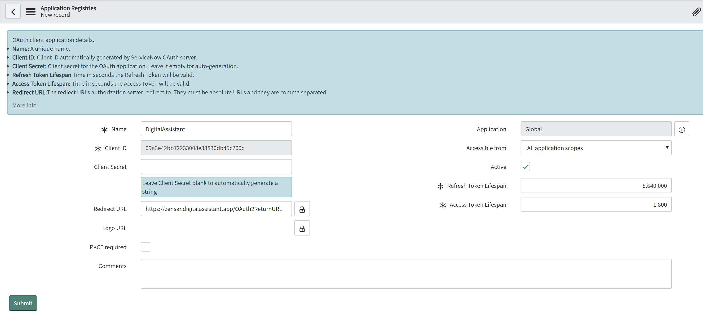

Send us the service now Url to be used (e.g. https://dev64094.service-now.com/) , and the values of “Client ID” and “Client Secret”