Day 01
Understanding my system
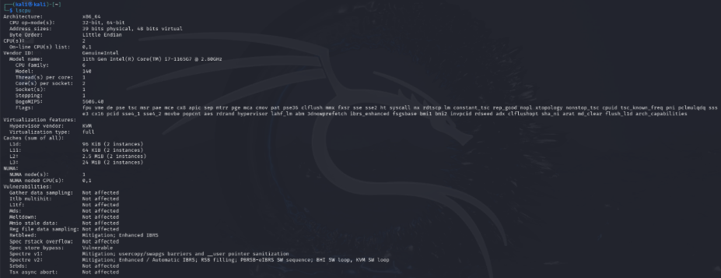
Screenshot 1: CPU Information
Command used: lscpu
The lscpu command displays information about the CPU architecture and processor configuration.
Observations:
CPU model: 11th Gen Intel(R) Core(TM) i7-1165G7 @ 2.80GHz
Number of logical CPUs visible to the VM: 2
Architecture: x86_64
Explanation:
The Kali virtual machine has been allocated two logical CPUs. The x86_64 architecture indicates that the operating system is running on a 64-bit processor architecture.
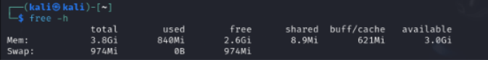
Screenshot 2: RAM Information
Command used: free -h
The free -h command displays RAM information (memory and swap usage) in a human-readable format.
Observations: Total memory: 3.8 GiB Available memory: 3.0 GiB
Explanation: The total memory represents the RAM available to the virtual machine. Available memory indicates the estimated amount of memory that can be used by new applications without requiring swapping. The -h option displays the values in an easily readable format.
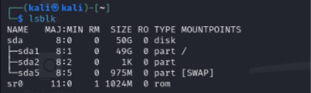
Screenshot 3: Block Devices and Partitions
Command used: lsblk
The lsblk command lists block devices connected to the system. Block devices store or transfer data in fixed-size blocks.
Observations: sda represents the disk. sda1 and sda2 represent partitions on that disk. sda5 is the first logical partition. sr0 represents a CD/DVD-ROM device.
Explanation: A partition is a logical division of a storage device. A single disk can contain multiple partitions, which can be used for different purposes by the operating system.
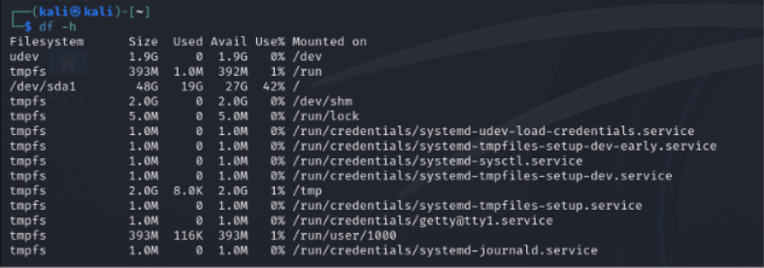
Screenshot 4: Filesystem Storage Usage
Command used: df -h
The df -h command displays filesystem storage usage (total size, used space and available space) in a human-readable format.
Observations: /dev/sda1 represents a filesystem on a disk partition. udev is associated with Linux device management. tmpfs is a temporary filesystem backed by virtual memory.
Explanation: df -h displays the storage usage of mounted filesystems. This helps identify how much filesystem space is being used and how much remains available.
Screenshot 5: Linux kernel and system information
Command used: uname -a
The uname -a command displays information about the Linux kernel and system information.
Observations: Kali is the hostname, 6.11.2-amd64 is the kernel release, x86_64 indicates the 64bit x86 architecture and SMP refers to support of symmetric multiprocessing.
Explanation: uname –a displays the Linux kernel and system information which can help check software compatibility, investigate kernel vulnerabilities and troubleshoot Linux machine.
Exploring hardware
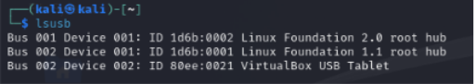
Screenshot 6: USB devices detected by Linux
Command used: lsusb
The lsusb command lists the USB devices detected by linux.
Observations: There are 2 linux foundation USB root hubs and a virtual USB box tablet.
Bus 001 is the USB bus number, Device 001 is the device number, ID 1d6b:0002 stands for Vendor ID:Product ID.
Explanation: lsusb command lists the USB devices detected by linux. The Device ID contains a Vendor ID and Product ID which can help identify the hardware. As shown, there are 2 USB root hubs present in which USB 2.0 root hub support USB 2.0 connections whereas USB 1.1 root hub supports USB 1.1 connections. VirtualBox USB Tablet is seen as VirtualBox provides a virtual input device which allows VirtualBox to communicate mouse movements, pointer positioning to the guest operating system.
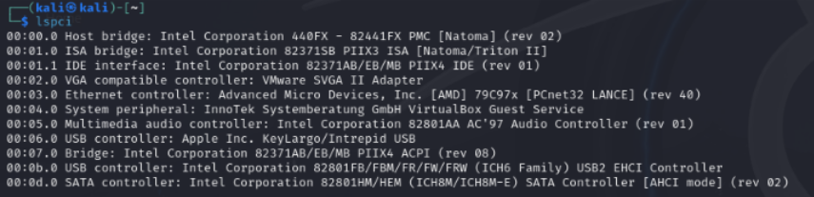
Screenshot 7: Devices connected through the PCI bus
Command used: lspci
The lspci command lists the devices connected through the PCI bus.
Observations: The output shows several devices, including Host Bridge, ISA Bridge, IDE Interface, VGA Controller, Ethernet Controller, USB Controllers, and SATA Controller. It also shows a VMware SVGA II graphics adapter.
Explanation: The lspci command lists the devices connected through the PCI bus. These devices help identify important hardware components such as network, graphics, storage and USB controllers. This information can be useful for troubleshooting hardware issues, checking drivers and identifying unfamiliar devices during a security investigation.
Process basics
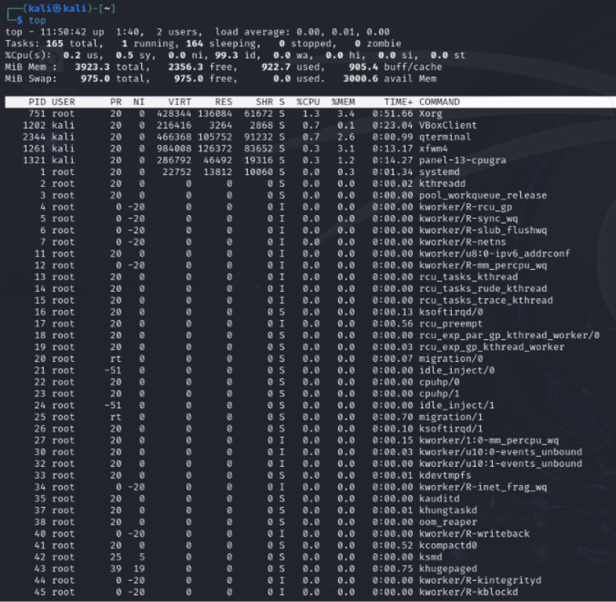
Screenshot 8: System resource and running processes.
Command used: top
The top command displays the live feed of system resources and processes running.
Observations: Xorg had the highest CPU and memory usage among the processes in the captured output.
Explanation:
top provides a live view of system resources usage and processes running. It displays RAM, CPU, Swap and process information. Every process has a unique process ID (PID) and information such as its user, CPU, usage and memory usage etc.
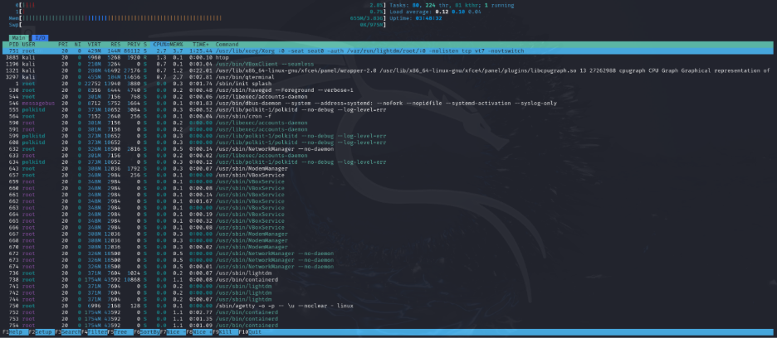Screenshot 9: System resource and running processes.
Command used: htop
Observations: The output displayed two CPU usage bars, indicating that two logical CPUs were allocated to the virtual machine. It also displayed memory usage and the processes currently running.
Explanation: htop provides a more visual and interactive view of system resources and running processes compared to top. It displays CPU, RAM and Swap usage along with process information. It also allows users to search, sort and manage processes, making it easier to monitor system performance.
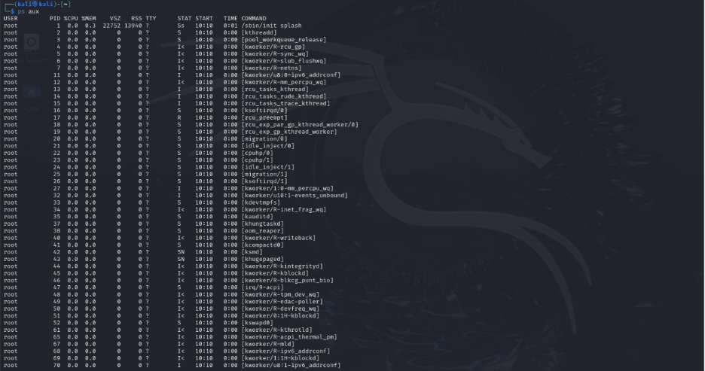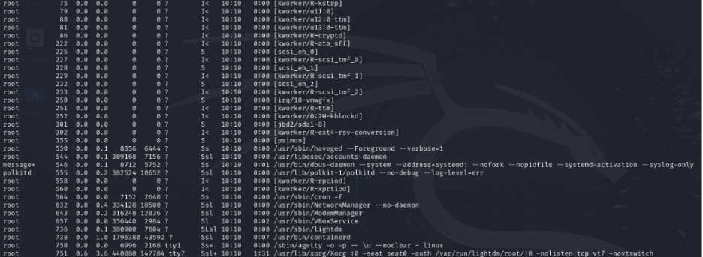Screenshot 10: Current running processes.
Command used: ps aux
Observations: Xorg was the process with the highest CPU and memory usage in my captured output. It was running under the root user, while several other processes were running under my Kali user.
Explanation: ps aux displays a snapshot of the processes currently running. It provides information about the PIDs, CPU, memory usage, etc.
Boot and Logs
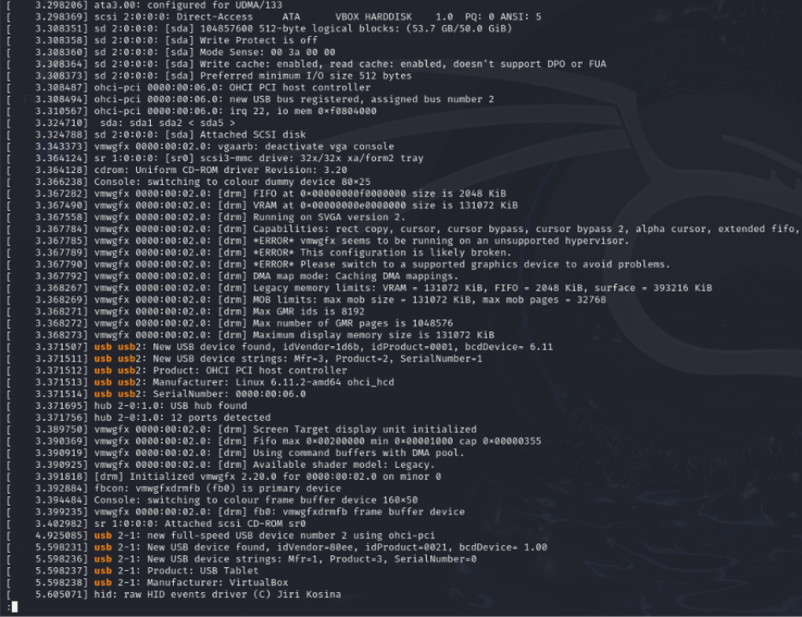 Screenshot 11: Linux kernel messages.
Command used: dmesg | less
Observations: I searched for USB messages and found information related to USB devices detected by the system.
Explanation: The dmesg command displays kernel messages related to hardware detection, drivers and system events. Using less makes it easier to read through the messages page by page. This information can help troubleshoot hardware and driver issues and investigate system events.
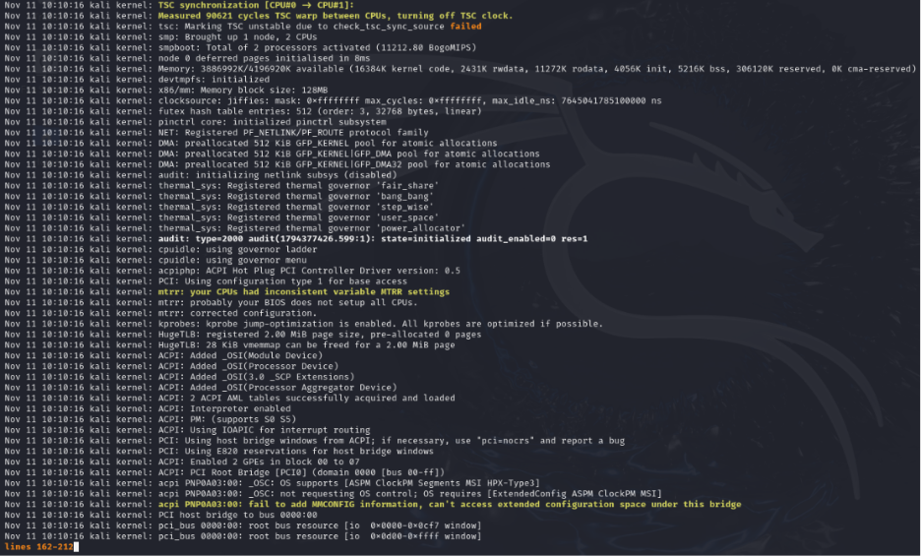Screenshot 12: System journal logs.
Command used: journalctl -xb
Observations: I searched for the word "failed" and found a failed message in the system logs.
Explanation: The journalctl -xb command displays logs collected by systemd during the current boot session. These logs contain information about system startup, services, warnings, and errors. This can help identify services that failed to start and troubleshoot problems during the boot process.
Hands on task
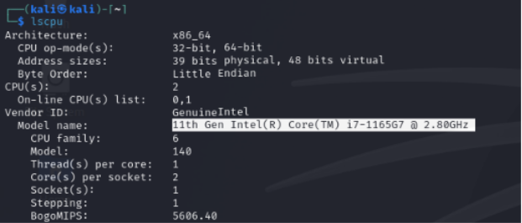
Screenshot 13: CPU Model “11th Gen Intel(R) Core(TM) i7-1165G7 @ 2.80GHz”
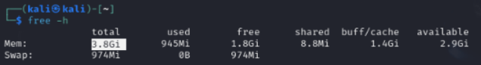
Screenshot 14: RAM Size 3.8GB
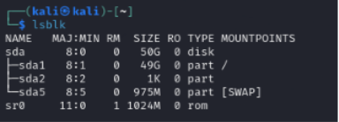
Screenshot 15: 50GB divided into 3 partitions
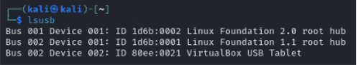
Screenshot 16: 3 USB records.
Question. Explain how a system boots.
Answer. When a computer is switched on, BIOS/UEFI checks and initializes the hardware and performs POST, then loads the bootloader (Grub). Grub loads the linux kernel into memory (RAM).
The kernel initializes the hardware and starts system (PID1), which starts the necessary system services. Finally, the login screen and desktop environment load, making the system ready to use.

