# List to do

1. State a design goal
   1. Goal: The main aim of this project is to automatically generate puzzles. Depending on the student, this could also involve implementing a game, or performing experiments which measure how well the difficulty measure lines up with real users. Note that the quality of any created game is NOT a primary measure of how well the project has gone!
   2. Games categories
      1. Match 3 fun :

Rule: In the game, players complete levels by swapping coloured pieces of candy on a game board to make a match of three or more of the same colour, eliminating those candies from the board and replacing them with new ones, which could potentially create further matches. Matches of four or more candies create unique candies that act as power-ups with larger board-clearing abilities. Boards have various goals that must be completed within a fixed number of moves or limited amount of time, such as a certain score or collecting a specific number of a type of candy. (from candy crush wiki)

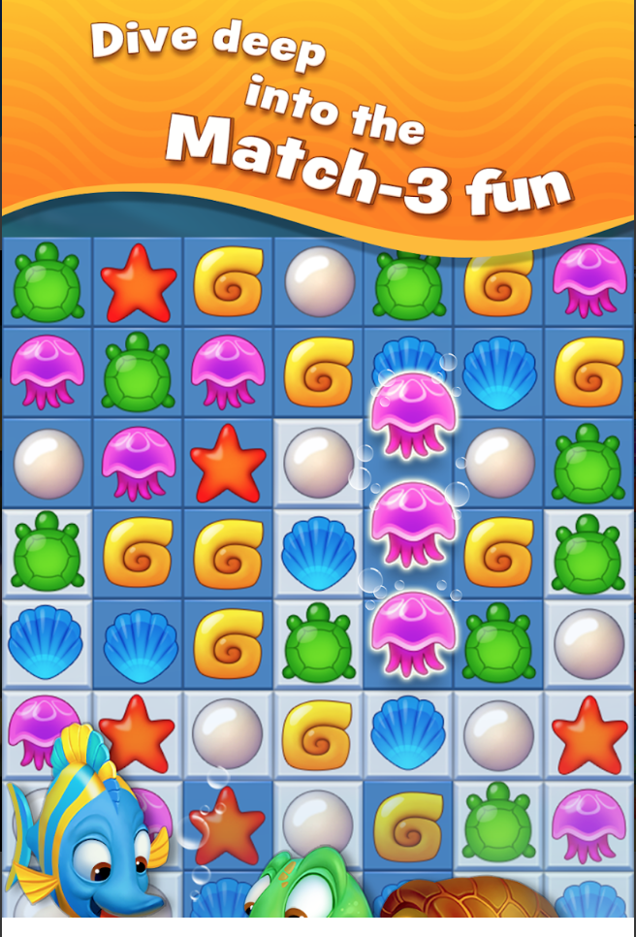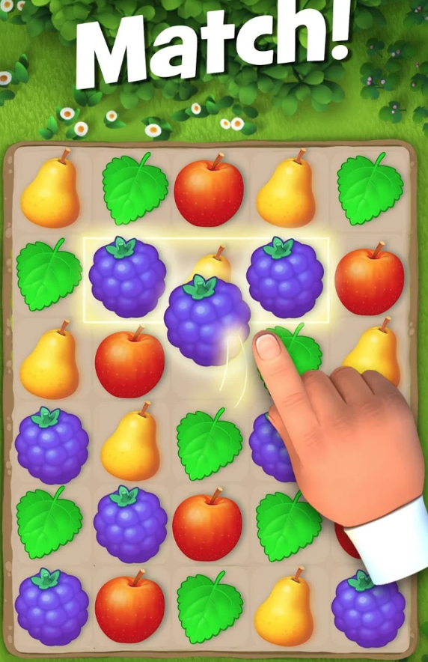

Difficulties:

* + - 1. Act as power-ups with larger board-clearing abilities can help finish games quicker and obtain higher score.
      2. With a fixed size board, more different objects make games more difficult.
      3. Different games have different assignments.
    1. Threes!

Rule: The player slides numbered tiles on a four-by-four grid to combine addends and multiples of three. For example, ones and twos merge to become a single "three" tile, two threes merge into "six", and two sixes merge into "12". Swiping the screen up, down, left, or right moves all of the tiles on the grid in that direction and adds a new tile to the grid in the same direction. The colour of the incoming tile is shown onscreen. Players can preview moves by sliding the grid without letting go. Each kind of number tile has its own personality, and new kinds of number tiles are introduced with a screen full of confetti when first unlocked. (from threes! wiki)

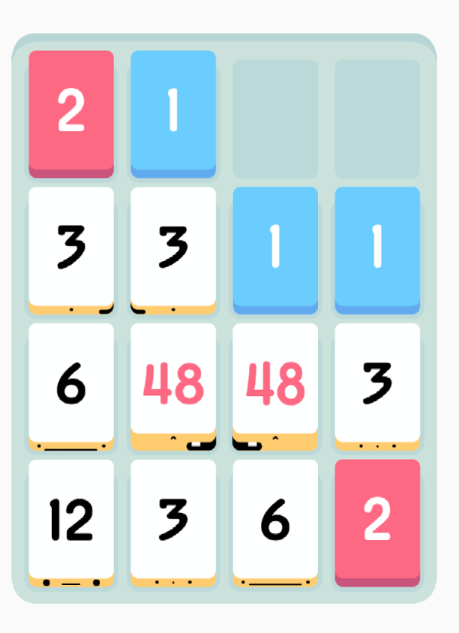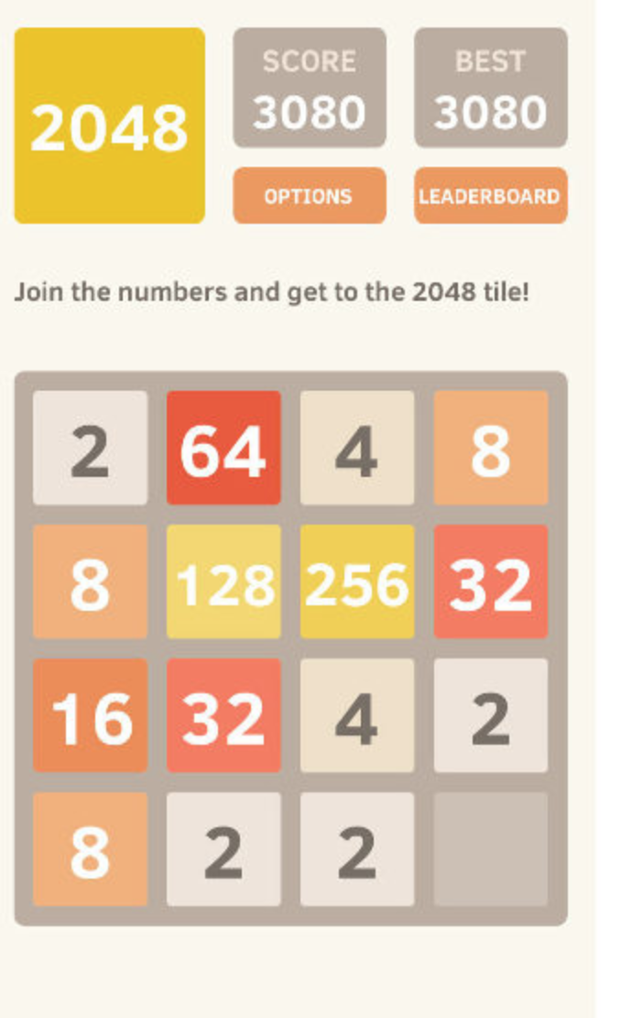

Difficulties:

1. The next tile could be any grid.
2. Need a little math.
   * 1. Minesweeper

Rule: The player is initially presented with a grid of undifferentiated squares. Some randomly selected squares, unknown to the player, are designated to contain mines. Typically, the size of the grid and the number of mines are set in advance by the user, either by entering the numbers or selecting from defined skill levels, depending on the implementations.

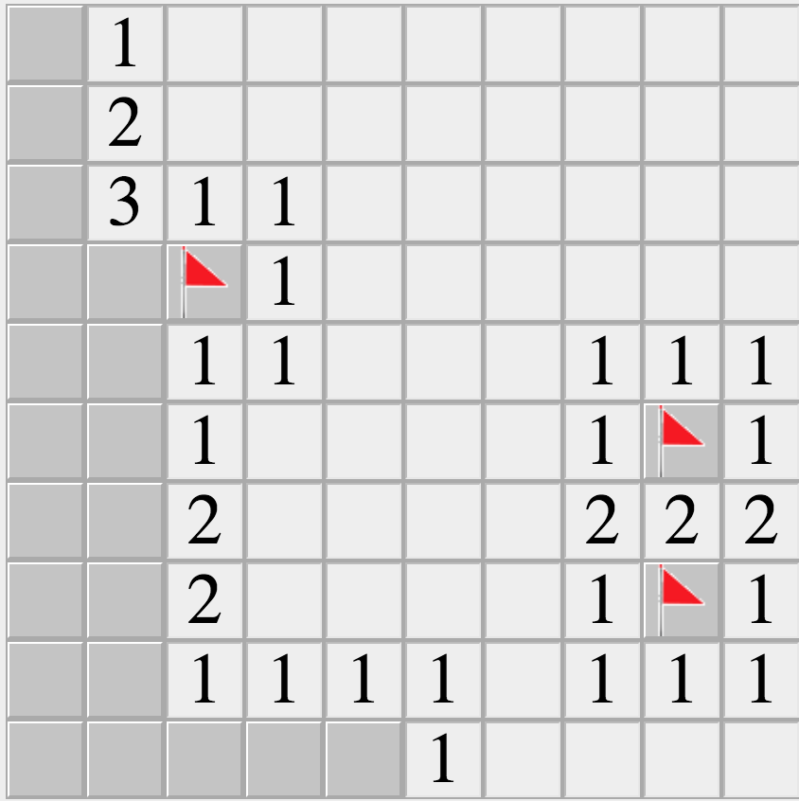 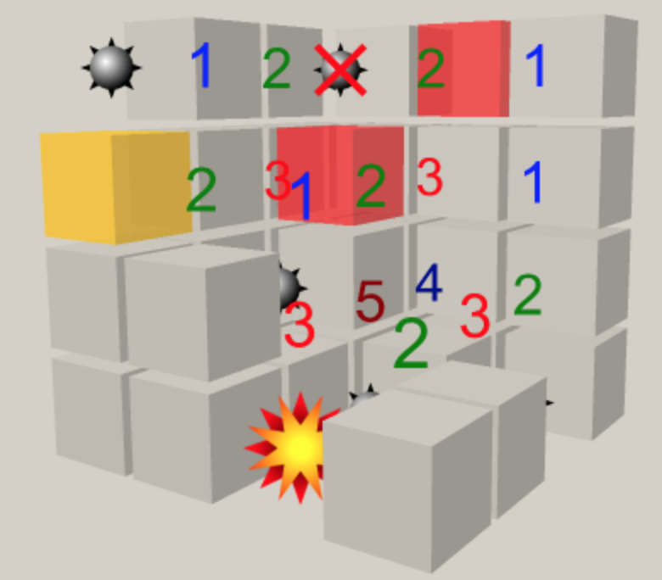

Difficulties:

* + - 1. It is a math question. It may be too easier for computers but too hard for humans.

1. Finish the ethics form