

AE3IDS Interim Report
Automated backgammon player: learning through self-play

Date: Submitted December 2017
Words: 3208

BAO Han
6514879

School of Computer Science
University of Nottingham

I hereby declare that this dissertation is all my own work, except as indicated in the text:

Signature ______________________

Date _____/_____/_____

Abstract
Backgammon is one of the oldest board game known which has simple rules and easier strategies to implement. Consequently, it has been implemented in machine learning in decades. On the other hand, Neural Network also is used widely in the modern society, especially in machine learning. Through Artificial Neural Network (ANN) could make machines think like a human and behave like a human.
In this dissertation, I will present, design, and implement a Backgammon self-player in Java using ANN to train a model. This model helps computer learn play backgammon that it could find the optimal solution as far as possible. My aim is to finish a backgammon model with a simplified backgammon game, and then evaluate the model with other similar games online.

Contents
Abstract 2
Contents 3
List of Figures 3
Chapter 1 Introduction 4
1.1 Project Description 5
1.1 Background [1] 5
1.3 Project Aim & Objectives 5
1.4 Motivations 5
1.5 Document Content & Scope 6
Chapter 2 Methodology 8
2.1 Preliminary Research 8
2.2 Summary of Research 8
Chapter 3 Requirements & Specifications 10
3.1 Functional Requirements 10
3.2 Non-functional Requirements 13
Chapter 4 Progress Report 15
4.1 Progress to date 15
4.2 Planning for the second half of the project cycle 15
Chapter 5 Feasibility Study 16
Chapter 6 Neural Network Design 16
Chapter 7 Implements 16
7.1 Human play in Java 16
7.2 Machine Random play in Java 16
7.3 ANN training of self-play (machine random play) 17
Chapter 8 Testing 17
Chapter 9 Review 17
9.1 Reflection 17
9.2 Kaizen 18
Chapter 10 Conclusion 18
Bibliography 19
Appendices 20
Appendix A 20
Appendix B 21
Appendix C 22

List of Figures
Figure 1- ANN mode 9
Figure 2- Black Part and White Part in the Board 11
Figure 3- Bar and StoneBar in the Board 11
Figure 4- Blot in the Board 12
Figure 5- Consequence of Machine Play Version 13
Figure 6- Gantt for initial plan 15
Figure 7- Gantt and plan for next stage 18

Chapter 1 Introduction

1.1 Project Description
The intention of this project is to create an automatic Backgammon player through its self-learning which could provide better interactive intelligent movements. In traditional board games with AI, the programmers set up the rules and provide strategy algorithms with a standard to judge the whole board. Typically, the self-learning player could learn the strategies during the practice and board games so that this method would help machine think like human more.

1.1 Background [1]
Backgammon is one of the oldest board game known and many computer scientists implement new techniques using Backgammon as a practice object. This board game not only depends on dice’s results but also needs a global view of whole board rather than each small movement. Due to the simplest rule compared to other board games and easiest implement using algorithms, Backgammon is suitable for beginners to do some mobile phone games and desktop games in the early stage. As a consequence, there is a great amount of development and research on this type of game.

1.3 Project Aim & Objectives
The aim of the project:
This project will attempt to replicate a backgammon player that had been developed by Pollack and Blair, successfully using an ANN trained through self-learning, beginning with a simplified version of backgammon, and moving on to a more realistic version of the game.
The main of objectives of the project are as follows:
• Design and implement Backgammon board game in Java and document.
• Do research on the former Backgammon games or ANNs.
• Create an ANN as described as the requirements specification mentioned in project description.
• Fully test the system against other Backgammon games online.
Firstly, I would write a demo in Java to be familiar to backgammon and read related paper on backgammon and ANN. Secondly, according to the optimal doubling written by Keeler and Spencer (1975) and the optimal strategy written by Thorp (1988), apply these strategies on demo. Then the demo should use self-learning and start applied in ANN model. Finally, testify the model and do reflection all the time. In this period, how to evaluate the board is the key point that it must satisfy the strategies noted before. Finish a report contained above mentioned.

1.4 Motivations
As mentioned in above, there are some possible use cases using the same method. Two use cases as following:
    - Game development
Regardless of board games or other puzzle games, programmers could implement self-learning to instead of the traditional programming mode that set up engine as AI. In addition, with the continuous progress of its algorithm of the game, it also can help human to cultivate more talented people. On the other hand, it is an opportunity to practice in Machine Learning for beginners.
    - ANN technological development
ANN could not only be used in development of games deeply, but also in other social areas. For example, ANN could be used in GPS navigation and always to provide users a better solution in different occasions and improve by self-learning.

1.5 Document Content & Scope
As mentioned before, this project will adopt the Waterfall engineering methodology and will thus proceed in a linear fashion. More specifically, the project will proceed with sequential steps, where each step will solve a particular problem in the process. The structure will thus be as follows:
    - Abstract: A section for summarizing the goal and result of the project.
    - Introduction: introduction of whole project and introduce more related information
a) Project Description: The project description of content of project
- Background: Introduce Backgammon board game and why I choose this game to implement ANN model to train an automatic Backgammon player
- Project Aim & Objectives: Give the project development direction and how it implement
- Motivation: List some possible further implications of this project or what goals could help to achieve
    - Methodology: To complete method in efficiency way, it introduces the spheres of technology, ideology and working methodology
    - Preliminary Research: Give examples of some related work and summarize the technology, ideology and working methodology
    - Requirements & Specifications: Give more detailed information on this model or what needs to prepare before training.
    - Feasibility Study: Analyze the problems based on the suitability of previous technologies.
    - Neural Network Design: A section introduce the design of ANN and specific components
a) ANN Design: A high level overview of the whole ANN model design
- Individual design components: A low level pay attention to how each individual component in the system will work
    - Implements: How it implement and analyze the result
    - Testing: Test the codes and evaluate this board game with other Backgammon board game
    - Review: Reflection on the process and project
    - Conclusion: Based on the testing result and ANN model, give a simple conclusion about the debate between Tesauro and Pollair & Blair. Finally, summarize the advantages and disadvantages of ANN model and coevolutionary self-play.
    - Appendices: Additional information about meeting records, tests and complimentary works completed for this project.

Chapter 2 Methodology

2.1 Preliminary Research
Firstly, the topic had been discussed and solved by 1990s and different people had various solutions. Mention ANN in Backgammon, Tesauro’ [2] work is one of the most significant that he has published dozens of paper about the Backgammon, especially his TD-Gammon program. Another influenced my work deeply is coevolutionary self-play approach worked by Pollack and Blair [4]. So in the following part, I would introduce more detailed information about their conclusion and controversy.

2.1.1 Gerald Tesauro [2]
In 1992, Gerald Tesauro developed a computer backgammon program “TD-Gammon” using artificial neural networks (ANNs). The performance of TD-gammon was at a level not far below that of the best human players of the time, and the strategies explored by TD-gammon led to advances in the theory of backgammon play. In 1998 [3], he also gave the comments on the conclusion worked by Pollack and Blair that he analyzed the differences between two totally different methods and proved the correctness of TD learning nets.

2.1.2 Jordan B. Pollack, Alan D. Blair [4]
In 1997, Pollack and Blair demonstrated that a coevolutionary self-play approach to developing backgammon strategies could be successful using ANNs and hill climbing (no reinforcement learning necessary). The result demonstrated that the dynamics of backgammon are particularly suited to coevolutionary learning through self-play (unlike many other games, such as chess). After this paper was published, Tesauro write a short comment to defend his work, arguing that hillclimbing alone is not sufficient to achieve successful learning.

2.1.3 Other Implements
Recent developments in ANNs (in particular deep learning methods) have generated international headlines through successful game playing implementations such as AlphaGo, capable of beating the best humans. In addition, based on previous professional research on backgammon through self-learning.

2.2 Summary of Research
TD-Gammon's exclusive training through self-play rather than tutelage that help computer enable explore strategies itself which had not been considered by human or implemented. The unorthodox strategies had a significant influence on the backgammon that provided compute scientists a thought-provoking solution. Pollack and Blair also helped to kaizen coevolutionary self-play approach and explain why TD-Gammon works. Based on these research and new implements used in contemporary society, self-play is one of the best method to implement self-learning.
As for the language, after scanning some papers, most of they use Java to write the UI and not mention which language they used. Then they would use Matlab to figure out the data algorithms. Consequently, I also could use Java to write most part and then use other tools to help analyze. ANN would be the main method to train the model.
2.2.1 ANN
ANN contain multiply hidden layers with dynamic weights and then get a output from its learning. The weights would be modified after each train or test so only if the accuracy would drop from a high level to a lower level that this ANN model is useful.
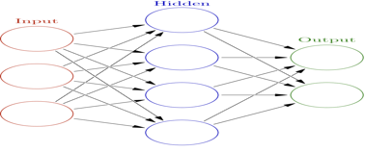
Figure 1- ANN mode
2.2.2 Co-evolution
Co-evolutionary algorithms are a class of algorithms used for generating artificial life as well as for optimization, game learning and machine learning. It is widely used in self-learning that help machines to behave with human-like intelligence.

Chapter 3 Requirements & Specifications
In this section, the requirements of the proposed solution would be discussed and listed which would be split into two parts, including functional and non-functional requirements. These requirements are based upon the summary of the research in Chapter 2 and then as the anaylze in Chapter 5 and design in Chapter 6 to implement in Chapter 7. This could work in Windows, Mac OSX or Linux operating system and the implemented interface is Eclipse. Besides, this work mainly divides into three main parts, backgammon game, ANN model and their final combination. Because of the limited time, I only focus on the requirements and specifications backgammon game in this part.

3.1 Functional Requirements

3.1.1 General System Requirements
1.Operating System: This could work in Windows, Mac OSX or Linux operating system. Furthermore, this computer should allow at least 2G CPU run alone.
2. System Requirements: The project could be implemented in the interface -- Eclipse.
3. Internet Connection: The project should be able to work without an Internet connection.

3.1.2. Backgammon Game

1. Rule of Backgammon [5]
There is one board that allows two players to play with two dices. In general, it could be divided into four parts, including outer board, home board, bar and home. Firstly we need to know the characters of each name.
a. Stones: pieces on the board.
b. Board：The whole board is split as left part and right part and also split as front part and bottom part, so there are four parts. The northern two parts are Black Part (this depends on the stone initial location) and southern two parts are White Part (see Figure 2).
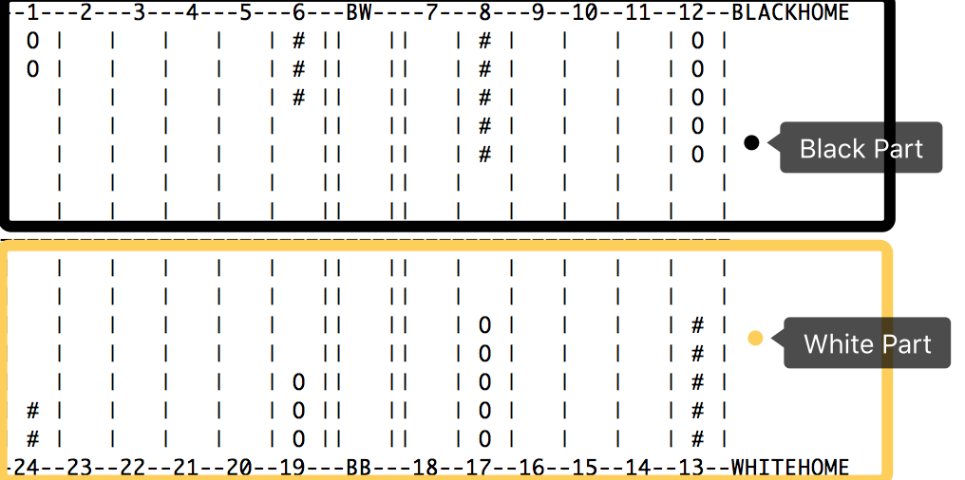
Figure 2- Black Part and White Part in the Board
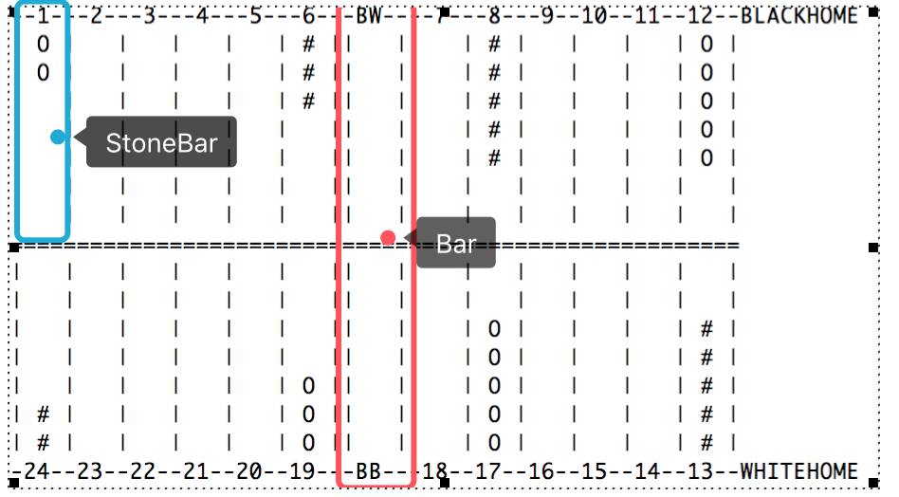
Figure 3- Bar and StoneBar in the Board
c. Bar: Located in the center of the board (see Figure 3).
d. StoneBar：Actually, the name should be “Point”. However, this is easily misunderstood as the pieces location. So I use “StoneBar” to stand for 24 columns in the whole board. Each board has six StoneBars (see Figure 3).
e. Blot：When there is only one stone is the StoneBar, this stone is “Bolt” (see Figure 4).
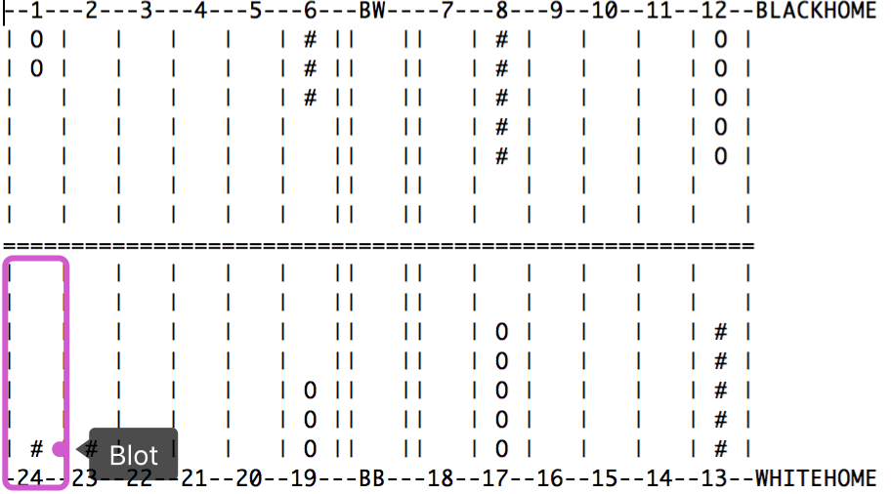
Figure 4- Blot in the Board
f. Hit: When other colour stone move to the “Blot”, this movement is named as “Hit”. Then this blot would be moved to the Bar.
g. Open：If there is no stone in the StoneBar, this StoneBar is open for two colours. If there are more than two stones located in this StoneBar, this StoneBar is open for this colour but not open (Or could say it is closed or made) for the other one. Only the destination is open for the stone, the stone could move to this destination.
h. Closed or made: Opposite to the “Open”.
i. Bear off: Stones move from the inner board and get home.
j. Shut out: Because there are no “open” places for the stones, so this turn is over.
k. Start the game: each player has 15 stones and placed in four bars. Then, each player would have two dices and roll to choose the colour that moves firstly. If Black’ dices sum number is bigger than White, Black moves firstly. Otherwise, White firstly.
l. Move the stone: If the numbers of rolled dices are same, player needs to move four times. Otherwise, only need to move two times.
m. Hit the stone: If only one stone is left in a bar and other colour player could move his stone to hit this stone, this stone would be moved to the center of bar. Next time, player has to move this stone firstly from opposite inner home board.
n. Bear off: Only all own pieces are located in inner board, then player can move the stone to bear off.
o. End the game: Once player’ all stones bear off, this player wins the game and the game ends.

2. Human play version
Human play this game should move the stone though the inputs and judge the whole board. This part could see more information in Chapter 7 and Appendix B.
And this requires the human play version following:
- Read the inputs and move the stone.
- If the input is invalid or movement is invalid, give a response and ask human enter the input again.
- Show the board after every movement.
- Human player needs to judge the “Shut out”.
- Once one player wins the game, present the message. “Congratulations! X is the winner!”

3. Machine play version
Machine play version is similar to Human play, only playing it automatically. This part could see more information in Chapter 7 and Appendix C.
And this requires the machine play version following:
- Once I enter “machine”, this would play game automatically and give me the result soon (see Figure 5).
- The movement is totally random.
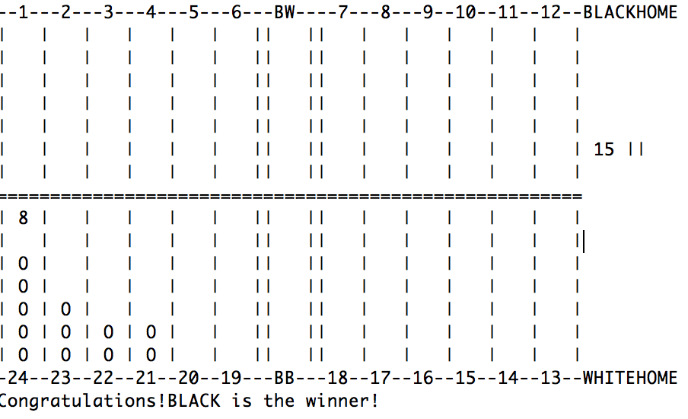
Figure 5- Consequence of Machine Play Version

3.1.2 ANN model
This section is currently under completion and has hence not been included

3.2 Non-functional Requirements
The high level constraints of the system have been outlined here:

3.2.1 Compatibility
This ANN model needs plenty of calculations so that the computer should be compatible with running the project. Large computation should be managed smoothly in this project.

3.2.2. Use-friendly
The game should be easy to use friendly and everyone could play Backgammon even he is no experience on this game. Human and computer will both work in this game. Consequently, this should have the ability to provide high interaction.

3.2.3 Feasibility
Only need to click “run” then all algorithms would run by themselves. Users do not need to understand much knowledge about how it runs or why it works.

Chapter 4 Progress Report

4.1 Progress to date
Firstly I did a Gratt plan for whole project then try to use it to solve all problems mentioned in this project.
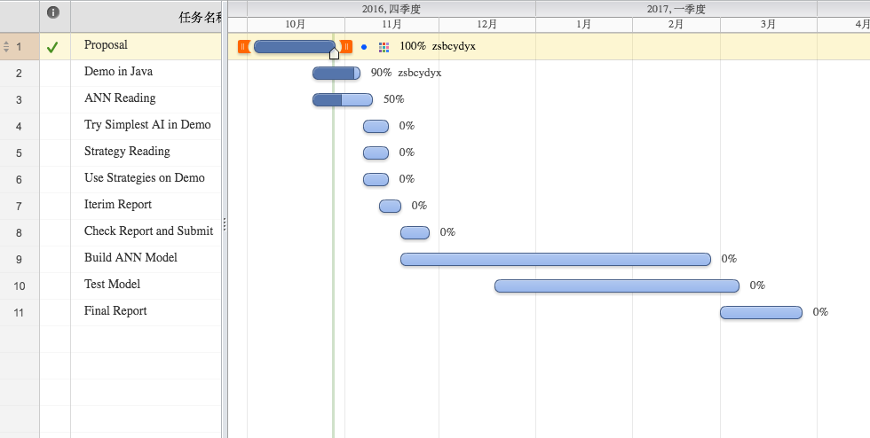
Figure 6- Gantt for initial plan
- Dissertation Structure: The whole structure of project has been listed in the report and explains the intended contents in the Document part. The most part would be change except for some additional contents in the final reports. See more information in Chapter 1.5.
- Research on Backgammon and self-learning: Considering the previous research on Backgammon and self-play, modify the plan and then list the requirement and specifications. This part has been detailed introduced in Chapter 3.
- Human play Backgammon in Java: This project involves research on Backgammon, ANN and self-play, therefore it needs time to implement in Java. Consequently, I choose do the basic frame of Backgammon game in Java firstly and then use ANN to train the work. Human play could only use the simplest play in Java and users must follow the instructions. The user manual is in the Appendix B and introduction in Chapter 7.1.
- Machine play Backgammon automatically in Java: Because the limited time and training requirements, the self-paly needs quick movements rather than human play. So I choose machine random play to implement. The user manual is in the Appendix C and introduction in Chapter 7.2.
The Gantt has been finished half of the whole part.

Planning for the second half of the project cycle
- ANN model design and training
- Testing and reflection
- Finish the report
They are planed in the Gantt as well as the previous semester.

Chapter 5 Feasibility Study
This section is currently under completion and has hence not been included

Chapter 6 Neural Network Design
This section is currently under completion and has hence not been included

Chapter 7 Implements
According to the design and feasibility, this part would divide into three parts and code source could be downloaded from github: https://github.com/Nowhy/backgammon.

7.1 Human play in Java
According to the optimal doubling written by Keeler and Spencer (1975) [6] and the optimal strategy written by Thorp (1988) [7], apply these strategies on demo. I try to write simple backgammon game in Java.

7.1.1 Main Objects
Due to the requirements mentioned in Chapter 3.1, this game needs dices, board and stones. Consequently, draw a board firstly, and then place 24 StoneBars and 30 stones on the board. Also add two dices as a main part. Use a “Game.java” to combine them together.

7.1.2 Design Functions
This part is designed by the rule mentioned in Chapter 3.1.1. Dices are rolled to decide the movements, and Stones with distinct colours should have different places. In addition, valid or invalid movements also designed in the part.

7.1.3 Output
As 7.1.1 and 7.1.2 described, the main board should print as the output and give error messages when any invalid movements or inputs.

7.2 Machine Random play in Java
After the third discussion with Super-Professor, I try to write automatic machine backgammon game in Java based on the human version. This part would let computer to choose a random number to move a valid stone. It is not only saving time and inputs but also useful for ANN model training. Compared to the Human version, I only add some functions on to choose a random number and judge the movement and the whole board.

7.2.1 Design Functions
Because it should use random number to get a valid movement, it should add an ArrayList to record the valid stones and then pick one to move. If it is invalid, choose another one and delete this from the ArrayList. If machine cannot find the valid movement so it has to shut out automatically and then has a turn.

7.2.3 Output
Except for the error messages, it also shows the consequences immediately which less than 1 second.

7.3 ANN training of self-play (machine random play)
This section is currently under completion and has hence not been included

Chapter 8 Testing
This section is currently under completion and has hence not been included

Chapter 9 Review
This part includes reflection on the past work and what could “Kaizen” for next stage.

9.1 Reflection

9.1.1 Complete
Most have been finished on time and did work as plan. Except for near one month, it is hard to spend much time on reading research. Most work would spend much more time I except so that I modify the plan which is suitable to complete in order.

9.1.2 Quality
Follow the instructions and finish it by self and complete requirements for human play and machine play two versions.

9.1.3 Communication with Super-Professor
Though there are only three official meetings with Super-Professor, I always could get significant information and modify some errors in my past work.

9.1.4 Documentation
Smoothly use “Slack” and “Github” to do the documentation. I also record the meeting content for each official meeting with Super-Professor.

9.2 Kaizen
As for the Kaizen part, documentation should have more detailed information on it and should work in advance rather than do the work in hurry. Last but not least, have more official or unofficial meeting with Super-Professor than before.
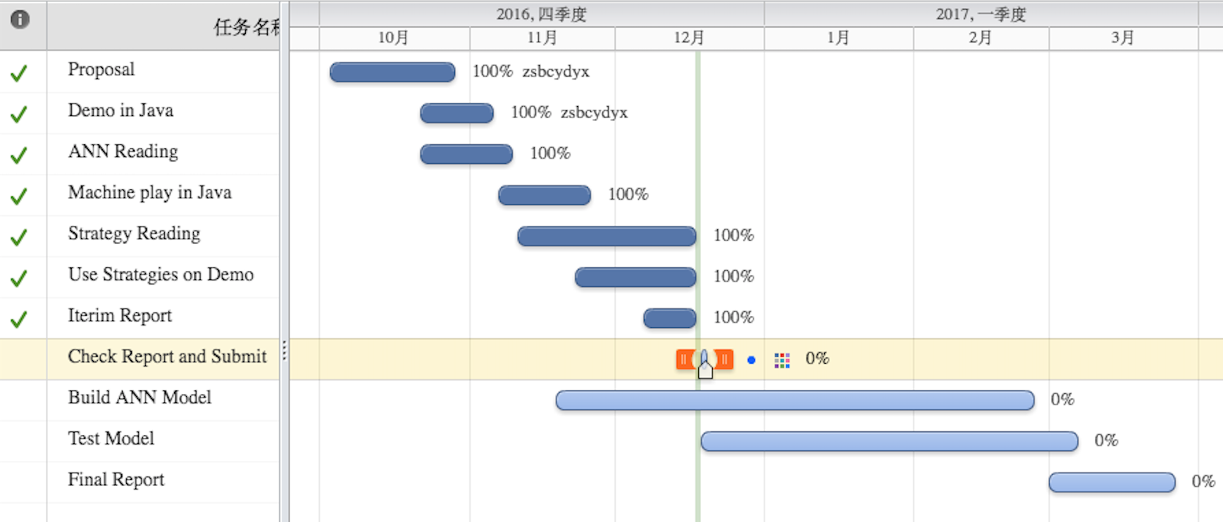
Figure 7- Gantt and plan for next stage

Chapter 10 Conclusion
This section is currently under completion and has hence not been include.

Bibliography
[1] “The History of Backgammon”[Online]. Available: http://www.bkgm.com/books/JacobyCrawford/HistoryOfBG/ [Accessed: 14-Dec-2016].
[2] “Practical issues in temporal difference learning” [Online]. Available: http://www.bkgm.com/articles/tesauro/tdl.html[Accessed: 14-Dec-2016].
[3] “Comments on Co-Evolution in the Successful Learning of Backgammon Strategy.” [Online]. Available: http://download.springer.com/static/pdf/542/art%253A10.1023%252FA%253A1007469231743.pdf?originUrl=http%3A%2F%2Flink.springer.com%2Farticle%2F10.1023%2FA%3A1007469231743&token2=exp=1481737468~acl=%2Fstatic%2Fpdf%2F542%2Fart%25253A10.1023%25252FA%25253A1007469231743.pdf%3ForiginUrl%3Dhttp%253A%252F%252Flink.springer.com%252Farticle%252F10.1023%252FA%253A1007469231743*~hmac=1aa84aaae9dd472e1b22173cf0148128bcc88cf1b90fb39f39294dbfa96b33ff [Accessed: 14-Dec-2016].
[4] “Co-Evolution in the Successful Learning of Backgammon Strategy” [Online]. Available: http://www.cse.unsw.edu.au/~blair/pub/ml_hcgam.pdf [Accessed: 14-Dec-2016].
[5] “Rules of Backgammon”[Online]. Available: http://www.bkgm.com/rules.html [Accessed: 14-Dec-2016].
[6] “Optimal Doubling in Backgammon” [Online]. Available: http://www.bkgm.com/articles/KeelerSpencer/OptimalDoublingInBackgammon/. [Accessed: 14-Dec-2016].
[7] “Backgammon: The Optimal Strategy for the Pure Running Game” [Online]. Available: http://www.edwardothorp.com/sitebuildercontent/sitebuilderfiles/BackGammon.pdf [Accessed: 14-Dec-2016].

Appendices

Appendix A
Meeting record including talk content and new plan
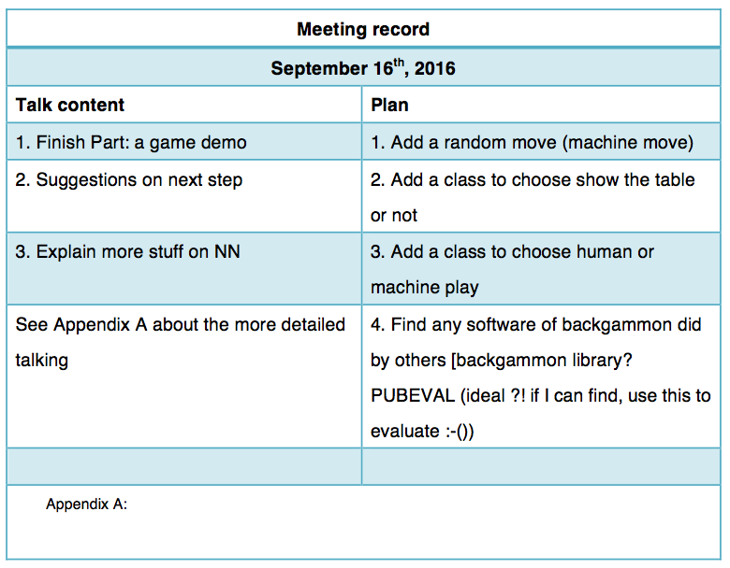
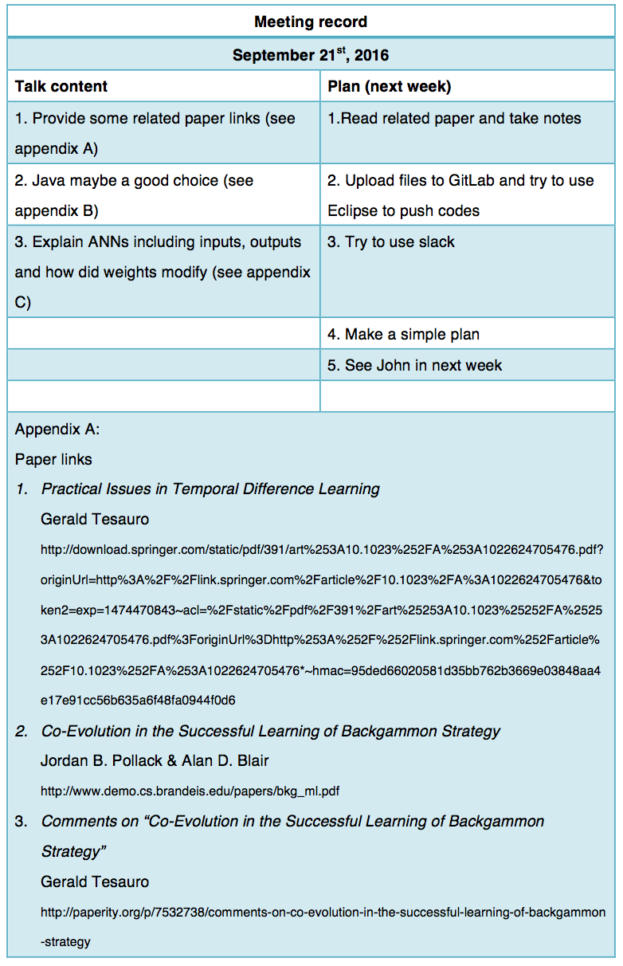

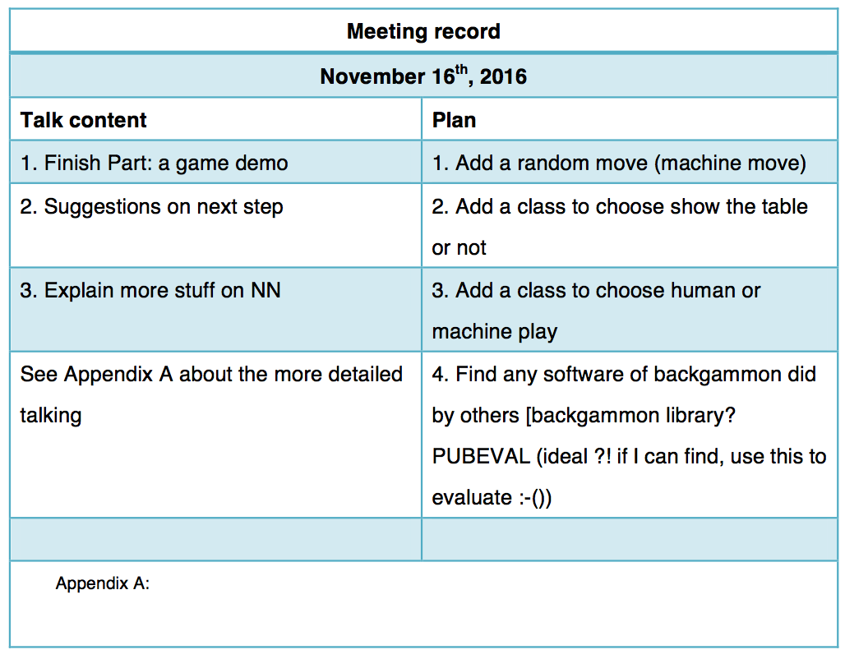

Appendix B
User Manual of Human play in Java
- Run the “Game.java”
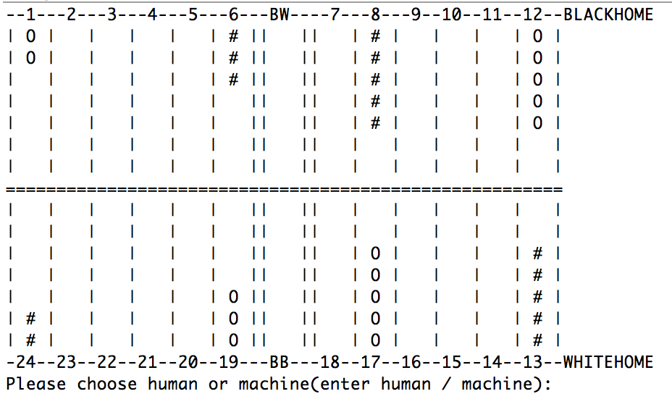
- Enter “human” and it would show the turn colour and numbers rolled by dices
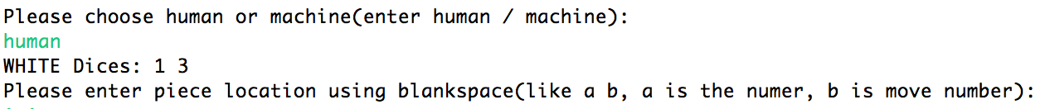
- Enter numbers from 1 to 24 then it would move the stone automatically. For example, move 1 to 2, please enter “1 1”
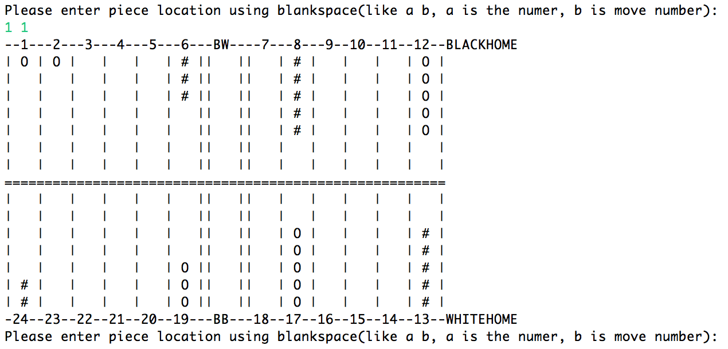
- Repeat 3 until the game ends
- Note: 1) If numbers rolled by dices are same, move 4 times, otherwise is 2 times.
- If only one piece in a column, the other colour stone could catch this piece and put it in the centre of the box and player have to move this piece firstly in next time.
- If the piece in the centre of box and next time it could not move, player should enter “no” to get out of this circle.

Appendix C
User Manual of Machine Random play in Java
- Run “Game.java”
- Enter “machine”
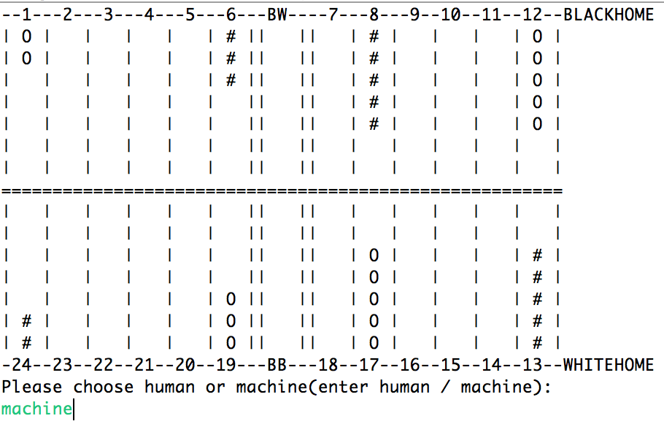
- Get the result
