1) Setup jenkins CICD pipeline using freestyle job using Docker containers using below code.

<https://github.com/betawins/java-Working-app.git>

Stages:

1) Git Clone

2) Sonarqube Integration

3) Maven Compilation

4) Nexus Artifactory

5) Slack Notification

6) Deploy On tomcat

**Pull images:**

Sonarqube

Dockette/nexus

Jenkins/jenkins

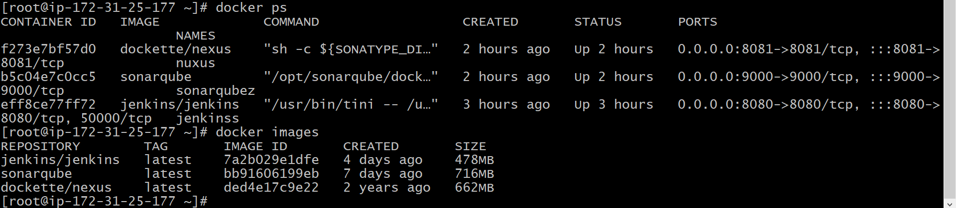

**1) Git Clone**

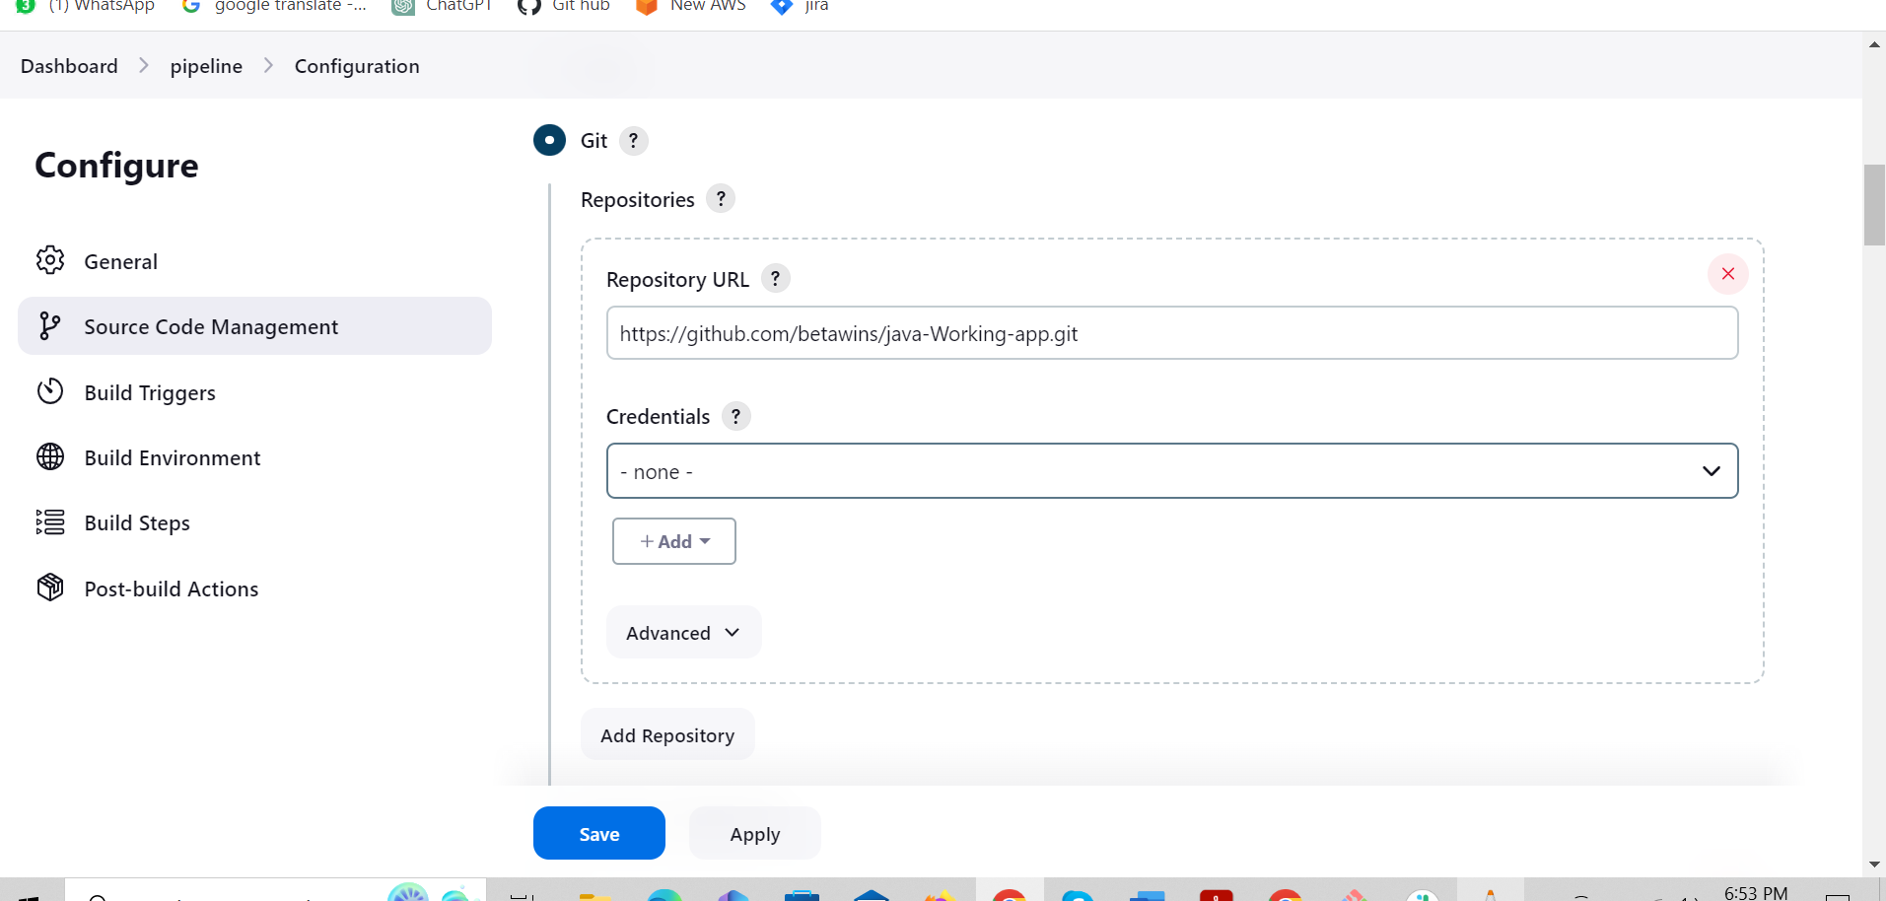

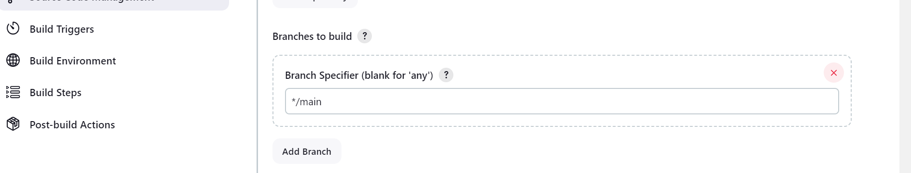

**Output:**

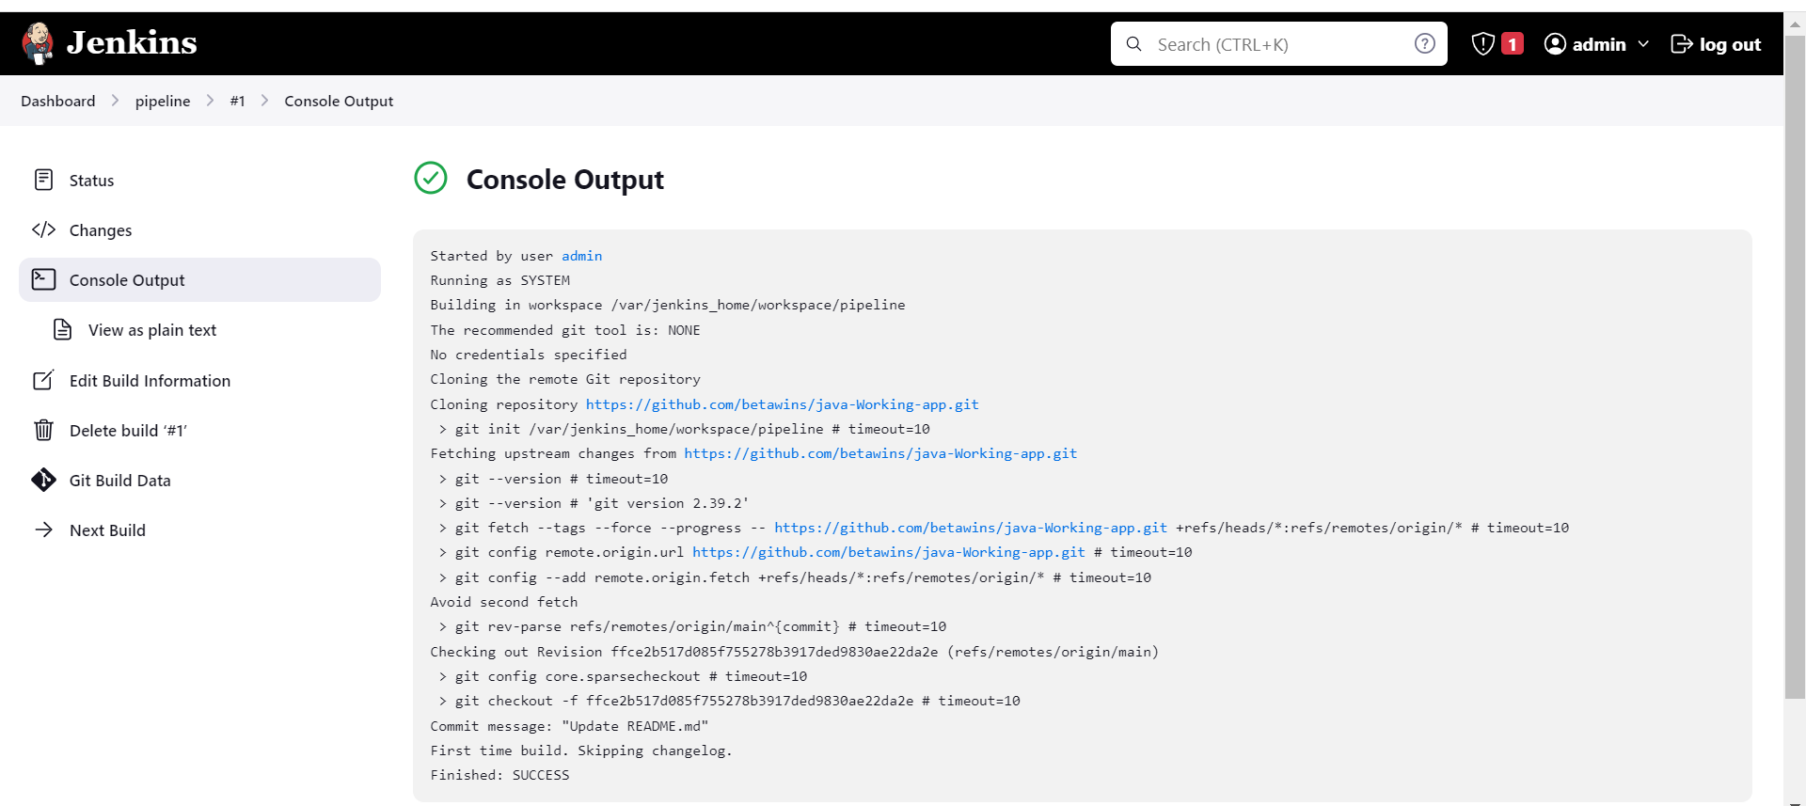

2) Sonarqube Integration

Install sonarqube scanner for Jenkins plugin

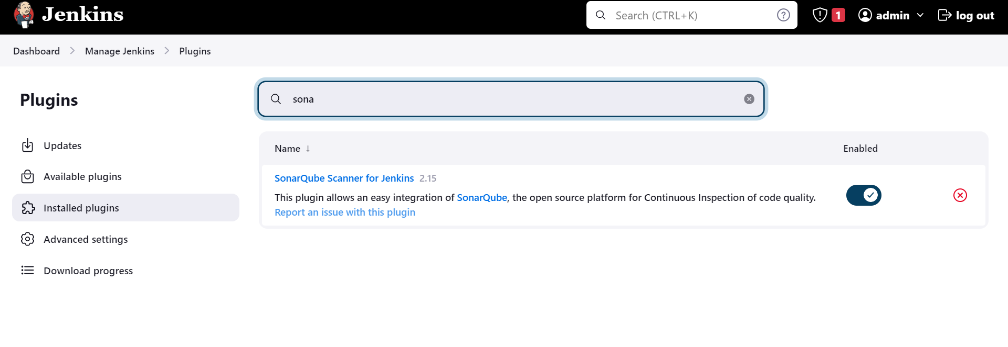

Create a token in sonarqube server

Click on A(administrator) and generate a tokens.

Copy token

**System configuration:**

paste into server authentication token (secret text)

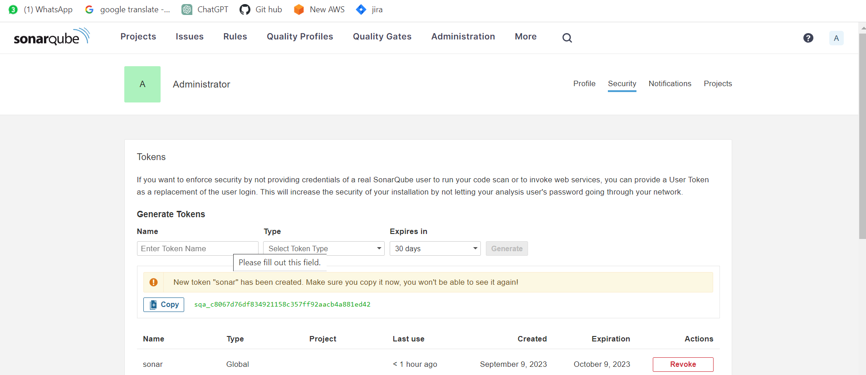

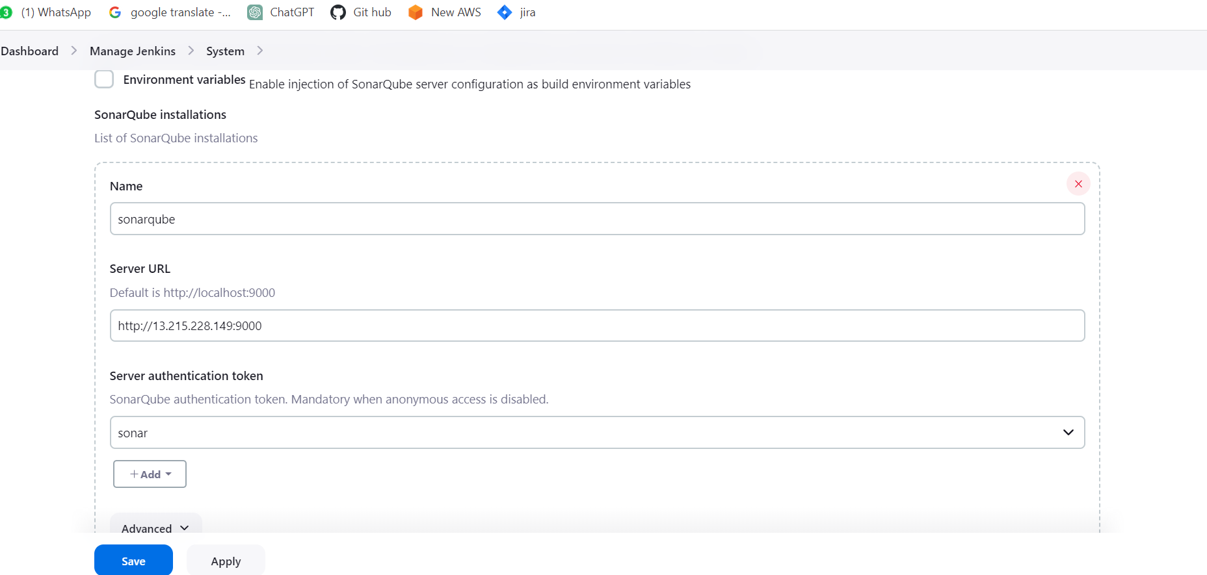

Install sonar_scanner (wget <https://binaries.sonarsource.com/Distribution/sonar-scanner-cli/sonar-scanner-cli-4.6.2.2472-linux.zip> ) inside Jenkins --> docker exec -it eff8c /bin/bash, cd /tmp/ then install.

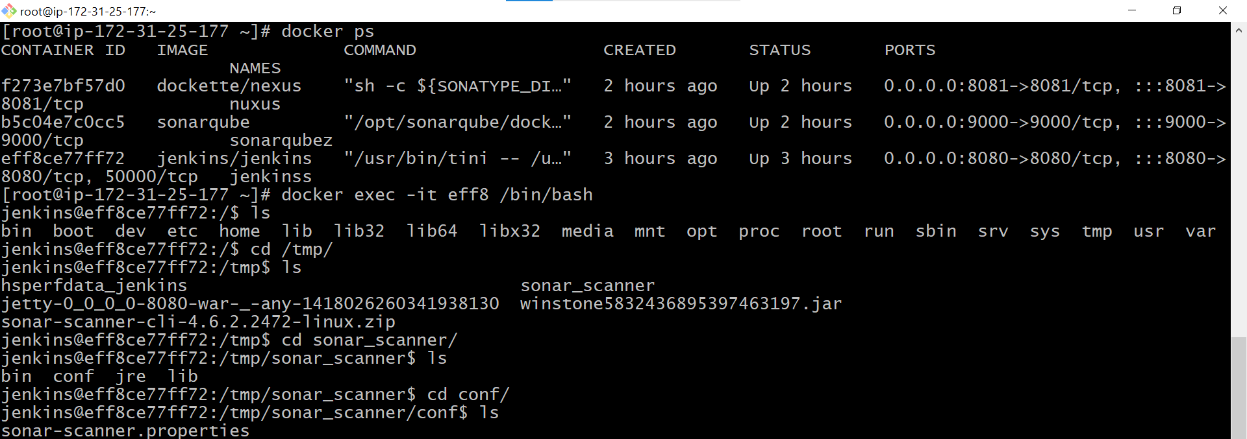



Replace public-ip inside of sonar-scanner.properties

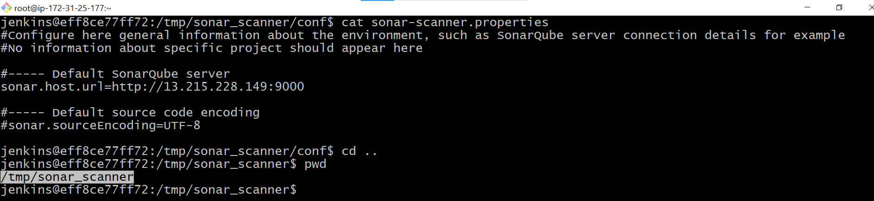

Paste path of where is installed in sonar_scanner into tools

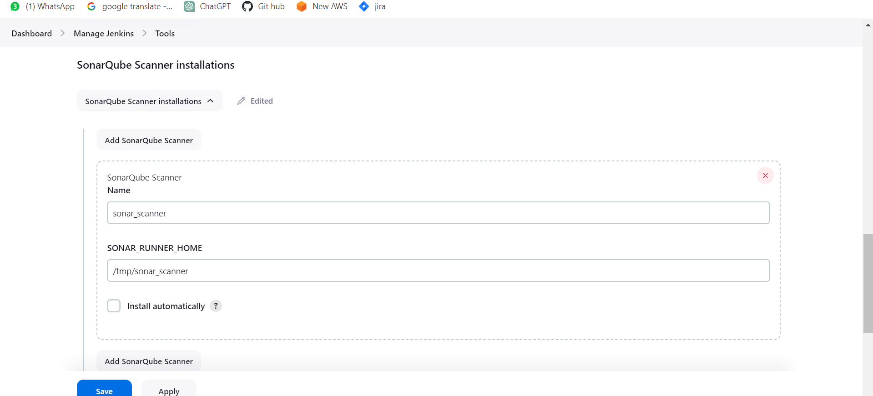

Now Configure sonarqube

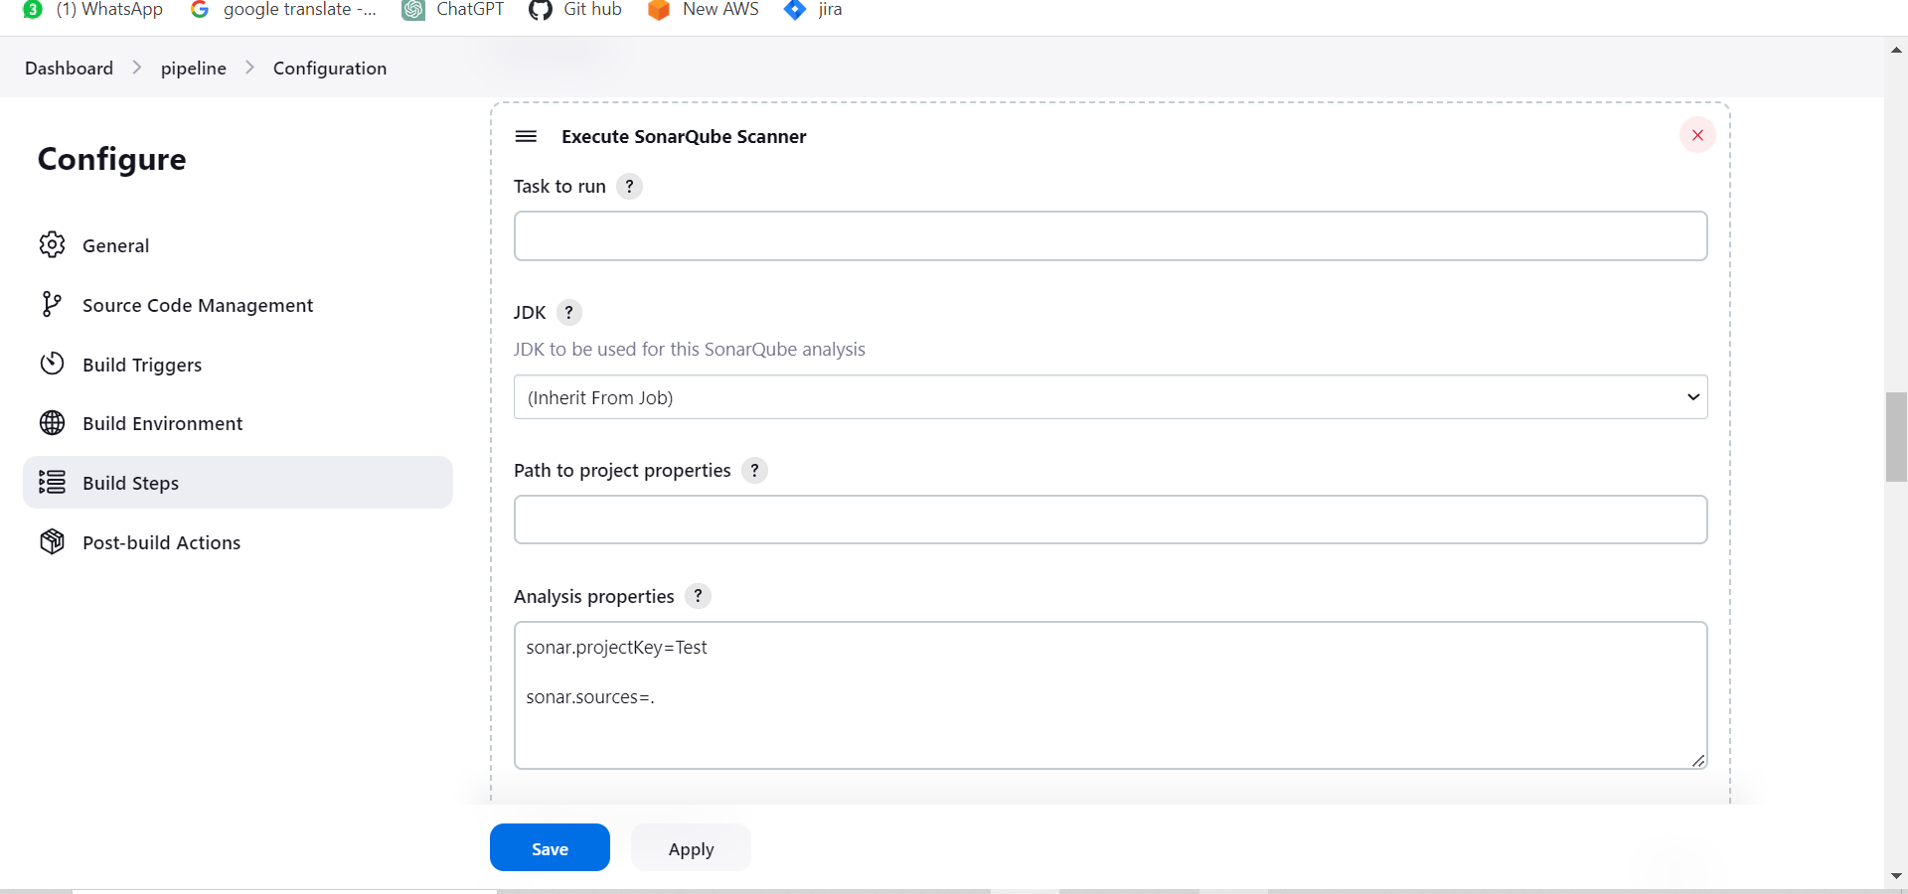

**Output:**

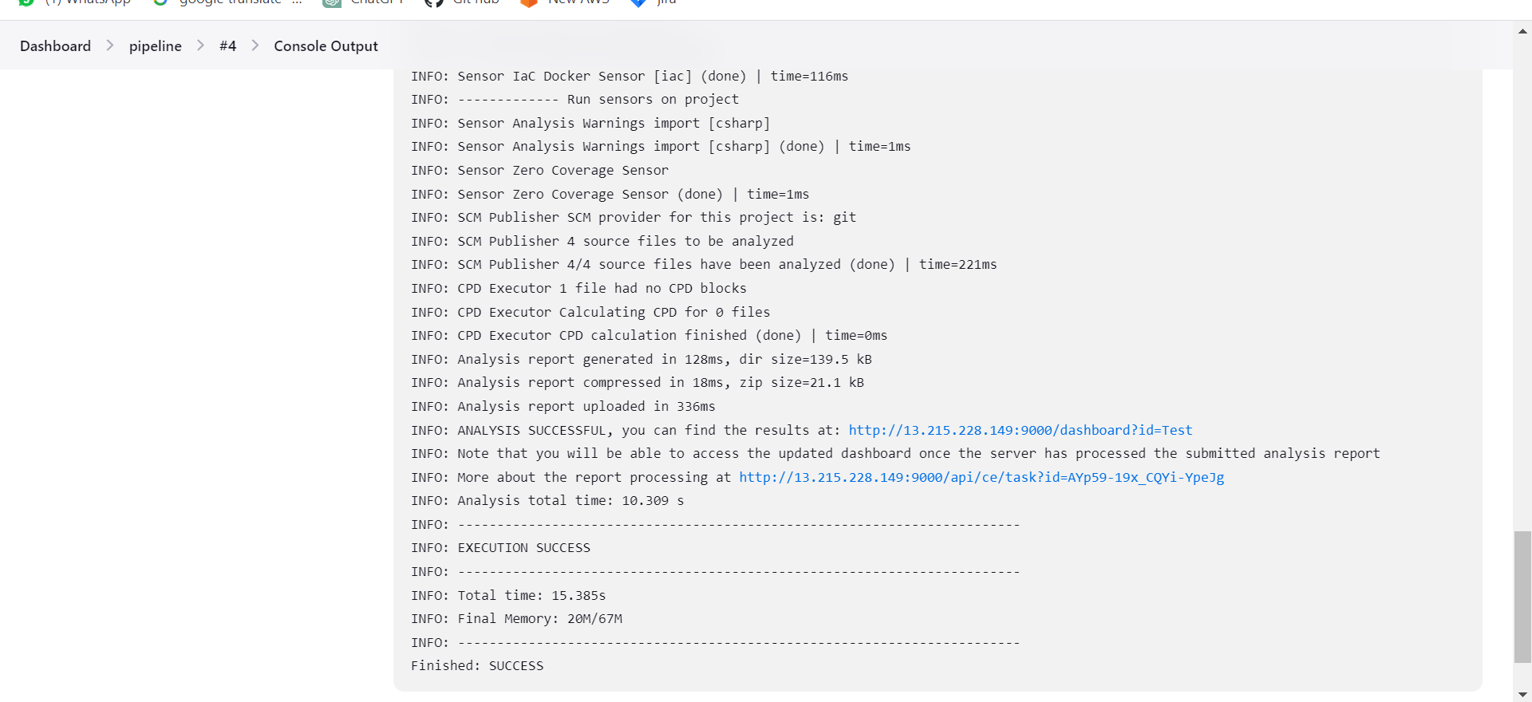

3) Maven Compilation

Install maven plugin

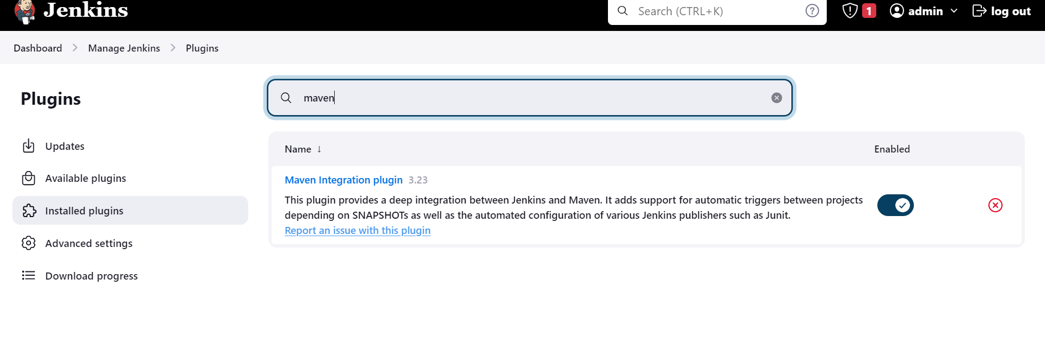

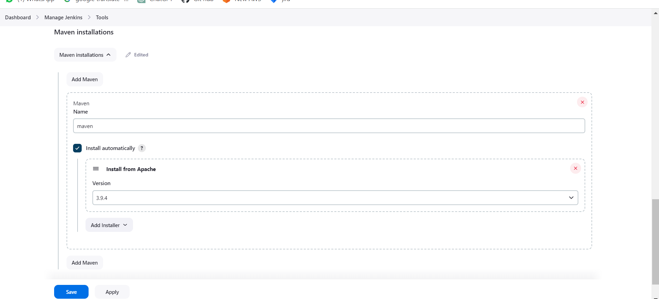

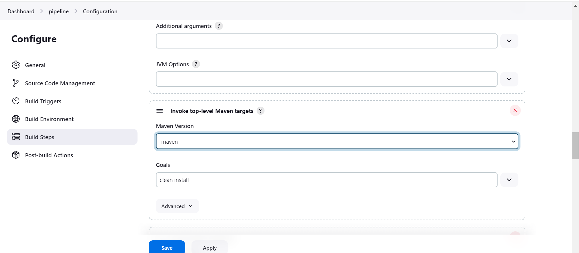

Maven output:

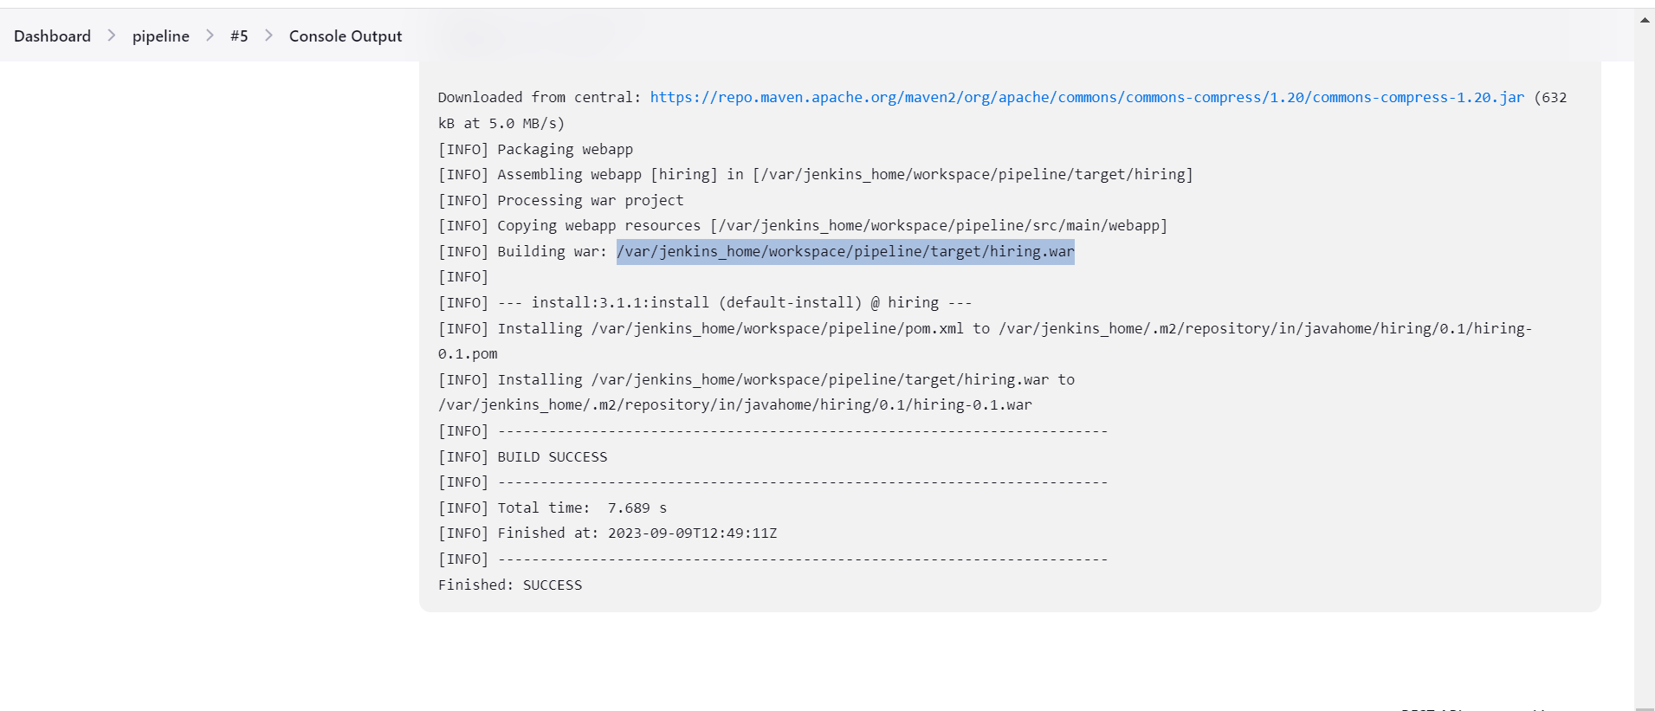

4) Nexus Artifactory

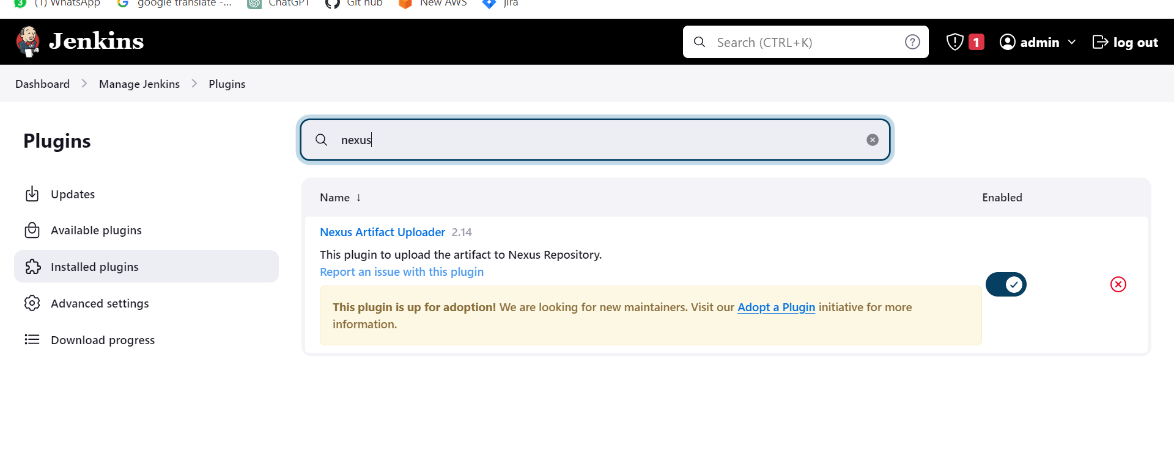

Launch nexus and create a repo

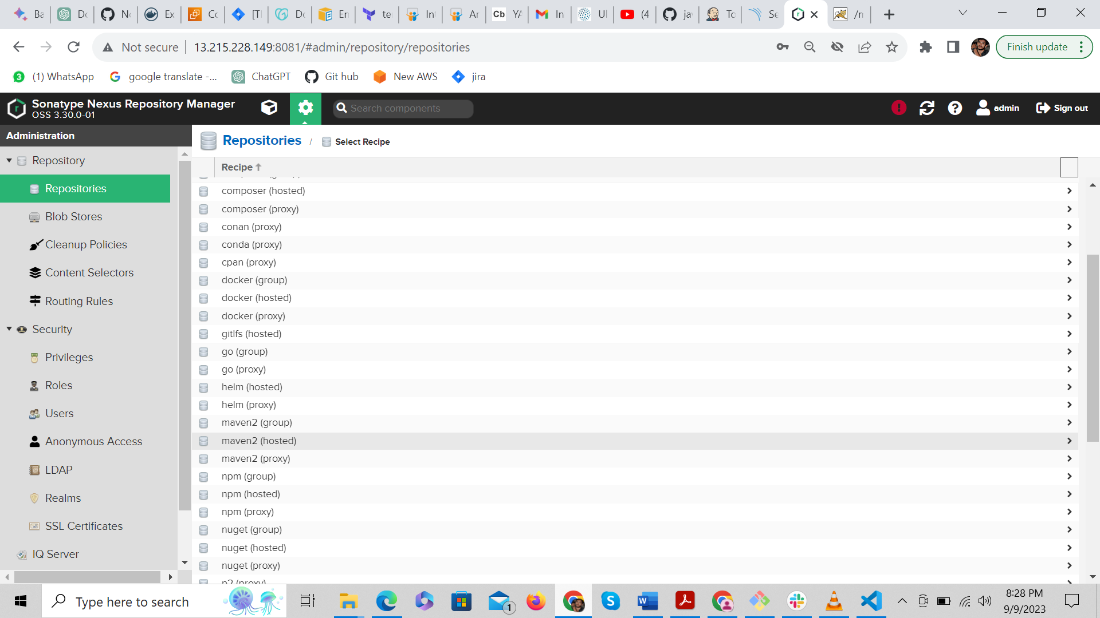

Copy nexus details from pom.xml

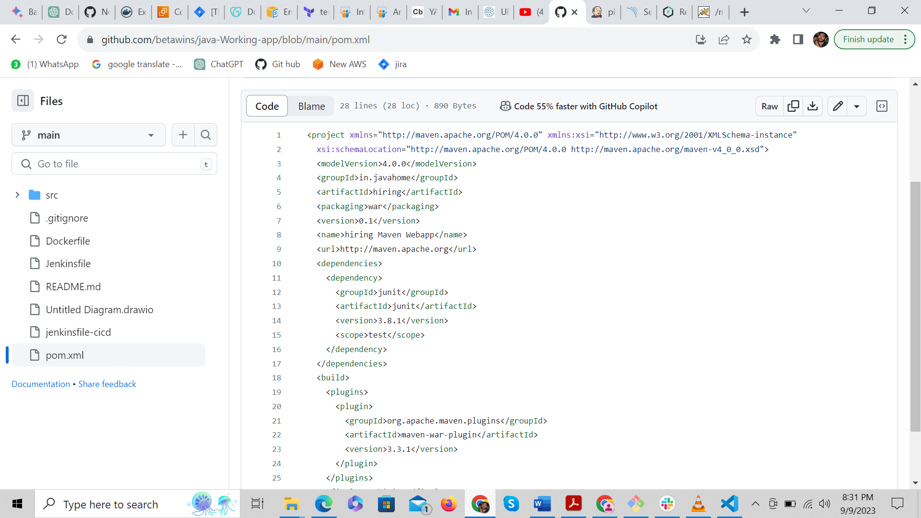

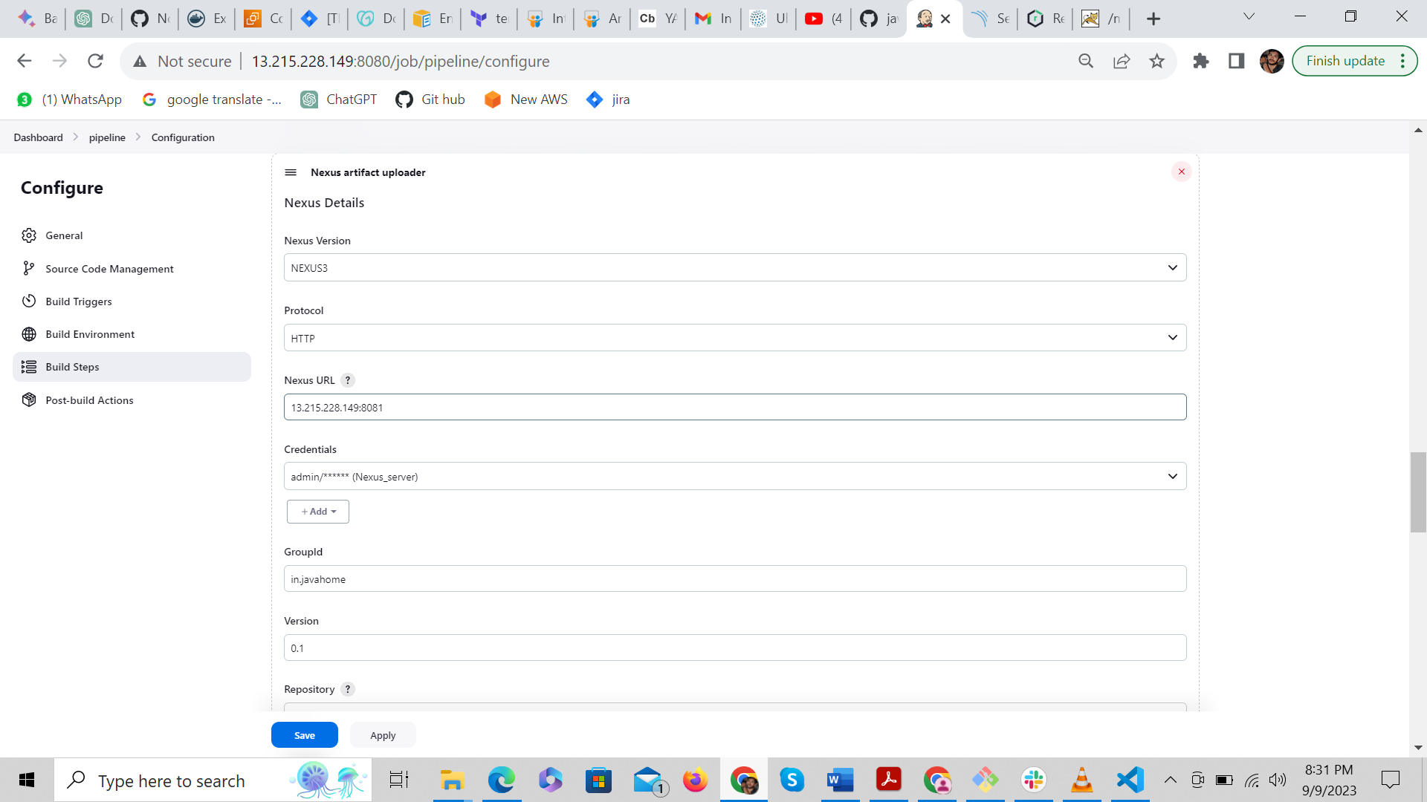

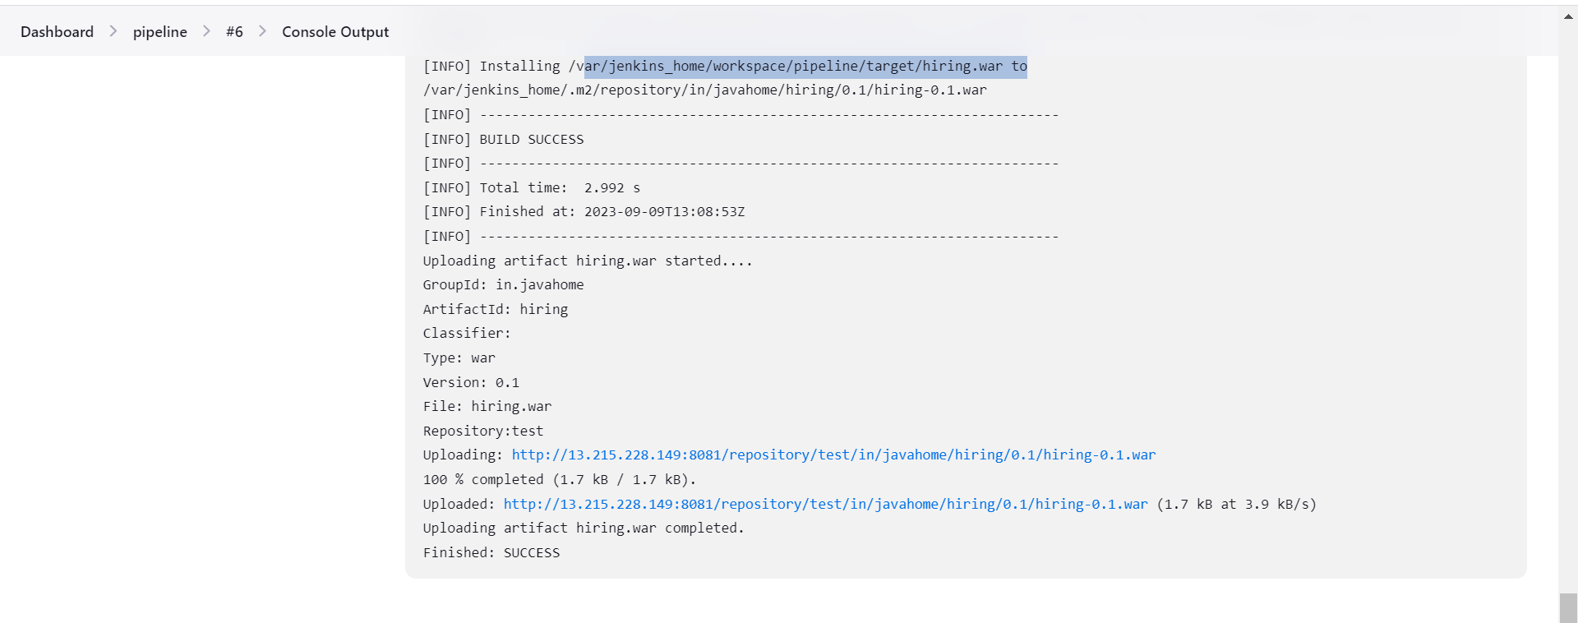

Slack:

<https://ncodeit.slack.com/services/B05RKA55PPX?added=1>