Exercise
- Prompt for amount, interest rate and no. of years and calculate simple interest.
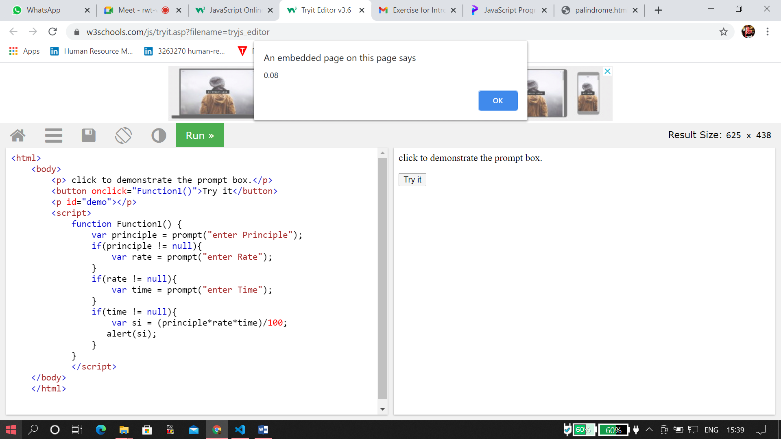

- is palindrome string
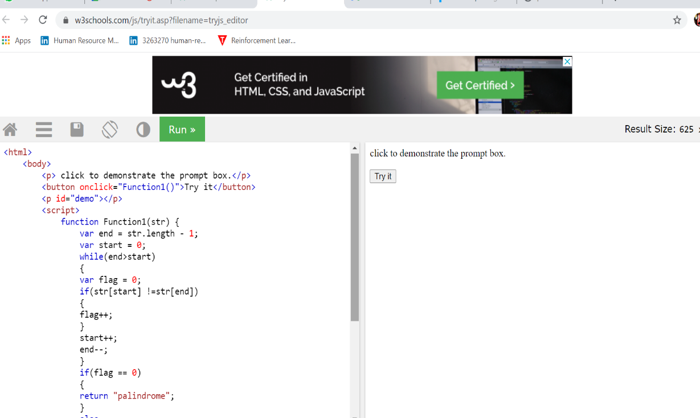

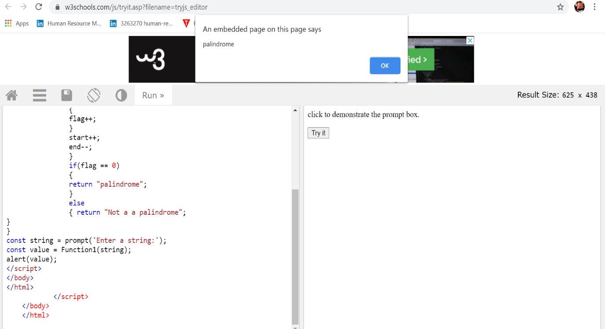

- Area of circle
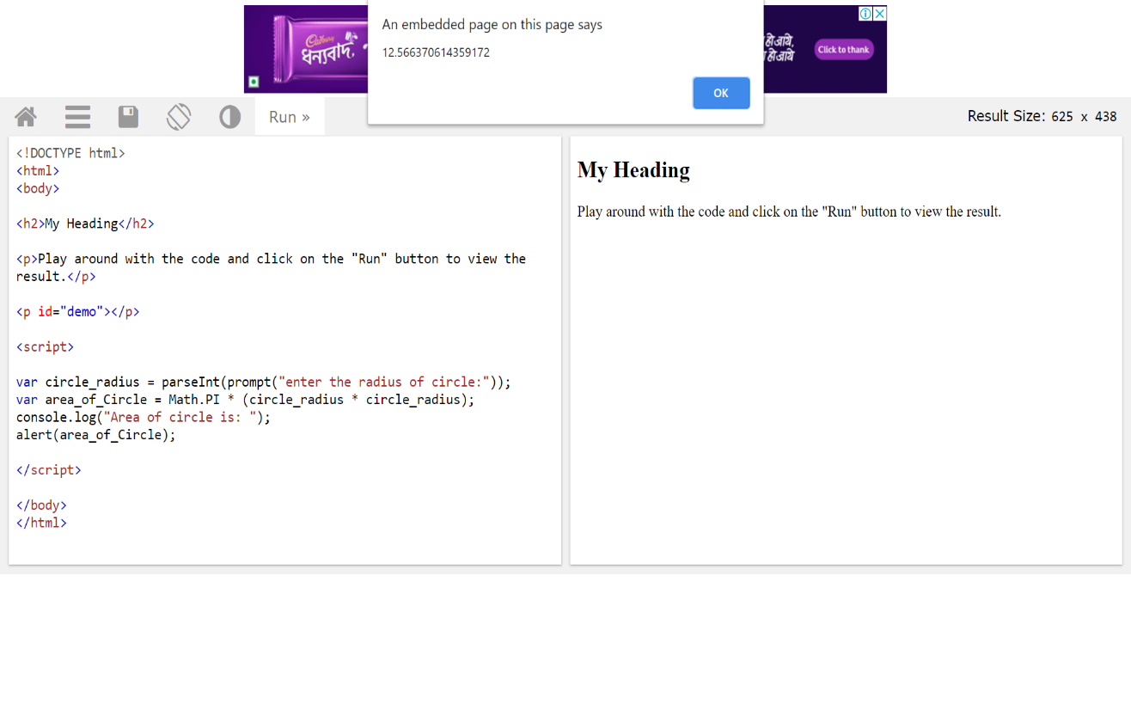
- Copy information of one object to another and log it to console.
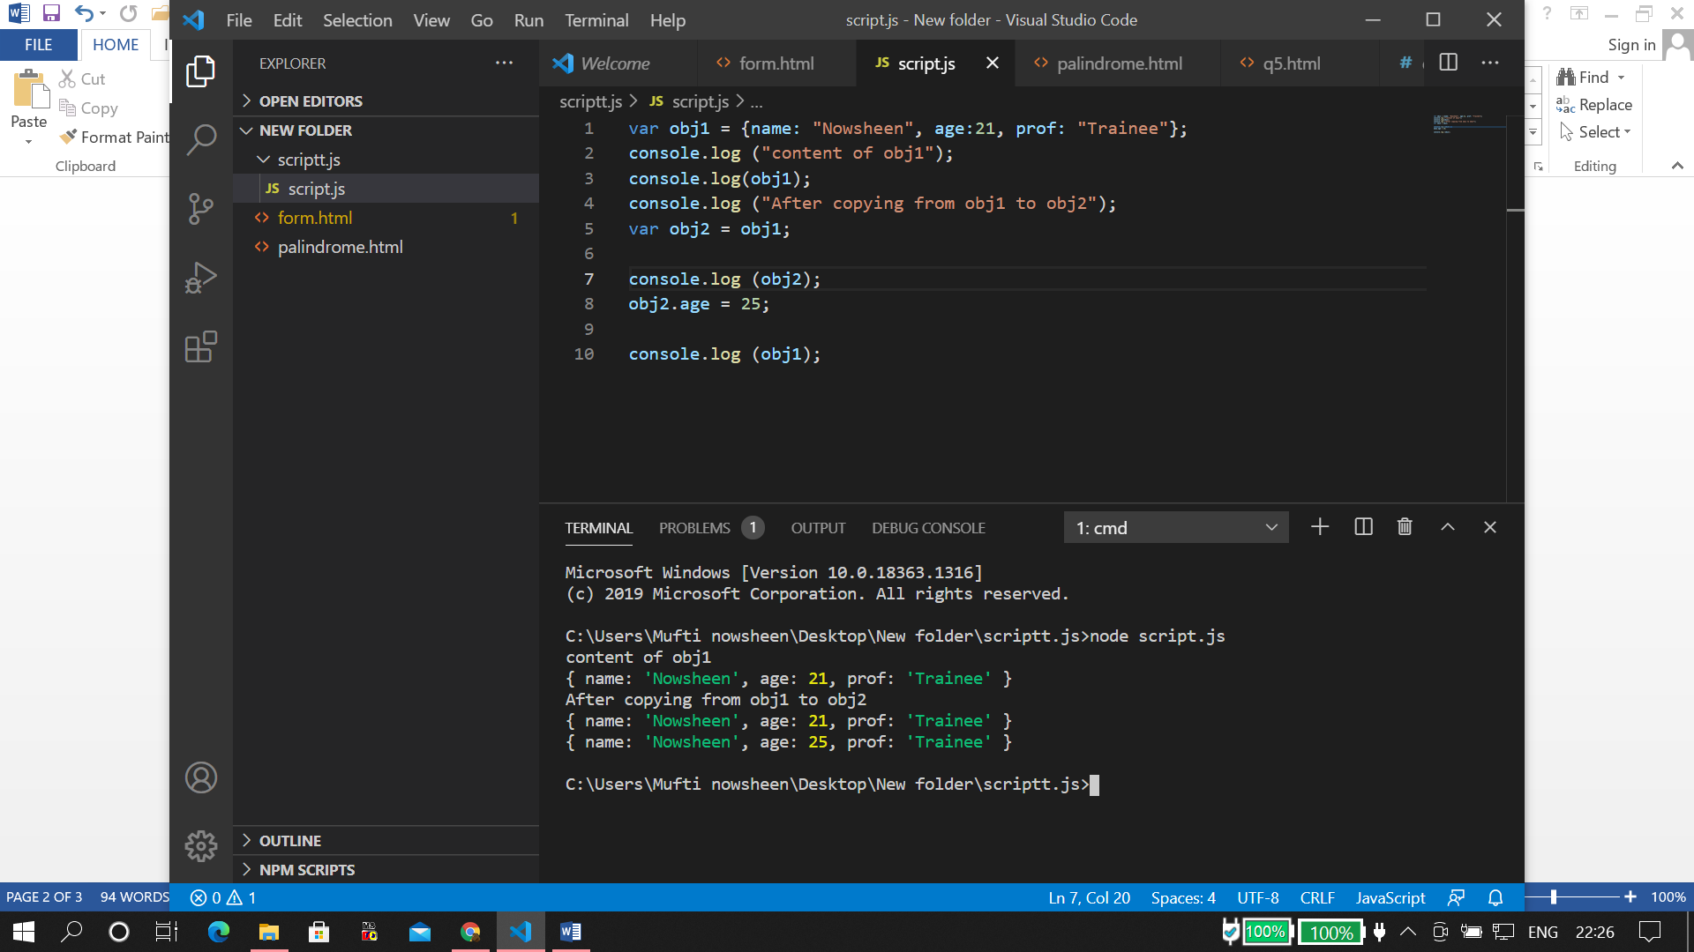

- create a list of objects of Employee with info as follow :
  - Name, age, salary ,DOB
  - filter all employees with salary greater than 5000
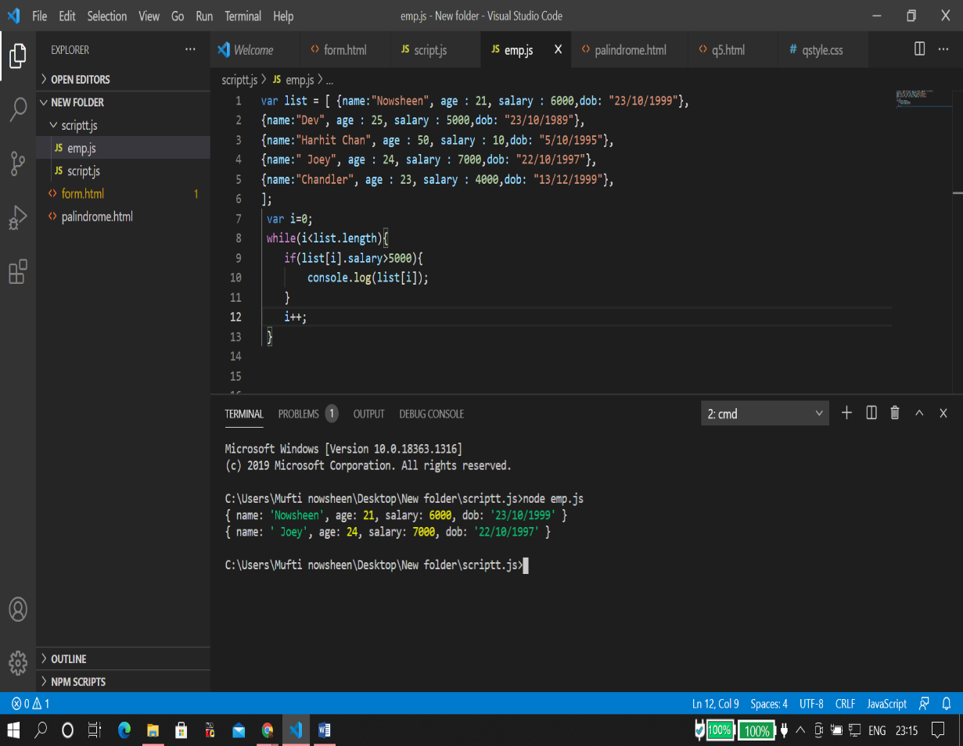

  - group employee on the basis of their age
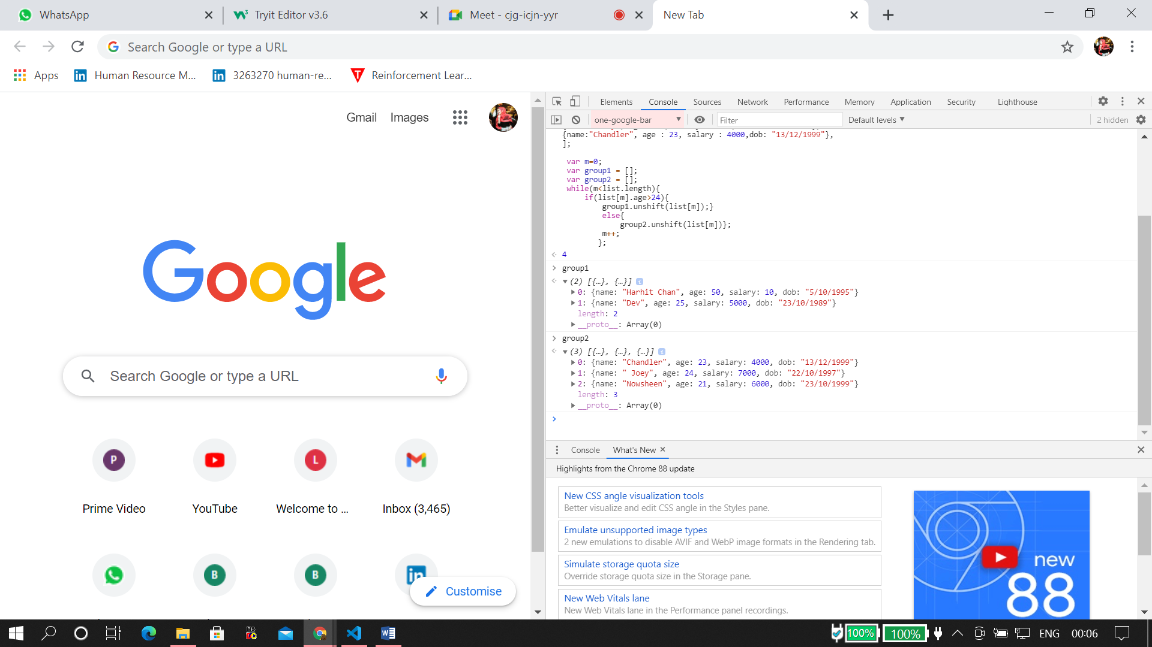
  - fetch employees with salary less than 1000 and age greater than 20. Then give them an increment 5 times their salary.
