Assignment 04

Sydney group 2

Name | Student No. | Preferred Email Address | Type “Yes” if you are an EXTERNAL student | Type “Yes” if you are enrolled at CDU Sydney
1. Nazia Afrin | S395590 |  |  | Yes
2. Manisha Gautam | S393017 |  |  | Yes
3.
4.

STEP 3 Sign this plan. This plan serves as a contract among all team members.

Name | Signature (compulsory) | Date  (dd/mm/yyyy)
1. Nazia Afrin |  | __/__/____
2. |  | __/__/____
3. |  | __/__/____
4. |  | __/__/____



PRT563- Advanced Data Management
Assignment 4: Group Project Report

Submitted to :
Submission Date:

Table of contents :

- Introduction

- Background / Problem Statement

- EER Model

Graph Blueprint
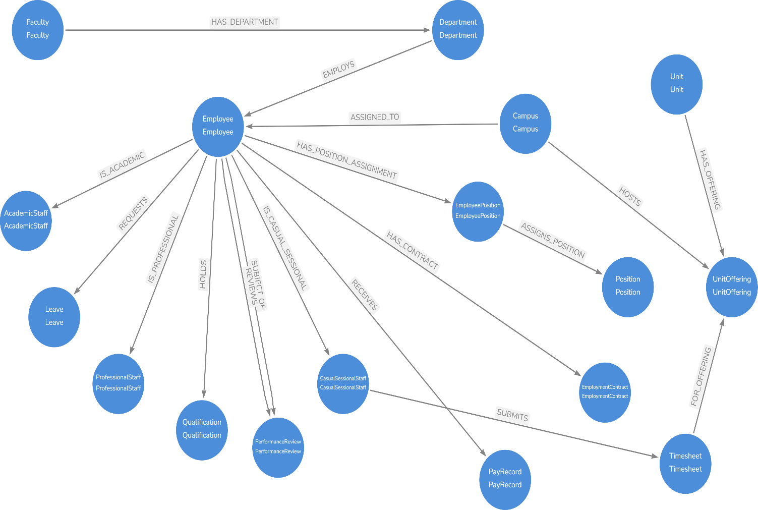

Graph Database Model

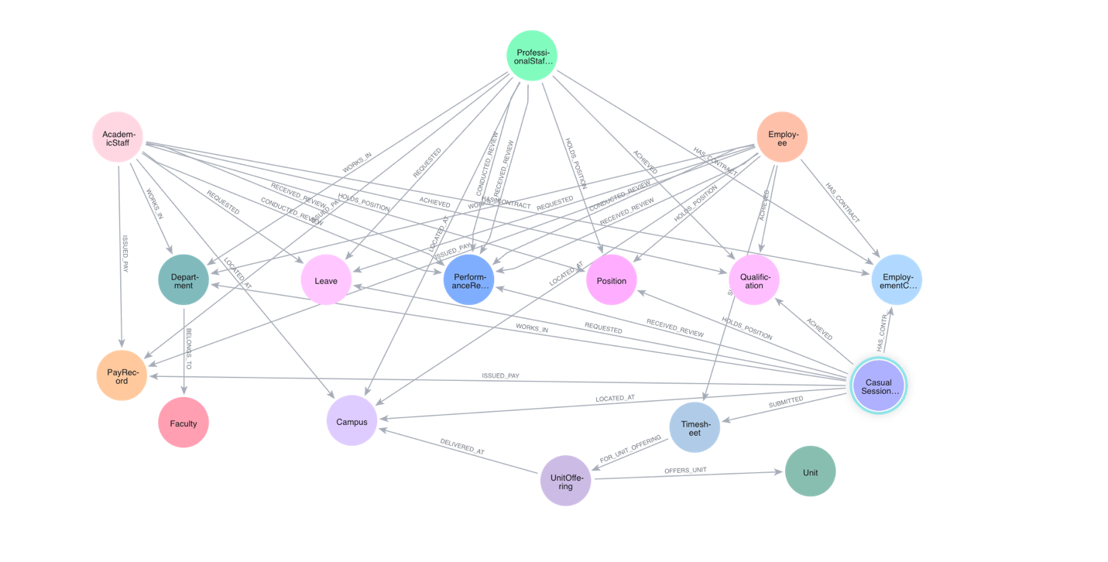

Graph Database Queries

Business use case

7.1. Business use case 01

For executive workforce promotion and retention planning, HR leadership needs to identify high-performing staff who achieved superior performance ratings, trace the reviewer who conducted the appraisal, check contract renewal/permanency status, and collect all verified academic qualifications held by the employee.
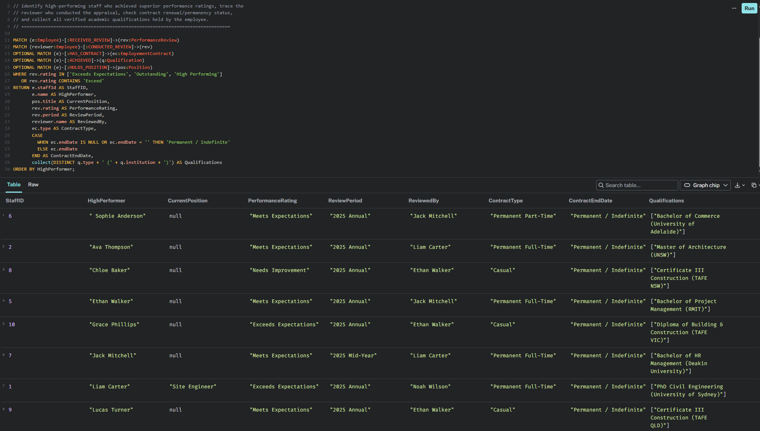

7.2. Business Use Case 02

The Academic Registrar must monitor unit offerings across multi-campus deliveries. This multi-hop querymtraverses from UnitOfferings to their parent Unit, delivery Campus, and associated Timesheet logs, identifying total hours taught and consolidating the list of academic instructors involved in teaching each offering.

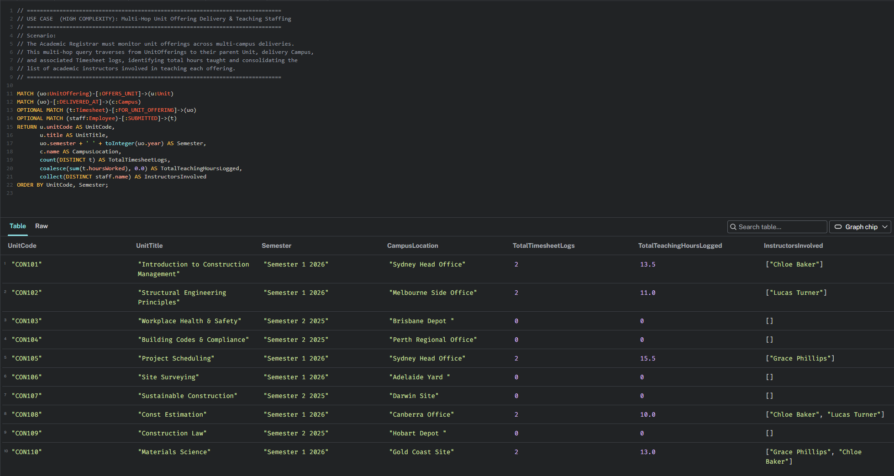

Centrality Algorithms

Centrality algorithms are used to determine the importance of distinct nodes in a network (Centrality, n.d.). The degree centrality algorithm is the easiest centrality algorithm to calculate in graph data science, as it just considers the total number of relationships connected to a particular node. It is a simple count of the total number of relationships linked to a node, showing how many connections a person has (Graphable, n.d.). There are different kind of centrality algorithms available in the Graph Database which include Production-quality Article Rank, Articulation Points, Betweenness Centrality, Bridges, CELF, Closeness Centrality, Degree Centrality, Eigenvector Centrality, Harmonic Centrality, Page Rank, HITS. For out business case we have chooses the Degree Centrality Algorithm.

8.1. Degree Centrality

8.2. Business case

- Similarity Algorithms

- Conclusion

- Contribution matrix

