**KHULNA UNIVERSITY OF ENGINEERING & TECHNOLOGY**

**DEPARTMENT OF COMPUTER SCIENCE AND ENGINEERING**

**PROJECT REPORT**

**COURSE NO: CSE 3104**

**Name of the Project**:

Smart Street Light Using LDR and Ultrasonic Sensor

**Group member :** Nowshin Tasnim (1607053)

Nipa Anjum (1607055)

**Group no. :** A2

**Year :** 3rd

**Semester :** 1st

**Date of Submission :** 03 - 07 – 19

**OBECTIVES:**

The objectives of this project are:

1. To know how to improve present situation using different sensors.
2. To make a system which is fully automated.
3. To find out a way that is cost efficient.

**INTRODUCTION:**

Street lights are doing more than ever in today’s smart cities. With digital networks and embedded sensors, they collect and transmit information that help cities monitor and respond to any circumstance, from traffic and air quality to crowds and noise. Street lights are doing more than ever in today’s smart cities. With digital networks and embedded sensors, they collect and transmit information that help cities monitor and respond to any circumstance, from traffic and air quality to crowds and noise. Automation is the use of control systems and information technologies to reduce the need for human work in the production of goods and services. In the scope of industrialization, automation is a step beyond mechanization, whereas mechanization provided human operators with machinery to assist the users with the muscular requirements of work, automation greatly decreases the need for human sensory and mental requirements as well. Automation plays an increasingly important role in the world economy and in daily experience.

At the beginning, street lamps were controlled by manual control where a control switch is set in  
each of the street lamps which is called the first generation of the original street light. After that, another method that has been used was optical control method done using high pressure sodium lamp in their system. Nowadays, it is seen that the method is widely used in the country. The method operates by set up an optical control circuit, change the resistance by using of light sensitive device to control street lamps light up automatically at dusk and turn off automatically after dawn in morning. Due to the technological development nowadays, road lighting can be categorized according to the installation area and performance, for an example, lighting for traffic routes, lighting for subsidiary roads and lighting for urban centre and public amenity areas.

**Apparatus:**

The required apparatus table is given below:

|  |  |  |
| --- | --- | --- |
| **Serial no.** | **Name of the apparatus** | **Quantity** |
| 1 | Arduino UNO | 1 |
| 2 | Ultrasonic sensor | 2 |
| 3 | Light Dependent Resistor (LDR) | 1 |
| 4 | Resistor (4.7k) | 2 |
| 5 | Light Emitting diode | 3 |

**THEORY:**

Smart lighting helps cities save energy, lower costs, reduce maintenance—all while better serving citizens and reducing energy use and CO2 emissions. Automation and networked control can further increase your energy savings and reduce maintenance spending. Networked street lighting built on a scalable platform can reduce crime up to 10% and make roadways safer through improved visibility. Leveraging intelligent control systems can rapidly increase lighting efficiencies and traffic management.

**Arduino Uno:**

Arduino Uno is a very valuable addition in the electronics that consists of USB interface, 14 digital I/O pins, 6 Analog pins, and Atmega328 microcontroller. It also supports serial communication using TX and RX pins.

It is an open-source platform, means the boards and software are readily available and anyone can modify and optimize the boards for better functionality. The software used for Arduino devices is called IDE (Integrated Development Environment) which is free to use and required some basic skills to learn it. It can be programmed using C and C++ language.

"Uno" means one in Italian and is named to mark the upcoming release of Arduino 1.0. Preferred quality and originals are made in Italy. The Arduino Uno and version 1.0 will be the reference versions of Arduino, moving forward. The Uno is the latest in a series of USB Arduino boards, and the reference model for the Arduino platform.

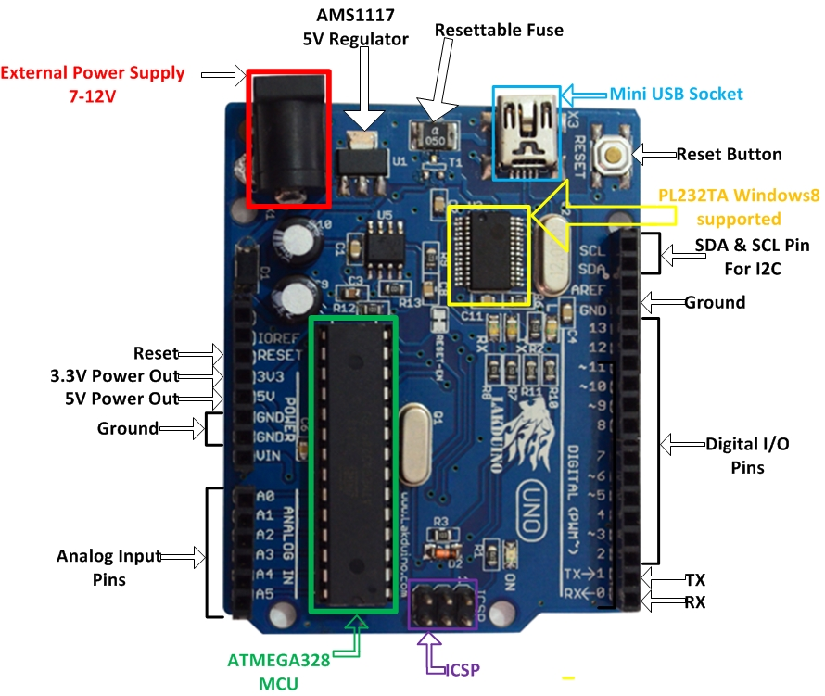

**Fig-1: Arduino Uno**

**Features of the Arduino UNO:**• Microcontroller: ATmega328  
• Operating Voltage: 5V  
• Input Voltage (recommended): 7-12V  
• Input Voltage (limits): 6-18V  
• Digital I/O Pins: 14 (of which 6 provide PWM output)  
• Analog Input Pins: 6  
• DC Current per I/O Pin: 40 mA  
• DC Current for 3.3V Pin: 50 mA  
• Flash Memory: 32 KB of which 0.5 KB used by bootloader  
• SRAM: 2 KB (ATmega328)  
• EEPROM: 1 KB (ATmega328)  
• Clock Speed: 16 MHz

**Ultrasonic Sensor:**

An Ultrasonic sensor is a device that can measure the distance to an object by using sound waves. It measures distance by sending out a sound wave at a specific frequency and listening for that sound wave to bounce back. By recording the elapsed time between the sound wave being generated and the sound wave bouncing back, it is possible to calculate the distance between the sonar sensor and the object. The formula for measuring distance is:

**Distance = Speed × (Time/2)**

|  |  |  |
| --- | --- | --- |
| **Pin Number** | **Pin Name** | **Description** |
| 1 | VCC | The VCC pin powers the sensor, typically with +5V |
| 2 | Trigger | Trigger pin is an Input pin. This pin has to be kept high for 10us to initialize measurement by sending US wave. |
| 3 | Echo | Echo pin is an Output pin. This pin goes high for a period of time which will be equal to the time taken for the US wave to return back to the sensor. |
| 4 | Ground | This pin is connected to the Ground of the system. |

### 

**Fig-2: Ultrasonic Sensor**

### **HC-SR04 Sensor Features:**

* Operating voltage: +5V
* Theoretical  Measuring Distance: 2cm to 450cm
* Practical Measuring Distance: 2cm to 80cm
* Accuracy: 3mm
* Measuring angle covered: <15°
* Operating Current: <15mA
* Operating Frequency: 40Hz

**Light Dependant Resistor Circuit:**

LDRs or Light Dependent Resistors are very useful especially in light/dark sensor circuits. Normally the resistance of an LDR is very high, sometimes as high as 1000000 ohms, but when they are illuminated with light resistance drops dramatically. Electronic onto sensors are the devices that alter their electrical characteristics, in the presences of visible or invisible light. The best-known devices of this type are the light dependent resistor (LDR), the photo diode and the phototransistors. Light dependent resistor as the name suggests depends on light for the variation of resistance. LDR are made by depositing a film of cadmium sulphide or cadmium selenide on a substrate of ceramic containing no or very few free electrons when not illuminated .The longer the strip the more the value of resistance. When light falls on the strip, the resistance decreases. In the absence of light the resistance can be in the order of 10K ohm to 15K ohm and is called the dark resistance. Depending on the exposure of light the resistance can fall down to value of 500 ohms. The power ratings are usually smaller and are in the range 50mw to .5w. Though very sensitive to light, the switching time is very high and hence cannot be used for high frequency applications. They are used in chopper  
amplifiers. Light dependent resistors are available as discs 0.5cm to 2.5cm. The resistance rises to several Mega ohms under dark conditions. The device consists of a pair of metal film contacts separated by a snakelike track of cadmium sulphide film, designed to provide the maximum possible contact area with the two metal films. The structure is housed in a clear plastic or resin case, to provide free access to external light. Practical LDRs are available in variety of sizes and packages styles, the most popular size having a face diameter of roughly 10mm.

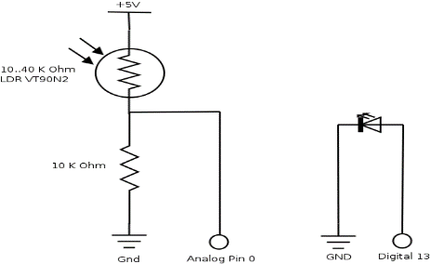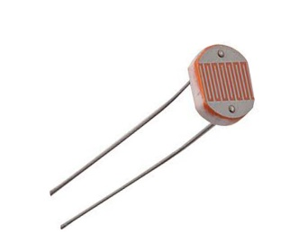

**Fig-3: Light Dependent Resistor and Circuit**

When an LDR is brought from a certain illuminating level into total darkness, the resistance does not increase immediately to the dark value. The recovery rate is specified in k ohm/second and for current LDR types it is more than 200k ohm/second. The recovery rate is much greater in the reverse direction, e.g. going from darkness to illumination level of 300 lux, it takes less than 10ms to reach a resistance which corresponds with a light level of 400 lux. A LDR may be connected either way round and no special precautions are required during the time of soldering.

**Darkness:** Maximum resistance, about 1Mega ohm.

**Very bright light:** Minimum resistance, about 100 ohm. The LDR is a variable resistor whose resistance decreases with the increase in light intensity. Two cadmium photoconductive cells with spectral response are very similar to that of the human eye. The cell resistance falls with increasing light intensity. Some of its features: 1) High reliability. 2) Light weight. 3) Wide spectral response. 4) Wide ambient temperature range.

**Resistor:**

A resistor is a [passive](https://en.wikipedia.org/wiki/Passivity_(engineering)) [two-terminal](https://en.wikipedia.org/wiki/Terminal_(electronics)) [electrical component](https://en.wikipedia.org/wiki/Electronic_component) that implements [electrical resistance](https://en.wikipedia.org/wiki/Electrical_resistance) as a circuit element. In electronic circuits, resistors are used to reduce current flow, adjust signal levels, to divide voltages, [bias](https://en.wikipedia.org/wiki/Biasing) active elements, and terminate [transmission lines](https://en.wikipedia.org/wiki/Transmission_line), among other uses. High-power resistors that can dissipate many [watts](https://en.wikipedia.org/wiki/Watt) of electrical power as heat, may be used as part of motor controls, in power distribution systems, or as test loads for [generators](https://en.wikipedia.org/wiki/Electric_generator). Fixed resistors have resistances that only change slightly with temperature, time or operating voltage. Variable resistors can be used to adjust circuit elements (such as a volume control or a lamp dimmer), or as sensing devices for heat, light, humidity, force, or chemical activity. It follows ohm’s law.

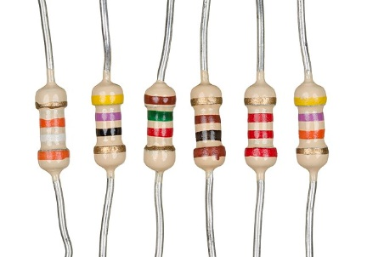

**Fig-4: Resistor**

The Color code details of the resistor used in the project is:

|  |  |
| --- | --- |
| Value | 4.7 kΩ / 4700 Ω |
| Type | 4 Band Color Code |
| Color Code | Yellow, Violet, Red, Gold |
| Multiplier | Red, 100 |
| Tolerance | Gold Band ±5% |

**Light Emitting Diode:**

A light-emitting diode (LED) is a two-lead semiconductor light source. It is p-n junction diode that emits light when activated. The long terminal is positive and the short terminal is negative. When a suitable current is applied to the leads, electrons are able to recombine with electron holes within the device, releasing energy in the form of photons. This effect is called electroluminescence, and the color of the light (corresponding to the energy of the photon) is determined by the energy band gap of the semiconductor. LEDs are typically small (less than 1 mm2) and integrated optical components may be used to shape the radiation pattern**.**

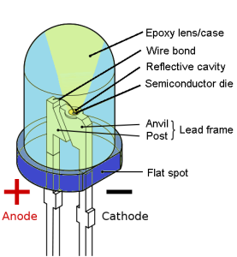

**Fig-5: Light Emitting Diode**

**WORKING PROCEDURE:**

The working procedure of the Smart street light using Ultrasonic sensors is explained below. The following are the different steps included in building a Smart street light.

1. One of the LDR pin is connected to A3 (Analog) port of Arduino Uno board and Resistor and another one to 5V pin of Arduino UNO board.
2. All Trigger pins (output) of the Ultrasonic sensors are connected to port numbers D4, D9 and Echo pins (input) to port numbers D2, D8.
3. The ground of all the Ultrasonic sensors are connected to GND port of Arduino UNO board.
4. The VCC pin of all the ultrasonic sensors are connected to 5V pin of Arduino UNO board.
5. The positive leg of LEDs are connected to port number D3.
6. All the negative terminals of LEDs are connected to GND port of Arduino UNO board.
7. Then the Arduino is connected to the power supply and the code is uploaded to Arduino Board.

**FLOWCHART:**

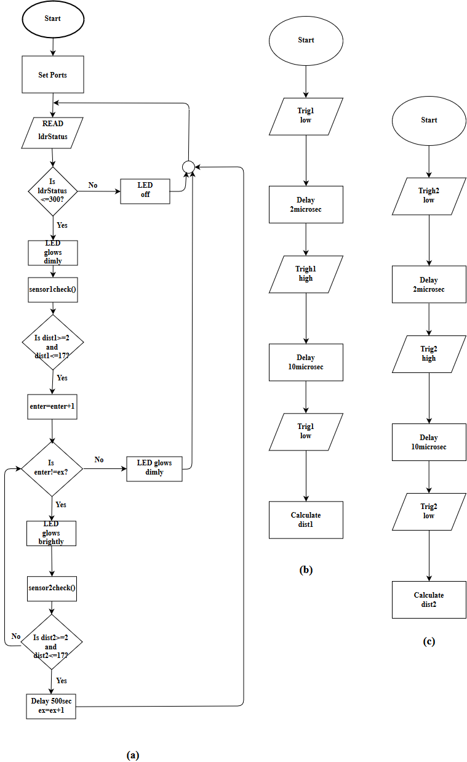

**Fig-6: Flow Chart for (a)the total system, (b)the function sensor1check and (c)the function sensor2check**

**HARDWARE SETUP:**

The hardware setup is given below:

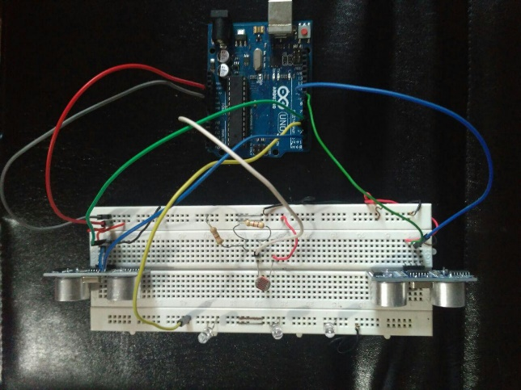 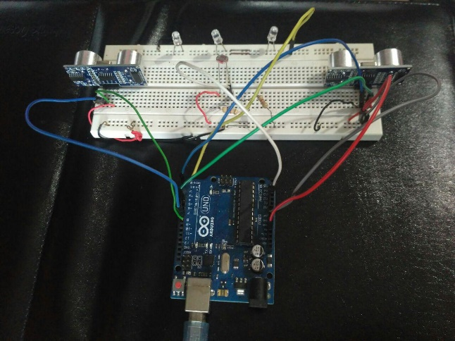

**Fig-7: Hardware setup of Smart Street Light Using Ultrasonic Senor and LDR**

**CONNECTION DIAGRAM:**

The connection diagram is given below:

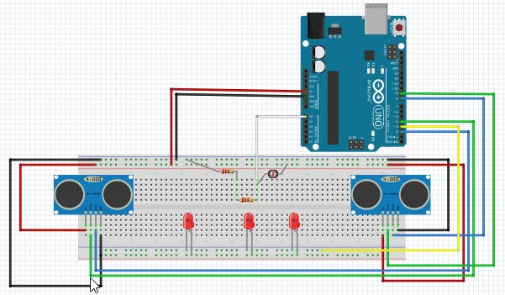

**Fig-8: Connection diagram**

**SYSTEM TESTING:**

1. Uploaded the code on Arduino UNO board.
2. Created a dark environment for observing the LDR’s response.
3. We observed that LEDs were glowing dimly.
4. Then we passed through an object for observing the Ultrasonic Sensor’s response.
5. As soon as the first Ultrasonic sensor detected the object within 15cm, LEDs started glowing brightly.
6. After crossing the second Ultrasonic sensor, LEDs again started glowing dimly.
7. In natural lighting condition, LEDs were found off.

**EXPERIMENTAL RESULTS:**

The system works in accordance with the varying sunlight. Whenever there is sufficient sunlight in surroundings, LDR exhibits high resistance and acts as an insulator, while in darkness this LDR behaves as low resistance path and allows the flows of electricity. LDR is operated with the help of photo sensitive characteristics, this sensor is activated under low illumination conditions. When any object comes in the range of Ultrasonic sensors, it detects the object.

The heart of Arduino circuit is the low power, high performance Arduino micro controller, is programmed by embedded assembly programming language for implementing these tasks; this program is stored and operated by means of storage device EPROM. The intensity of LED’s is remained at low initially (when no object is detected, at no natural light condition) by Arduino using Pulse Width Modulation (PWM) technique where Analog signal is converted to Digital signal. ON-OFF process of LEDs take place so rapidly in such a way, the LEDs seem to glow dimly when seen by naked eye. Hence, intensity of LEDs is controlled by varying duty cycle. While coming to the functional block i.e. LDR, LEDs, Ultrasonic sensors, these components are inexpensive, smaller in size, less complexity, highly reliable, low power applications, minimum risk with greater accuracy.

The switching of the LEDs is operated through coding applied in Arduino using Arduino software.

So after this experiment, we found that the system is working as proposed and all sensors are responding perfectly.

**IMPROVEMENTS IN CURRENT SITUATION:**

All the street lights are operated manually by human being. Power consumption in this current situation is very high. In day light if the street lights are kept on, then energy is wasted. So cost of the system rises.

In our newly designed system, we can solve all these problems. The improvements are-

1. All the street lights are kept off in day light automatically.
2. When natural light is absent, the street lights are on automatically by the response of the LDR sensor.
3. As the system is automatically operated, waste of power and energy is resolved. Hence the cost is decreasing.
4. As the cost of this system is very low, it is more efficient than the current situation.

**DISCUSSION:**

In this experiment, we have shown an automated smart street light which is very cost effective. All the initial setup of hardware was given. Two Ultrasonic Sensors were placed on Breadboard’s two ends. They are connected to the Arduino Uno board. All the wirings with the Breadboard were installed and three LED’s were also placed. Then LDR with two 4.7k resistor in series was also placed. All the circuit setup was successfully given. After that code was uploaded on the Arduino Uno Board. In natural lighting condition the LDR circuit detects light and LDR worked as an insulator that does not allow the current to pass through the circuit. Hence, LEDs were remained turn off. In dark condition, the resistance of LDR became very high, allowing current to pass through the LDR circuit. Thus, LEDs glow dimly and the Ultrasonic sensor started working. When any object was detected by the first Ultrasonic Sensor LEDs started glowing brightly. When the object passed through the second Ultrasonic Sensor, LEDs again started glowing dimly.

**CONCLUSION:**

The system is very cost effective and our aim is to conserve energy at low cost. It keeps the environment safe from light pollution and it works automatically, so no extra manpower is needed. It prevents unnecessary wastage of electricity, caused due to manual switching of streetlights when it is not required. It provides an efficient and smart automatic streetlight control system with the help of Ultrasonic sensors. It can reduce the energy consumption and maintains the cost. We can add some other features for security purposes. The system is versatile, extendable and totally adjustable to user needs.

The system is now used only for one-way traffic in highway and continuously used the LDR even in day time. It was not switched on before the sunset. So we can further make it for two way traffic, make it more flexible in case of rough weather. We can also make it GSM based service.

**REFERENCE:**

1. <https://www.arduino.cc/>
2. <https://www.instructables.com/id/Smart-Street-Light-Using-Ir-Sensor-With-Arduino/>
3. P. P. Fathima Dheena, [Greema S. Raj](https://ieeexplore.ieee.org/author/37086355843), [Gopika Dutt](https://ieeexplore.ieee.org/author/37086354056), S. Vinila Jinny. IoT based smart street light management system,  [IEEE International Conference on Circuits and Systems (ICCS)](https://ieeexplore.ieee.org/xpl/conhome/8320243/proceeding). 368--371, 2017. DOI: [10.1109/ICCS1.2017.8326023](https://doi.org/10.1109/ICCS1.2017.8326023)