mRNA SQD and SKQD Extension
Project Description
The earlier WISER-Moderna project predicted mRNA secondary structure by writing RNA folding as a binary optimisation problem (QUBO) over candidate helices, or stems, and solving it with an exact solver and with the variational quantum eigensolver (VQE). It was tested on self-generated target structures and left two gaps. The exact optimum of the model reached a Matthews correlation coefficient (MCC) of only 0.764 against the targets, and VQE reached 0.693.
This extension does three things. It replaces the self-generated targets with experimentally determined RNA structures from the Protein Data Bank (PDB). It fixes the model so that its optimum agrees better with those structures. It then adds two newer quantum methods, sample-based quantum diagonalisation (SQD) and sample-based Krylov quantum diagonalisation (SKQD), following the IBM Quantum learning course, and compares them with the exact optimum, VQE and classical sampling on the same problems. All quantum runs are exact or noise-modelled circuit simulations; no quantum hardware was used.
Methodology Workflow
1. Experimental dataset
792 RNA chains of 20 to 150 nucleotides from the PDB, one per class of the BGSU non-redundant list. Base pairs annotated by FR3D are the reference structures. Chains are split by RNA family into a calibration set (317) and a held-out test set (475).
↓
2. Mapping structures to qubits
Every helix the sequence can form is listed as a candidate stem, together with its shortened versions. Each candidate stem is one binary variable: 1 if the stem is in the structure, 0 if not. Each variable becomes one qubit.
↓
3. Energy model and Hamiltonian
Each stem gets its Turner free energy, pairs of stems get an exact correction where it is valid, and stems that share a nucleotide get a large penalty. The 24 most stable stems of each chain are kept, which gives a 24-qubit Hamiltonian.
↓
4. Quantum sampling
SKQD measures short time evolutions of the Hamiltonian (Krylov states). SQD measures a fixed linear-ramp QAOA circuit. The baselines (exact CP-SAT optimum, VQE as in the original project, simulated annealing, random bitstrings) work on the same Hamiltonian.
↓
5. Diagonalisation in the sampled subspace
The Hamiltonian is restricted to the measured bitstrings and diagonalised on a classical computer. The bitstring with the largest weight in its ground state is the predicted structure.
↓
6. Evaluation
Predicted base pairs are compared with the experimental pairs (sensitivity, PPV, MCC) on held-out chains. SKQD is also simulated with gate noise, and its circuits are compiled to count two-qubit gates on an all-to-all device and on IBM heavy-hex hardware.
Mapping and Hamiltonian
Each candidate stem i is a binary variable x_{i} (x_{i} = 1 when the stem is chosen). The energy of a choice of stems is the cost Hamiltonian
$H_{C}(x)=\sum_{i}{h_{i}}x_{i}+\sum_{i<j}{J_{ij}}x_{i}x_{j}+P\sum_{(a,b)∈𝒞}{x_{a}}x_{b}$
Here h_{i} is the Turner free energy of stem i closing its own hairpin loop (computed with ViennaRNA). The pair term is the exact two-stem correction J_{ij} = E(i∪j) − E(i) − E(j), kept only for stems side by side and for stems nested directly inside each other, where it is exact; all other pairs, including crossing (pseudoknot) pairs, get zero. 𝒞 is the set of stem pairs that share a nucleotide, and the penalty
$P=\max_{i}\left(|h_{i}|+\sum_{j}{|}J_{ij}|\right)+1$
is large enough that the lowest-energy state is always a valid structure. The variables are mapped to qubits with x_{i} = (1 − Z_{i})/2, which turns H_{C} into an Ising Hamiltonian of Z and ZZ terms.
H_{C} is diagonal, so on its own its time evolution and its projection onto sampled bitstrings do nothing useful. A driving term is therefore added for SKQD and for the diagonalisation step:
$H(Γ)=H_{C}-Γ\sum_{i}{X_{i}}$
SKQD measures the Krylov states
$|ψ_{k}⟩=U^{k}|0…0⟩, U=e^{-iΔtH_{C}}e^{iΓΔt\sum_{i}{X_{i}}}, k=1,…,r-1$
and SQD measures the linear-ramp QAOA state. In both cases the measured bitstrings form a set S, and the projected Hamiltonian
$H_{S}=Π_{S}H(Γ_{d})Π_{S}, Π_{S}=\sum_{x∈S}{|x⟩⟨x|}$
is diagonalised classically. The settings used in all runs are listed below.
Qubits | 24 per chain (the 24 most stable stems); 26 and 28 for a scaling check
Test chains for the quantum methods | 100 held-out chains of up to 60 nt; 25 of them for the method comparison
SKQD | Start state |0…0⟩ (empty structure), Γ = 0.5, Δt = 0.3, r = 10 Krylov states, one first-order Trotter step per state
SKQD drives | Transverse field, or a constrained mixer that only flips a stem when none of its conflicting stems is selected
SQD sampler | Linear-ramp QAOA from |+⟩ on all qubits, p = 4 layers, Δγ = 2, Δβ = 0.4, no training
Diagonalisation | qiskit-addon-sqd, drive Γ_{d} = 0.1 in the projected Hamiltonian
VQE (original setup) | Two-local RY/CZ ansatz, 1 repetition, COBYLA, 300 evaluations
Shots and seeds | 100, 1000 and 10000 shots; 5 seeds (VQE: 1 seed)
Noise model | Pauli errors after each Trotter step, two-qubit gate error 0.1 % or 0.3 %, readout error 1 %; checked against exact density-matrix runs at 8 qubits

Results
Model gap. Most of the original model gap came from the candidate set. Keeping only the longest stem on each diagonal caps the best reachable MCC at 0.767 on experimental structures; adding shortened stems raises it to 0.954. With the corrected energy terms, the exact optimum of the new model reaches MCC 0.775 on the 475 held-out chains, against 0.713 for the original model. This is level with the classical pseudoknot predictor pKiss (0.771) and close to ViennaRNA (0.792).
Method comparison. Figure 1 compares all methods on 25 held-out chains at 24 qubits, all solving the same Hamiltonian. The exact optimum (MCC 0.711) is therefore the ceiling for every method.
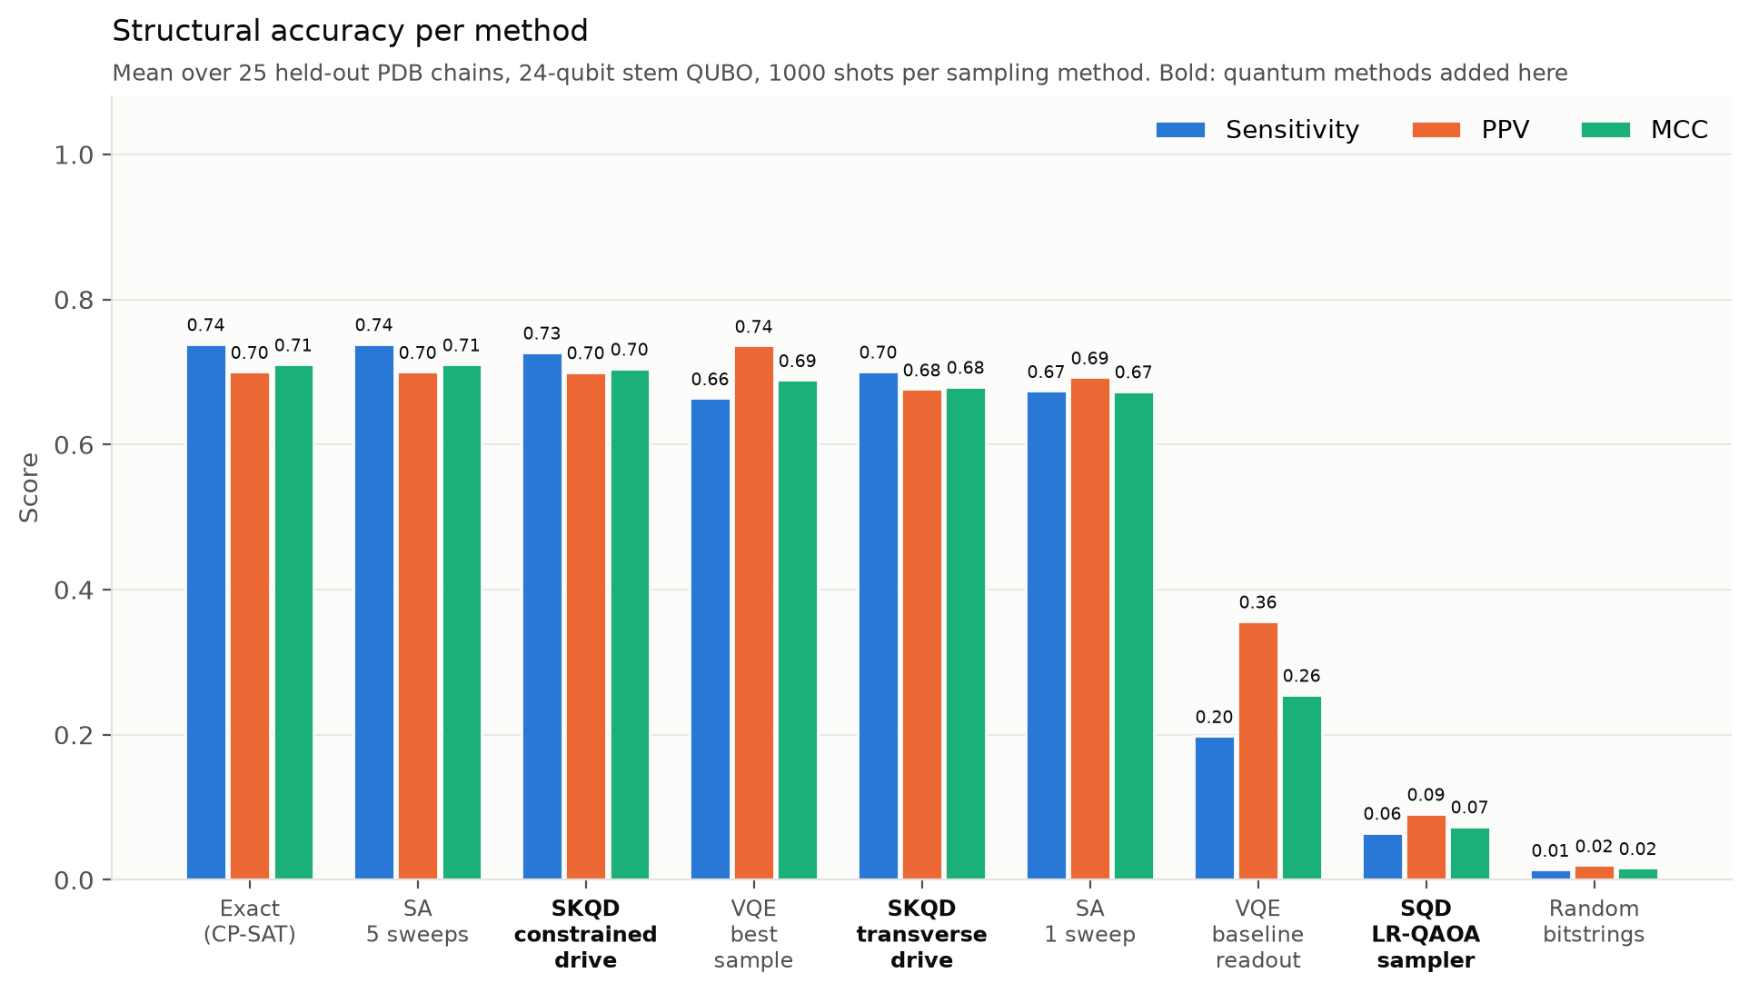
Figure 1. Sensitivity, PPV and MCC per method on 25 held-out PDB chains (24 qubits, 1000 shots, mean over chains). Bold labels are the quantum methods added in this extension.
SKQD with the constrained drive is the best quantum method. It reaches MCC 0.705, only 0.006 below the exact optimum, and finds the exact optimum in 90 % of runs (96 % at 10000 shots). SKQD with the transverse drive reaches 0.680 (0.700 at 10000 shots). Both are far ahead of the original VQE readout (0.255, optimum found on 4 % of chains). SQD with the linear-ramp QAOA sampler reaches only 0.074, because almost none of its samples are valid structures, so the sampled subspace rarely contains the optimum. Simulated annealing with 5 sweeps finds the optimum on every chain, so the quantum methods do not beat the best classical sampler at this size.
Noise and hardware. Figure 2 repeats SKQD with simulated two-qubit gate errors.
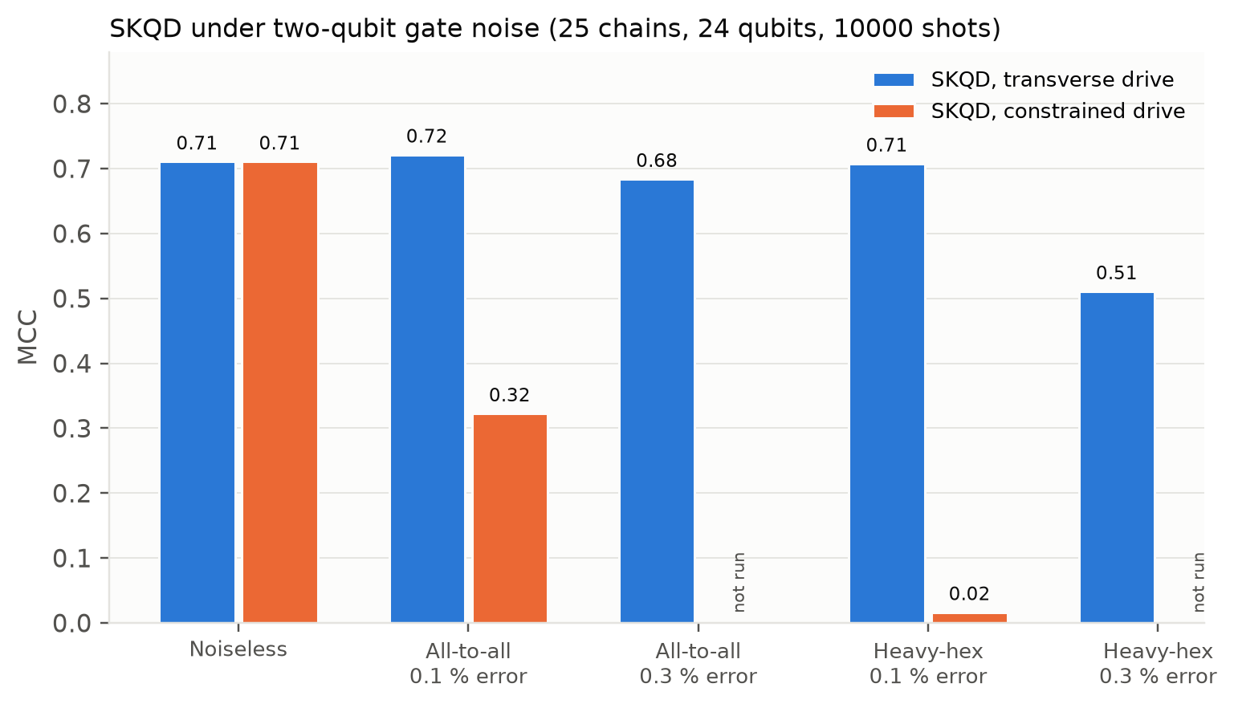
Figure 2. MCC of SKQD under two-qubit gate noise on the same 25 chains (10000 shots). The constrained drive was not run at 0.3 % because it had already failed at 0.1 %.
The transverse drive keeps its accuracy at 0.1 % error (MCC 0.721 on an all-to-all device, 0.708 on heavy-hex) and drops to 0.511 at 0.3 % on heavy-hex. The constrained drive fails under noise because its circuits are 12 to 14 times larger. One transverse SKQD step needs 425 two-qubit gates on an all-to-all device and about 1300 on heavy-hex, since the conflict penalty couples most pairs of stems.
Summary. On experimental structures the corrected stem model is as accurate as standard classical predictors. On this model SKQD is clearly the strongest quantum method and tolerates moderate noise, while SQD with a QAOA sampler and the original VQE readout perform poorly. No quantum advantage is shown, since simulated annealing still matches the exact optimum at 24 to 28 qubits.

