Readout costs decide whether quantum computers can speed up stochastic simulation of gene networks
Aarush Das Bansiwal* ª
ª Indian Institute of Information Technology, Nagpur, Off Adilabad - Nagpur Rd, Waranga, Maharashtra 441108
* Corresponding author. E-mail address: db.aarush@gmail.com

Abstract
Quantum computers can store a probability distribution over exponentially many states in a few qubits. This has prompted claims of exponential speedups for stochastic simulation, including the chemical master equation of gene networks. Here we show that the cost of reading the answer out of the quantum state decides these claims. For the standard amplitude encoding, estimating a probability to relative precision needs a number of queries set by the size of the state space relative to the number of occupied states. This factor is exponential in the number of molecular species. Of 14 published proposals, five claim costs that do not grow exponentially with dimension yet omit it. Under the available certificates, reweighting the encoding does not remove it on twelve published gene-network models, even with the exact solution as the weight. Fault-tolerant resource counts show that quantum Monte Carlo over trajectories is cheaper than every counted master-equation encoding.
Keywords: Chemical master equation; Quantum algorithms; Amplitude estimation; Stochastic simulation; Gene regulatory networks; Readout complexity

1. Introduction
Gene expression is noisy because many regulators are present at low copy numbers [1,2]. The chemical master equation (CME) describes this noise exactly. It tracks one probability for every combination of molecule counts, so the number of entries multiplies with each added species. A few species with a few hundred copies each already give more entries than a classical computer can store. Classical practice therefore relies on stochastic simulation [3], finite state projection [1,4], tensor networks [5] and low-rank compression [6,7].
A register of n qubits carries 2^{n} amplitudes, so it is natural to ask whether a quantum computer can propagate the CME directly. Kabengele et al. computed eigenvalues and the steady state of a one-species CME on a quantum device [8]. Yao simulated reaction–diffusion master equations on a lattice [9]. Several groups have treated the Fokker–Planck and Kolmogorov equations, which describe the same kind of probability flow in continuous variables [10,11,12,13,14,15,16]. Zhang et al. applied the idea to probability densities in reacting flows [17], and two recent perspectives discuss it for whole-cell and multiscale models [18,19]. Several of these works claim exponential speedups in dimension. The quantum algorithms that propagate such linear equations are now well developed [20,21,22,23,24,25].
These algorithms produce a quantum state rather than a number. A probability vector sums to one, whereas the squared amplitudes of a quantum state sum to one. When the probability sits in a small region of a large state space, as it does for gene networks, the encoded state is spread thinly relative to the answer. Reading out a probability or a mean then costs a factor that grows with the state space. The mismatch between the two norms has been noted before [11,26,27]. Its size for biochemical networks has not been measured, and it is not known whether the published speedups survive it.
Lower bounds for quantum differential-equation solvers are also known. An et al. proved worst-case lower bounds for quantum differential-equation solvers, including a cost that grows as the norm of the solution decays [23]. The approximate-counting bound of Nayak and Wu sets the cost of estimating a small amplitude [28]. Amplitude estimation, introduced by Brassard et al., attains that cost [29]. Reweighted encodings that remove the norm mismatch exist for reversible dynamics with an exactly known stationary law [14,10], and square-root encodings avoid it by sampling [30,31]. For non-reversible networks such as gene regulatory circuits, no comparable route has been shown to work.
Here we quantify this readout cost and audit the published proposals against it. We then test the two ways around it. The first reweights the encoding with a classical guess of the solution, and the second changes the quantum algorithm. We find that the readout cost is the dividing line. The proposals that claim exponential speedups in dimension omit it. Under the certificates available, reweighting cannot be shown to remove it on published gene-network models. Quantum Monte Carlo over stochastic trajectories, which does not encode the distribution at all, is cheaper than every quantum master-equation encoding we counted.

2. Method
The study has three parts. A theoretical part derives the readout cost of the standard encoding and measures it on benchmark and published gene-network models. A second part tests a reweighted encoding with a classically computable certificate. A resource count then compares the quantum routes at the level of fault-tolerant gates. The literature audit that applies these results to published proposals is described in Supplementary Section S1.

2.1 The readout barrier
Let S be a finite box of molecule counts and A_{S} the truncated generator of the CME on S. The truncated law obeys
 | $$\frac{dp_{t}}{dt}=A_{S}p_{t}, m_{T}=\sum_{x∈S}{p_{T}}(x),$$ | (1)
where m_{T} is the probability retained in the box at the horizon T. For a nonnegative vector q we define the effective number of occupied states as
 | $$S_{eff}(q)=\frac{{\left(\sum_{x}{q}(x)\right)}^{2}}{\sum_{x}{q(x})^{2}}.$$ | (2)
It equals $\left|S\right|$ for a uniform law and 1 for a point mass.
The solver gives black-box access to a unitary U whose top-left block is the propagator, $⟨0|U|0⟩=e^{TA_{S}}/c$ with $c≥‖e^{TA_{S}}‖_{2}$, and to a preparation of $p_{0}/‖p_{0}‖$. We consider the class $C$ of readouts that recover m_{T} from an amplitude $⟨ϕ|v⟩$, where $|v⟩$ is prepared from U and the initial state, and $|ϕ⟩$ is prepared without any knowledge of p. The class has two members. In direct overlap readout, U is applied to the initial state and the result is compared with the uniform state $|+⟩$ on S. In normalize-then-overlap readout, the normalized solution ${\hat{p}}_{T}=p_{T}/‖p_{T}‖$ is prepared first, its norm is estimated, and the overlap with $|+⟩$ is taken afterwards. In both cases the relevant amplitude obeys
 | $$a≤\sqrt{\frac{S_{eff}(p_{T})}{\left|S\right|}}.$$ | (3)
This follows from $‖p_{T}‖_{2}=m_{T}/\sqrt{S_{eff}(p_{T})}$ and $c≥‖p_{T}‖/‖p_{0}‖$ (Supplementary Section S2, Lemma S1).
Theorem 1 (readout barrier). Any algorithm in $C$ that estimates m_{T} to relative precision ε with success probability at least 2/3 uses a number of queries Q with
 | $$Q≥\frac{c_{0}}{ε}\sqrt{\frac{\left|S\right|}{S_{eff}(p_{T})}}$$ | (4)
for a constant c₀ > 0. The proof combines Eq. (3) with the approximate-counting lower bound of Nayak and Wu [28], which needs $Ω(1/(εa))$ queries to estimate an amplitude a of a black-box unitary to relative precision ε. Amplitude estimation attains this bound [29], and it is the readout form of the bounds of An et al. [23]. The full proof is given in Supplementary Section S2 (Theorem S1). The theorem is a relativized statement. It constrains algorithms that use the propagator as a black box, not every conceivable algorithm.
When the normalized law factorizes over species, ${\hat{p}}_{T}=q_{1}⊗⋯⊗q_{d}$ on a box $S=S_{1}×⋯×S_{d}$, the ratio in Eq. (4) is a product of one factor per species,
 | $$\frac{\left|S\right|}{S_{eff}(p_{T})}=\prod_{i=1}^{d}{\frac{\left|S_{i}\right|}{S_{eff}(q_{i})}},$$ | (5)
so the bound grows exponentially with the number of species d (Supplementary Section S2, Corollary S1).

2.2 Models and readout factors
The benchmark networks were birth–death, telegraph, bursty, Schlögl, toggle, Michaelis–Menten, self-repressor and linear cascade models. The published models are twelve instances of eight models from five sources [32,33,4,34,6], with the parameters of their sources (Supplementary Table S3). Each truncated CME was solved by finite state projection [1] with entrywise-accurate uniformization. Boxes were grown until the leaked probability was at most 10⁻⁶ over one relaxation time or the horizon of the source. Where this needed more than 10⁷ states we used the largest box within that limit. The readout factor $\sqrt{|S|/S_{eff}}$ was computed from the solution on the same boxes. One toggle-switch instance with 3.66 million states was too large for the direct solution used here and its readout factor is not reported.

2.3 Weighted encoding and certificates
The natural repair lets the quantum computer correct a classical guess rather than carry the full solution. Given a positive reference μ_{t} on S, we encode
 | $$ψ_{t}=D_{t}^{-1/2}p_{t}, D_{t}=diag(μ_{t}), \sum_{x∈S}{f(x)}p_{T}(x)=⟨f\sqrt{μ_{T}},ψ_{T}⟩.$$ | (6)
The last identity is the readout. With f = 1 it returns m_{T}, so the readout cost is set by how much $\left\|ψ\right\|$ grows during the run. Defining h = p/μ, denoting by ℓ(x) the rate of leaving S from state x, and defining the residual of the reference
 | $$r_{t}=\frac{A_{S}μ_{t}-{\dot{μ}}_{t}}{μ_{t}},$$ | (7)
we derived for the weighted dynamics dψ_{t}/dt = B_{t}ψ_{t} the exact identity
 | $$⟨ψ,B_{t}ψ⟩=-\frac{1}{2}E_{t}(h)-\frac{1}{2}\sum_{x∈S}{μ_{t}}(x)h(x)^{2}l(x)+\frac{1}{2}\sum_{x∈S}{μ_{t}}(x)h(x)^{2}r_{t}(x),$$ | (8)
where $E_{t}(h)≥0$ is a Dirichlet form (Supplementary Section S4, Lemma S3). This is the χ² analogue of the relative-entropy method of Yau [35,36]. When μ is the stationary law of a closed box, r and ℓ vanish and the identity gives the contraction used by Fill [37].
The growth rate of $\left\|ψ\right\|$ is bounded by the largest eigenvalue ω_{t} of the symmetric part Σ_{t} of B_{t}. Because Σ_{t} is a Metzler matrix, every positive weight w gives a local Collatz–Wielandt bound [38],
 | $$ω_{t}≤{CW}_{t}(w)=\max_{x∈S}\frac{\left(Σ_{t}w)(x\right)}{w(x)}.$$ | (9)
We used $w=\sqrt{μ_{t}}$ and a resolvent weight (Supplementary Section S4, Proposition S1). With references held fixed on time windows j of length Δt_{j}, the certificate is
 | $$\frac{\left\|ψ_{T}\right\|}{\left\|ψ_{0}\right\|}≤e^{{K_{T}}/2}, K_{T}=2\sum_{j}{{CW}_{j}}Δt_{j}+2\sum_{j}{ln}ρ_{j},$$ | (10)
where ρ_{j} is the largest jump in $\sqrt{μ}$ between windows. Certificates never read the CME solution, and a test in the code enforces this. For the certified cost to match the uncertified one, K_{T} would have to be about 2.
We split the looseness of the certificate into three factors (Supplementary Section S4.4). The window penalty compares the certificate with the continuous estimate $exp(∫ω_{t}dt)$. The non-normality term compares the continuous estimate with the worst-case growth over the horizon,
 | $$W={\left\|D_{T}^{-1/2}e^{A_{S}T}D_{0}^{1/2}\right\|}_{2}.$$ | (11)
The instance slack compares W with the measured growth of the actual initial state.

2.4 Resource counts
Total Toffoli counts are given at relative precision ε = 10⁻² and failure probability 10⁻². A master-equation encoding is costed as a single time-dependent linear combination of Hamiltonian simulations with the kernel of Low and Somma [20,21], block encodings of the reweighted generator, state preparation, and canonical amplitude estimation with median boosting. The coherent stochastic-simulation baseline uses uniformization, which is exact in law, followed by amplitude estimation [39]. The Lindblad embedding [27] is costed with the schemes of Ding, Li and Lin [40]. Every block encoding was written out explicitly and verified at gate level. Subroutine counts agree with Qualtran 0.7.0 [41] on 50 of 52 subroutine cases compared, and the two differences are explained in Supplementary Section S5. Two oracle designs were counted for the diagonal of the generator. All weighted costs use the uncertified growth W of Eq. (11). Certified costs are given in Supplementary Table S6. Rigorous interval bounds on the propagation kernel cover the primary kernel only.

2.5 The swap-test example
The option-pricing algorithm of Guseynov et al. estimates a price as a ratio of two overlaps, each measured by a swap test [12]. One overlap is with the payoff state $|C⟩$ and the other with the uniform state $|+⟩$. A swap test between two states with squared overlap F returns 0 with probability (1 + F)/2. Propagating the binomial variances of the two overlaps by the delta method gives, for N shots per test,
 | $$V=\frac{⟨C|p⟩}{⟨+|p⟩}, \frac{δV}{V}=\frac{1}{2}\sqrt{\frac{1-F_{1}^{2}}{NF_{1}^{2}}+\frac{1-F_{2}^{2}}{NF_{2}^{2}}},$$ | (12)
where F₁ and F₂ are the squared overlaps with the uniform and payoff states. We evaluated Eq. (12) on a product Gaussian law on [0,1]^{d} with a standard deviation of 8% of the interval and 32 grid points per asset, and a geometric-basket call payoff (Supplementary Section S3.2). No random numbers were used.

2.6 Code and data
All calculations use the open-source Python package qcme together with analysis scripts organized by task. The readout part computes readout factors and the swap-test example. The certificates part evaluates the weighted encoding on the toggle switch, and the published-models part does the same on the twelve published instances. The costs part produces the resource counts and the Qualtran cross-check, and the literature part produces the coded table of published proposals. A single script runs these parts in order, regenerates every figure and table, and checks every number quoted in this article against the stored results. A quick mode recomputes the faster calculations from scratch and compares them with the stored results. Supplementary Section S6 describes the layout of the code and how to run it.

3. Results

3.1 The readout barrier grows with the number of species
The size of the omitted factor depends on how many species the model has (Figure 1). On a linear cascade it grows from 10^{0.17} with one species to 10^{2.45} with six. On published gene-network models with one or two species it is modest, between 10^{0.34} and 10^{1.55} on the ten instances we computed (Table 1). On the five-species λ-phage model it reaches 10^{2.18} [32,6]. The barrier is therefore not a grid-resolution effect. Li showed that refining the grid of a smooth density keeps the ratio bounded for parabolic equations [42], whereas adding species multiplies it, as Eq. (5) predicts.
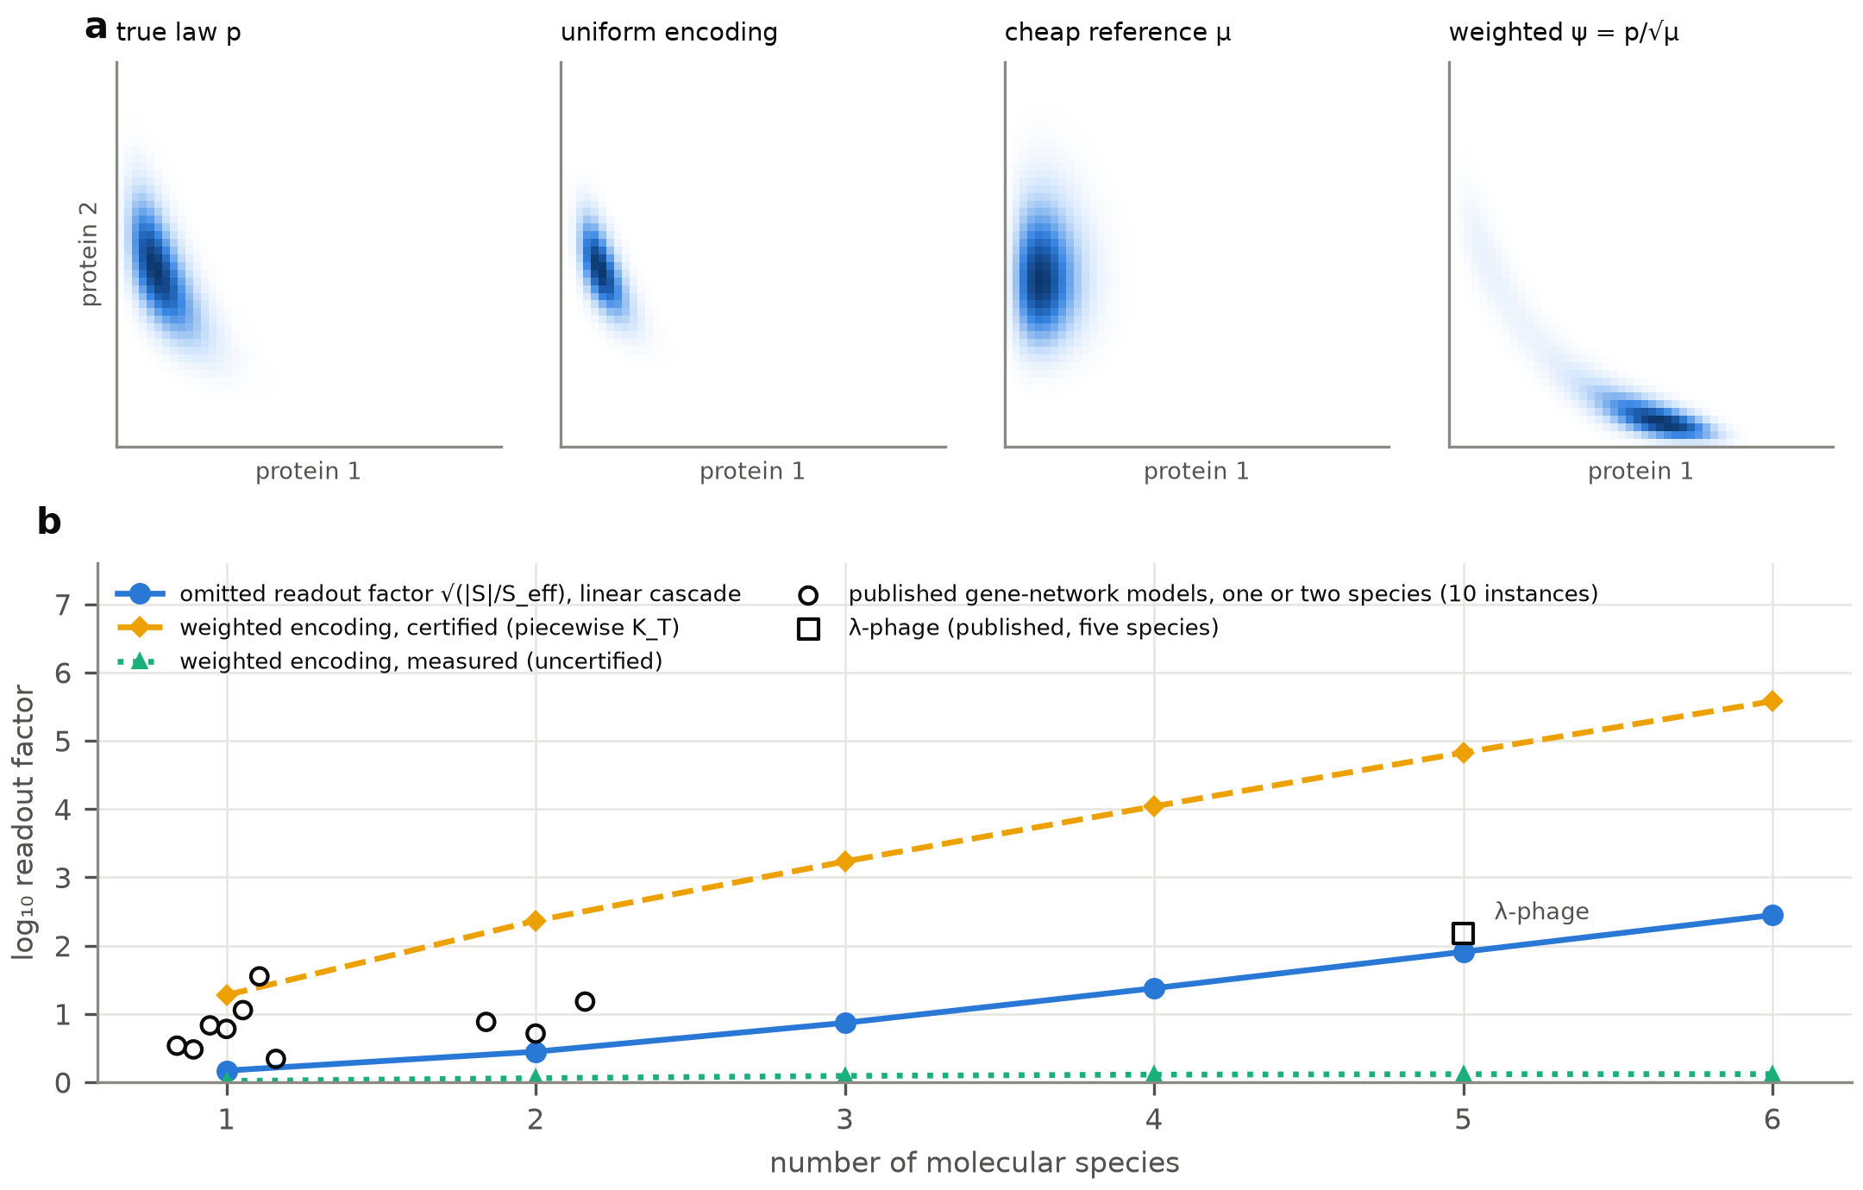
Figure 1. The readout barrier. (a) A two-gene toggle-switch distribution, its uniform amplitude encoding, a cheap reference and the reweighted encoding $ψ=p/\sqrt{μ}$ on a 50 × 50 box at t = 1. (b) The factor $\sqrt{|S|/S_{eff}}$ omitted by uniform-encoding readouts, plotted against the number of molecular species. Filled circles show linear cascades with one to six species, open symbols the published gene-network instances with one or two species, and the labelled point λ-phage. Lines show the certified readout factor of the best reweighted encoding (dashed) and its measured growth (dotted) on the cascade.
Table 1. Readout factor of the uniform encoding on the published gene-network instances. Count species exclude binary promoter states. The readout factor is $\log_{10}\sqrt{|S|/S_{eff}}$ at the horizon T.
Instance | Count species | |S| | T | log₁₀ readout factor
Schlögl (Kuntz et al.) | 1 | 200 | 0.5721 | 0.34
Toggle switch (Hegland et al.) | 2 | 4,096 | 146.7 | 0.88
Toggle switch (Kuntz et al.) | 2 | 1,800 | 1.477 | 0.71
Toggle switch (Gardner et al.) | 2 | 3,655,744 | 6.151 | not computed
Bursty feedback, ⟨b⟩ = 1 | 1 | 80 | 0.5 | 0.78
Bursty feedback, ⟨b⟩ = 10 | 1 | 314 | 0.5 | 1.06
Bursty feedback, ⟨b⟩ = 100 | 1 | 3,126 | 0.5 | 1.55
λ-phage | 5 | 7,428,456 | 10 | 2.18
Toggle switch (Tang et al.) | 2 | 40,000 | 54.2 | 1.18
Autoregulation, case 1 | 1 | 120 | 1.684 | 0.53
Autoregulation, case 2 | 1 | 120 | 1.327 | 0.48
Autoregulation, case 3 | 1 | 120 | 1.149 | 0.83

3.2 An audit of published proposals
We searched the literature for quantum algorithms that output the law of a classical stochastic process, or an observable of that law, from an amplitude encoding and that state a complexity or resource claim. Three literature searches gave 2,335 records, and fourteen works met the criteria. Supplementary Section S1 describes the search, the inclusion criteria and the coding, and Supplementary Table S1 gives the location of each coded statement. We call a work "accounted" if the readout cost is counted, or if its encoding removes the cost by a proven argument. We call it "omitted, bounded" if the cost is left out but stays small in the work's own setting, and "omitted, growing" otherwise. Table 2 gives the encoding, the readout, whether the readout cost enters the stated complexity, the scaling claimed and the verdict for each work.
Table 2. How published proposals treat the readout. Encoding, readout, whether the readout cost enters the stated complexity, the scaling claimed and the verdict for the 14 works.
Ref. | Task | Encoding | Readout | Cost counted | Scaling claimed | Verdict
[18] | whole-cell CME / SSA (perspective) | p/‖p‖ | not specified | partly | log in state-space dimension | omitted, grows
[9] | reaction–diffusion master equation | p/‖p‖ | overlap with uniform state | no | removes exponential post-processing | omitted, grows
[13] | Fokker–Planck via linear solvers | p/‖p‖ | normalized state only | no | exponential in dimension | omitted, grows
[12] | Kolmogorov forward (option baskets) | p/‖p‖ | swap tests, cost O(1/V₀²) | partly | exponential in assets | omitted, grows
[17] | PDF transport, reacting flows | p/‖p‖ | Hadamard test vs fixed state | no | polylog in system size | omitted, grows
[8] | CME, 1 species (Schlögl), eigenproblem | p/‖p‖ (zero mode) | components of a 2-4 qubit state | no | qubit count | omitted, bounded
[11] | Fokker–Planck of low-dim. ODEs | p/‖p‖ | post-selection (norm decay noted) | partly | potential advantage | omitted, bounded
[15] | drift–diffusion, d dimensions | p/‖p‖ | AE tomography, additive error | yes | advantage at fixed time | accounted
[16] | Fokker–Planck prediction (Bayesian) | √p | sampling | partly | polynomial in grid points | accounted
[19] | multiscale kinetics (perspective) | walk operators | phase / amplitude estimation | yes | conditional on readout | accounted
[31] | non-reversible Markov chains | √π | sampling | yes | up-to-exponential (mixing) | accounted
[14] | Fokker–Planck reaction rates (reversible) | exact √Boltzmann weight | Hadamard test | yes | polynomial in particles | accounted
[30] | Gibbs sampling (Langevin) | √σ | sampling | yes | up to quartic | accounted
[10] | Fokker–Planck (reversible) | exact stationary weight | basis sampling | yes | Schrödingerisation cost | accounted

Seven works account for the readout. Five of them use encodings in which the cost does not arise. Kharazi et al. and Jin, Liu and Yu use an exactly known stationary law as a weight, which exists for reversible dynamics [14,10]. Leng et al., Claudon et al. and Govaers encode the square root of the target law and sample it directly [30,31,16]. Devereux and Datta count an explicit tomographic readout to additive error [15]. The perspective of Hariharan et al. states the readout condition explicitly [19].
The other seven works omit the readout cost. Two do so in settings where it stays small, namely a one-species eigenvalue study [8] and Fokker–Planck emulations in two or three dimensions [11]. The remaining five omit it in exactly the regime where it grows [9,12,13,17,18]. They claim costs polynomial in the logarithm of the state-space size, or exponential speedups in dimension. Yet they read out through an overlap with a state that does not depend on p. In the option-pricing algorithm of Guseynov et al. the omitted cost appears as a parameter, the overlap V₀, without a bound in dimension [12]. For their estimator on a localized product law, Eq. (12) gives a relative error at 10⁶ shots that grows from 0.071 with one asset to 2.7 with four (Supplementary Table S4).
The pattern is consistent across the corpus. Every proposal that counts the readout relies on one of three things. It uses reversibility or an exact stationary weight, it samples a $\sqrt{p}$ state, or it targets additive error. Gene regulatory networks are not reversible. Their observables of interest, such as switching probabilities and tail probabilities, also need relative precision.

3.3 Available certificates cannot show that reweighting removes the barrier
For reversible dynamics with μ equal to the stationary law, the weighted encoding of Eq. (6) is exactly the encoding that works [14,37]. For non-reversible networks no such weight is known, and the weighting removes the barrier only when K_{T} of Eq. (10) stays small. In practice it does not. On a two-gene toggle switch the best of twelve references we tested reaches K_{T} = 36.81 (Figure 2a). Using the exact solution as the weight does worse, with K_{T} = 217. Here 92% of the certificate is the penalty for holding a moving reference fixed over each window. This is the jump factor known from the theory of switched systems [43,44]. Removing that penalty would still leave non-normal transient growth of 10^{3.42}. No instantaneous certificate can see this growth [45,46], and the actual excess growth is only 10^{0.44}.
The result is not specific to one model. We tested twelve instances of eight published gene-network models from five sources. They include toggle switches, burst-with-feedback circuits, autoregulation and λ-phage [32,33,4,34]. The best cheap reference has K_{T} between 12.6 and 2.07×10⁴ (Figure 2b). The exact reference, wherever it is computable, has K_{T} of at least 53.7. Non-normal transient growth is the largest source of looseness on eight of the twelve instances, and the window penalty is the largest on the rest (Supplementary Table S5).
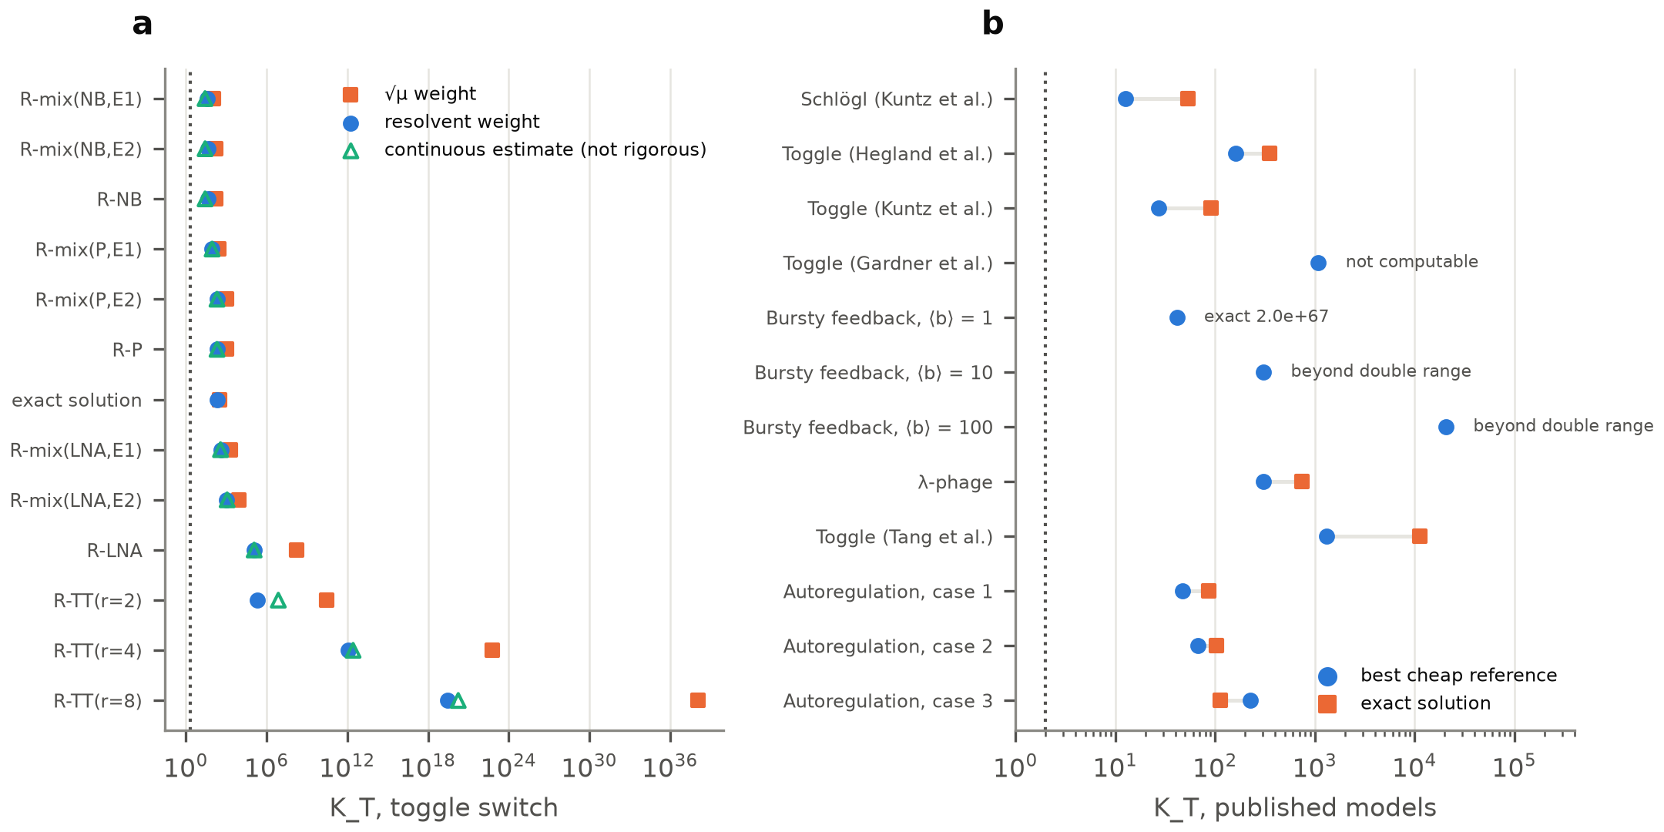
Figure 2. Available certificates cannot show that reweighting removes the barrier. (a) Certified exponent K_{T} on the toggle switch for every reference tested and for the exact solution used as the reference. Squares show the $\sqrt{μ}$ weight, circles the resolvent weight and triangles a non-rigorous continuous estimate. The dotted line marks K_{T} = 2. (b) Best cheap reference (circles) and exact reference (squares) on the twelve published instances. Instances where the exact reference cannot be computed in double precision are labelled.
Under these certificates the weighting also worsens the scaling with species. On the cascade the certified readout factor of the best reference grows by 0.85 decades per species, against 0.65 for the uniform encoding (Figure 1b). The measured growth of the weighted state is nearly flat, at 0.02 decades per species. The weighted encoding would therefore remove the barrier in practice, but no available certificate can show it.

3.4 Trajectory sampling is the competitive quantum route
A different quantum algorithm avoids the encoding altogether. Montanaro showed that amplitude estimation over a coherent version of a classical sampler gives a quadratic speedup over Monte Carlo [39]. Applied to the stochastic simulation algorithm, it prepares a superposition over trajectories rather than over states and reads out an expectation value. Ueno and Miura recently used the same route for the collision and coalescence of cloud droplets [47].
Coherent stochastic simulation is cheaper than every master-equation encoding on every benchmark network (Figure 3). It wins by at least a factor of 167 under the better of the two oracle designs we counted, and by at least 372 under the other. This holds even when the weighted solver is credited with its true worst-case growth W instead of its certificate. The Lindblad embedding is not competitive either. For tail probabilities it costs 146 to 12,462 times more than trajectory sampling. For total probability the default comparison is degenerate, because both methods conserve probability. Against a trajectory step count matched to that observable, the Lindblad embedding costs 42 to 504 times more.
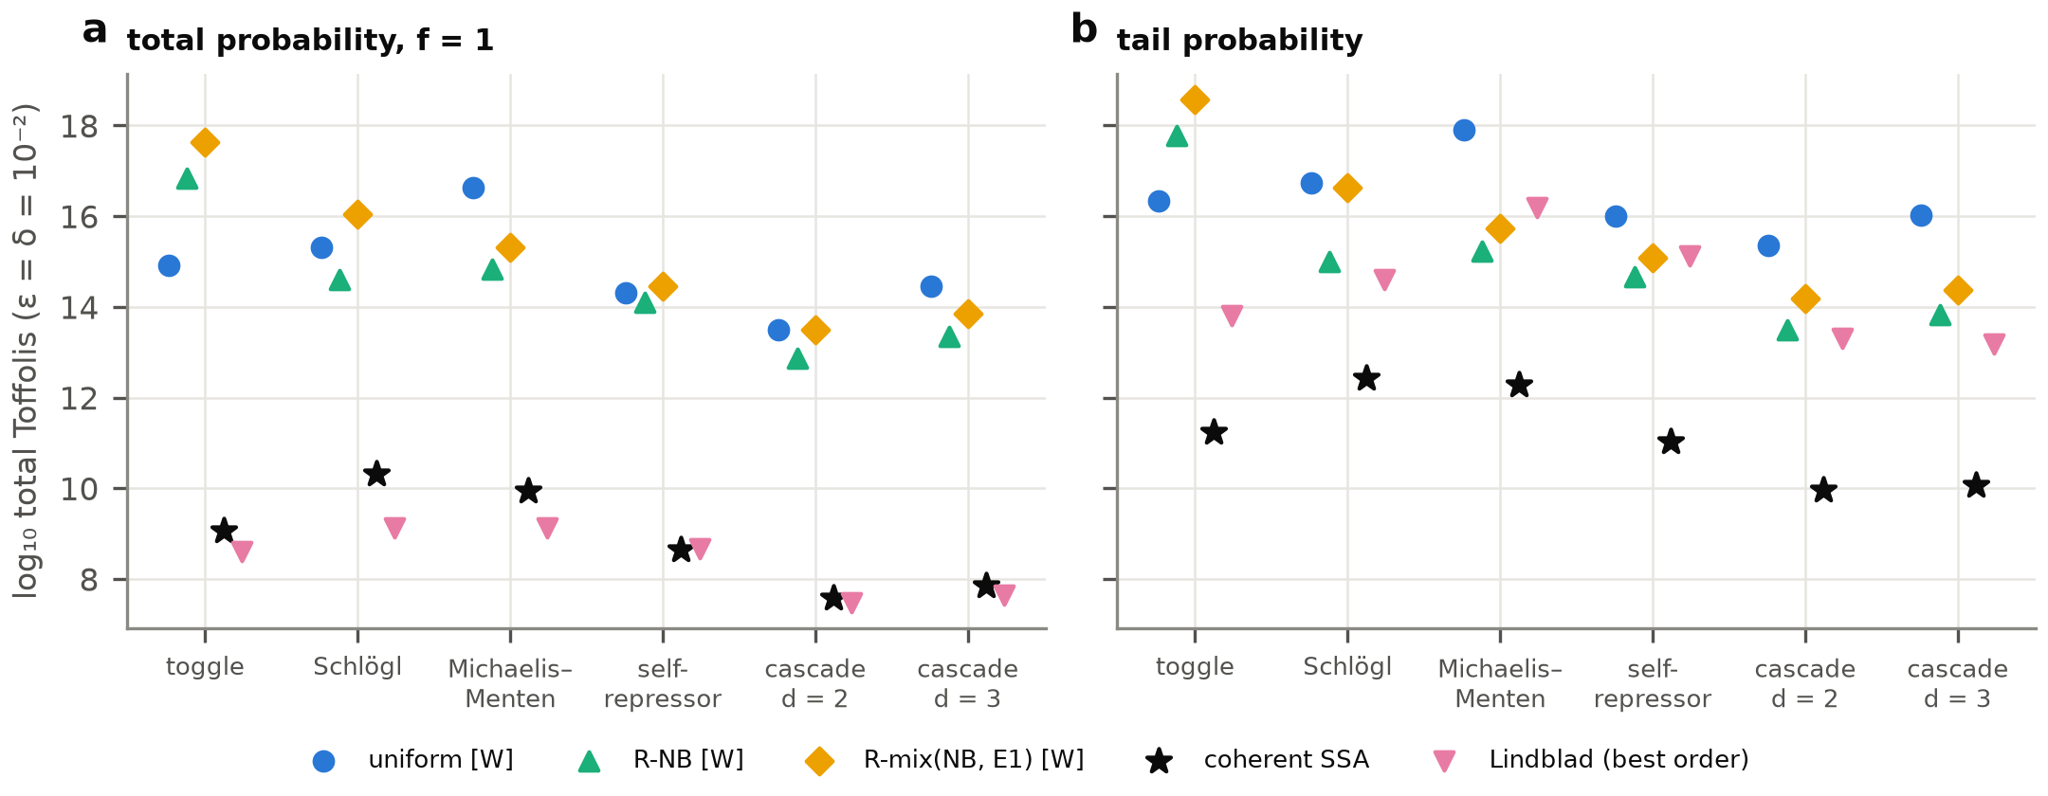
Figure 3. Trajectory sampling is cheaper than every counted master-equation encoding. Total Toffoli gates at ε = δ = 10⁻² on six benchmark networks, for total probability (a) and a tail probability (b). The uniform, negative-binomial and mixture-weighted encodings use the uncertified growth W. Stars show coherent stochastic simulation, and the best Lindblad embedding is shown for comparison.
Credited with the growth W, the weighting stops the readout factor from growing on the cascade. The uniform factor grows by 0.66 decades per species, while the weighted factor stays between 10^{0.02} and 10^{0.11} for one to four species. Its certified factor grows faster than the uniform one, as shown above. The totals still stay far above trajectory sampling, at 10^{3.1} to 10^{3.8} for the negative-binomial reference on the tail probability (Supplementary Table S6). The reason is that each use of the propagator costs many queries to the block encoding.

3.5 A checklist for future proposals
These results suggest five questions that any claimed quantum speedup for stochastic simulation should answer (Table 3). The questions make the readout explicit and separate certified growth from measured growth. They also name the quantum baseline that a claim has to beat.
Table 3. Five questions for a claimed quantum speedup in stochastic simulation.
No. | Question
1 | Which encoding is used (p/‖p‖, √p or a weighted variant), and what does the readout measure?
2 | Is the amplitude or norm that the readout estimates bounded in the claimed scaling variable, such as species, dimension or state-space size? Is its cost included in the stated complexity?
3 | If a classical guess or weight is used, is the growth of the encoded state certified, or only measured on small instances?
4 | Is the precision relative or additive, and is it adequate for the observable, for example a rare switching probability?
5 | Does the claim beat quantum Monte Carlo over trajectories (amplitude estimation over stochastic simulation), counted at the same precision?

4. Discussion

4.1 Interpretation
The claimed exponential speedups for stochastic simulation are decided at the readout of the quantum state, not at its preparation. For the uniform encoding the omitted cost is exponential in the number of species. It is modest for the one- and two-species models used as benchmarks today, so emulations on small instances cannot reveal it. It grows on exactly the multi-species networks that motivate a quantum approach. The encodings that avoid it rely on reversibility or on exact stationary weights. For non-reversible gene networks we found no way to certify that a cheaper weight works. The counted costs instead favour quantum Monte Carlo over trajectories, whose speedup is at most quadratic.

4.2 Limitations
The limits of these results are specific. The certificate failure holds for piecewise Collatz–Wielandt certificates. A certificate with continuously varying weights, or one that tracks transient growth, was not ruled out. Our own attempt at a rigorous continuous certificate was valid but too loose to help. The cost comparisons use measured or worst-case growth, which we label as uncertified, and they use specific solver and oracle designs. Other designs could narrow the gaps, although the gap to trajectory sampling exceeds two orders of magnitude under both oracle designs we counted. The Lindblad embedding was costed only with the schemes of Ding, Li and Lin [40], and algorithms with better scaling in precision could narrow its gap. Moment-matching dilations and Schrödingerisation were represented only by an idealized growth factor, not counted gate by gate. The barrier is relativized, so a readout that uses more of the structure of the CME than black-box access is not excluded.
The audit covers proposals found by our searches up to October 2026. It describes how the readout is treated, not the overall quality of the works. Several authors state the relevant caveats themselves. Tennie and Magri note the decay of the 2-norm against the conserved 1-norm [11], and Hariharan et al. write that speedups "depend heavily on" classical readout costs [19].

4.3 What would change the conclusion
What would change this conclusion is equally specific. One route is a certificate that stays bounded for a non-reversible network with several species. Another is a readout that beats the relativized bound by using the structure of the generator. A third is an observable whose amplitude does not shrink as the state space grows. Until one of these is shown, quantum algorithms for stochastic gene networks should be compared with quantum Monte Carlo over trajectories, with the readout counted.

5. Conclusion
This study shows that the cost of reading a probability out of a quantum state decides whether quantum master-equation solvers can speed up the stochastic simulation of gene networks. For the standard amplitude encoding this cost grows with the size of the state space relative to the number of occupied states, and therefore exponentially with the number of molecular species. Of the fourteen published proposals we audited, five claim costs that do not grow exponentially with dimension but leave this cost out of the stated complexity.
Reweighting the encoding with a classical guess would remove the cost in practice, but under the available certificates it cannot be shown to do so, even with the exact solution as the weight. Fault-tolerant resource counts favour quantum Monte Carlo over stochastic trajectories, which beats every counted master-equation encoding. The five questions of Table 3 give a simple way to check future claims against these findings.
Declaration of competing interest
The author declares that they have no known competing financial interests or personal relationships that could have appeared to influence the work reported in this paper.
Declaration of generative AI and AI-assisted technologies
[AUTHOR TO CONFIRM BEFORE SUBMISSION] During this work the author used Claude (Anthropic), a large language model, through the Claude Code tool. Under the author's direction it implemented the analysis and simulation code, ran the computations, drafted proofs, screened and coded the literature, and drafted and edited the manuscript. The author defined the research question, directed and reviewed each step, checked the code, the proofs, the literature coding and the conclusions, and takes full responsibility for the content of the publication.

Data and Code availability
The Python package qcme, the analysis scripts that reproduce every figure, table and quoted number, the stored results and the coded literature tables are available at [repository URL and archive DOI to be added: decision D4] (version 1.0.0, MIT licence).
Acknowledgement
[AUTHOR TO CONFIRM] No specific grant from a public, private, or nonprofit organization was given for this research.

References
[1] Munsky, B. & Khammash, M. The finite state projection algorithm for the solution of the chemical master equation. The Journal of Chemical Physics 124, 044104 (2006).
[2] Peccoud, J. & Ycart, B. Markovian Modeling of Gene-Product Synthesis. Theoretical Population Biology 48, 222–234 (1995).
[3] Gillespie, D. T. Stochastic Simulation of Chemical Kinetics. Annual Review of Physical Chemistry 58, 35–55 (2007).
[4] Gupta, A., Mikelson, J. & Khammash, M. A finite state projection algorithm for the stationary solution of the chemical master equation. The Journal of Chemical Physics 147, 154101 (2017).
[5] Kazeev, V., Khammash, M., Nip, M. & Schwab, C. Direct Solution of the Chemical Master Equation Using Quantized Tensor Trains. PLoS Computational Biology 10, e1003359 (2014).
[6] Jahnke, T. & Huisinga, W. A Dynamical Low-Rank Approach to the Chemical Master Equation. Bulletin of Mathematical Biology 70, 2283–2302 (2008).
[7] Prugger, M., Einkemmer, L. & Lopez, C. F. A dynamical low-rank approach to solve the chemical master equation for biological reaction networks. Journal of Computational Physics 489, 112250 (2023).
[8] Kabengele, T., Lokare, Y. M., Marston, J. B. & Rubenstein, B. M. Modeling stochastic chemical kinetics on quantum computers. The Journal of Chemical Physics 164, 194117 (2026).
[9] Yao, L. H. Digital quantum simulation of reaction–diffusion systems on lattice. The European Physical Journal B 98, 81 (2025).
[10] Jin, S., Liu, N. & Yu, Y. Quantum Simulation of the Fokker-Planck Equation via Schrödingerization. Communications in Computational Physics 39, 969–1001 (2026).
[11] Tennie, F. & Magri, L. Integration of the Fokker–Planck equation on quantum computers: a new path to modelling nonlinear dynamics. Proceedings of the Royal Society A: Mathematical, Physical and Engineering Sciences 481, 20250016 (2025).
[12] Guseynov, N., Sanz, M., Rodríguez-Rozas, Á., Liu, N. & Gonzalez-Conde, J. Quantum Algorithm for Local-Volatility Option Pricing via the Kolmogorov Equation. Preprint at https://arxiv.org/abs/2511.04942 (2025).
[13] Gnanasekaran, A., Surana, A. & Sahai, T. Efficient Quantum Algorithms for Nonlinear Stochastic Dynamical Systems. 2023 IEEE International Conference on Quantum Computing and Engineering (QCE), 66–75 (2023).
[14] Kharazi, T., Alkadri, A. M., Mandadapu, K. K. & Whaley, K. B. Provable Quantum Speedups for Reaction-Rate Estimation in High-Dimensional Fokker-Planck Dynamics. PRX Quantum https://doi.org/10.1103/r888-s8t3 (2026).
[15] Devereux, E. & Datta, A. Quantum algorithms for solving a drift-diffusion equation: analysing circuit depths. Preprint at https://arxiv.org/abs/2509.21509 (2025).
[16] Govaers, F. Quantum Prediction of Transport Dynamics in Discretized State Spaces. Preprint at https://arxiv.org/abs/2604.24161 (2026).
[17] Zhang, J., Yang, Z., Meng, Z., Lu, Z. & Yang, Y. Quantum computing of nonlinear reacting flows via the probability density function method. Proceedings of the Combustion Institute 42, 106601 (2026).
[18] Gopalakrishnan Meena, M. et al. Exploring the use of quantum computing for facilitating spatially and temporally resolved models of a biological cell. Preprint at https://arxiv.org/abs/2607.27571 (2026).
[19] Hariharan, S., Schoutens, K., Kinge, S. & Visscher, L. Quantum Multiscale Modeling: A Hierarchy of Algorithms for Complex Chemical Systems. Preprint at https://arxiv.org/abs/2607.11217 (2026).
[20] An, D., Liu, J. P. & Lin, L. Linear Combination of Hamiltonian Simulation for Nonunitary Dynamics with Optimal State Preparation Cost. Physical Review Letters 131, 150603 (2023).
[21] Low, G. H. & Somma, R. D. Optimal quantum simulation of linear non-unitary dynamics. Preprint at https://arxiv.org/abs/2508.19238 (2025).
[22] Li, X. From Linear Differential Equations to Unitaries: A Moment-Matching Dilation Framework with Near-Optimal Quantum Algorithms. PRX Quantum 7, 020350 (2026).
[23] An, D., Liu, J. P., Wang, D. & Zhao, Q. Quantum Differential Equation Solvers: Limitations and Fast-Forwarding. Communications in Mathematical Physics 406, 189 (2025).
[24] Krovi, H. Improved quantum algorithms for linear and nonlinear differential equations. Quantum 7, 913 (2023).
[25] Jennings, D., Lostaglio, M., Lowrie, R. B., Pallister, S. & Sornborger, A. T. The cost of solving linear differential equations on a quantum computer: fast-forwarding to explicit resource counts. Quantum 8, 1553 (2024).
[26] Costa, P. C. S., Schleich, P., Morales, M. E. S. & Berry, D. W. Further improving quantum algorithms for nonlinear differential equations via higher-order methods and rescaling. npj Quantum Information 11, 141 (2025).
[27] Wu, H. C. & Li, X. From Nonlinear Stochastic Differential Equations to Quantum Channels: The Kolmogorov--Lindblad Mapping. Preprint at https://arxiv.org/abs/2608.09903 (2026).
[28] Nayak, A. & Wu, F. The quantum query complexity of approximating the median and related statistics. Proceedings of the thirty-first annual ACM symposium on Theory of Computing, 384–393 (1999).
[29] Brassard, G., Høyer, P., Mosca, M. & Tapp, A. Quantum amplitude amplification and estimation. Contemporary Mathematics 305, 53–74 (2002).
[30] Leng, J., Ding, Z., Chen, Z. & Lin, L. Operator-level quantum acceleration of non-logconcave sampling. Proceedings of the National Academy of Sciences 123, e2512789123 (2026).
[31] Claudon, B., Piquemal, J. P. & Monmarché, P. Quantum speedup for nonreversible Markov chains. Nature Communications 16, 10732 (2025).
[32] Hegland, M., Burden, C., Santoso, L., MacNamara, S. & Booth, H. A solver for the stochastic master equation applied to gene regulatory networks. Journal of Computational and Applied Mathematics 205, 708–724 (2007).
[33] Kuntz, J., Thomas, P., Stan, G. B. & Barahona, M. Bounding the stationary distributions of the chemical master equation via mathematical programming. The Journal of Chemical Physics 151, 034109 (2019).
[34] Tang, Y., Weng, J. & Zhang, P. Neural-network solutions to stochastic reaction networks. Nature Machine Intelligence 5, 376–385 (2023).
[35] Yau, H. T. Relative entropy and hydrodynamics of Ginzburg-Landau models. Letters in Mathematical Physics 22, 63–80 (1991).
[36] Kipnis, C. & Landim, C. Scaling Limits of Interacting Particle Systems (Springer Berlin Heidelberg, 1999).
[37] Fill, J. A. Eigenvalue Bounds on Convergence to Stationarity for Nonreversible Markov Chains, with an Application to the Exclusion Process. The Annals of Applied Probability 1 (1991).
[38] Zeifman, A. et al. On three methods for bounding the rate of convergence for some continuous-time Markov chains. International Journal of Applied Mathematics and Computer Science 30 (2020).
[39] Montanaro, A. Quantum speedup of Monte Carlo methods. Proceedings of the Royal Society A: Mathematical, Physical and Engineering Sciences 471, 20150301 (2015).
[40] Ding, Z., Li, X. & Lin, L. Simulating Open Quantum Systems Using Hamiltonian Simulations. PRX Quantum 5, 020332 (2024).
[41] Harrigan, M. P. et al. Expressing and Analyzing Quantum Algorithms with Qualtran. Preprint at https://arxiv.org/abs/2409.04643 (2024).
[42] Li, X. Exponential Reduction of Mesh Dependence in Quantum Estimation of Parabolic PDE Observables. Preprint at https://arxiv.org/abs/2607.18113 (2026).
[43] Branicky, M. Multiple Lyapunov functions and other analysis tools for switched and hybrid systems. IEEE Transactions on Automatic Control 43, 475–482 (1998).
[44] Hespanha, J. & Morse, A. Stability of switched systems with average dwell-time. Proceedings of the 38th IEEE Conference on Decision and Control (Cat. No.99CH36304) 3, 2655–2660 (1999).
[45] Söderlind, G. The logarithmic norm. History and modern theory. BIT Numerical Mathematics 46, 631–652 (2006).
[46] Trefethen, L. N. & Embree, M. Spectra and Pseudospectra (Princeton University Press, 2005).
[47] Ueno, K. & Miura, H. Quantum algorithm for the collision-coalescence of cloud droplets. Physical Review Applied https://doi.org/10.1103/ffxz-ttw7 (2026).

