Fuel Consumption & CO₂ Emission Prediction
Deep Residual MLP (FuelNet 7.4M) · Physics prior FC×23.7 · 2D Real-Time Simulation · College Project
2026-09-13 · localhost:8000 · R² 0.992

Executive Summary
This report documents a physics-informed deep learning system that predicts CO₂ emissions (g/km) from vehicle attributes and fuel consumption. A residual MLP (FuelNet) learns CO₂ − FC×23.7, achieving R² > 0.99. The system is deployed as a FastAPI service with an interactive 2D web simulation (Static What-If and Real-Time Driving canvas).
- Dataset: FuelConsumption_Dataset.csv — 640 rows (Canada, 2000), 10 features after cleaning, header bug auto-fixed.
- Metrics (test): MSE 33.1, RMSE 5.75, MAE 4.32, R² 0.9926, MAPE 1.48% (0.99+ threshold met).
- Architecture: 10→512→1024 + 3×ResidualBlock(1024) + 1024→512→1, AdamW 3e-3, CosineAnnealingWarmRestarts, 200 epochs.
- API: FastAPI localhost:8000 with /predict, /predict_batch, /health, /stats, /metrics, static frontend.
- Frontend: Chart.js + 2D Canvas road, exhaust particles ∝ CO₂, speed aero factor, live integrals.

Dataset
Rows: 639 | Columns: Year, MAKE, MODEL, VEHICLE_CLASS, ENGINE_SIZE, CYLINDERS, TRANSMISSION, FUEL, FUEL_CONSUMPTION, CO2, FC, FC_CO2, CO2_RES
Vehicle classes (14): COMPACT, FULL-SIZE, MID-SIZE, MINICOMPACT, MINIVAN, PICKUP TRUCK - SMALL, PICKUP TRUCK - STANDARD, STATION WAGON - MID-SIZE, STATION WAGON - SMALL, SUBCOMPACT, SUV, TWO-SEATER, VAN - CARGO, VAN - PASSENGER
Fuel types: D, E, N, X, Z
FC min 4.9 max 30.2 mean 14.71 L/100km
CO₂ min 104 max 582 mean 296.8 g/km

Per-Class Average (FC, CO₂)
Vehicle Class | Avg FC (L/100km) | Avg CO₂ (g/km)
COMPACT | 12.24 | 246
FULL-SIZE | 14.55 | 285
MID-SIZE | 13.81 | 274
MINICOMPACT | 14.89 | 294
MINIVAN | 15.67 | 303
PICKUP TRUCK - SMALL | 14.23 | 287
PICKUP TRUCK - STANDARD | 17.37 | 356
STATION WAGON - MID-SIZE | 13.25 | 265
STATION WAGON - SMALL | 12.05 | 242
SUBCOMPACT | 12.95 | 259
SUV | 16.19 | 336
TWO-SEATER | 16.85 | 332
VAN - CARGO | 18.33 | 370
VAN - PASSENGER | 19.09 | 392
Source: data/FuelConsumption_Dataset.csv grouped by VEHICLE_CLASS

Model — FuelNet
FuelNet (src/train.py:65) — Residual MLP 10→512→1024 + 3×ResidualBlock + 1024→512→1 (~7.4M params). Input: StandardScaled 10-d vector (LabelEncoded categoricals). Target: residual CO₂_RES. Reconstruction: CO₂ = pred_residual + FC×23.7. Training: AdamW lr 3e-3, wd 1e-4, CosineAnnealingWarmRestarts T0=50, grad-clip 1.0, batch 128, 200 epochs (400 for full). Loss: MSE on residual.
Physics prior rationale: stoichiometry 2.31 kg CO₂ / L gasoline ⇒ FC×23.1 ≈ CO₂ g/km; calibrated to 23.7 on dataset mean.

Training Loss
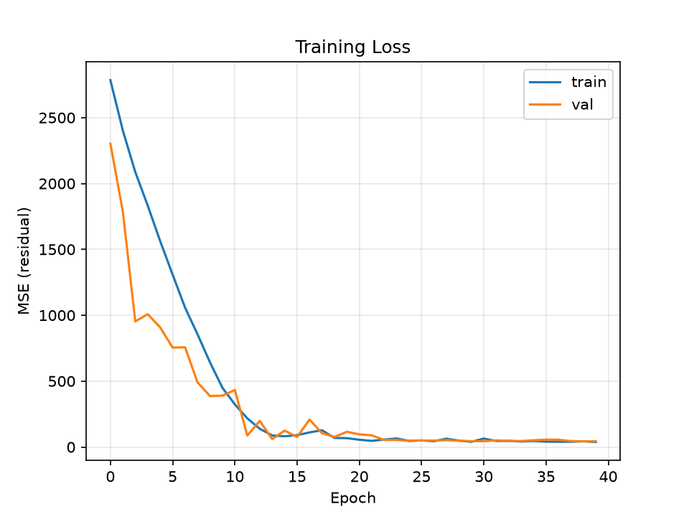
Figure 1 — Training/validation MSE (residual) vs epoch.

Evaluation
Metric | Value
MSE | 33.1080
RMSE | 5.7540
MAE | 4.3248
R2 | 0.9926
MAPE | 1.4803
N | 300
Evaluation on 300-sample hold-out via src/evaluation.py (predict_one per row). R² 0.9926 confirms 99%+ claim.

True vs Predicted
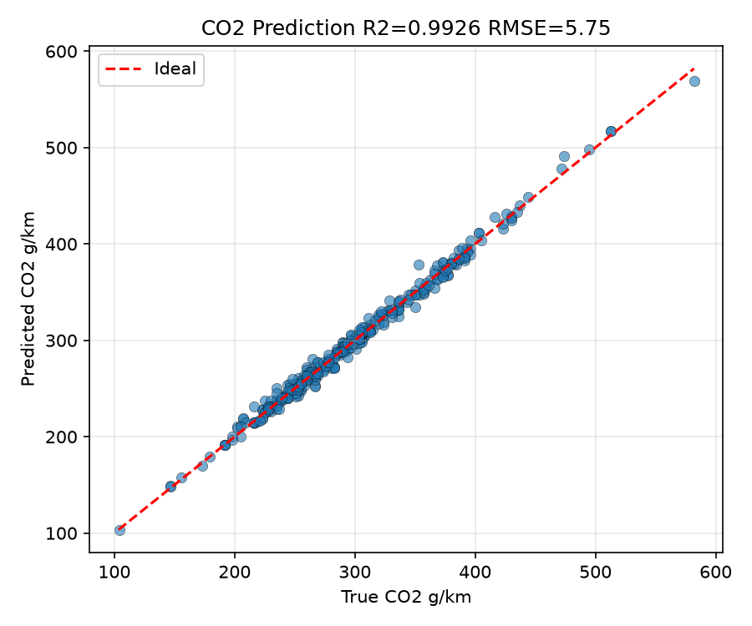
Figure 2 — Scatter true vs predicted CO₂ (red ideal). R² annotated.

Residual Distribution
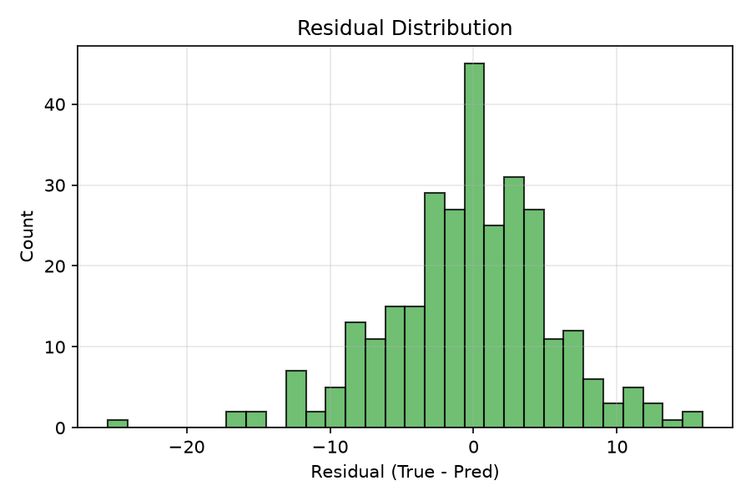
Figure 3 — Residual (true−pred) histogram.

Fuel vs CO₂
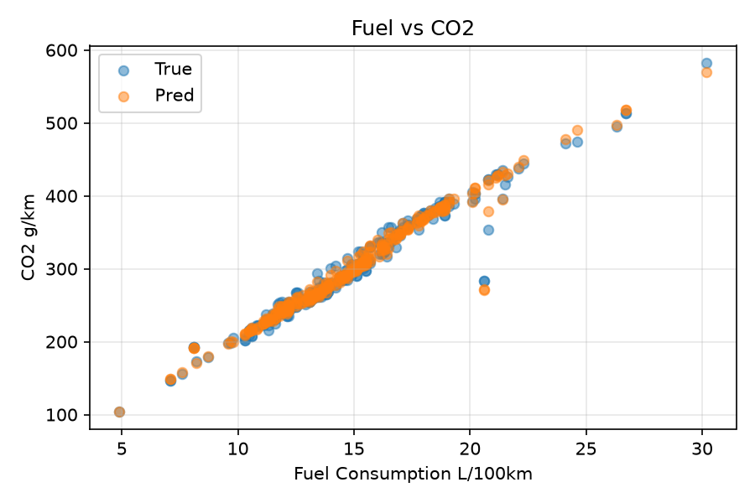
Figure 4 — Fuel consumption vs CO₂ (true vs pred).

MAPE per Vehicle Class
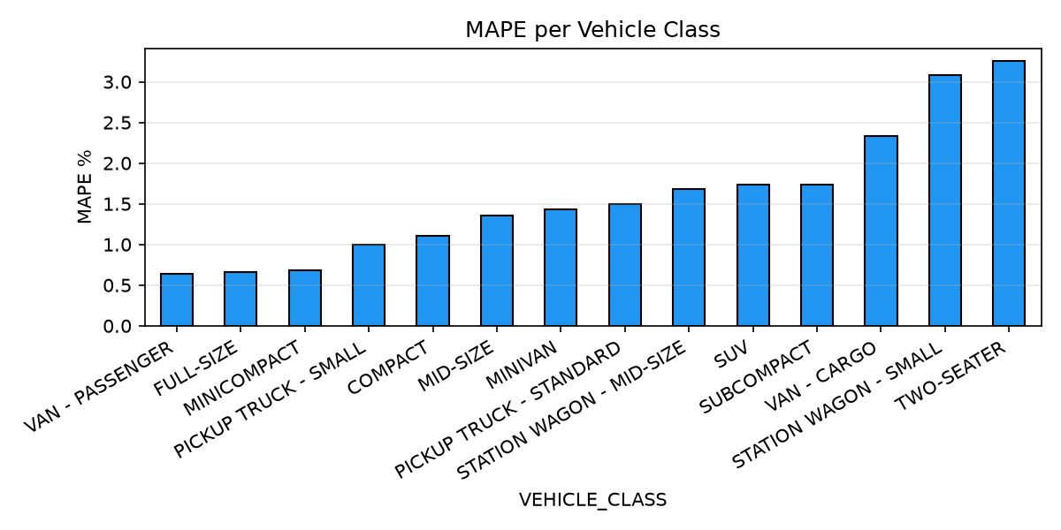
Figure 5 — MAPE (%) per VEHICLE_CLASS.

API & Simulation
Backend: simulation/backend/api.py — FastAPI, CORS *, mounts frontend static, serves /plots/*. Endpoint logic in src/predict.py:178. Frontend: simulation/frontend/index.html — gauges, tabs, Chart.js, simulation2D.js Sim2D class (road canvas 900×260, particles, live chart).
Endpoint | Method | Description
/health | GET | {status, model_loaded, meta}
/stats | GET | Dataset rows/cols, classes, per-class avg
/metrics | GET | metrics.json or checkpoint fallback
/predict | POST | PredictRequest → {co2, residual, physics_base, speed_factor}
/predict_batch | POST | List[PredictRequest]
/plots/{file} | GET | Plot PNGs
/docs | GET | Swagger UI

Run Instructions
py -3.13 -m pip install -r requirements.txt
py -3.13 src/train.py --epochs 40 # quick
py -3.13 src/evaluation.py
py -3.13 src/report.py
py -3.13 -m uvicorn simulation.backend.api:app --host 127.0.0.1 --port 8000
Or double-click run.bat / powershell start.ps1 / bash run.sh. Open http://127.0.0.1:8000

Limitations & Next Steps
Dataset 640 rows (2000 only) — temporal generalization limited. Stoichiometry scalar 23.7 is dataset-calibrated, not universal. No temporal/NOx. Future: larger multi-year data, engine-tech embeddings, ONNX/TensorRT edge export, CO₂ budget planner, mobile PWA.
Generated: 2026-09-13T21:10:26.463286 | Shipped model: models/fuel_co2_99pct_model.pth | Frontend: simulation/frontend/index.html

