logo

QEDistribution Widget

Andrew Starritt

25th July 2020

Copyright (c) 2020 Australian Synchrotron

Permission is granted to copy, distribute and/or modify this document under the terms of the GNU Free Documentation License, Version 1.3 or any later version published by the Free Software Foundation; with no Invariant Sections, no Front-Cover Texts, and no Back-Cover Texts.  
A copy of the license is included in the section entitled "GNU Free Documentation License" within the QE_QEGuiAndUserInterfaceDesign document.

Contents

Introduction 3

QNumericEdit 3

Description 3

Properties 4

QENumericEdit 5

Description 5

Properties 5

# Introduction

This document describes in detail the QNumericEdit and QENumericEdit widgets provided by the EPICS Qt, aka QE, Framework.

This document was created as a separate widget specification document. The main reason for this is ease of maintenance and avoiding editing large and unwieldly word documents.

The QE Framework is distributed under the GNU Lesser General Public License version 3, distributed with the framework in the file LICENSE. It may also be obtained from here: <http://www.gnu.org/licenses/lgpl-3.0-standalone.html>

The QNumericEdit is a non-EPICS aware widget that allows the editing of numerical values. QENumericEdit extends the functionality of the QNumericEdit widget and provides EPICS-awareness via a single control Process Variable.

# QNumericEdit

## Description

QNumericEdit extends the functionality of the QLineEdit widget, and is somewhat like a spin box, save that the spin or increment/decrement value depends upon which character of the numerical field is selected/highlighted. This widget also supports the following functionality:

1. Radix selection: 10 (default), 16, 8, 2;
2. Optional “thousands” : comma (‘,’), underscore (‘_’) or space (‘ ’);
3. Notation: Fixed point (default) or scientific.  
   ***Note:*** only the decimal radix is allowed for scientific notation.

The QNumericEdit widget provides the ability to modify the value of a single numerical value, either integer or floating point. Figure 1 shows examples of the widget in several configurations, and in each case the widgets’ suffix values have been set to “ sec”.

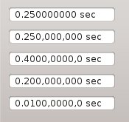

Figure 1 QNumericEdit examples

The first example shows a QNumericEdit in its default configuration, and in appearance at least, looks very much like its QLineEdit counterpart. The second example shows the appearance with the separator property set to "comma". The 3rd, 4th and 5th show the same with the radix property set to Hexadecimal, Octal and Binary respectively. The widgets tool tip will be annotated accordingly.

Unlike QLineEdit, the user may only enter valid radix digits and if a sign is present enter a plus/minus ("+", "-") . A sign is displayed if and only if the allowed range of values encompasses negative values. The user may also the left and right key to navigate sideways to select a digit and use the up and down keys to increment or decrement the overall value by an amount corresponding to the unit value of the selected digit. An example sequence is shown below (***note:***using an approximate representation of the widget appearance):

0.2589 Amps  
0.2589 Amps - widget gets focus – the current selected digit is after the first decimal point  
0.2589 Amps - left key – first digit selected – note: the decimal point skipped   
0.2589 Amps - right key three times – third digit after point selected  
0.2599 Amps - up key – increment value by 0.001   
0.2609 Amps - up key – increment value by 0.001, second digit has changed from 5 to 6.

## Properties

The QNumericEdit widget specific properties are shown In Figure 2. These are described below:

1. frame (default: true): when true the widget is displayed with a boarder;
2. suffix (default: “”): fixed text appended to the end of the numerical text;
3. prefix(default: “”): fixed text prepended to the start of the numerical text;
4. alignment(default: right, vertical centre): alignment applied to embedded QLineEdit;
5. notation (default Fixed): selects the notation used, fixed point or scientific;
6. radix (default Decimal): allows the selection of display/editing radix. Unlike other widgets, this is restricted to just four options: Decimal, Hexadecimal, Octal orBinary.  
   Note: the widget assumes that the precision/leading zeros are appropriate for the selected radix;  
   Note: Scientific notation and non-decimal radix selections are mutually exclusive.
7. separator (default None): allows the use of a character to break up the textual representation of the numerical value. This may be one of None, Comma, Underscore or Space. For Decimal and Octal, this is between every third digits, whereas for Hexadecimal and Binary, this is every 4th digit;
8. leadingZeros (default 3): specified the number of digits before the decimal point;
9. precision (default 4): specifies the number digits after the decimal point for display and editing;
10. minimum: specifies the minimum value allowed to be entered;
11. maximum: specifies the maximum value allowed to be entered; and
12. value: specified the current value.

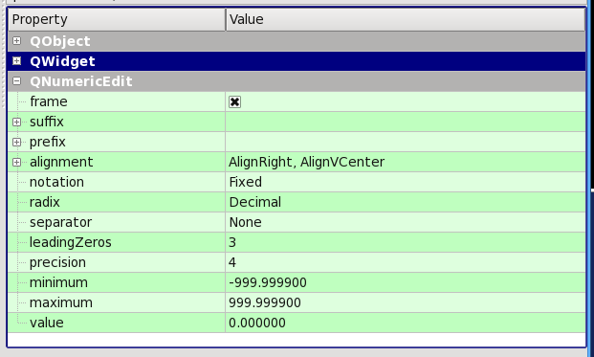

Figure 2 QNumericEdit properties

## 

# QENumericEdit

## Description

QENumericEdit is derived directly from QEAbstractWidget and thus inherits many standard properties used by QEWidgets, and includes an embedded QNumericEdit widgets in order to provide the numerical editing capability (recall Qt only allows direct inheritance from one QObject/QWidget only). This allows the QENumericEdit to set the value of numeric PVs.

## Properties

Like the QELineEdit widget, the subscribe, writeOnLoseFocus, writeOnEnter, writeOnFinish, confirmWrite and allowFocusUpdate properties modify the behaviour is exactly the same manor. The widget specific properties are shown in Figure 3. The additional properties, in addition to those provided by QNumericEdit, are described below:

1. autoScale (default true): when true the number of leading zeros, precision, minimum and maximum values will be determined from the PV’s associated meta values. When false (or when not connected), the precision, leadingZeros, minimum and maximum property values are used; and
2. addUnits (default true): the widget displays includes any engineering units.

Note: the widget ensures consistency. For example: the maximum value is always greater than or equal to the minimum value. When in decimal mode, he sum of (b) and (c) is never greater than 15 which is approximately the maximum significance of an IEEE 64 bit float which is used to hold the underlying widget value (and indeed is the "best" significance supported by Channel Access).

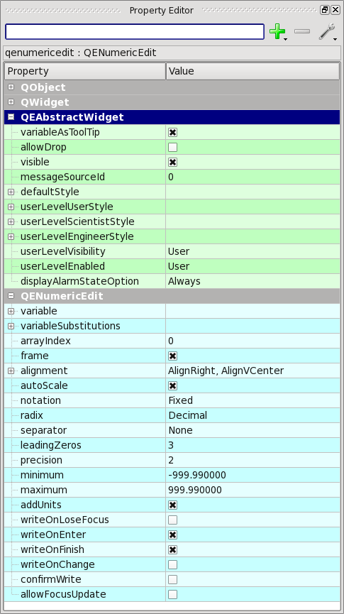.

Figure 3 QENumericEdit properties