Furqan khan | Ahmed Butt

OOP Project Report
1. Introduction

2. OOP Design Decisions

Class Hierarchy Design
The enemy class hierarchy was the most important design decision. All enemies inherit from a base abstract class called Enemy. This class holds common fields like position, health, gemDrop, and isEncased, and declares three pure virtual functions: update(), draw(), and onHit().
The hierarchy goes three levels deep to satisfy the project requirement:
- Enemy (abstract base)
- Botom inherits from Enemy >basic walking enemy
- FlyngFoogaFoog inherits from Botom >adds flight behaviour
- Tornado inherits from FlyngFoogaFoog >adds knife throwing
- Mogera and Gamakichi both inherit from enemy.

This design means each enemy only adds what is new. Tornado does not repeat walking code because it inherits it from FlyngFoogaFoog which inherited it from Botom. This is clean inheritance in practice.

Encapsulation
All fields in some class are private. Getter and setter functions are used to access them. For example the Player class holds score, lives, gemCount, and all powerup booleans as private fields. The only way to change them is through functions like addLife(), spendGems(), and enemyKilled(). This prevents accidental changes from outside the class.

Polymorphism
Because update() and draw() are declared as pure virtual in the Enemy base class, Student A can call these functions on any enemy type without knowing which specific enemy it is. The correct version runs automatically based on the actual object type. This is how polymorphism is applied in the game loop.

Design Pattern
The EnemyFactory class was implemented as the Factory design pattern. Instead of creating enemy objects directly, you call EnemyFactory::create() and pass the enemy type as a string. It returns the correct enemy object. This makes adding new enemy types easy since you only change the factory, not the game engine code.

Systems Built by Student B

Authentication System
The AuthManager class handles registration and login. A custom hash function called to converts the password into a number before saving it to users.txt. On login the same hash is applied and compared to the saved value. This satisfies the project rule of never storing plain text passwords.

Database System
The Database class saves and loads player progress using plain text files. Three files are used: users.txt for accounts, progress.txt for game progress, and leaderboard.txt for scores. Custom functions intToStr and strToInt were written to convert between numbers and text without using built in library functions. The leaderboard uses bubble sort to display top 10 scores from highest to lowest.

Player and Scoring System
The Player class holds all player data including score, lives, gems, chain count, and powerup states. The scoring system uses random ranges per enemy type as required by the spec. Each chain kill adds a 10 percent bonus. The Player class also handles all powerup activation and gem spending for the shop.

Shop System
The Shop class connects directly to the Player object. When a player buys an item, gems are deducted from their Player object and the effect is activated immediately. The SFML UI shows the current gem count updating in real time and displays success or failure messages after each purchase.

UI Screens
Eight UI screens were built using SFML. All screens follow the same structure with a setup() function to initialize elements, a handleInput() function to detect mouse clicks, and a draw() function to render everything. The screens include Login, Main Menu, Character Select, HUD, Pause Menu, Shop, Game Over, Level Complete, and Boss Defeated.
The Login screen handles registration and login with error messages. The Character Select screen supports both single player and multiplayer, showing each player selecting separately. The HUD draws on top of the game every frame showing score, lives, gems, level, and boss health bar on boss levels.

Systems Built by A:
Enemy logic handling:
From enemy movement to collision to damage to class heirarchy of botom→FlyingFoogaFoog→Tornado and the implemntation of Boss’s such as Mogera and Gamkichi. They all follow a inheritance scheme of Enemy.h and Boss.h inheritance where boss inherits from enemy.
Main:
The accumulation of instances, declerations, drawing and event handling done is done in main with input handling deleting and loops for game state managements.
Physics:
Made to allow for platformer logics such as gravity, collision checks and more.
LevelManager:
Made to create a file system of loading levelss data and create on runtime.
AssetLoader:
Made to load all assets of files in variables.
Animations:
Made to hold and implement player animations.

5. Challenges Faced
First of all deciding which task belongs to student A Student B was the difficult observation. Then understanding of player and enemy classes and their child classes was challenging which later on provide clear path. Understanding of sfml library was the major challenge in the beginning but it made sense later somehow.

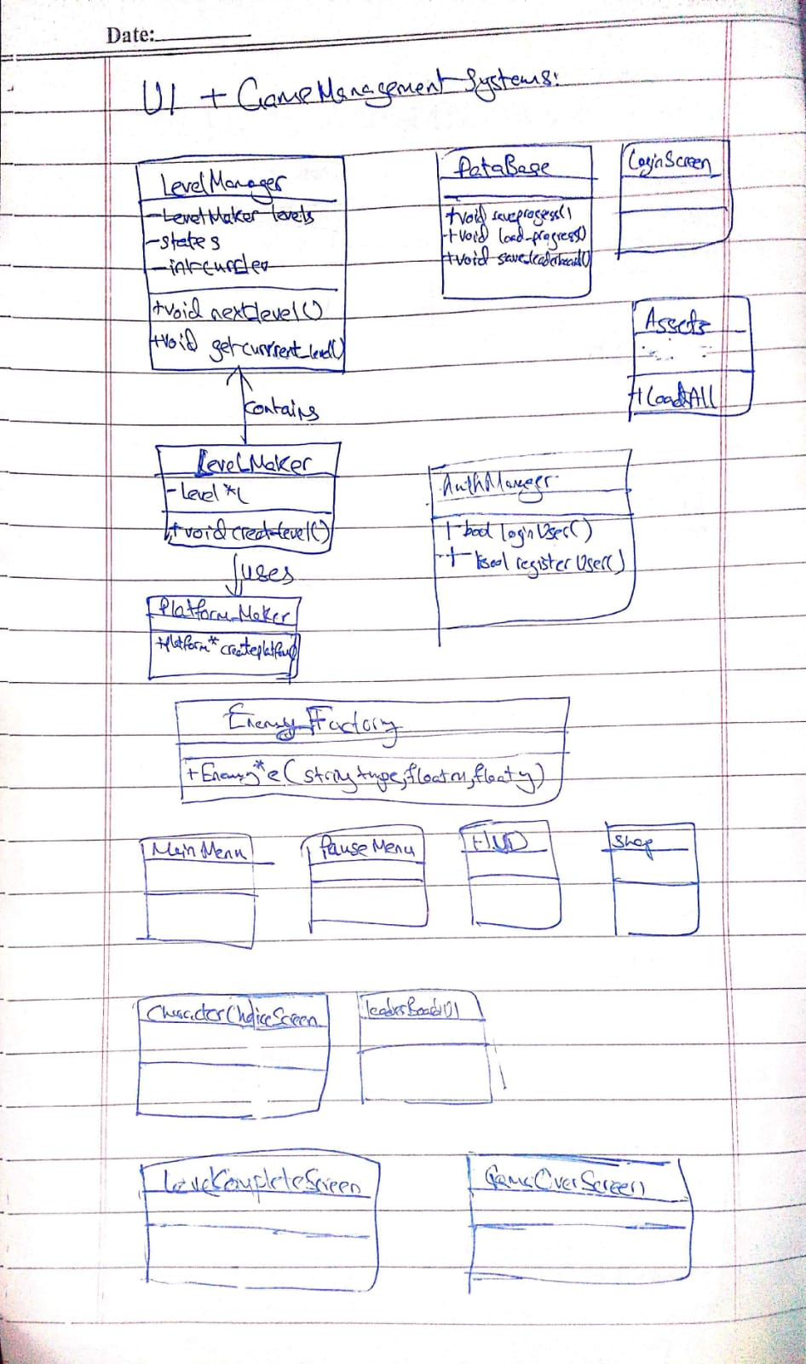

Conclusion:
It was tough near the end wherte I am right now, I hope spelling mistakes are ignored for me. This was a good project as it allowed me to learn sfml and implement a game. It was good for my future as a game dev but is quite gruelling for the time crunch.

