Part I
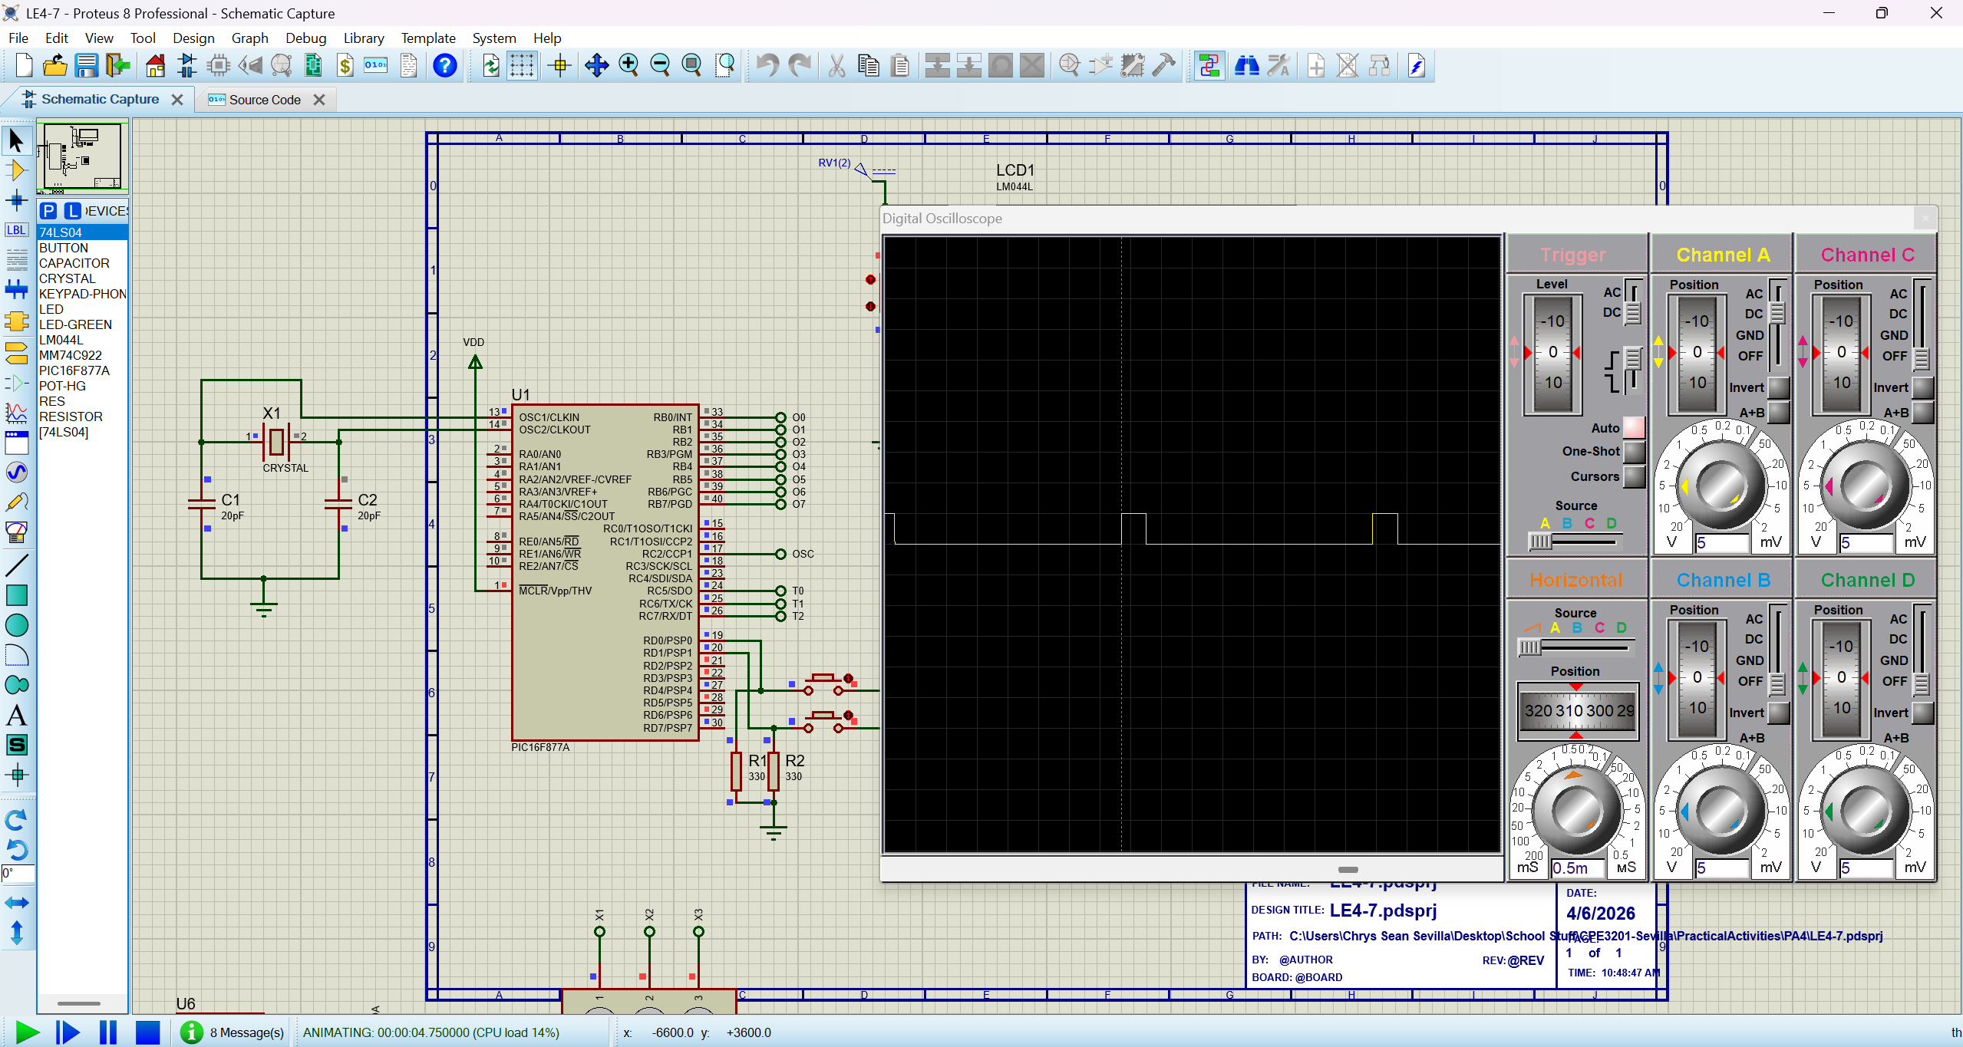
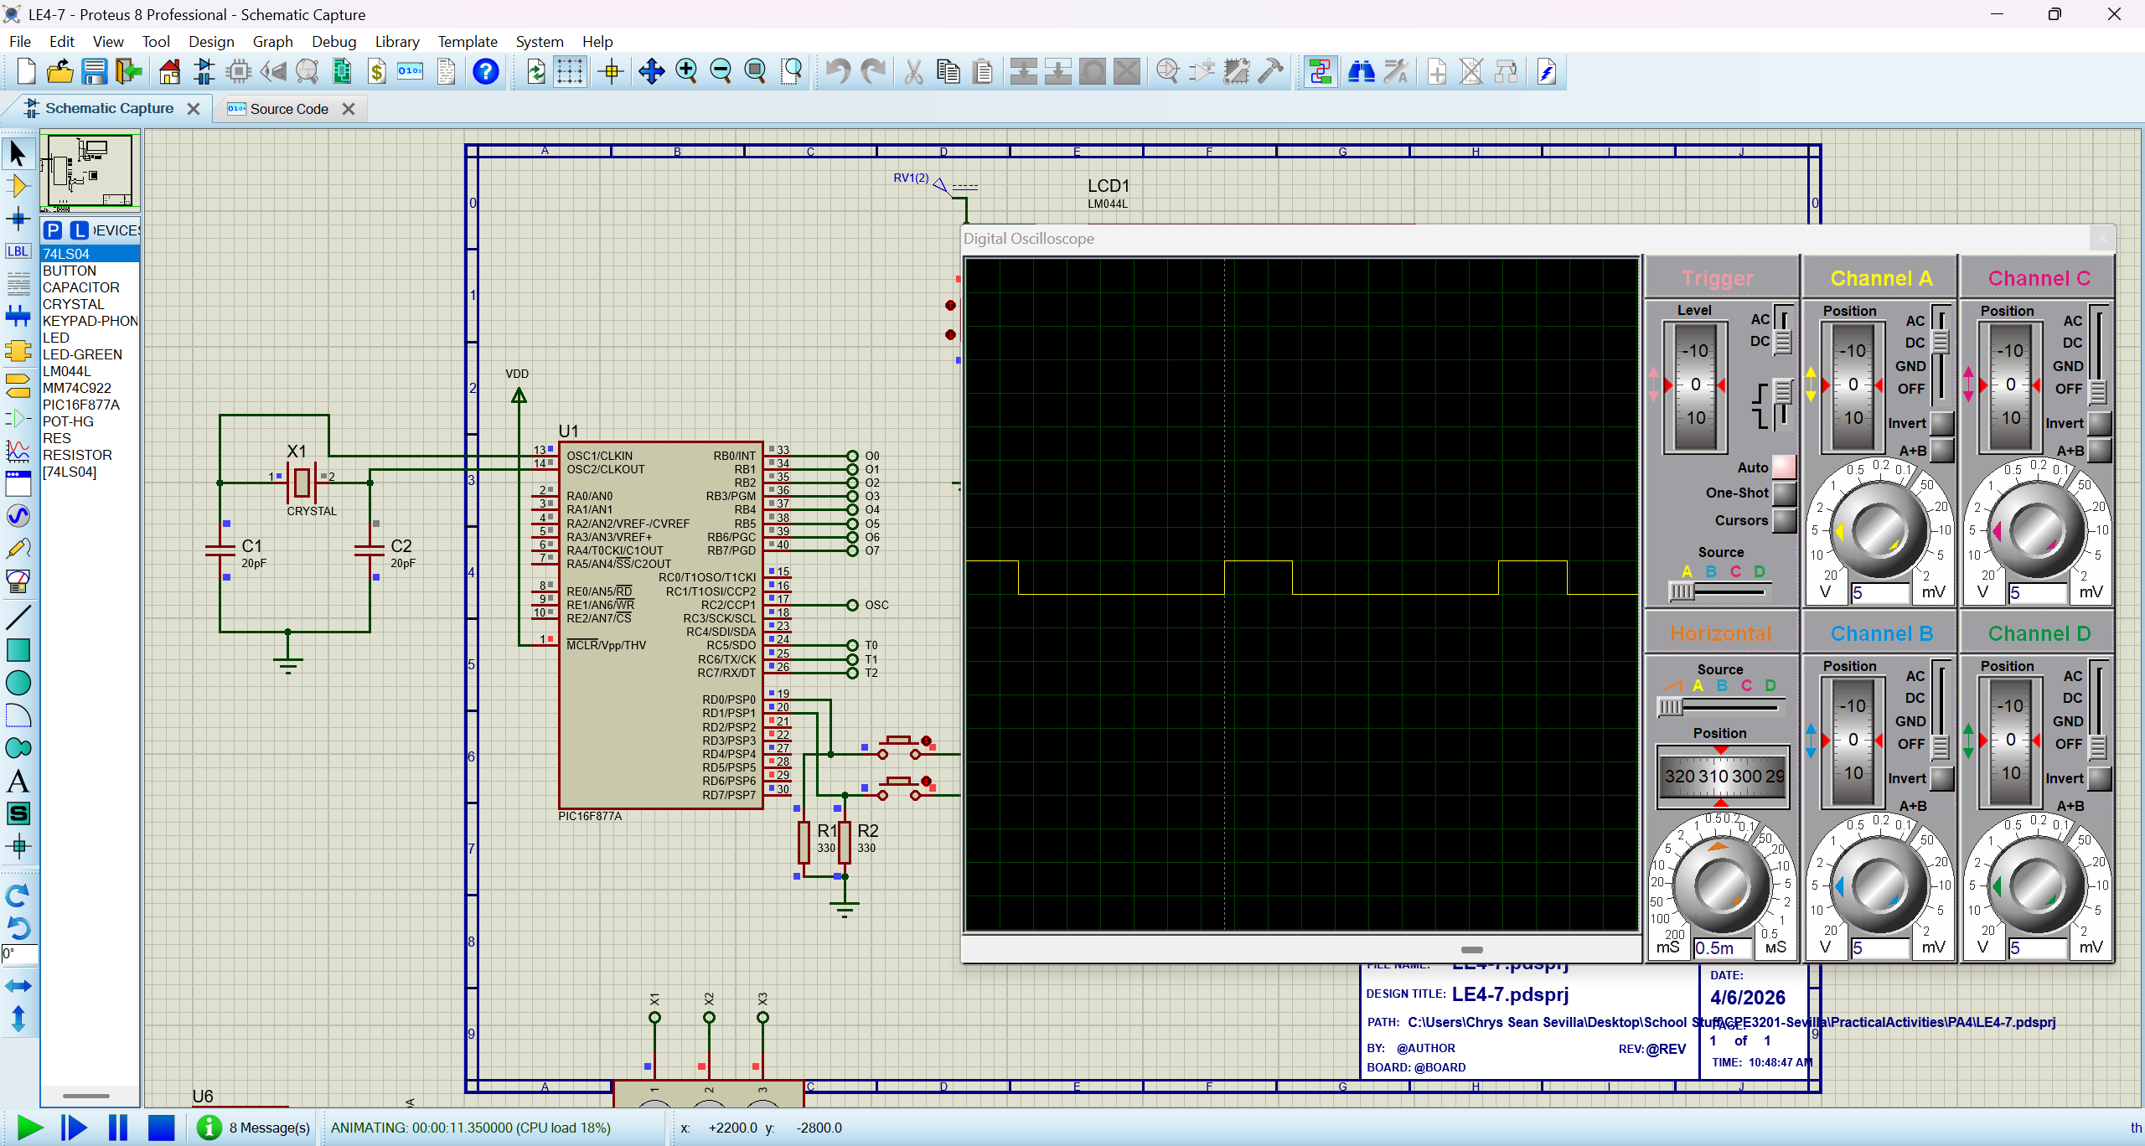
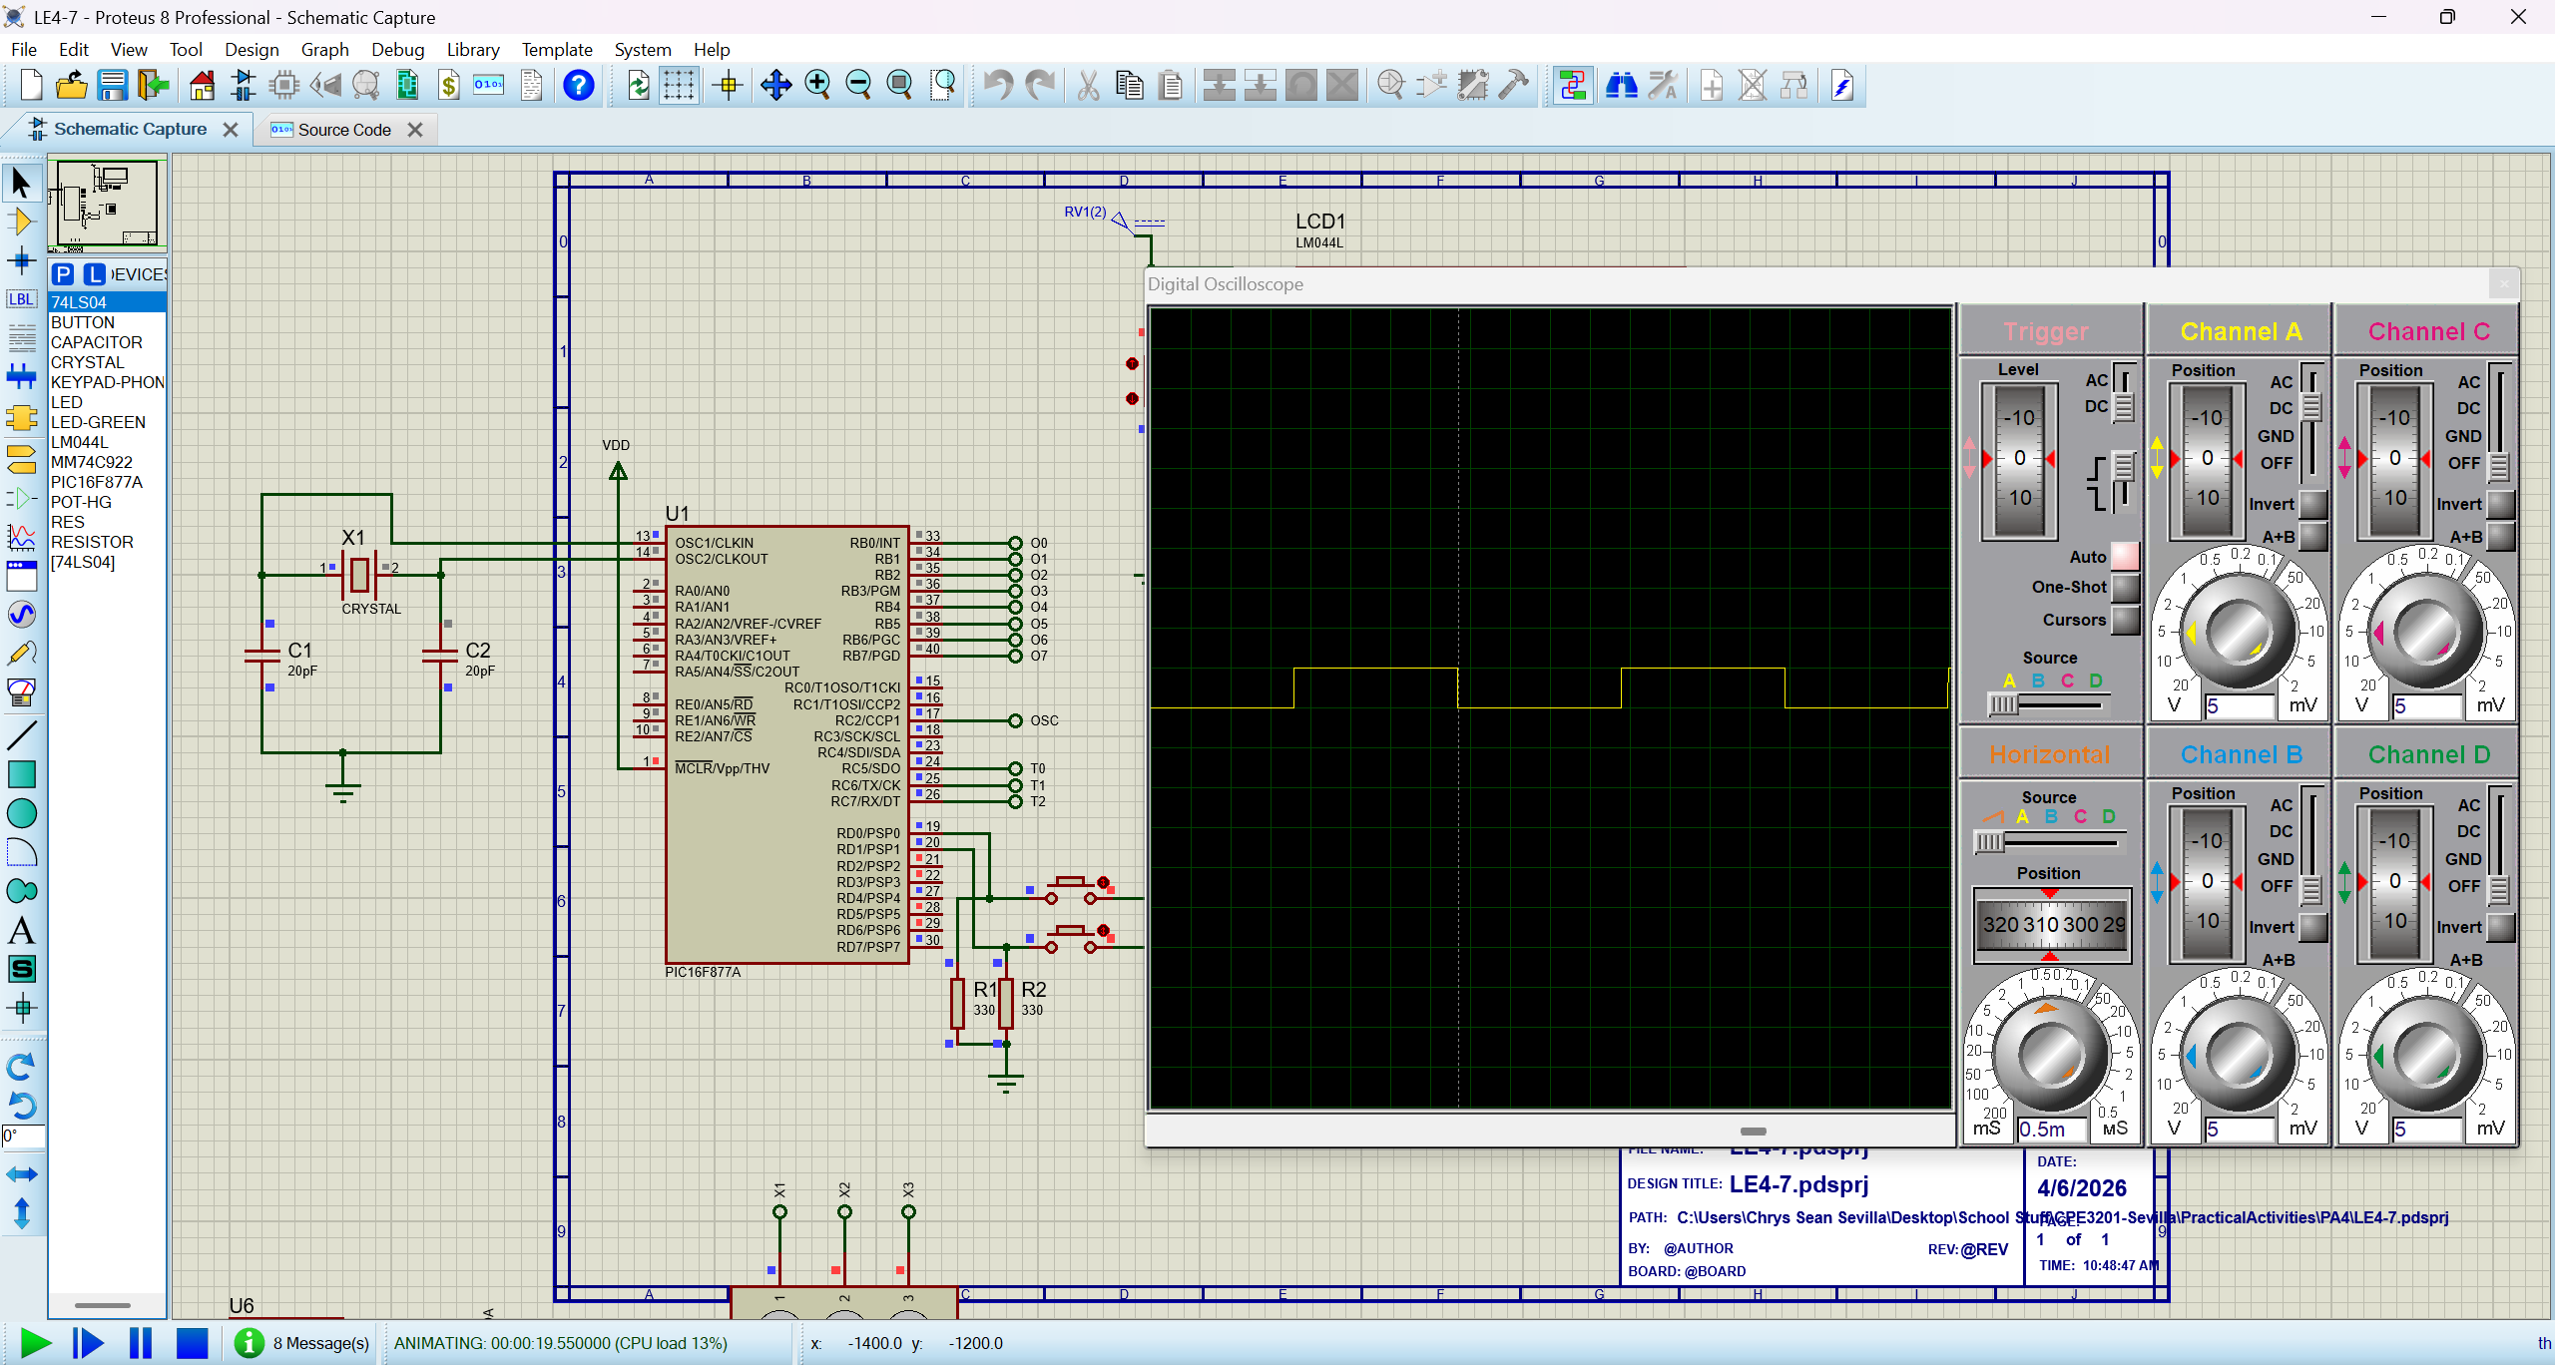
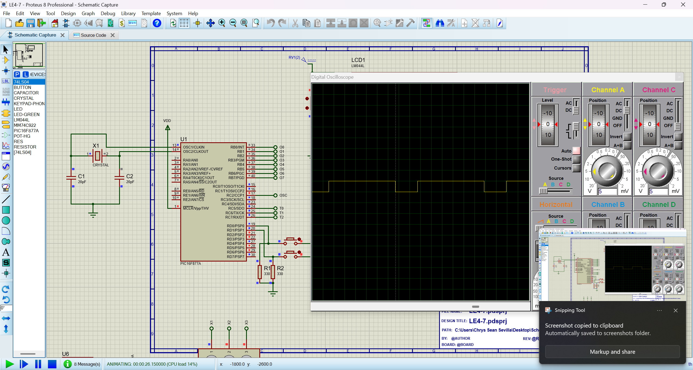
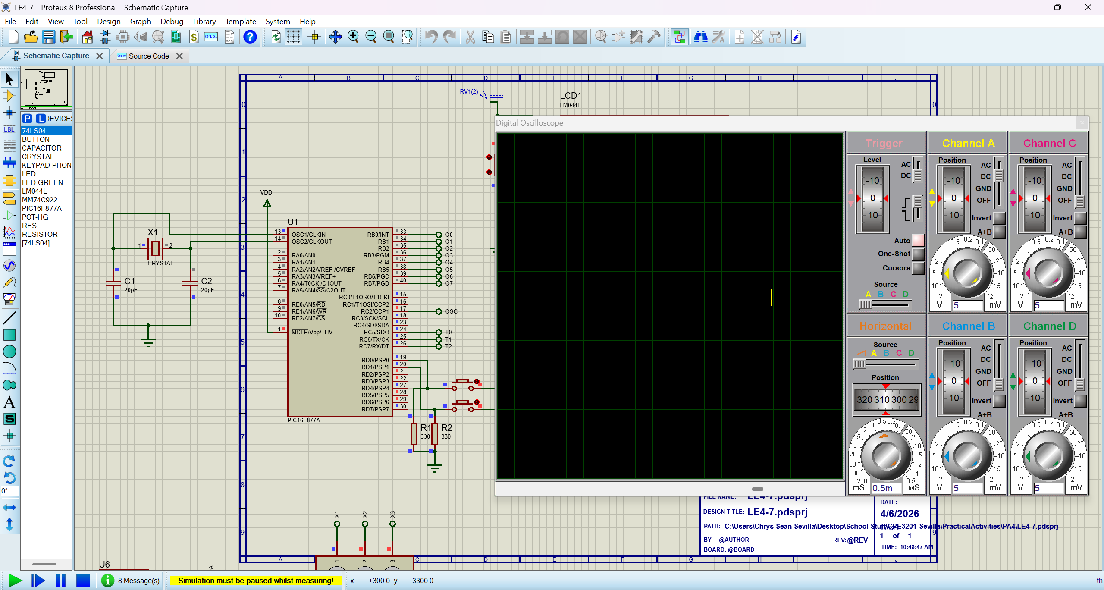
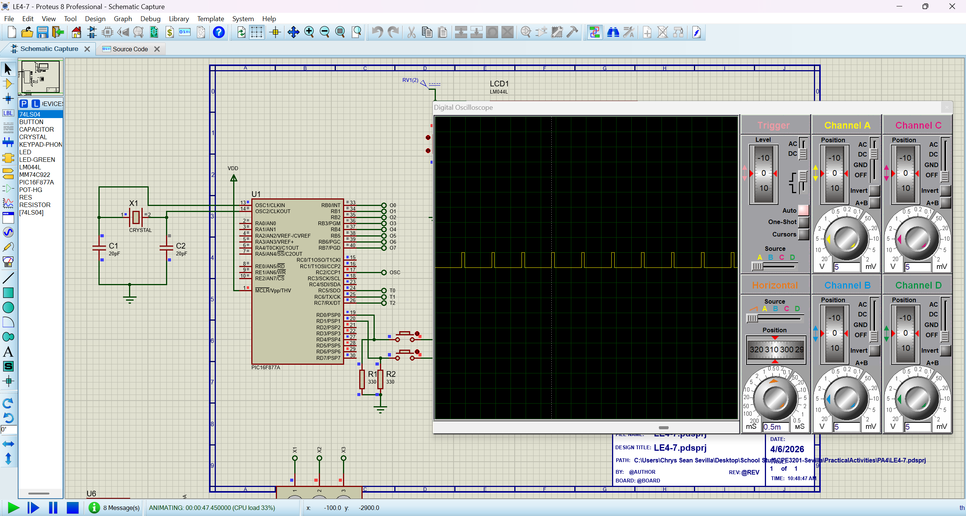
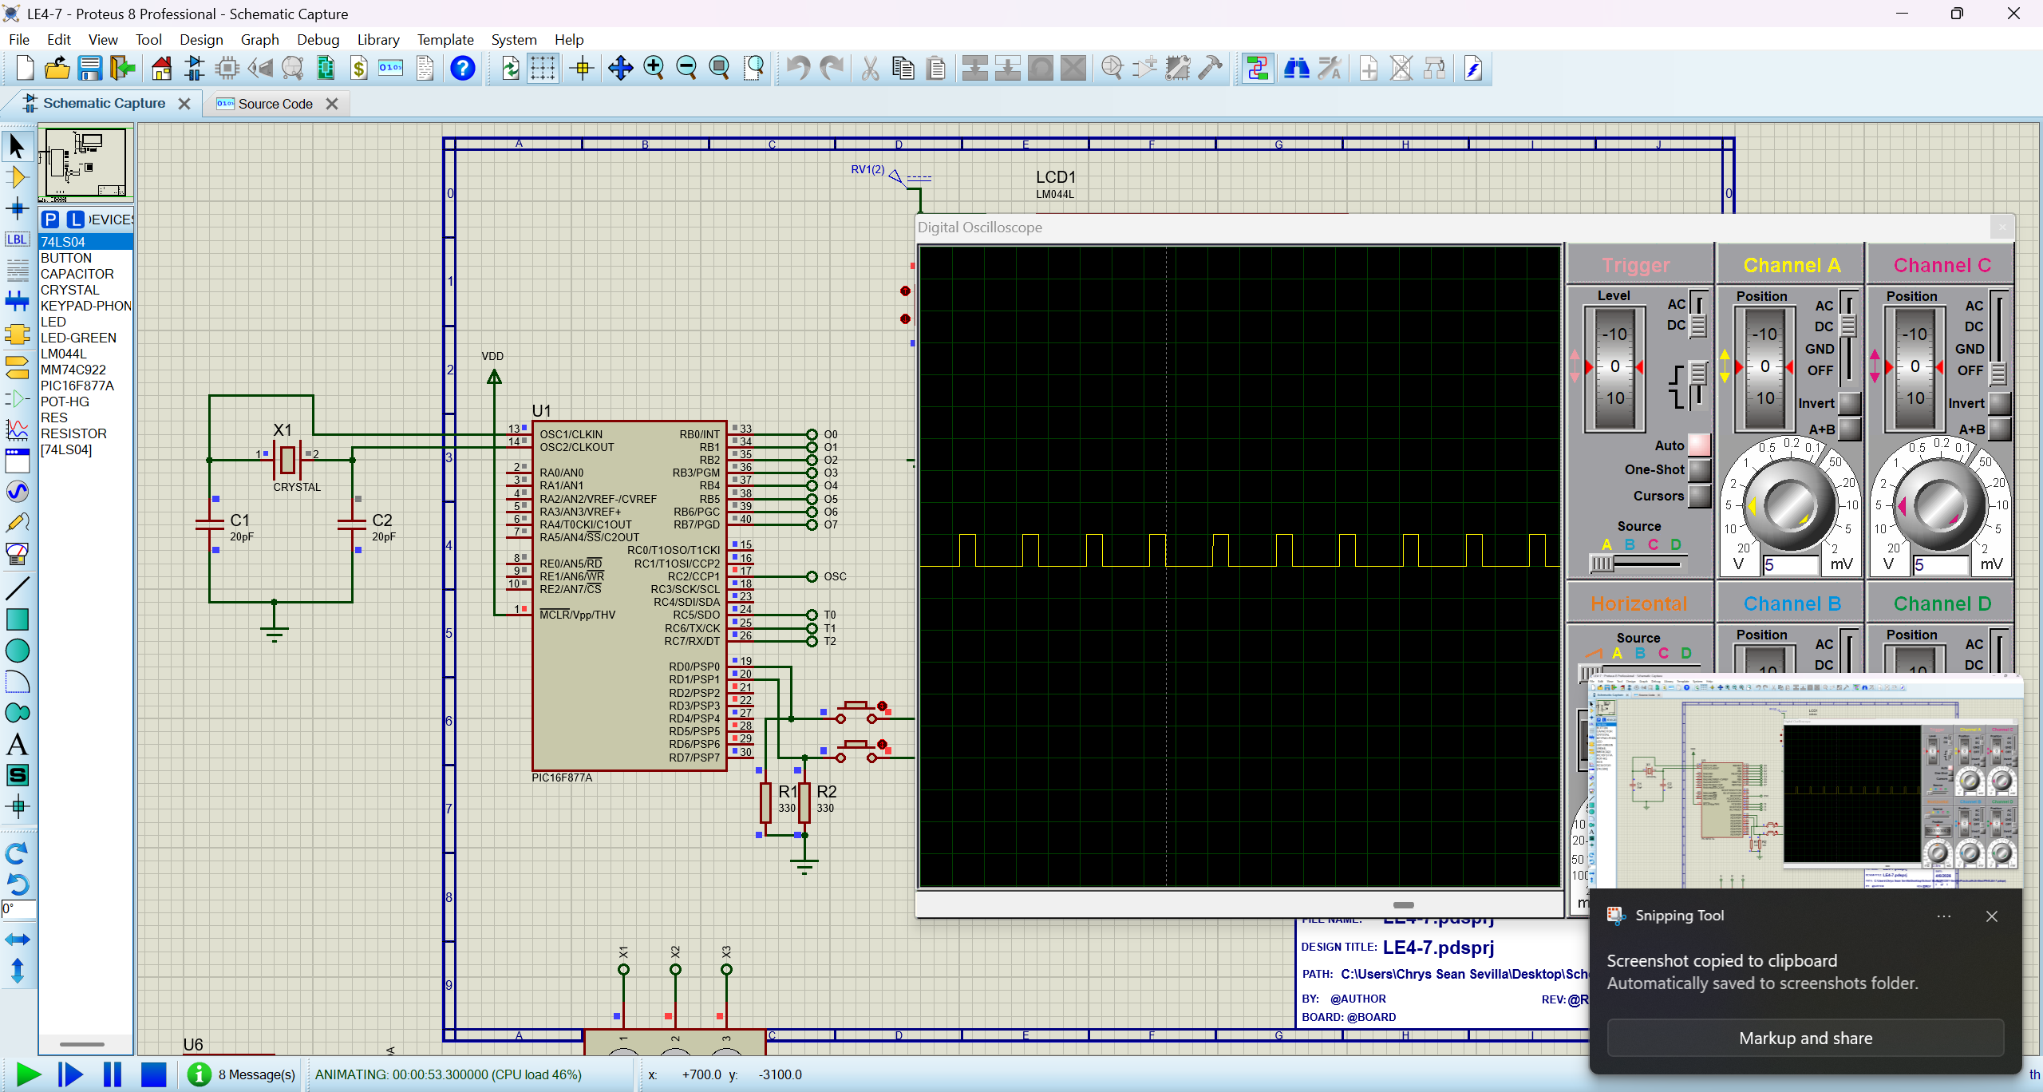
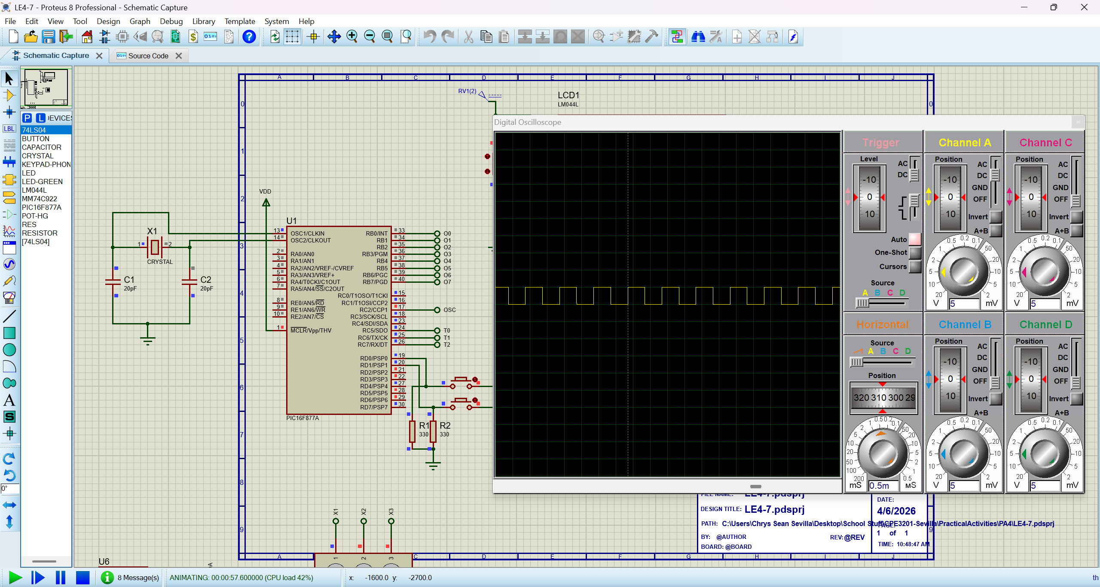
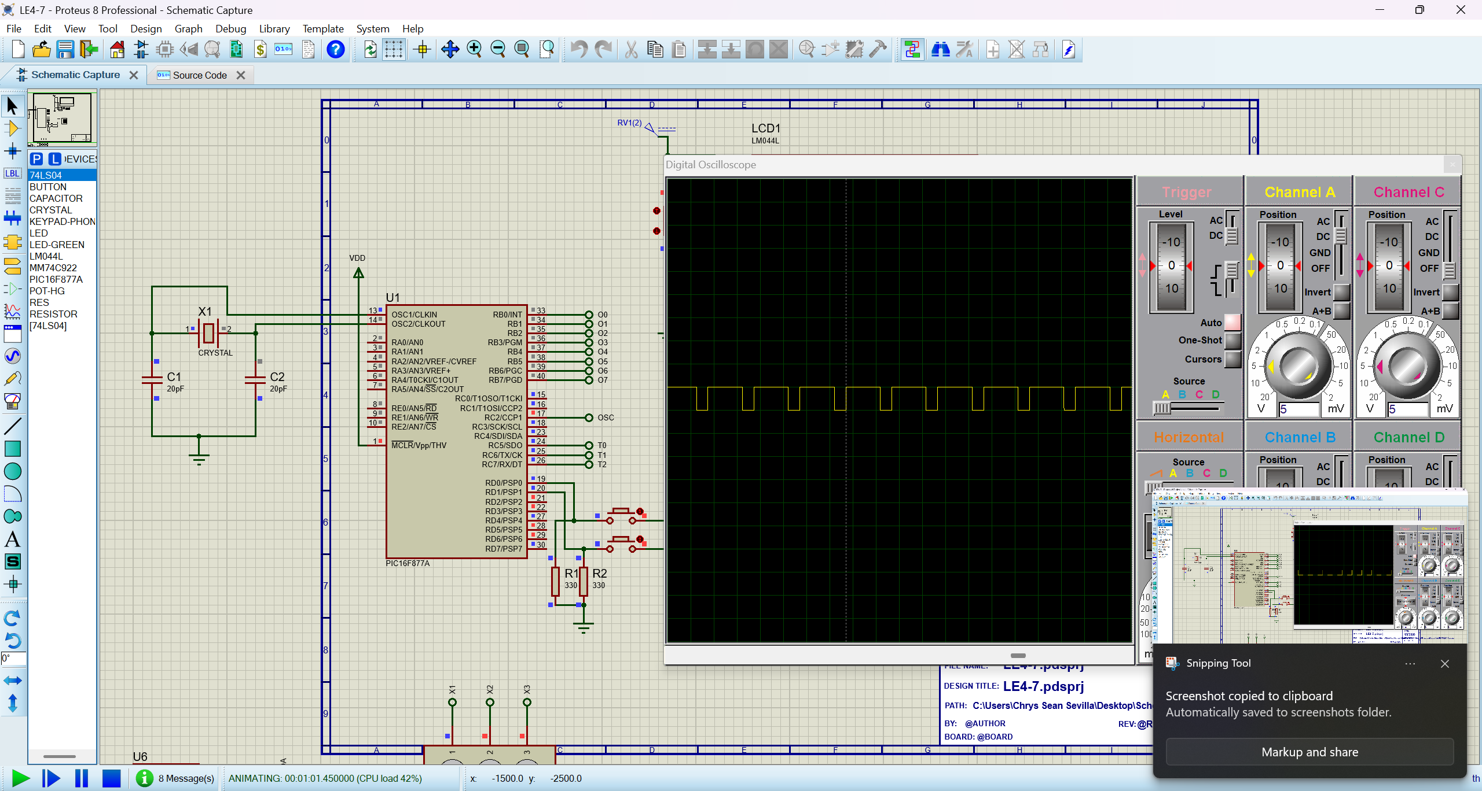
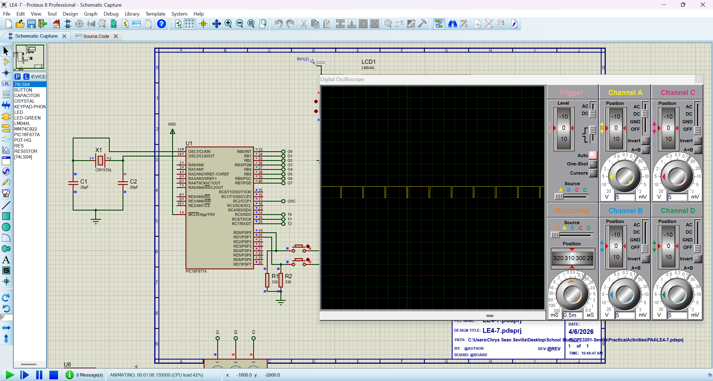

Part II
$$F_{min}=\frac{4000000}{4⋅16⋅256}=244.14\text{ Hz}$$

$$PR2=\frac{F_{osc}}{4⋅F_{pwm}⋅\text{Prescaler}}-1$$

$$\text{10-bit Duty Value}=\left(\text{Duty Ratio}\right)⋅4⋅\left(PR2+1\right)$$

$$PR2=\frac{4000000}{4⋅500⋅16}-1=124$$
$$\text{Max Resolution}=4⋅\left(124+1\right)=500$$
$$10\%\text{ Duty}=500⋅0.10=50$$
$$25\%\text{ Duty}=500⋅0.25=125$$
$$50\%\text{ Duty}=500⋅0.50=250$$
$$50\%\text{ Duty}=500⋅0.50=250$$
$$95\%\text{ Duty}=500⋅0.95=475$$

Duty Cycle | 10-bit Decimal Value | CCPR1L (8 MSB) | CCP1CON<5:4> (2 LSB)
10% | $$10\%\text{ Duty}=500⋅0.10=50$$ | 12 (0x0C) | 2
25% | $$25\%\text{ Duty}=500⋅0.25=125$$ | 31 (0x1F) | 1
50% | $$50\%\text{ Duty}=500⋅0.50=250$$ | 62 (0x3E) | 2
75% | $$50\%\text{ Duty}=500⋅0.50=250$$ | 93 (0x5D) | 3
95% | $$95\%\text{ Duty}=500⋅0.95=475$$ | 118 (0x76) | 3

$$PR2=\frac{4000000}{4⋅700⋅16}-1=88.28≈88$$
$$\text{Max Resolution}=4⋅\left(88+1\right)=356$$
$$10\%\text{ Duty}=356⋅0.10=35.6≈35$$
$$25\%\text{ Duty}=356⋅0.25=89$$
$$50\%\text{ Duty}=356⋅0.50=178$$
$$75\%\text{ Duty}=356⋅0.75=267$$
$$95\%\text{ Duty}=356⋅0.95=338.2≈338$$
Duty Cycle | 10-bit Decimal Value | CCPR1L (8 MSB) | CCP1CON<5:4> (2 LSB)
10% | $$10\%\text{ Duty}=356⋅0.10=35.6≈35$$ | 8 (0x08) | 3
25% | $$25\%\text{ Duty}=356⋅0.25=89$$ | 22 (0x16) | 1
50% | $$50\%\text{ Duty}=356⋅0.50=178$$ | 44 (0x2C) | 2
75% | $$75\%\text{ Duty}=356⋅0.75=267$$ | 66 (0x42) | 3
95% | $$95\%\text{ Duty}=356⋅0.95=338.2≈338$$ | 84 (0x54) | 2

$$PR2=\frac{4000000}{4⋅1000⋅16}-1=61.5≈61$$
$$\text{Max Resolution}=4⋅\left(61+1\right)=248$$
$$10\%\text{ Duty}=248⋅0.10=24.8≈24$$
$$25\%\text{ Duty}=248⋅0.25=62$$
$$50\%\text{ Duty}=248⋅0.50=124$$
$$75\%\text{ Duty}=248⋅0.75=186$$
$$95\%\text{ Duty}=248⋅0.95=235.6≈235$$
Duty Cycle | 10-bit Decimal Value | CCPR1L (8 MSB) | CCP1CON<5:4> (2 LSB)
10% | $$10\%\text{ Duty}=248⋅0.10=24.8≈24$$ | 6 (0x06) | 0
25% | $$25\%\text{ Duty}=248⋅0.25=62$$ | 15 (0x0F) | 2
50% | $$50\%\text{ Duty}=248⋅0.50=124$$ | 31 (0x1F) | 0
75% | $$75\%\text{ Duty}=248⋅0.75=186$$ | 46 (0x2E) | 2
95% | $$95\%\text{ Duty}=248⋅0.95=235.6≈235$$ | 58 (0x3A) | 3

