|  |  |  |  |
| --- | --- | --- | --- |
| **NAME:** | Chrys Sean T. Sevilla | **DATE:** | 3 November 2024 |

**LE 6.1 Drawable Shape**

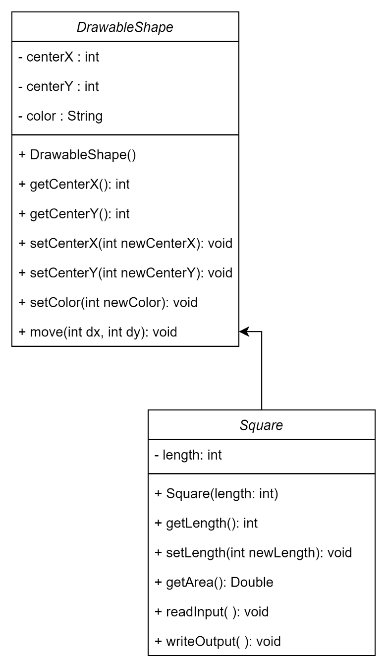

**LE 6.2 Patient-Billing**

