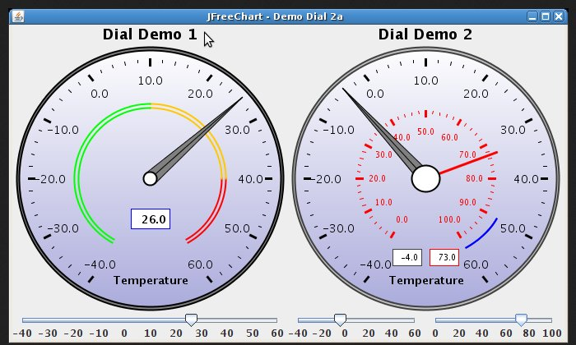 | Chart 1 (left chart):  Title: Incomes this month  Lowest value: 0  Highest value: the highest income over all months combined.  Arrow marks the current incomes/expense of the current month.  Chart 2 (right chart)  Title: Incomes this year  Lowest value: 0.  Highest value: the highest income over all years combined.  Arrow marks the current incomes/expense of the current year.
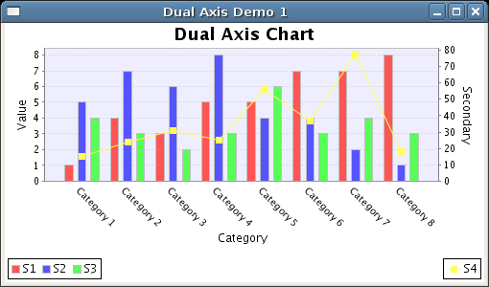 | Title: Monthly results  Incomes/Expenses/Result of each month of the current year
Title: Yearly results
Incomes/Expenses/Result of each month of the current and the past 11 years
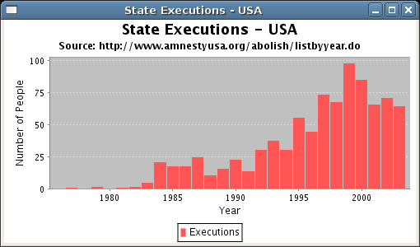 | Title: Incomes overall  1 bar for each income category  Color of the bars: green  3 charts:  1 chart for overall results  1 chart for current year  1 chart for current month
Title: Expenses overall
1 bar for each expense category
Color of the bars: red
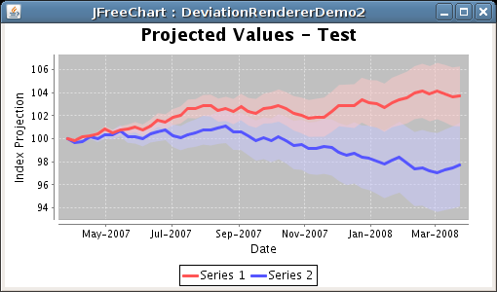 | Line 1: Results of each date overall  Text:  With a current total budget of … EURO and an average expense of … EURO per day based on xxx items of expenses since dd/mm/yyyy (date of first expense ever) you can live financially free for … years, … months and … days.

