Testing image: Assets/Screenshots/main menu.png
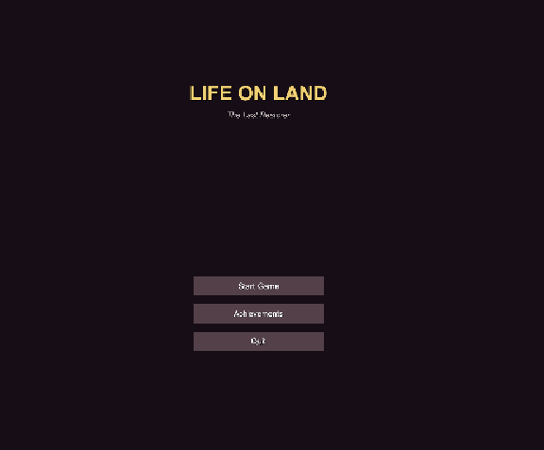
Testing image: Assets/Screenshots/achievement_main_menu.png
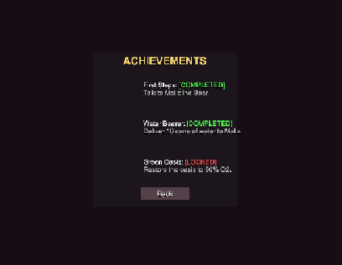
Testing image: Assets/Screenshots/viallin_dialogs_2.png
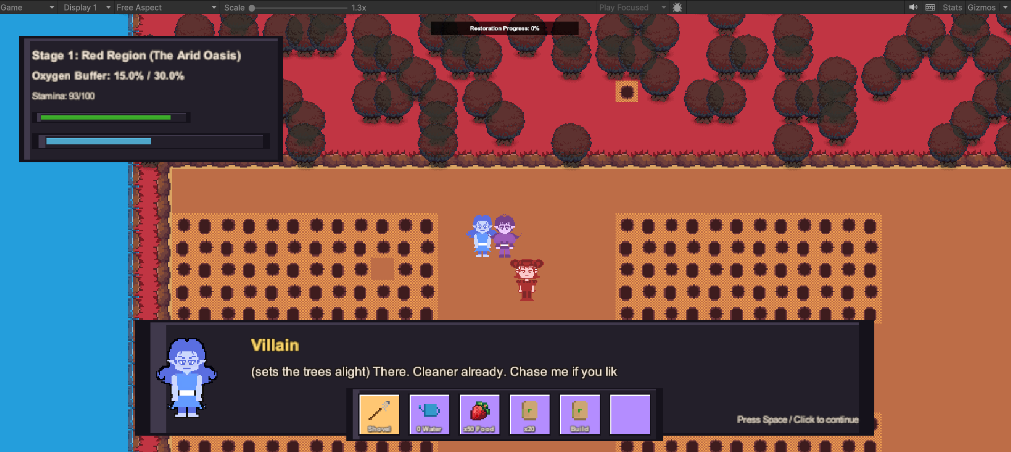
Testing image: Assets/Screenshots/maliz_dialogs.png
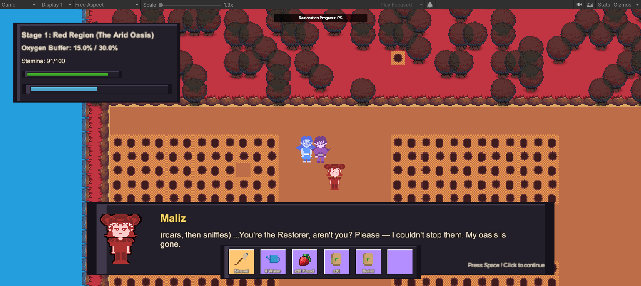
Testing image: Assets/Screenshots/quest_dialog.png
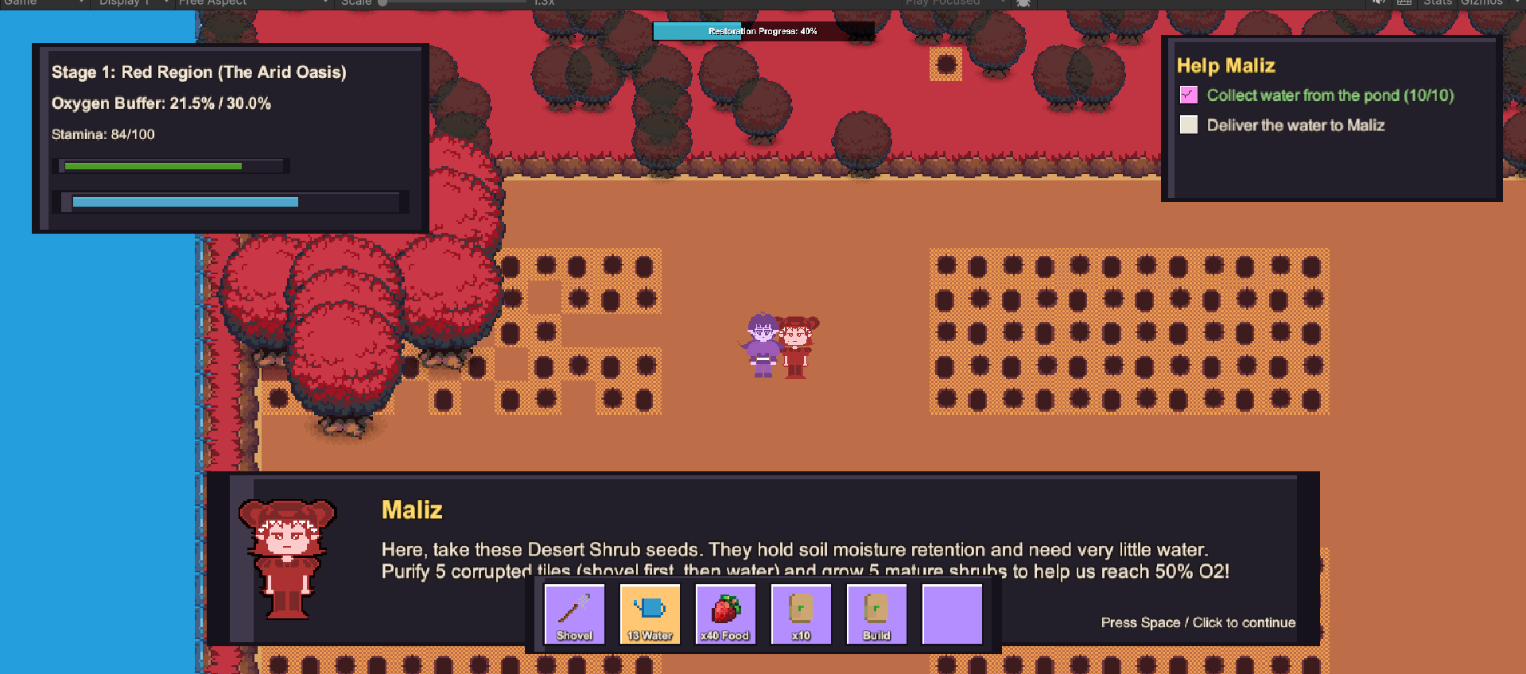
Testing image: Assets/Screenshots/watered_soil_1.png
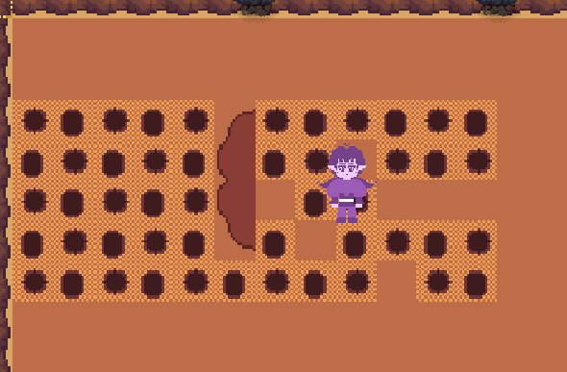
Testing image: Assets/Screenshots/grown_trees.png
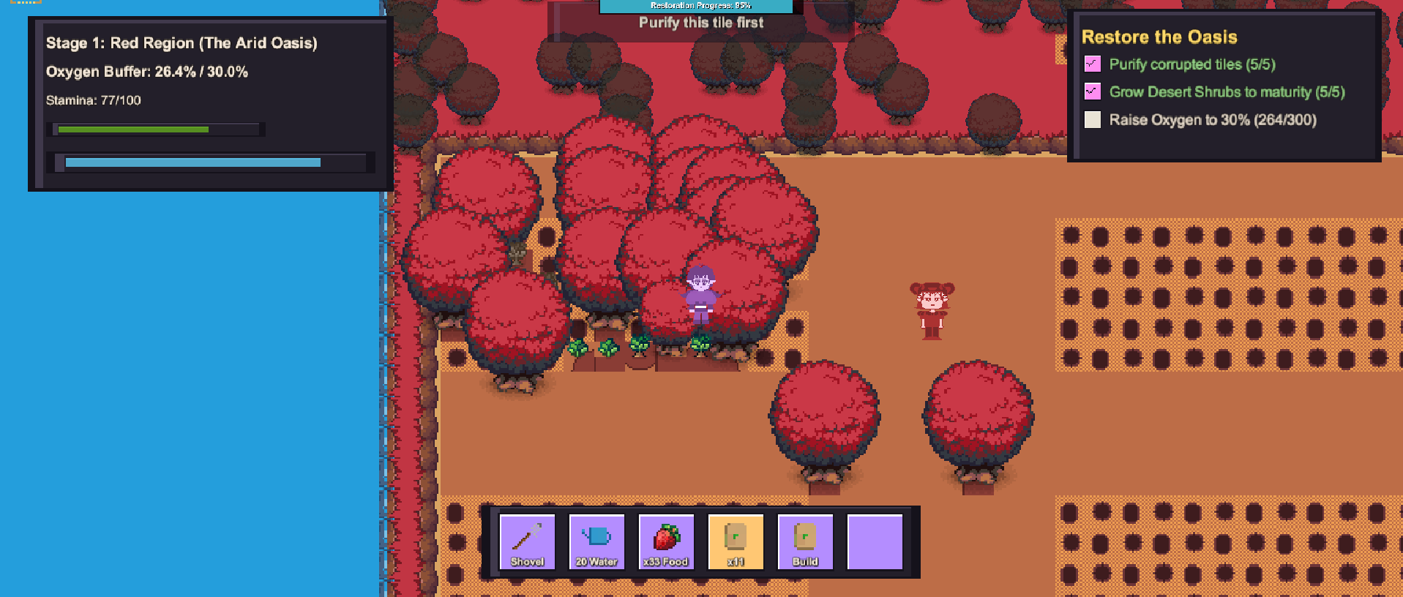
Testing image: Assets/Screenshots/trees_growing_1.png
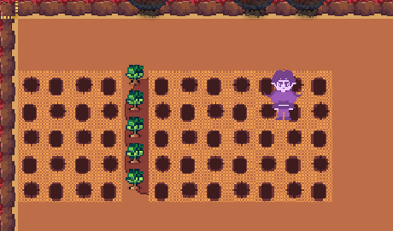
Testing image: Assets/Screenshots/stage_complete.png
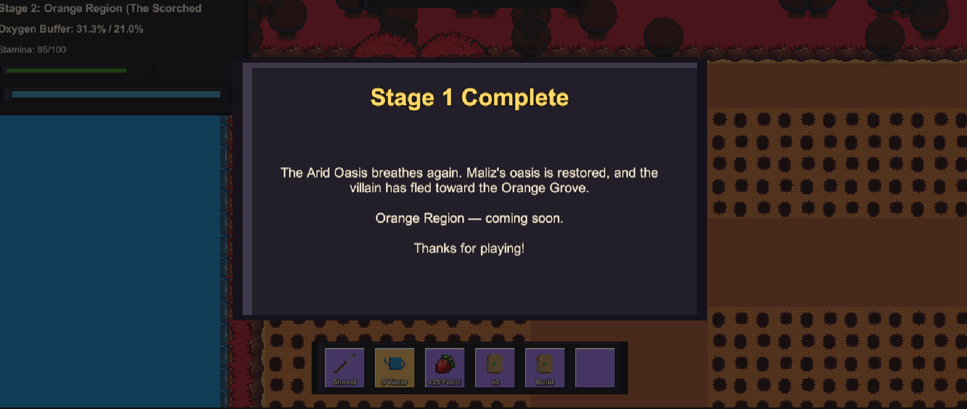
Testing image: Assets/Screenshots/achievement.png
